Need to install the following :

Node version need to install 16.10.0

Check with cmd (Node –v)

Need to Install Necessary file as (Npm install ) it will install the necessary files for the project

Need to install Mangobd and Mongodb Compass as the below followed link

(<https://fastdl.mongodb.org/windows/mongodb-windows-x86_64-6.0.5-signed.msi>)

After installed the mangodb you need to create a database like below the following

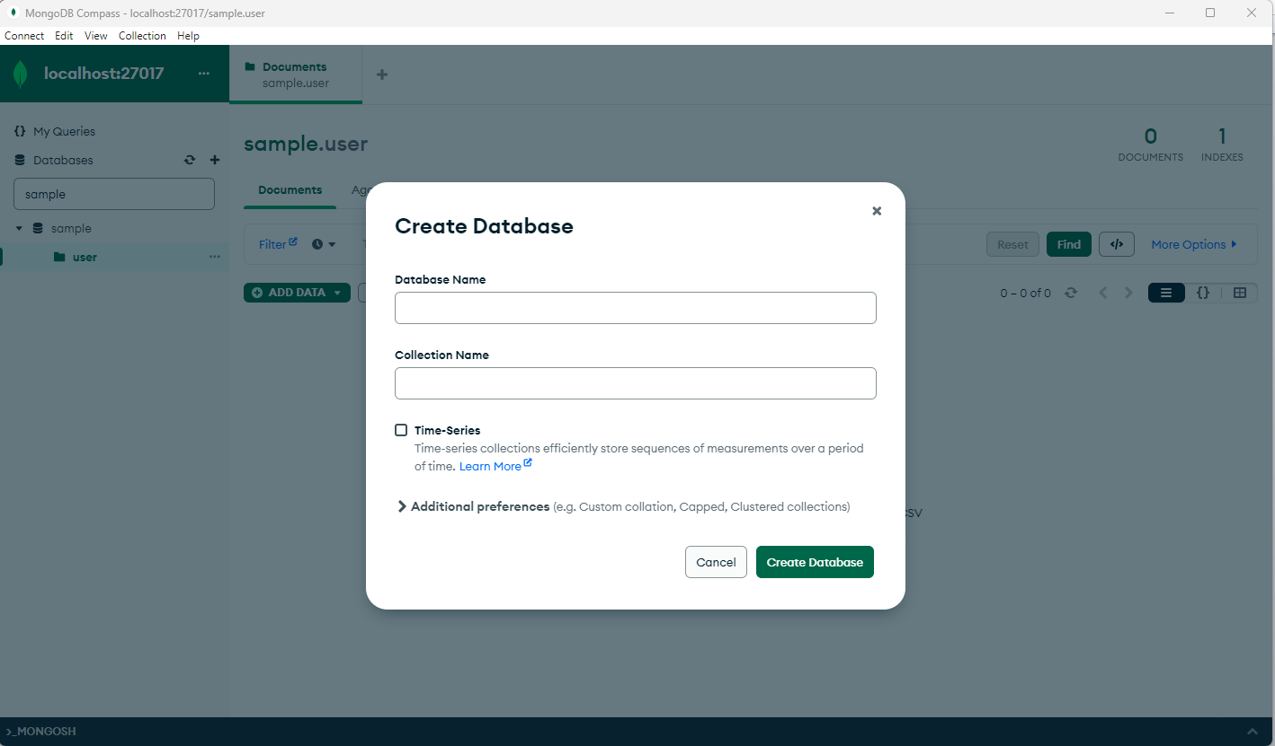

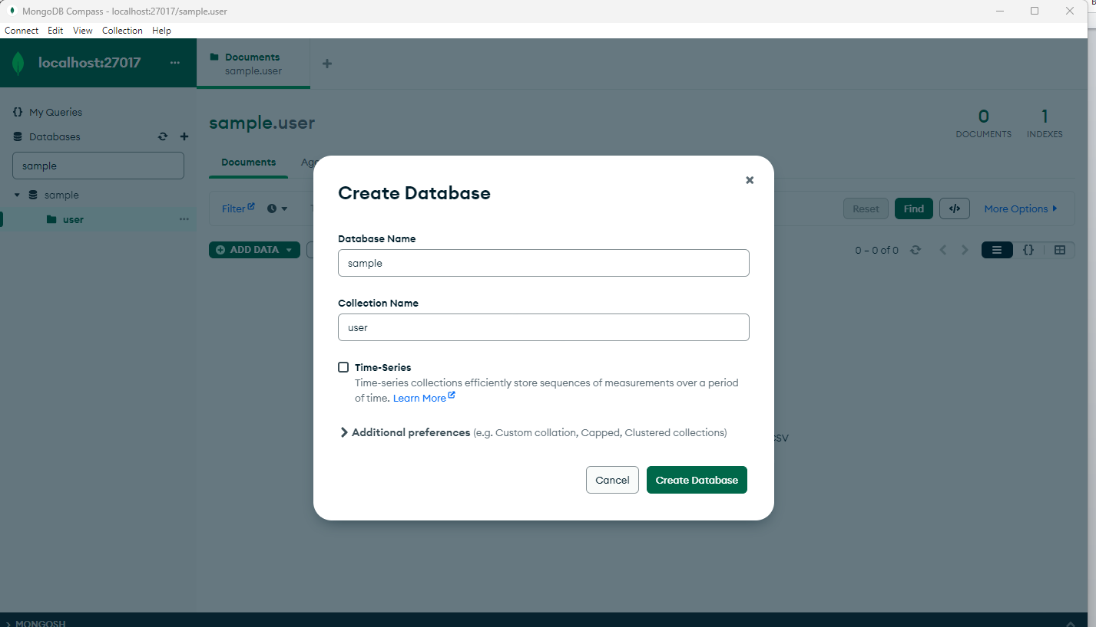

Then you need to create a database followed below screens look like

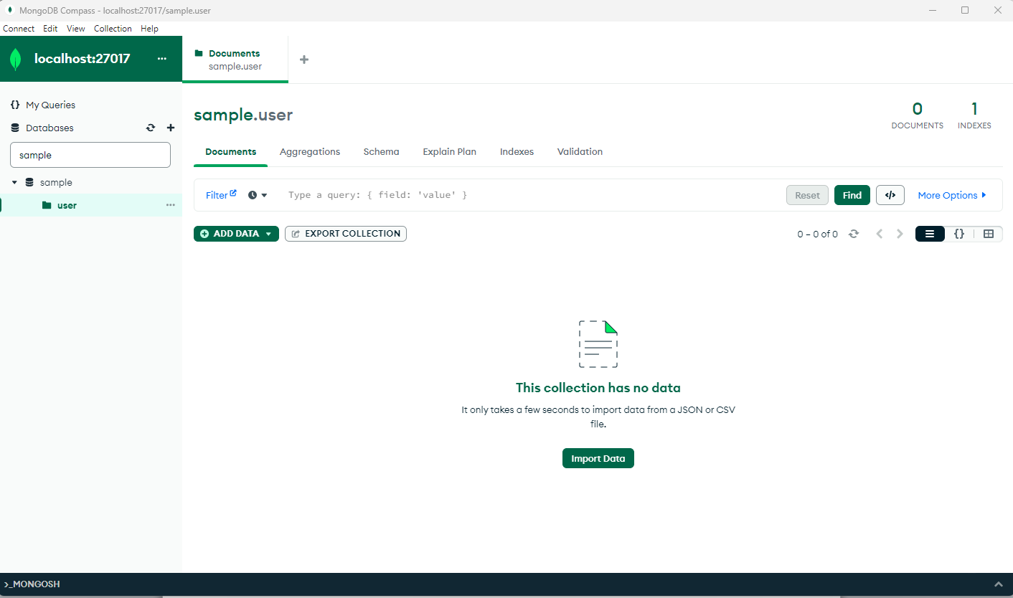

Then you need to replace the mangouri in the dbconnect.js file

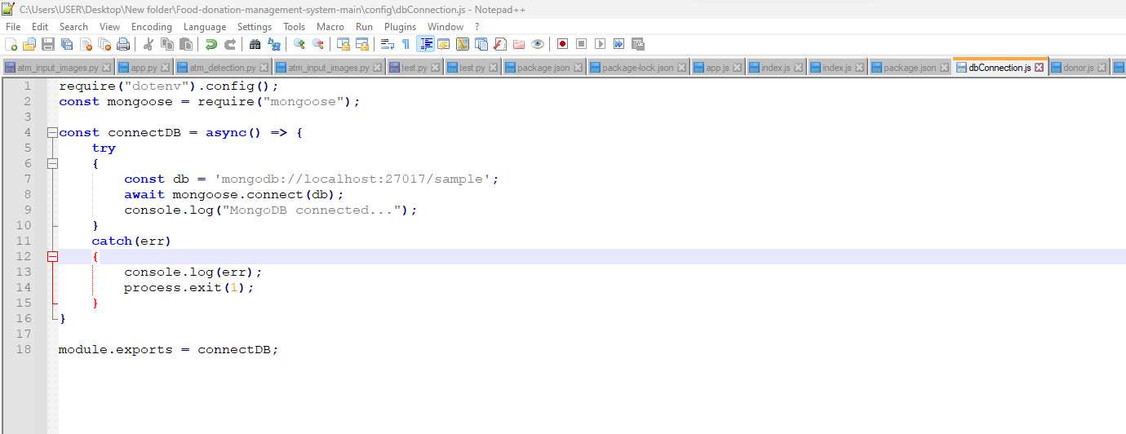

Here the uri will be create by our own as .env text file then you need to add the database name along with that

Mongodb uri will be

MONGO_URI = mongodb://localhost:27017/

The you have to add the database name with that

mongodb://localhost:27017/sample;

then you have to paste the above command on mentiond screenshot

cheers::