CSE 3302: Programming Languages
Crash Course Computer Science 5-8
Name: Mary-Rose Tracy
1000 number: 1001852753
Date: 10/20/2023
NOTE: IMOW= Means In My Own Words
Questions:
- Design a “Half Adder” circuit for two inputs A and B. Now, design a “Full Adder” circuit using previously designed half adders. [15 points]
Half Adder: (Blue is an example) outputs are sum & carry. A half adder does the add operation on a binary digit specifically two of them.
Inputs |  | Outputs
A | B | Carry | Sum
0 | 0 | 0 | 0
0 | 1 | 0 | 1
1 | 0 | 0 | 1
1 | 1 | 1 | 0
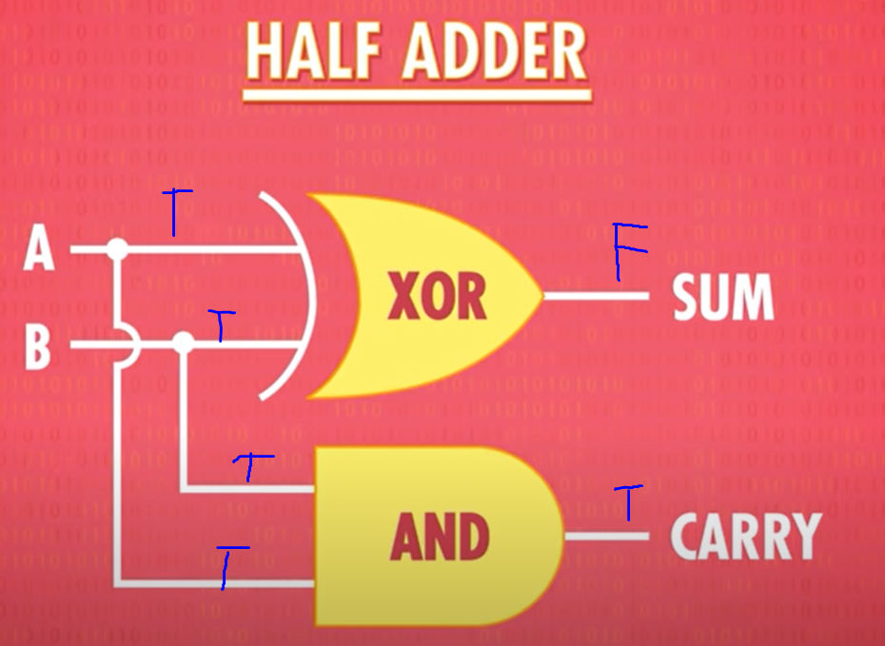
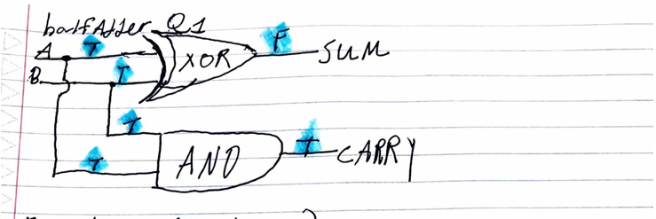
Full Adder: Unlike a half adder. The full adder has three binary digits. It has the same outputs carry & sum. The main difference between the full and half adder is that it has A, B, and C.
A | B | C | CARRY | SUM
0 | 0 | 0 | 0 | 0
0 | 0 | 1 | 0 | 1
0 | 1 | 0 | 0 | 1
1 | 0 | 0 | 0 | 1
0 | 1 | 1 | 1 | 0
1 | 1 | 0 | 1 | 0
1 | 1 | 1 | 1 | 1
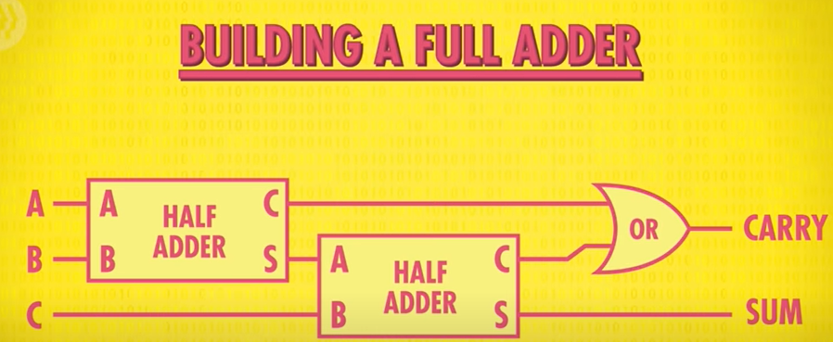
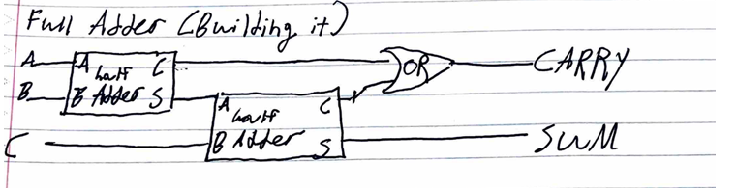
2. What is an overflow? When does it occur? [6 points]
“An overflow occurs when the result of an addition is too large to be represented by the number of bits you are using. This can usually cause errors and unexpected behavior. For example, if you played the 8-bit game Pacman, and you went 256 the ALU overflowed causing the game to have major glitches.”
IMOW: Overflow is when a calculation's result is too big (or sometimes too small) to fit into the space designated for it. Take for example, in real life putting 100 lbs of water into a pool that carries 98 lbs of water. The result of will be the pool will overflow. I had this happen in code. I believe when I was doing a program in C my output was a bunch of weird numbers that were just strewn out for no reason.
3. What is Random Access Memory? Why is this called so? [6 points]
“Random Access memory (AKA RAM) stores things like game state as long as the power stays one.” “When you hear people talking about how much RAM a computer has – that’s the computer’s memory. Ram is like a human’s short term or working memory, where you keep track of things going on right now.”
IMOW: The reason why RAM is defined as "random access" is because you can have immediate access any part without possessing to go through the other parts of it first. In essence, it’s the computers storage that is only temporary. It can read, write that data in any case of its position in a fast manner.
4. What is “And-Or Latch”? Why is this called “latch”? [5 points]
“And-Or Latch is for a useful piece of memory. Has two inputs, a set input, which sets the output to a 1, and a reset input which resets the output to a 0. If set and reset= 0, the circuit just outputs whatever was last put in it. It remembers a single bit of information -AKA memory.”
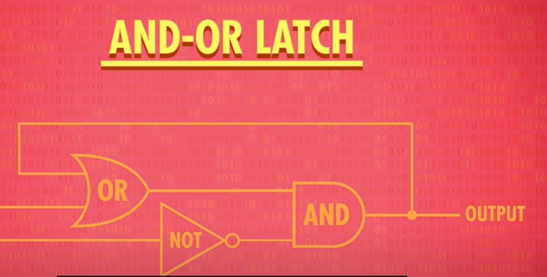
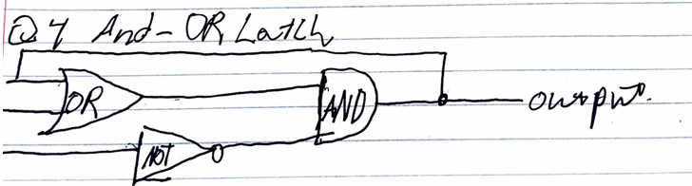
“This is called a “Latch” because it “Latches onto” a particular value and stays that way. The action of putting data into memory is called writing, whereas getting the data out is called reading.”
5. What is “register”? [3 points]
“If we put 8 latches side-by-side, we store 8 bits of information like an 8 bit number. A group of latches operating like this is called a register, which holds a single number, and the number of bits in a register is called it’s width.”
IMOW: A register is in the CPU. It is a tiny, but speedy cache/storage location within the CPU. Is a tiny storage area in the CPU that quickly holds and retrieves data for immediate use, helping the computer process tasks more swiftly.
6. What is “multiplexer”? [3 points]
A multiplexer is a device that takes multiple inputs (or input signals), and then it selects one of them to output based on control signals. Multiplexer kinda acts like a switch, directing one of the input lines to its single output. A multiplexer is also known as mux or MUX.
7. Explain fetch phase, decode phase, and execute phase in short. [12 points] (3rd vid)
Fetch phase- “retrieve our first instruction.” This is where the CPU retrieves an instruction from the memory.
Decode phase- “Now that we fetch the instruction an instruction memory. We need to figure out what that instruction is, so we can execute it (AKA run it and not kill it). The instructions are decoded and interpreted by a control unit.” The CPU interprets from the fetch phase. It’s to recognize what specific action/instruction we require. For example, in real life this is like reading and understanding what it is on our to do list.
Execute phase- To initiate or to “Perform that instruction.” The CPU performs the action or task specified by an instruction we made in our code. For example, this is us checking the box when finish our Todo list.
8. What is clock speed? What is overclocking and underclocking? [6 points]
Clock speed- “The speed at which a CPU can carry out each step, of a fetched-decode-execute cycle. Its speed is measured in hertz.” This is pretty obvious, but if your computer has higher clock speed. Then more problems/operations the CPU can execute in less time.
Overclocking- “You might’ve heard people overclocking their computers. This is when you modify the clock to speed up the tempo of the CPU. Like when the drummer speeds the speed.” This is making the clock speed of a CPU grow beyond it’s the default rate to solve mass problems in a shorter time. Pros: increase in performance Cons: heat, more power consumption, make your computer break because of an overworked CPU.
Underclocking- Antonym of overclocking. “Not many people talk about it, but it’s super useful. Sometimes it’s not necessary to run the processor at full speed. Maybe the user has stepped away or just not running a particularly useful program. By slowing the CPU down (AKA underclocking) you can save a lot of power. [This is good for] laptops and smartphones.” This has the opposite pros and cons of overclocking.
9. Why is security important for Programming Language Design? [8 points] (From Chapter 02 slides)
“Reliability can be affected if restrictions are not imposed on certain features, Pascal: pointers are restricted to reduce security problems C: pointers are much less restricted and thus more prone to misuse and error Java: pointers were eliminated altogether (they are implicit in object allocation), but Java requires a more complicated runtime environment Security: closely related to reliability A language designed with security in mind:Discourages programming errors, Allows errors to be discovered and reported. Types, type-checking, and variable declarations resulted from a concern for security. Exclusive focus on security can compromise the expressiveness and conciseness of a language. Typically forces the programmer to laboriously specify as many things as possible in the code.”
IMOW: Security is important programming language design because it averts potential vulnerabilities and helps ensure data protection. A secure language increases useras well as coders confidence. It also helps with regulatory compliance, and can prevent costly data breaches/leaks. By integrating security at the language level, developers can build safer applications more easily.
10. What would be some of the design goals if you were to design a Programming Language? Explain your answer. [15 points] (From Chapter 02 slides)
“Design goals for C++: Support for good program development in the form of classes, inheritance, and strong type-checking. Efficient execution on the order of C or BCPL. Highly portable, easily implemented, and easily interfaced with other tools. Design goals for C++:. Maintain C compatibility as far as practical. Should undergo incremental development based firmly in practical experience. Any added feature must not degrade runtime efficiency or affect existing programs negatively. Should not force any one style of programming. Should maintain and strengthen its type-checking. Should be learnable in stages. Should maintain compatibility with other systems and languages. (python)Design goals included: A simple regular syntax. A set of powerful data types and libraries. Easy to use by novices.”
IMOW: This is a loaded question because there are so many aspects that can make a programming language really good. Hence, why there is so much variety of programming languages. However, this is what I would personally incorporate if I made my own programming language (only 4 things because there are multiple aspects I can talk about from class, that will be more than a few sentences):
A medium learning curve: just like anything in life if something is really difficult to learn. Chances are your not going to pick it up. This is the same with languages. Therefore, my ideal programming language would be medium in difficulty because if it’s too easy it would be like python, and not be ideal to do long complicated algorithms. Whereas, if it’s too hard like assembly then it’s going to take too long to do a simple hello world for example.
Portability & Compatibility: The language should be portable and compatible with different platforms. Meaning it cannot just be compatible with a certain system. The languages can work on VS code, as well as it can work on a virtual machine. This can also help with already alive systems and or languages.
Have good Libraries & data types: This will allow coders or software developers do very complicated algorithms or problems with ease. Without trying to solve every aspect of the code over and over again.
An effective Execution: Having a good execution phase along with the other phases helps with runtime. Prioritizing execution can help with runtime make programs run in a fast manner.
11. What is “writability” of a programming language? [3 points] (From Chapter 02 slides)
“Writability- the quality of a language that enables a programmer to use it to express computation clearly, correctly, concisely, and quickly. In the early days, writability was less important than efficiency.” In essence, writability is how efficiently/ effectively can a developer add their idea/solutions in their code. Conciseness and correctness of the code are important.
12. What are the differences between primitive type and reference type in Java? [5 points] (From Chapter 02 slides)
“Example: primitive and reference types In Java, primitive types use value semantics (values are copied during assignment), while object types (or reference types) use reference semantics (assignment produces two references to the same object) Example: irregularity of primitive types and reference types in Java is the result of the designer’s concern with efficiency.”
Primitive Type- basic data types like float, char int and even boolean. Primitive type stores actual values and this is stored in stack memory. This types value is directly stored and manipulated. The main thing about primitive types is they hold actual values in stack memory.

Reference Type- Reference types usually mean objects and arrays. Reference type hold/store actual data, they store the memory address where that data is kept. Usually reference types store in heap memory. Classes, interfaces, and arrays fall under reference types. The important thing about reference types is they store memory addresses that point toward the heap.
13. What is “extra semicolon problem” in C++? [3 points] (From Chapter 02 slides)
“Many irregularities are case studies in the difficulties of language design.
Example: extra semicolon problem in C++ was a byproduct of the need to be compatible with C.”
IMOW: The extra semicolon problem is when you put an extra semicolon in a while, if or for loop that can cause some extra problems. I did this one time in my intro CSE class, and I wondered why my for loop was causing so many errors.
EX: for(int i = 0; i <25 ; i++); -Wrong the semicolon terminates it!!!!{}
14. What is “macro”? Write a piece of code using a macro. [7 points] (From Chapter 02 slides)
“Macro- specifies the syntax of a piece of code that expands to other standard code when compiled.” IMOW: It usually is the #define part of it. Not sure if this is how you want me to copy and paste it.
//Let's do something really simple.
//Mary-Rose Tracy
#include <iostream>
#define MAX(x, y) ((x)>(y)?(x):(y))
int main()
{
int A=8,B=14;
std::cout<<"The max of "<<A<<" & "<<B<<" equals: "<<MAX(A, B)<<std::endl;
return 0;
}
15. What is “dynamic typing” mechanism? [3 points] (From Chapter 02 slides)
“Dynamic- Occurs once exec begins. Python incorporates the dynamic typing mechanism found in Lisp and Smalltalk. All variables are untyped. Any variable can name any thing, but all things or values have a type/ Type-checking occurs at runtime. This results in less overhead for the programmer. Less “finger typing”. Programmer can get a code segment up and running much faster.”
“Dynamic typing" is when a mechanism where a variable's type is checked at runtime rather than at the compile time. In languages with dynamic typing, a variable can hold values of different types during its lifetime, and its type is determined based on the value it holds at a certain point. Dynamic typing helps with flexible coding. However, can also create runtime errors if the assumptions about a variable's type are inaccurate.
Extra credit (bonus question):
- Give an example (do not use the examples from the slides and the book) of: [15 points]
(No Slide & book examples. Let’s first define generality, orthogonality, uniformity from the sldies. Then give our own examples).
a. Generality
“Generality- achieved by avoiding special cases in the availability or use of constructs and by combining closely related constructs into a single more general one.”
Examples:
- the same for loop structure can be created to iterate over numbers. For instance. a loop counters. This is also over elements in a collection such as an array/list.
b. Orthogonality
“Orthogonality- (orthogonal design) constructs can be combined in any meaningful way, with no unexpected restrictions or behaviors.”
Examples:
- A programming language where functions can be passed through arguments, returned as certain value, and then assigned to variables with not no exceptions. This is orthogonality because it’s going through various ways.
c. Uniformity
“Uniformity- refers to the consistency of appearance and behavior of language constructs.”
Examples:
- A programming language where all of the values like ints, defines, or even objects. could be treated as an object, allowing for methods to be initiated with them. This is uniformity because it’s uniform in an object-oriented way, and no matter what it is, it is consistent.

