CSE 3302: Programming Languages
Crash Course Computer Science 1-4
Name: Mary-Rose Tracy
1000 number: 1001852753
Date: 09/29/2023
Questions:
- Describe the Difference engine. [7 points]
The Difference engine was created by Charles Babbage. This machine could calculate or “approximate” polynomials. “Polynomials could describe several variables.” This engine was especially useful for logarithmic & trigonometric Functions. The inventor created the blueprints of the Difference engine, but failed to successfully create it. Then decades later in 1991 scientists utilized his blue prints, and successfully created it. When they successfully created the difference engine, they wanted to improve it to where it can successfully become a general-purpose engine. In other words, they wanted to create to make another machine called the analytical engine.
- From the following list, which can be considered as a “general purpose computer”? [3 points]
a. Step Reckoner- Nope too primitive.
b. Difference Engine- Was the basis for the Analytical Engine.
c. Analytical Engine-This is the engine that can be considered the “General purpose engine.”
Thus, the answer choice C is the correct answer according to the video.
- What were the limitations of Harvard Mark 1? How does current technology deal with those problem? [7 points]
One of the limitations of the Harvard mark 1 is that it sounds very time consuming. The second problem is that it had to be repaired constantly. Therefore, if one of the parts were broken then it may or may not have computed accurately. The Harvard mark 1 was also so huge, and so damp that it naturally attracted insects. The Harvard mark 1 could compute: 3 additions/subtractions per second, Multiplications per 6 sec, Divisions per 13 seconds, Complex problems over 1 minute. However, those are slow calculations in present day.
- Why is Silicon Valley so called? [3 points]
Silicon Valley is founded in San Francisco California in 1931. The reason why Silicon Valley is known as Silicon Valley is because there was a lot of silicon in that area. Tech scientists, and inventors needed silicone to help create semi-conductors. Hence, why still to this day Silicone valley is notorious for having all the major tech companies in this small area. Silicon Valley has successfully spawned massive tech companies including Intel.
- Make boolean logic tables for AND, OR, and XOR (A XOR B). [9 points]
Here are all the tables for AND, OR, and XOR according to the crash course video:
AND
Input A: | Input B: | Output:
True | True | True
True | False | False
False | True | False
False | False | False

OR
Input A: | Input B: | Output:
True | True | True
True | False | True
False | True | True
False | False | False

XOR
Input A: | Input B: | Output:
True | True | False
True | False | True
False | True | True
False | False | False

- Can we implement XOR gate using only NOT, AND, and OR gates? If yes, how? [6
points]
Yes, so Exclusive or AKA XOR is similar to OR. The only difference is if both inputs are True then it is false. So, it’s like if you input an AND on top of an OR, then proceeded to connect it to a not then another AND on top. Then you get the correct inputs of XOR. This is equivalent to XOR. XOR is so useful that scientists now represent it like the OR, but with an extra underline on the OR curve. Thus, according to the video it looks like a “smiley face.”
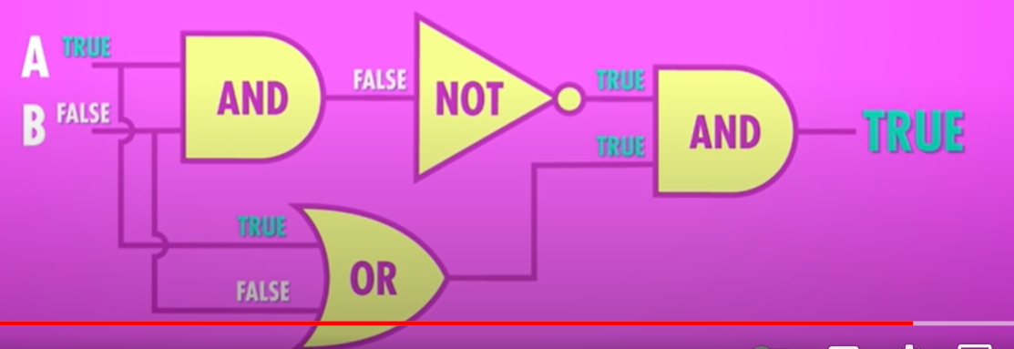
- How many bits would you need to represent 2018 in binary? How many bytes is that? [5 points]
Okay, I watched the video twice, and I couldn’t find the specific number 2018. Therefore, I believe you want me to calculate it myself:
2^10 = 1024, but 2^11 = is over 2018. Thus, let’s use 2^10.
2018-1024=994 (now we subtract the lower powers by 2 & repeat the process)
The Calculation:
In Binary:
2018-1024= 994 = 1
994-512= 482 = 1
482-256= 226 = 1
226-128= 98 = 1
98-64= 34 = 1
34-32= 2 = 1
(The 2^ (4,3,2) = 0 (because we didn’t use them,)
Then 2 = 2^1 = 1
(The 2^0 = 0)
Thus, 111111011010 = 2018 (6=1’s in the first). That comes to a total of 11 bits. However, you need to / by 8 because 8 bits= 1 byte or 1.375 bytes. However, I’m pretty sure you round up so it’s 2 bytes.
11/8= 2 bytes.

- Write “Programming Languages” (excluding the quotes) using ASCII code. [5 points]
So let me get the ASCII table:
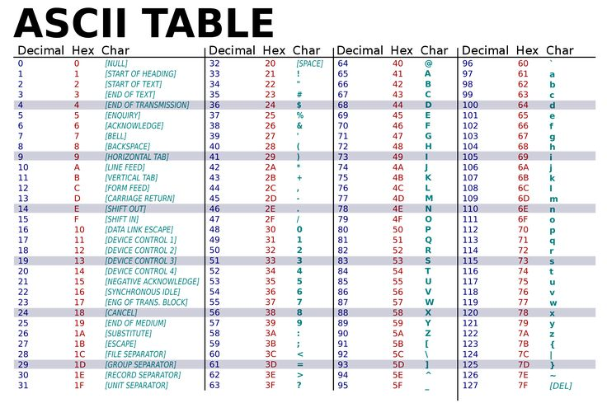
P=80, r=114, o=111, g=103, r=114, a=97, m=109 (2 times), i=105, n=110, g=103
[SPACE]=32
L=76, a=97, n=110, g=103, u=117, a=97, g=103, e=101, s=115
80 114 111 103 114 97 109 109 105 110 103 32 76 97 110 103 117 97 103 101 115 (in Ascii/decimal not in hex)
- What were the shortcomings of Assembly languages? [7 points]
Here is the list of disadvantages of Assembly Languages that we talked about in class, as well as other obvious aspects. Firstly, because Assembly is considered a “low level language.” It is close to the computer, and more error prone for human error. It is also more difficult for a human to understand what exactly is going on, and to debug because of how long it is. Another thing is that you have to write a long list of code to even do the bare minimum of a task, aka it takes a lot of time. Finally, it significantly lacks portability meaning you can’t switch in between machines.
- What were the advantages and limitations of ALGOL? [8 points]
Here is a small list of advantages and disadvantages of ALGOL aka (ALGOrithmic Language) according to the slides, and the lectures.
Advantages:
- AGOL is seen as more portable.
- AGOL is “supported different numeric types, procedures, and recursion procedures.”
- AGOL “introduced the array structure(s).”
Disadvantages:
- ALGOL could be extremely complex, and therefore had to have an instruction manual for each different one.
- ALGOL handling of string was limited for string processing, and or string handling.
- ALGOL has no Standard Libraries, and so different small tech companies would try to have their own ALGOL for certain companies.
- What is the difference between parameters and arguments of a procedure? Explain with appropriate examples. [7 points]
Parameters are “values that can change from call to call.” Whereas, “arguments (or actual parameters), values supplied by the caller for the parameters.” Parameters are the variables listed in the procedure's definition. It is like a placeholder for the values it can accept. Conversely, Arguments are actual values that are passed to the procedure when it’s called. For instance, in a function add (x, y), x and y are parameters. When we call this function as add (3, 4), 3 and 4 are arguments for x and y. A procedure requires certain inputs to function, known as parameters. On the other hand, when you call or invoke the procedure, the actual values you supply for these parameters are called arguments.
- Write a recursive factorial function/method in C/C++ or Java (No limitation on number of lines. [7 points]
#include <iostream>

using namespace std;

long long factorial(long long Num)
{
if(Num == 0)
return 1;
return Num*factorial( Num-1 );
}

int main()
{
long long Num;
cout<<"Enter the number: ";
cin>>Num;
cout<<"The Factorial "<<Num<<" is "<<factorial(Num)<<endl;
return 0;
}

- Explain Language Syntax and Language Semantics in your own words. [10 points]
Syntax is essentially the grammar of a programming language, dictating how you can write code so that it is in a structure that is correct. It also says to us what combinations of symbols and words are allowed, and not allowed. However, Semantics is about the definition of the code. In essence semantics is what it actually undertakes when you run it. In summary, semantics is what you want a sentence to send the meaning. Then syntax is making sure the specific words are right in a sentence.
- Explain how Java codes are compiled and then interpreted. [10 points]
Java has two facets that make the code work, compilation, and interpretation. From the slides the “compiler translates programming language statements into machine code,” and the “Interpretation is a one-step process where both the program and the input are provided to the interpreter.” Then “the output is obtained.” Firstly, the code is passed into the compiler, then it transforms the code into bytes or in other words bytecode. The bytecode then precedes to give the instructions to the machine, or in this case the Java machine. Usually, it is a virtual machine with whatever you’re working on code that shouldn’t mess with your overall computer. The java machine then deciphers the bytecode, then converts it to the machine where then it goes to the compiler to execute the overall code.
- Explain the following terms: [6 points]
- Syntactic sugar
According to the slides “Syntactic sugar: a mechanism that allows you to replace a complex notation with a simpler, shorthand notation.” The example, in the slides is “x += 10 instead of x = x + 10.” Syntactic sugar can help with an iterator, and create a better for loop. It’s called syntactic sugar because it’s like adding decorations to a cake, but it still tastes the same. It essentially makes it better for the reader, and makes specific tasks to denote.
- API
According to the slides “Application programming interface (API) gives information about the resource’s components.” This interface helps facilitate conventions, tools, and even defines code for applications so that they can connect with each other. This helps developers acquire data, and or features from other services with not need to have any further knowledge of the other field. In other words, they don’t need to know the nitty gritty of the minute aspects of the interface.
Extra credit (bonus question):
- Do you think that C programming language is a successful programming language
even though it’s not the most popular language today? Explain your reasonings. [10
points].
I fervently believe that the C programming language is a successful programming language even though it is not the most popular today. First of all, the C language has an impactful influence; C is the blueprint of a plethora of other languages that came arose today. Take for example, C++, Python, and even Java. C helped facilitate a unique combination of high-level features, while still retaining low-level power that assembly has. This made C the idealistic language for tasks. For instance, the language C helped create many things such as embedded systems, operating systems, and even UNIX. In summary, the C language is just like Latin. Even though Latin is technically a dead language, you can still see the extreme influence it has on present day romantic languages.

