Name: Adalynn Cadence Everly
ID: 1001852753
Class: CSE-4321-001
HW 1:
Exercises Chapter 1: Problem 5 (parts a, b, c, d, and e). That is, you don't need to work on part (f). Also, you only need to work on the two programs, findLast and countPositive. HW1_questions.pdf
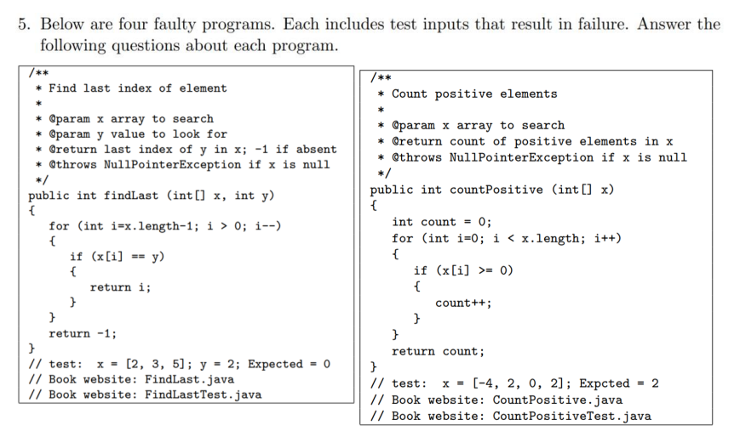
findLast (A):
- The issue is in how the loop is written. The minus sign between x.length and 1 isn’t actually a minus. It’s a lookalike symbol, probably from copying text from a PDF or website. It breaks the loop so it doesn’t run properly. The fix is just to retype that line and use a real minus sign: for (int i = x.length - 1; i >= 0; i--)
countPositive (A):
- The condition inside the loop is off. It counts numbers that are zero or greater, but the method is supposed to count strictly positive numbers. Zero isn’t positive, so the if-statement should check if the value is greater than zero, not greater than or equal to zero. So, change x[i] >= 0 to x[i] > 0.
findLast (B):
- If you use an empty array, like x = {} and any value for y, the loop never runs. It jumps straight to returning -1, which is actually correct in this case. So that avoids the problem entirely.
countPositive (B):
- Using only negative numbers, like x = {-5, -3, -1}, avoids the bug. Since nothing in the array is positive or zero, the count ends up being zero, which is correct even if the condition is wrong.
findLast (C):
- Say the input is x = {1, 2, 3} and y = 4. This goes through the loop like normal but doesn’t find the value, so it returns -1. It triggers the faulty loop code but doesn't crash or throw an error.
countPositive (C):
- Try x = {0, 0, 0}. With the current condition, it counts every zero, so it returns 3 instead of 0. This runs the code and clearly shows the mistake, but doesn’t result in an error or exception.
findLast (D):
- If you pass in null for x, the program throws a NullPointerException. That’s an error state, but it’s allowed according to the method description. So yes, that counts as an error state but not a failure of logic.
countPositive (D):
- If you set x to null, the method throws a NullPointerException. That’s an error state, but not a failure, since it’s part of the spec that null inputs throw that error. So yes, it’s an error state by definition.
findLast (E):
- In the given test (x = {2, 3, 5}, y = 2), the loop should go from the end of the array backward, looking for 2. Since 2 is the first element, the loop should return index 0. But because the loop doesn’t run correctly (due to the bad minus), it never sees that match and returns -1 instead. That’s the first place where the program behaves wrong, even though the array and value are valid.
countPositive (E):
- With the test input x = {-4, -2, 0, 2}, the loop looks at each value. It skips the first two, then hits 0 and counts it, even though it shouldn’t. Then it counts 2, which is correct. So it returns 2 instead of the correct answer, which is 1. The first sign something’s off is when the loop counts 0. That’s when it starts giving the wrong output.
you don't need to work on part (f). SKIP
NOTES: (on what the code looks like in VS code. Helped me visually see what it’s looking like with colors)
/**
* Find last index of element
*
* @param x array to search
* @param y value to look for
* @return last index of y in x; -1 if absent
* @throws NullPointerException if x is null
*/
public int findLast (int[] x, int y)
{
for (int i=x.length-1; i > 0; i--)
{
if (x[i] == y)
{
return i;
}
}
return -1;
}
// test: x = [2, 3, 5]; y = 2; Expected = 0
// Book website: FindLast.java
// Book website: FindLastTest.java

/**
* Count positive elements
*
* @param x array to search
* @return count of positive elements in x
* @throws NullPointerException if x is null
*/
public int countPositive (int[] x)
{
int count = 0;
for (int i=0; i < x.length; i++)
{
if (x[i] >= 0)
{
count++;
}
}
return count;
}
// test: x = [-4, 2, 0, 2]; Expcted = 2
// Book website: CountPositive.java
// Book website: CountPositiveTest.java

