CSE 4344–Lab 2: Distance Vector Routing
Name: Mary-Rose Tracy
Due Date: 04/16
Professor: Yonghe Liu

Programming Language: Python

Lab Objective
This lab focused on bringing the Distance Vector routing algorithm to life through a hands-on simulation. I built an interactive GUI that models how routers (represented as nodes) exchange routing information and gradually converge on the shortest paths through a network. Each node keeps its own DV table and communicates with its immediate neighbors, updating its routes as needed. The simulation includes a step-through mode for analyzing DV updates cycle by cycle, an automatic mode that runs until the system reaches a stable state, and support for modifying link costs mid-simulation to mimic failures or repairs. Overall, the goal was to understand how distributed routing adapts in dynamic environments — and to reinforce that understanding by coding and visualizing the process.

Input File Used
1 3 4
1 4 2
2 3 1
2 5 7
3 6 3
4 5 5
5 6 2
(Note: I used several different .txt files to see how they were, but this is network1.txt)

Implementation Highlights
Fully functional DV simulation with GUI
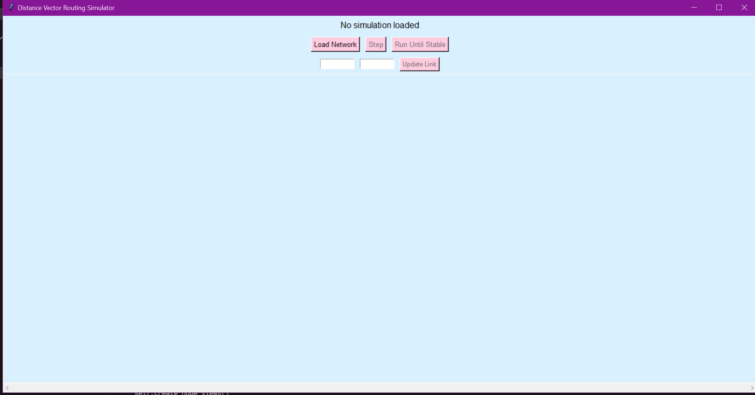
Real-time DV table display for each node
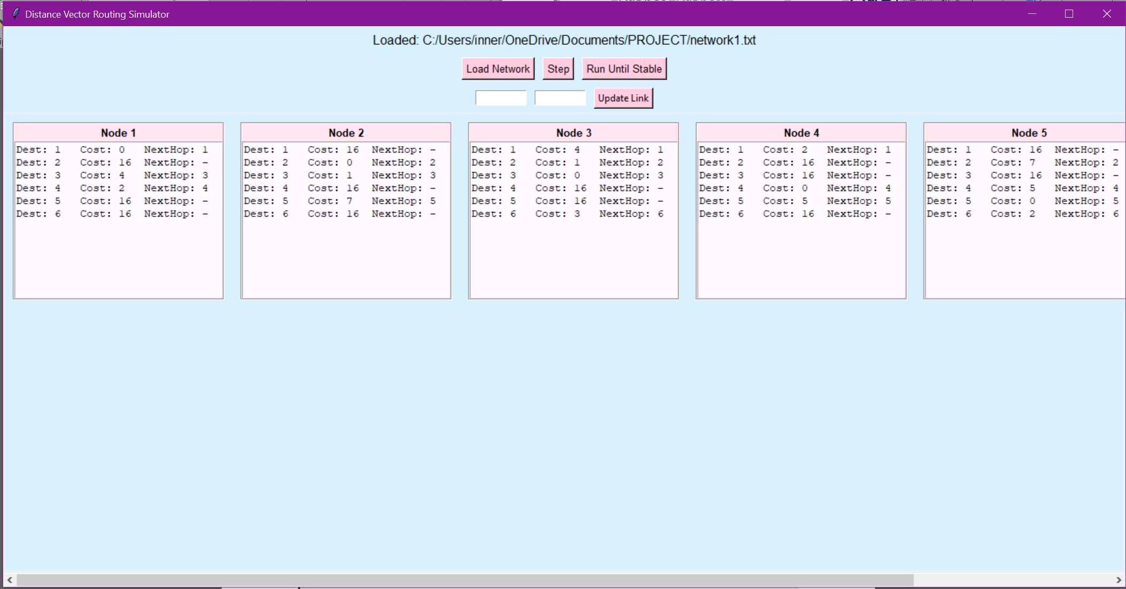
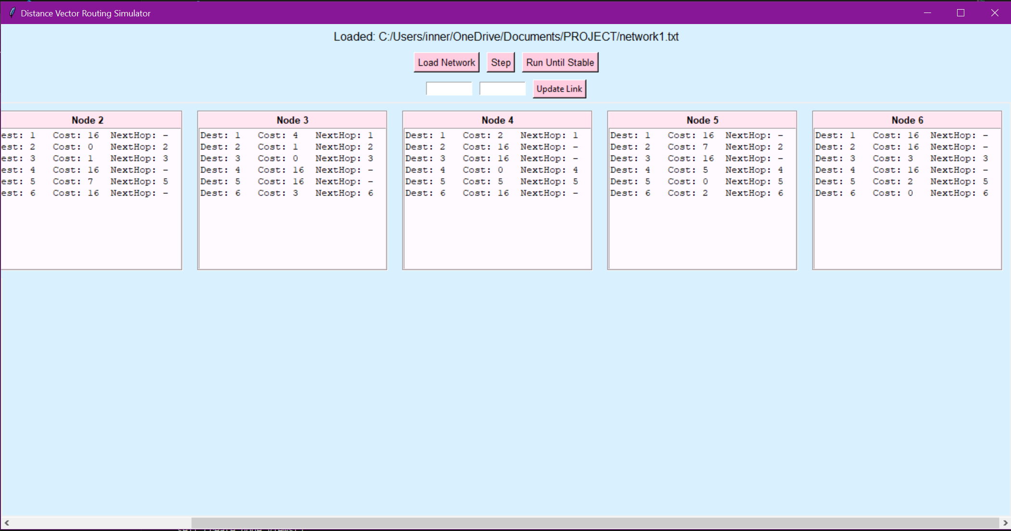
Doing step cycles:
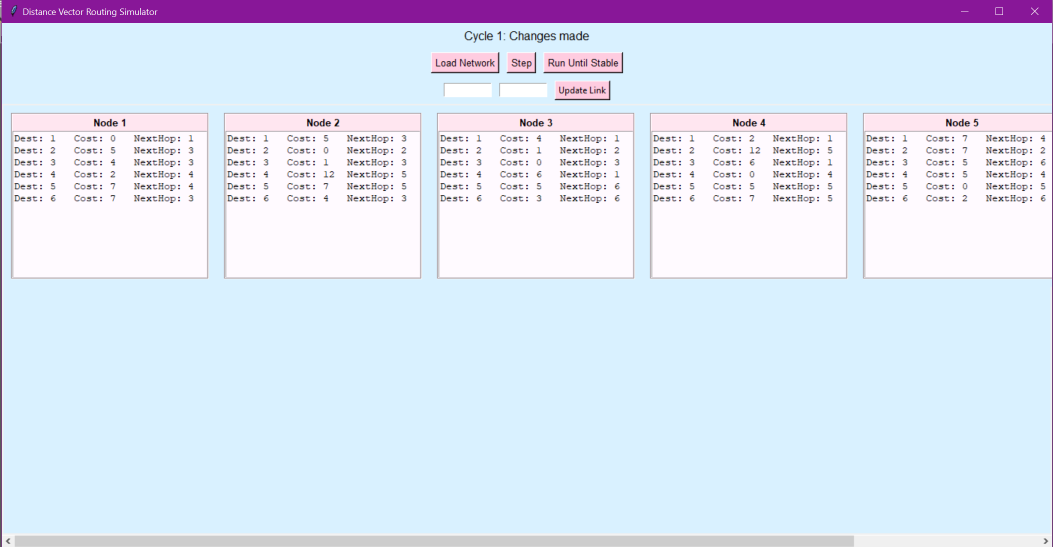

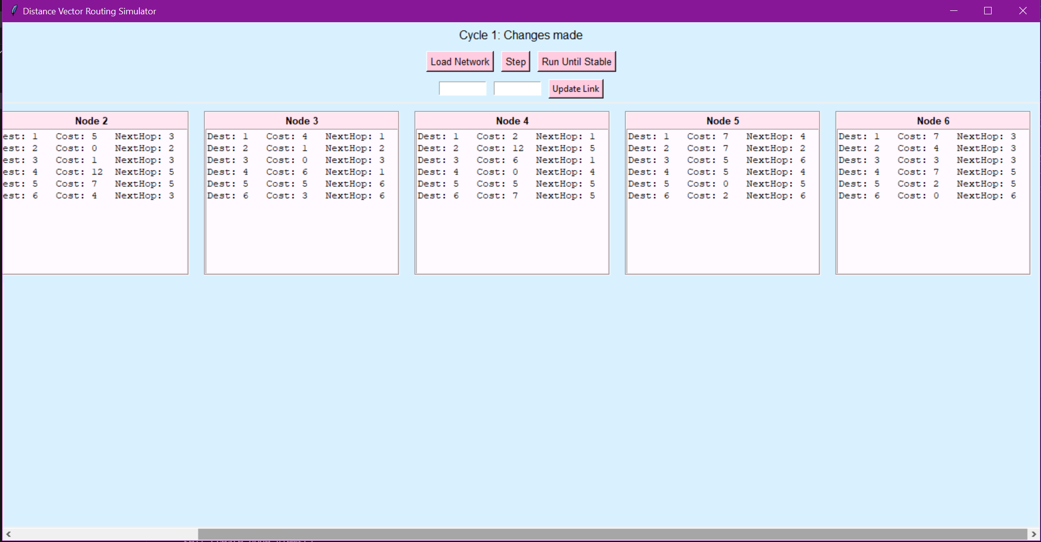
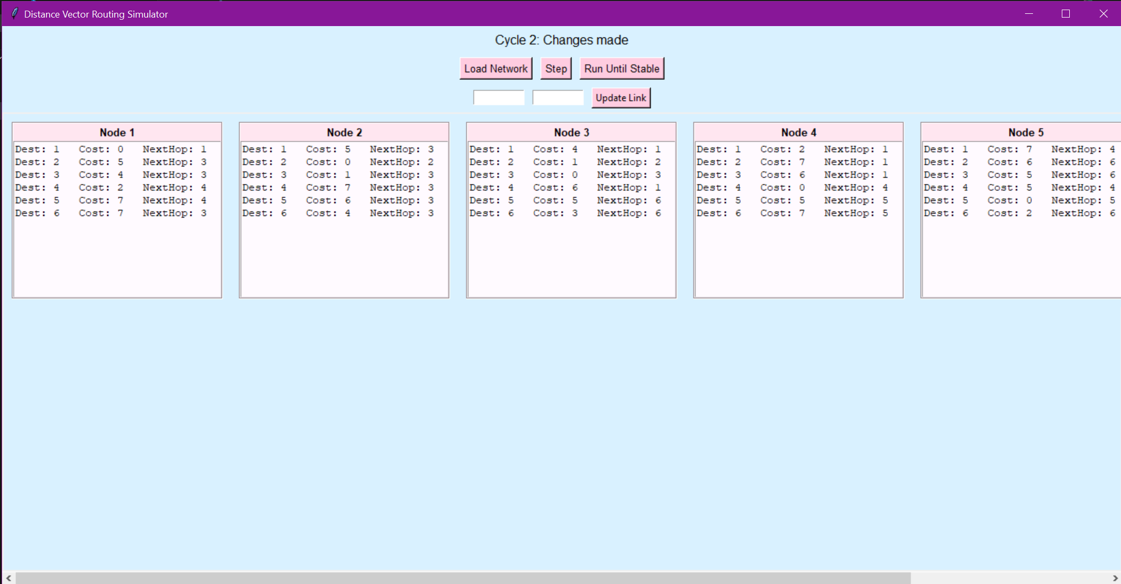
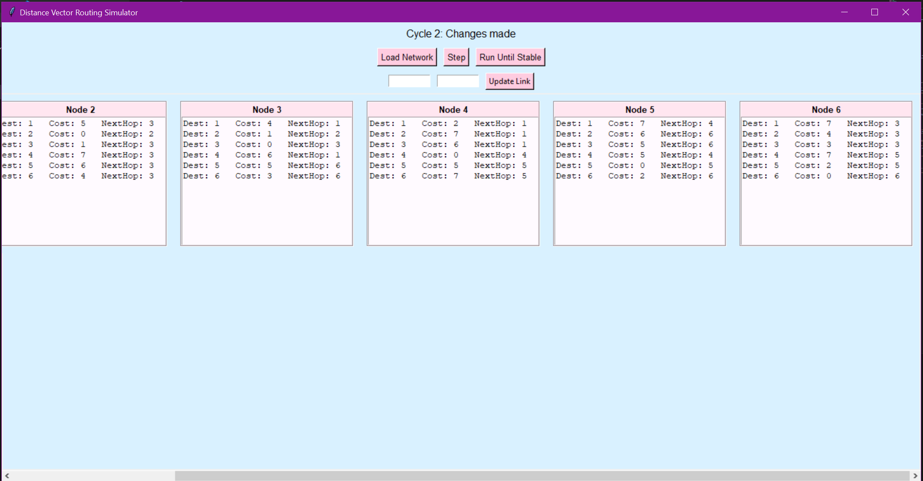
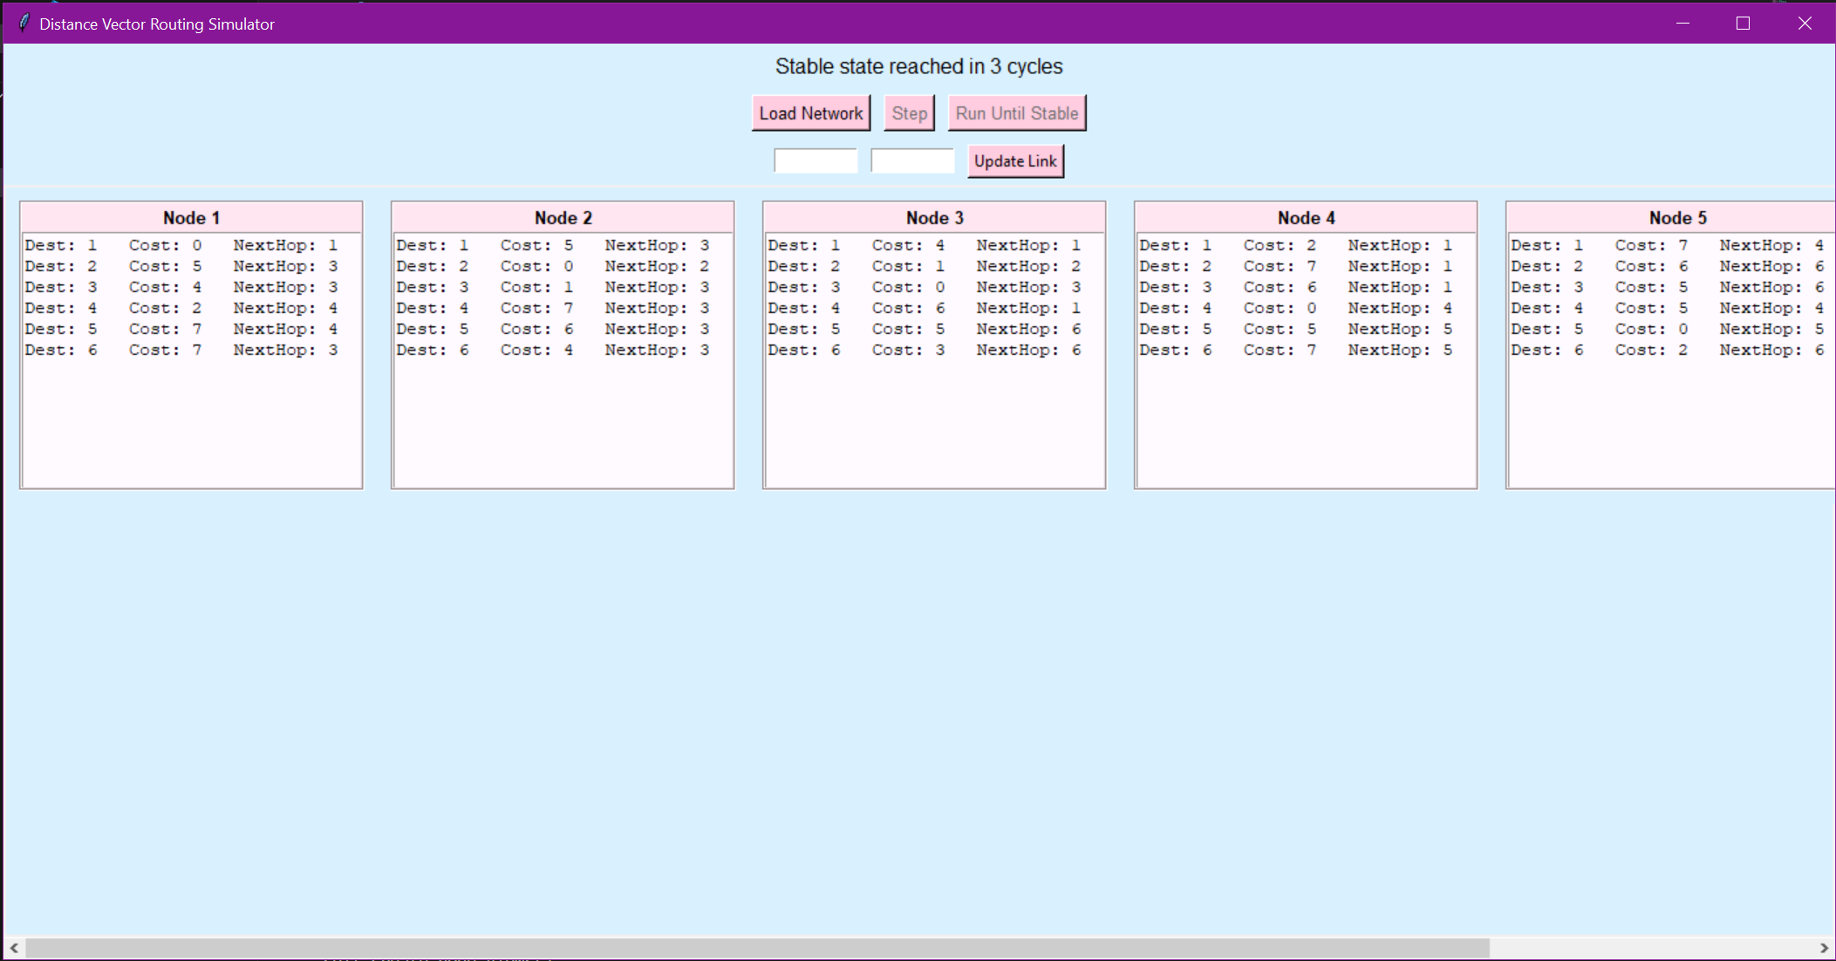
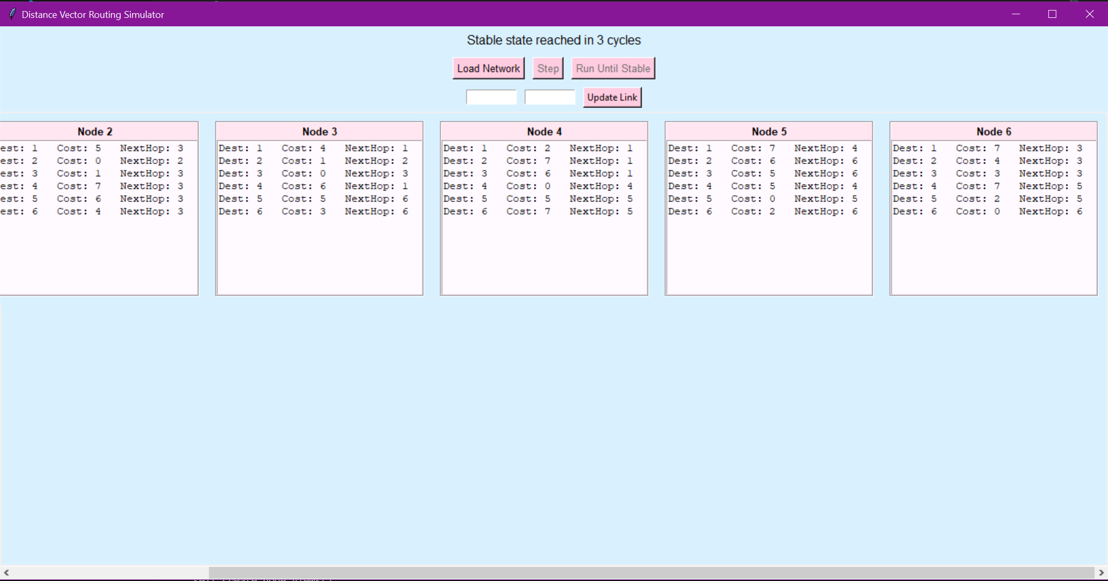
Run until stable
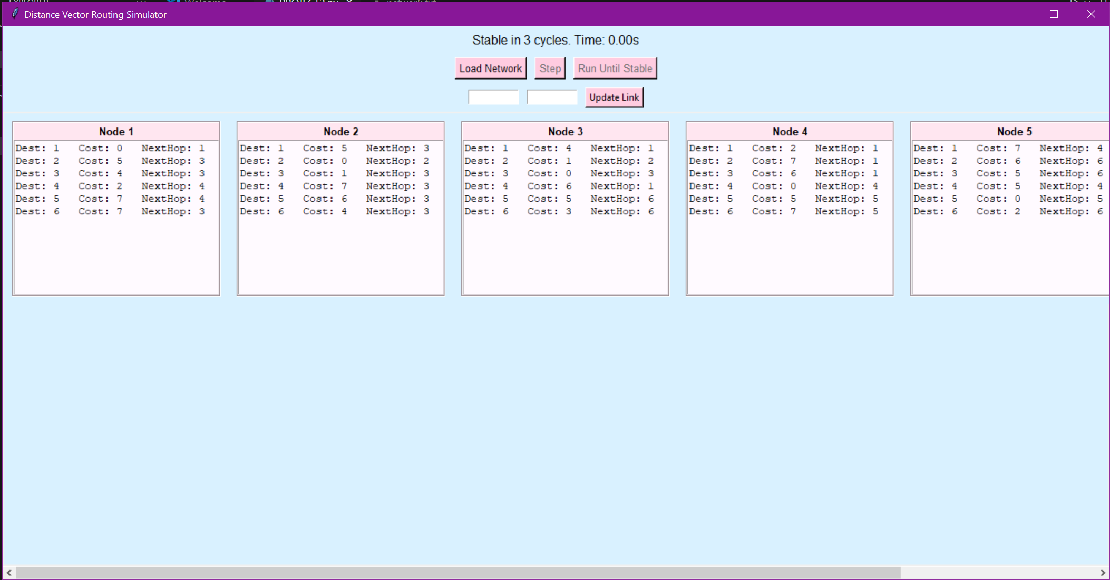
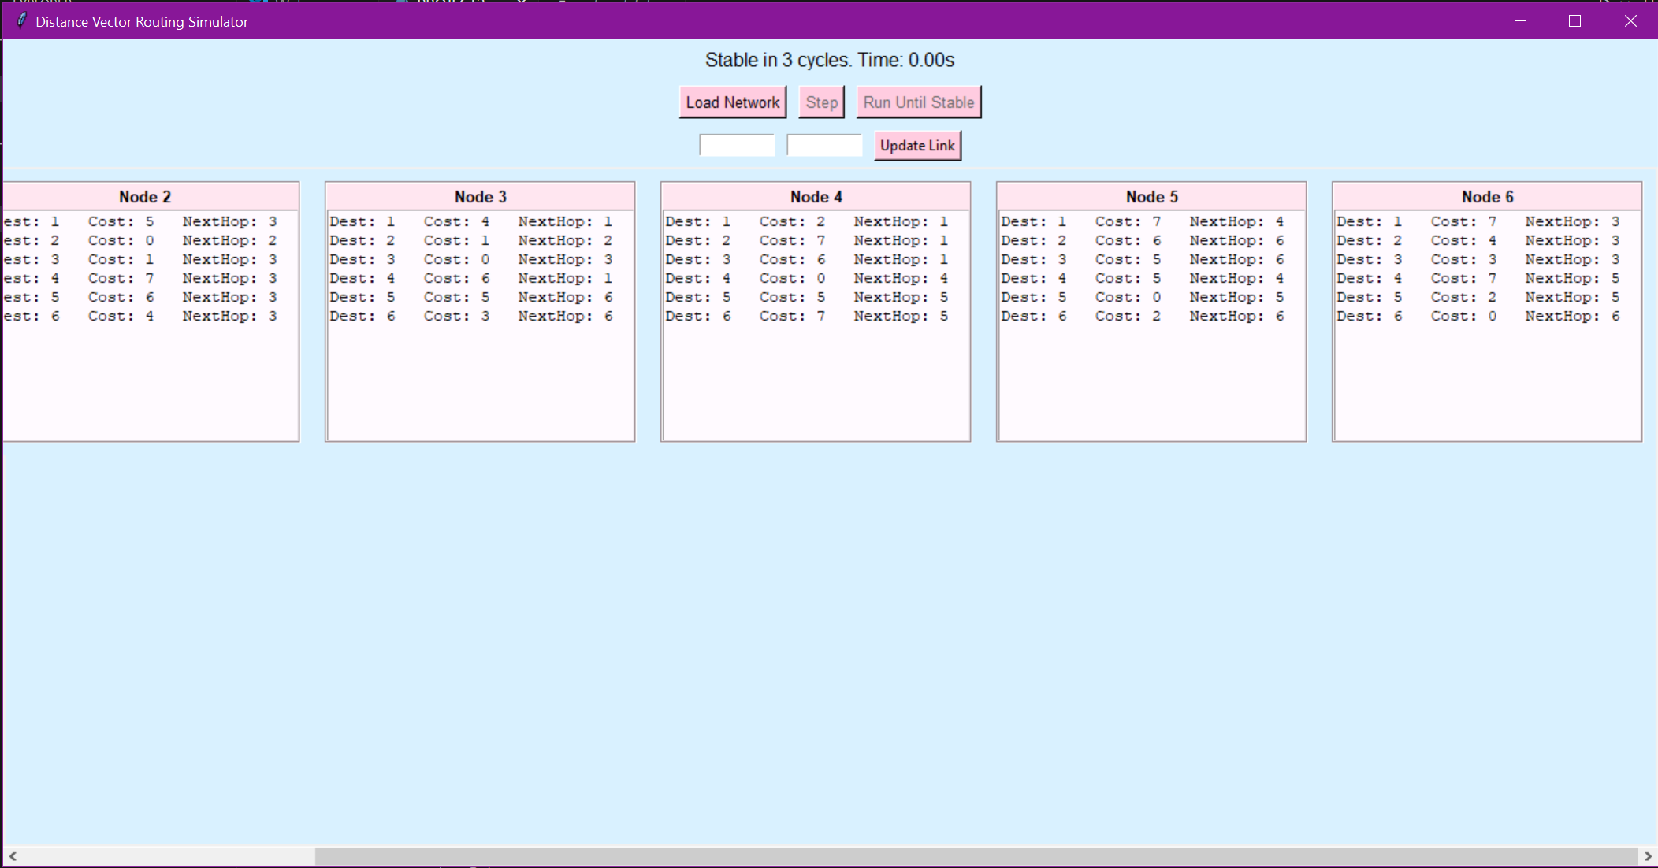
Step-by-step and full-run simulation modes
Live link cost modification with failure/repair testing
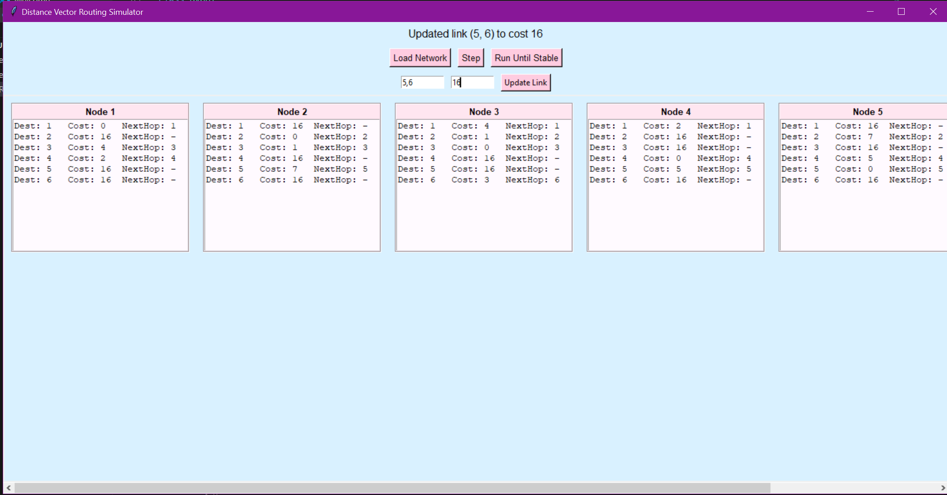
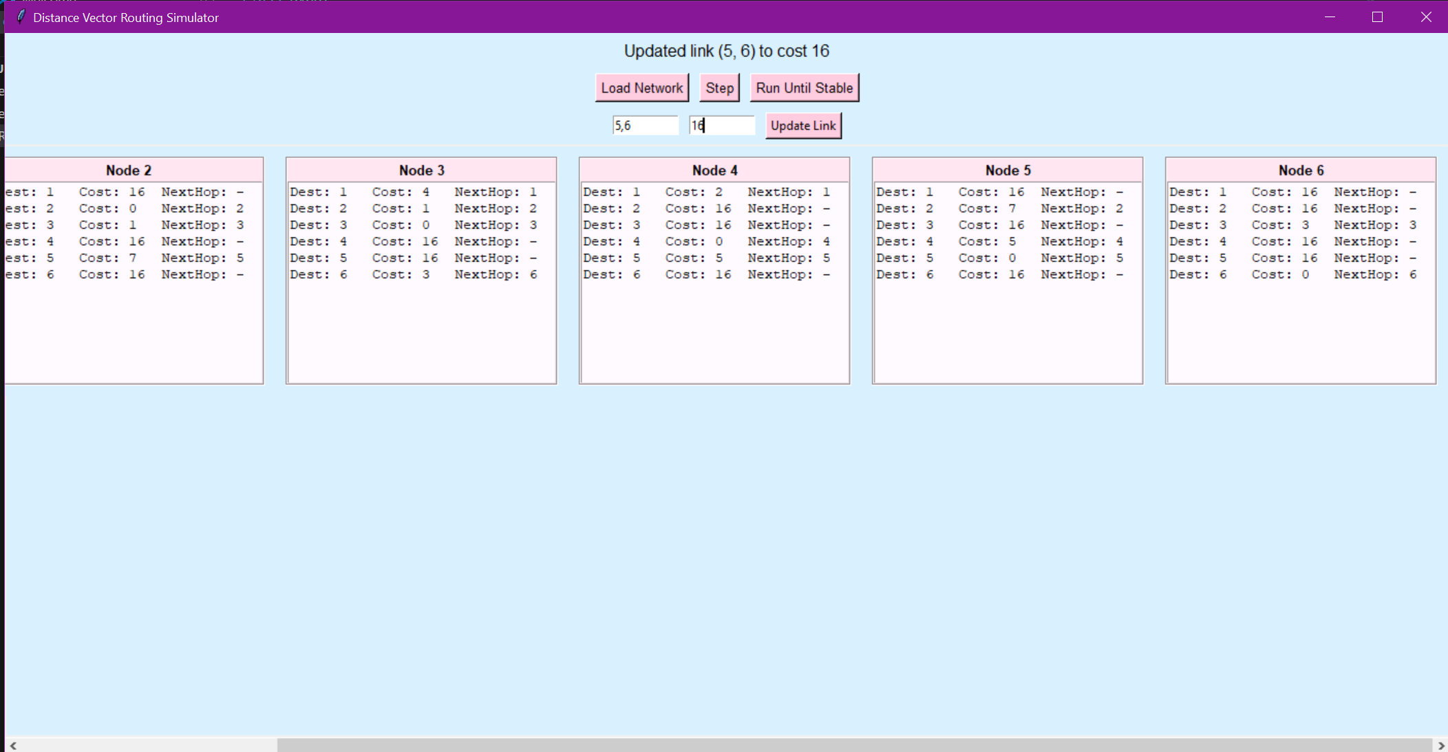
I simulated a link failure between Node 5 and Node 6 by setting the cost to 16, and the result was immediate: both nodes dropped each other from their routing tables as reachable neighbors. Their DV tables updated to show a cost of 16 with no next hop, meaning they had no known path to reach one another anymore. What’s cool is that the rest of the network kept functioning- only that direct route was lost. This showed how the DV algorithm adapts locally when a connection goes down, without breaking the whole system.
Stable state detection and time tracking
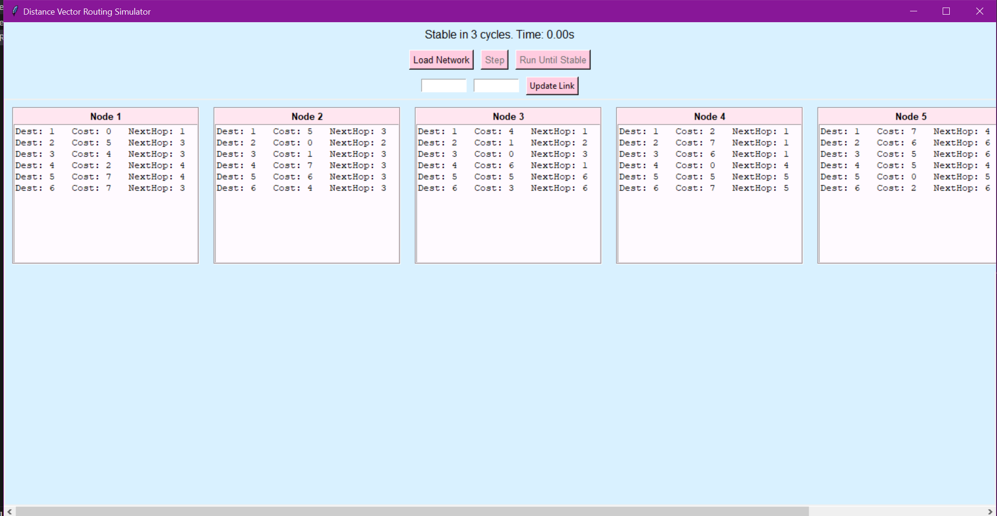
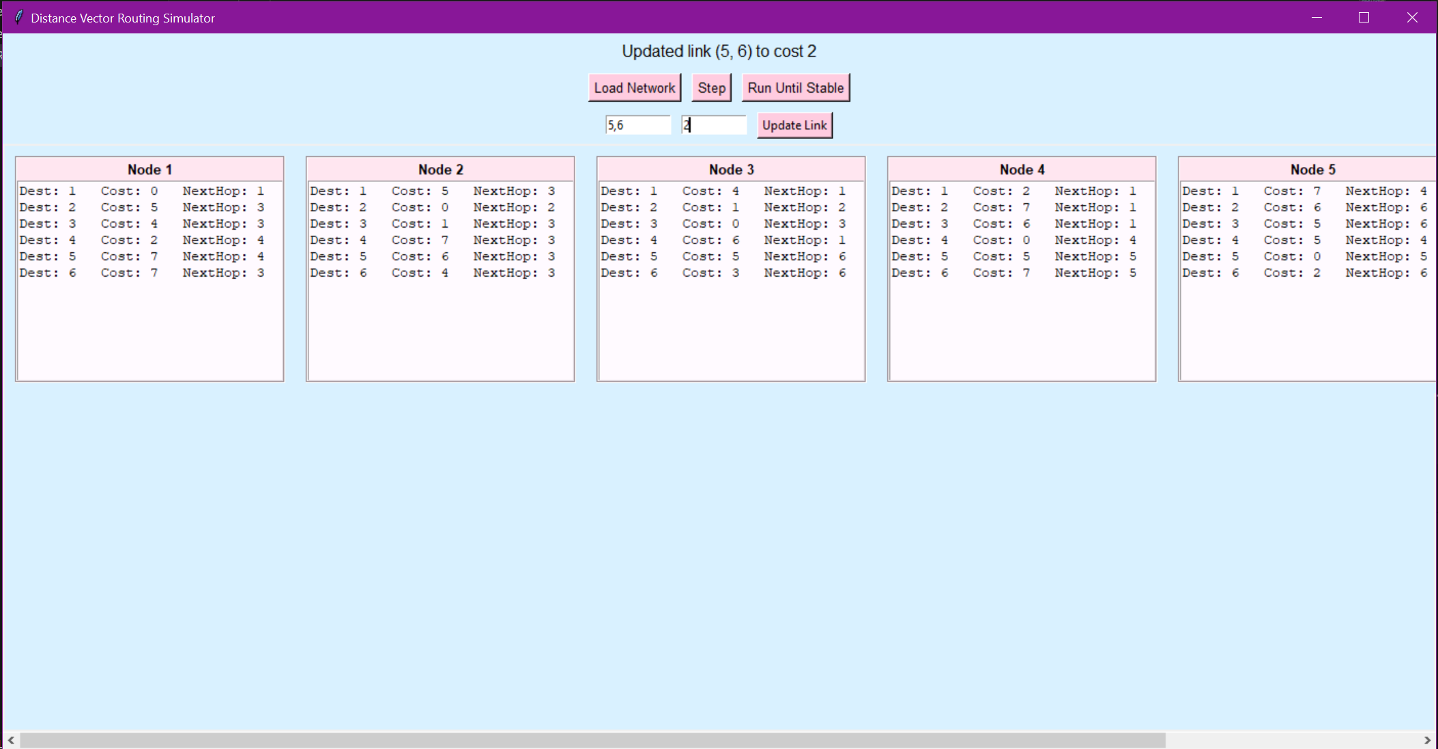
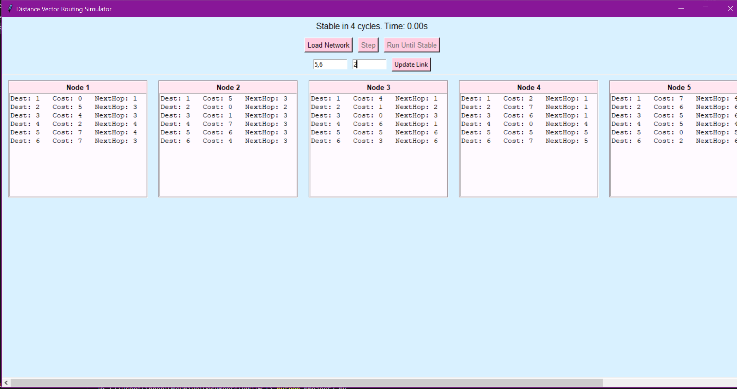
NOTE: changed the code because I was worried about the timing part of it.
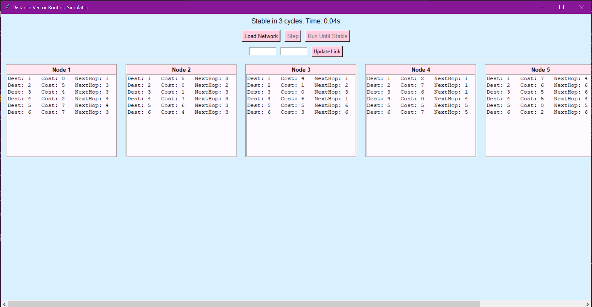
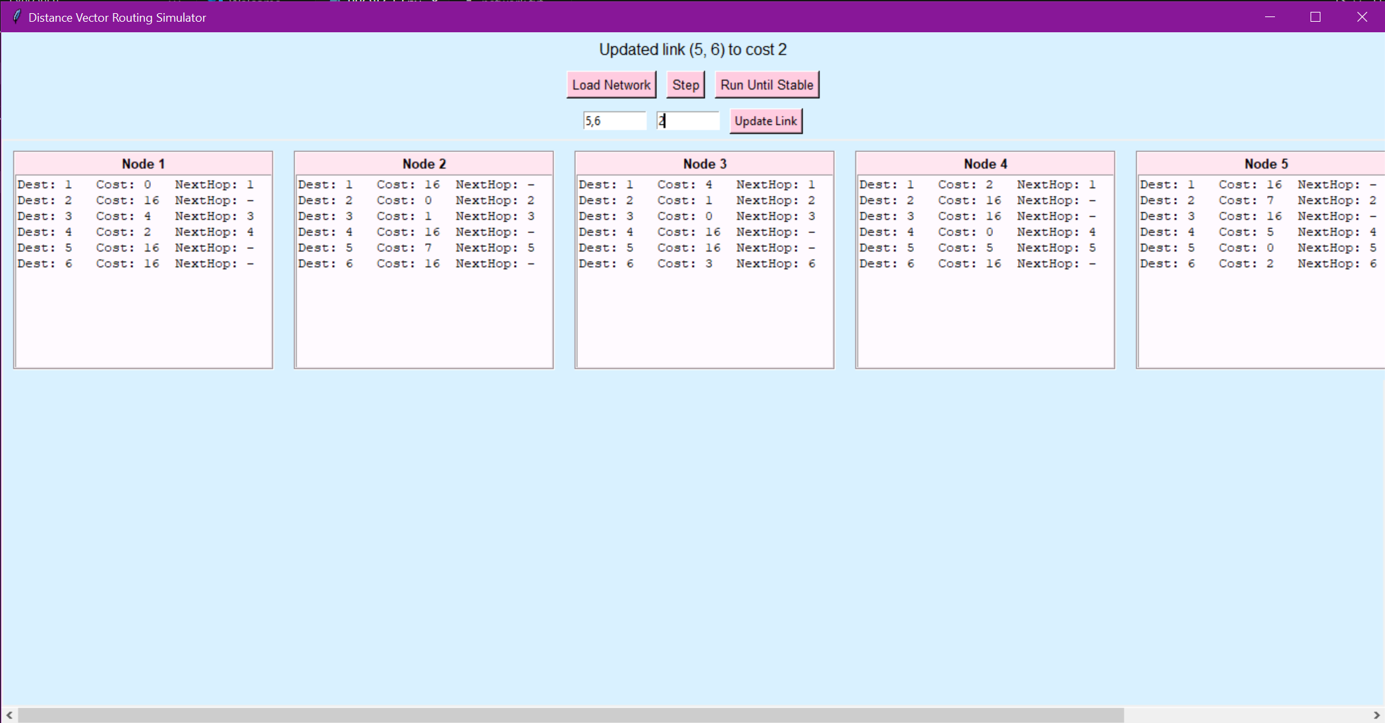
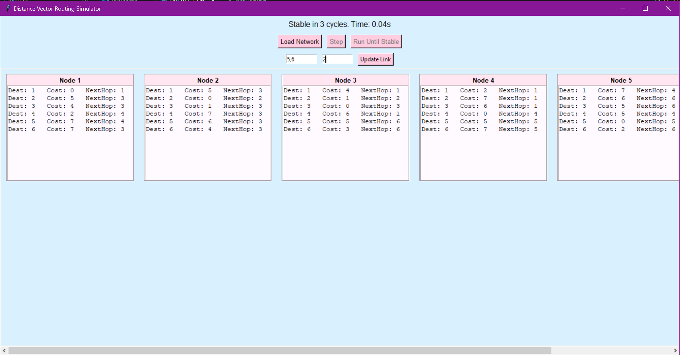

Initial DV Tables
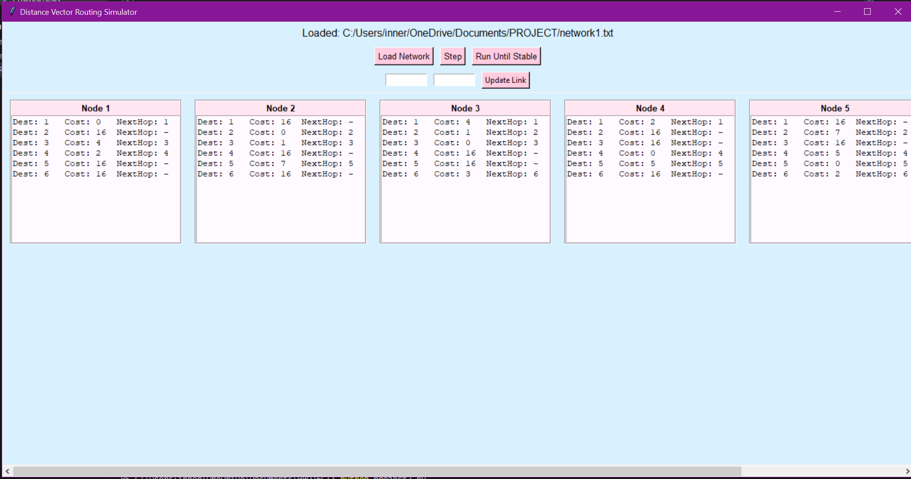
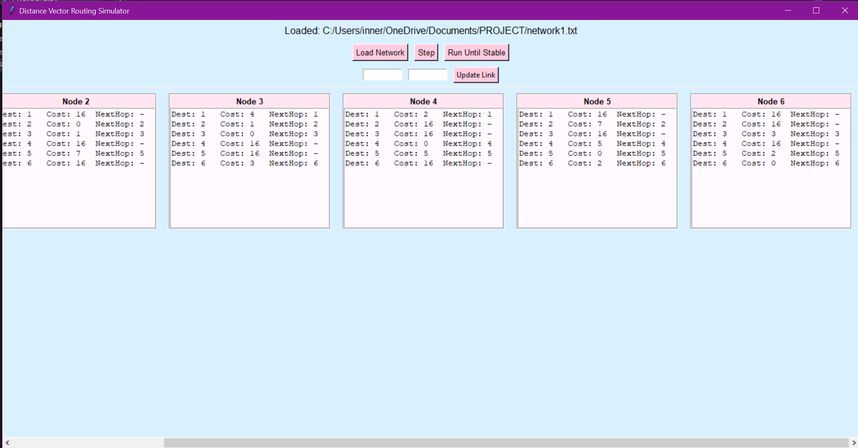

Simulation in Single-Step Mode
See above for the full screenshots of this, but since I changed the code slightly:
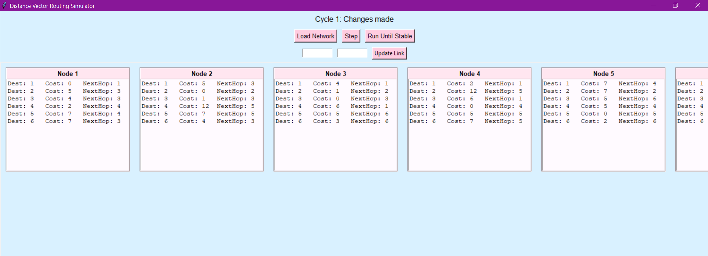
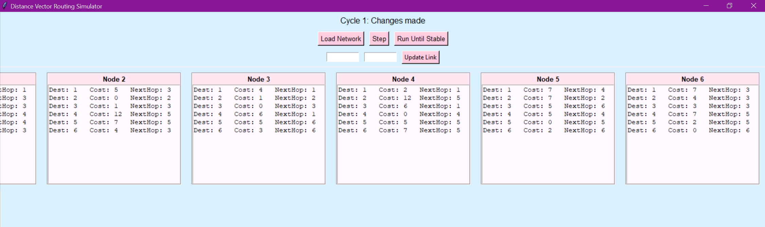
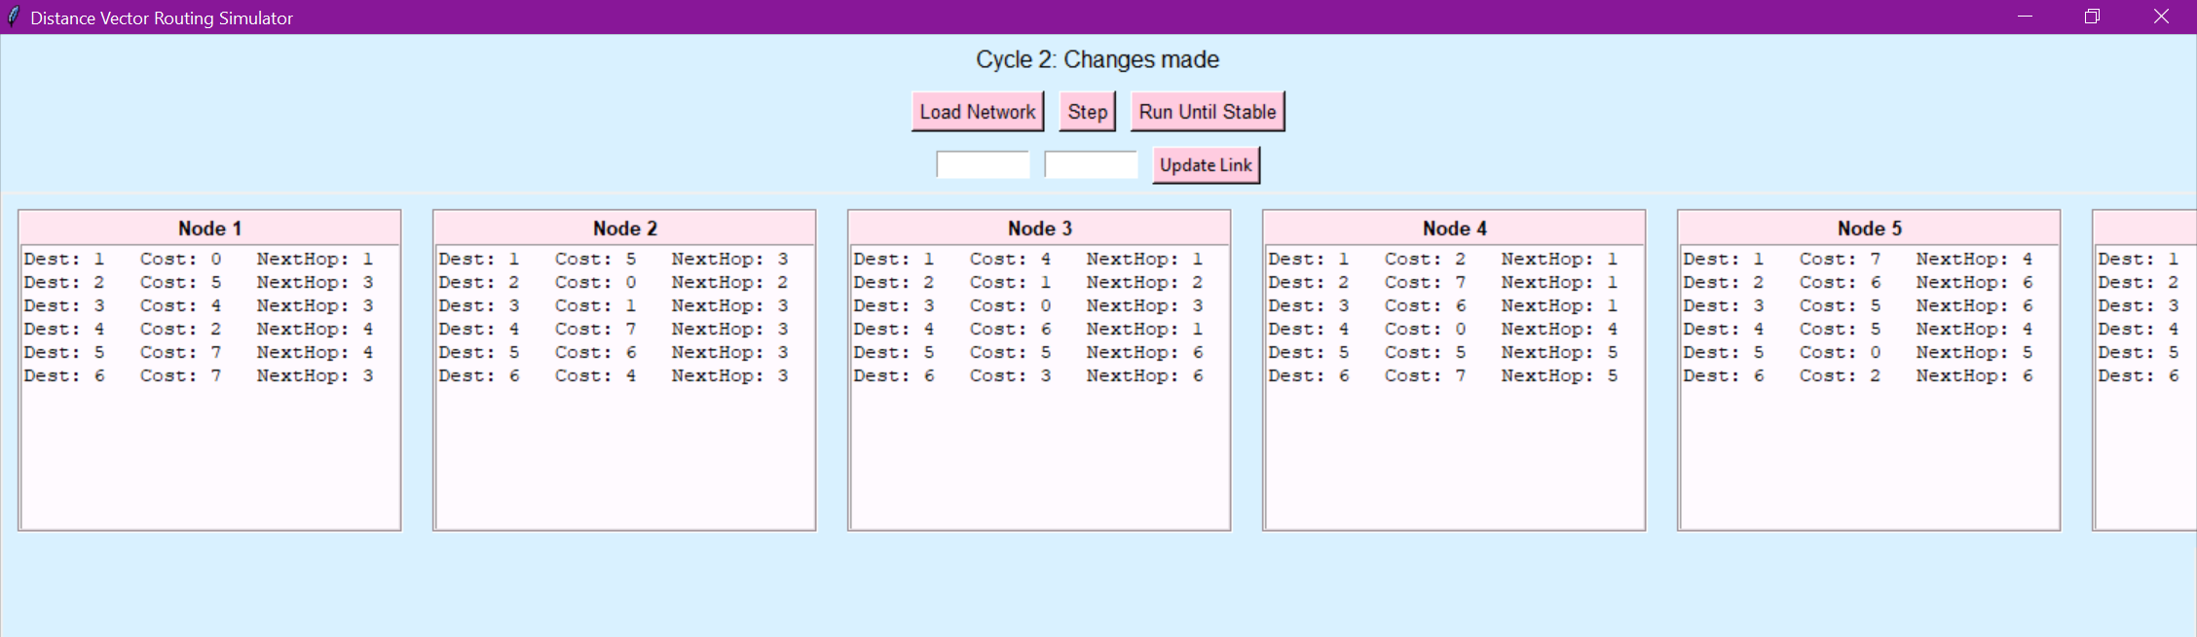
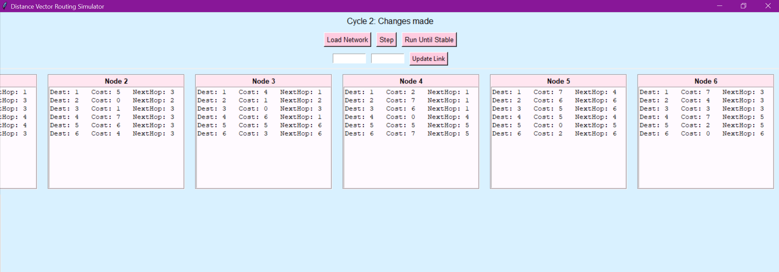
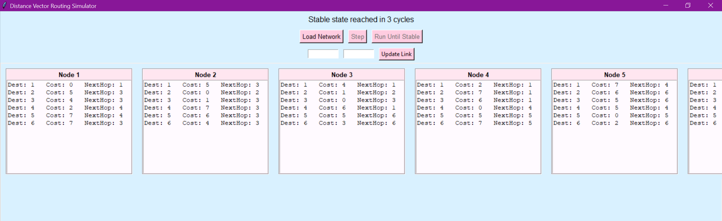
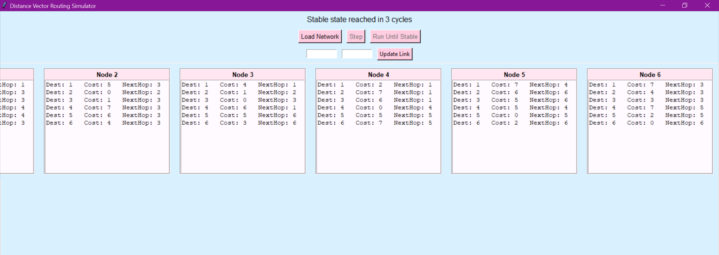
What’s happening:
Cycle 1: Nodes shared their initial tables with neighbors. Most nodes began updating costs based on these first exchanges. For example, Node 1 learned a path to Node 3 through Node 2, and Node 6 began seeing alternate routes emerge.
Cycle 2: More updates spread through the network as nodes received updated vectors from neighbors. Tables began converging, and several next-hop adjustments occurred.
Cycle 3: Only minor changes happened. No further updates were needed after this round. Stable state reached in 3 cycles.
Observation:
During the simulation, I noticed how the distance vector algorithm steadily converged as nodes exchanged updated routing information. With each cycle, the nodes refined their tables using new cost data from neighbors, which led to progressively better paths across the network. By the third cycle, every node had calculated its shortest routes, and no further updates were triggered — showing that the protocol had reached convergence just as expected.

Simulation in Auto-Run Mode
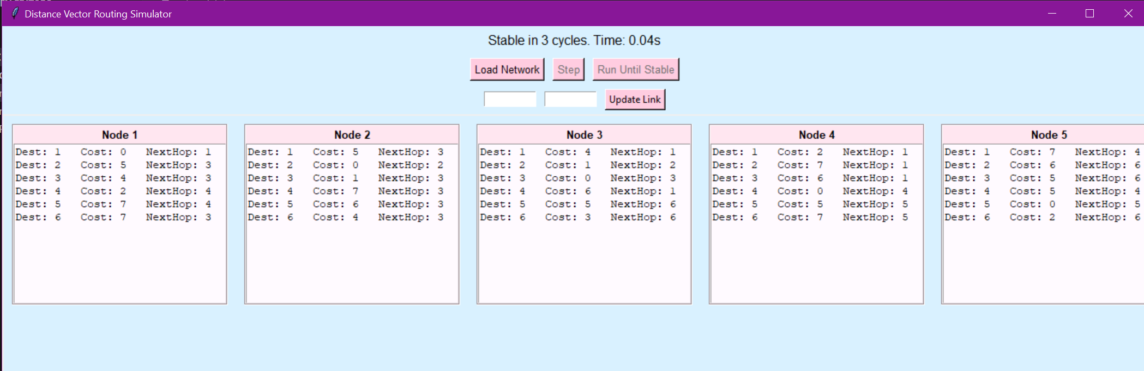
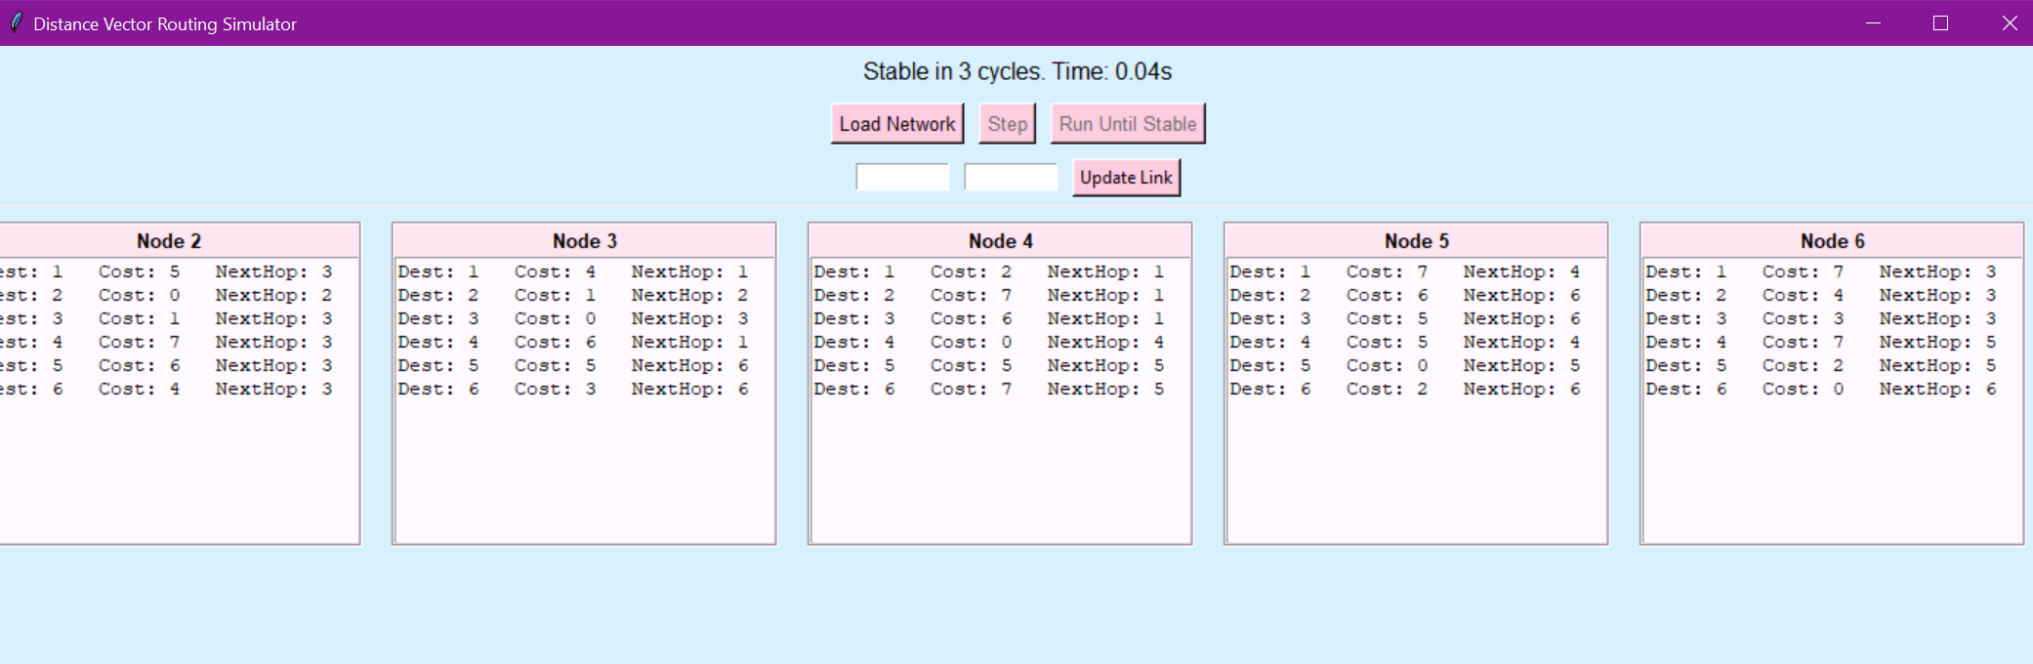
• Total convergence time: 0.04 seconds
Observation:
In auto-run mode, the network stabilized in just a few cycles, clocking in at around 0.04 seconds. Since all nodes could exchange their distance vectors simultaneously, the routing information propagated efficiently without waiting for step-by-step updates. The final DV tables confirm that each node converged to the shortest paths, highlighting how quickly and effectively the DV algorithm adapts when allowed to run without manual intervention.

Link Failure Simulation
• Link failed: 2,5 → cost 16
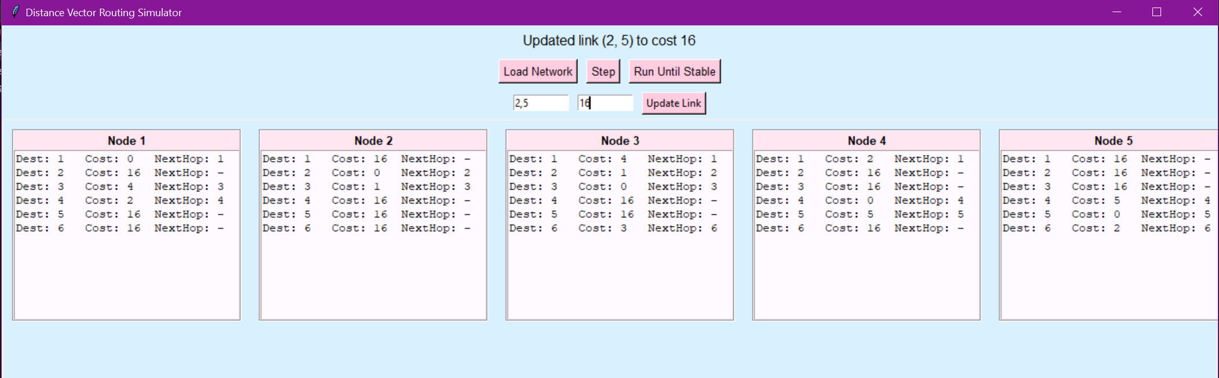
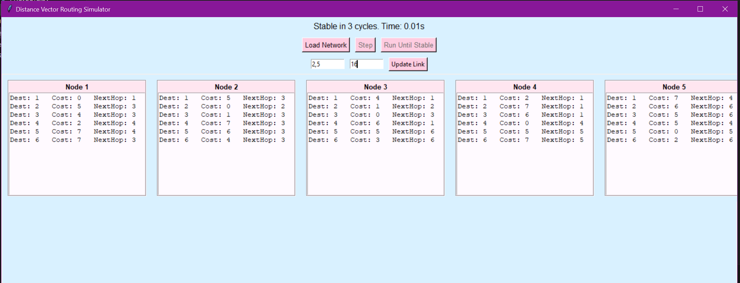
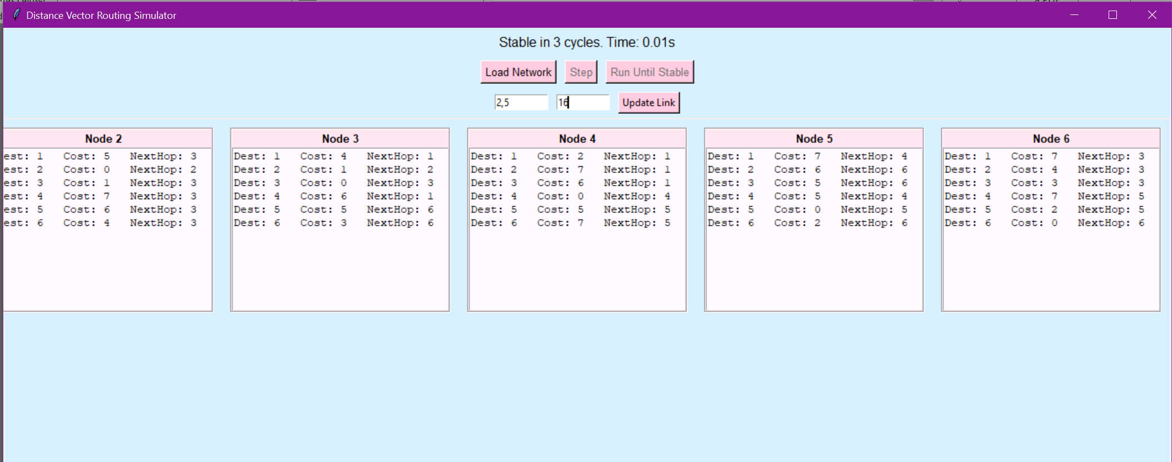
• Re-convergence cycles: 3
• Time: 0.01 seconds
Observation:
Once the direct connection between Node 2 and Node 5 was severed by setting the cost to 16, both nodes had to re-evaluate their routing paths. Node 2 no longer had a direct next hop to 5, and traffic was rerouted through alternate paths based on neighboring node updates. This demonstrates how the DV algorithm reacts to topology changes by gradually shifting routing decisions to maintain connectivity.

Link Repair Simulation
• Link restored: 2,5 → cost 8
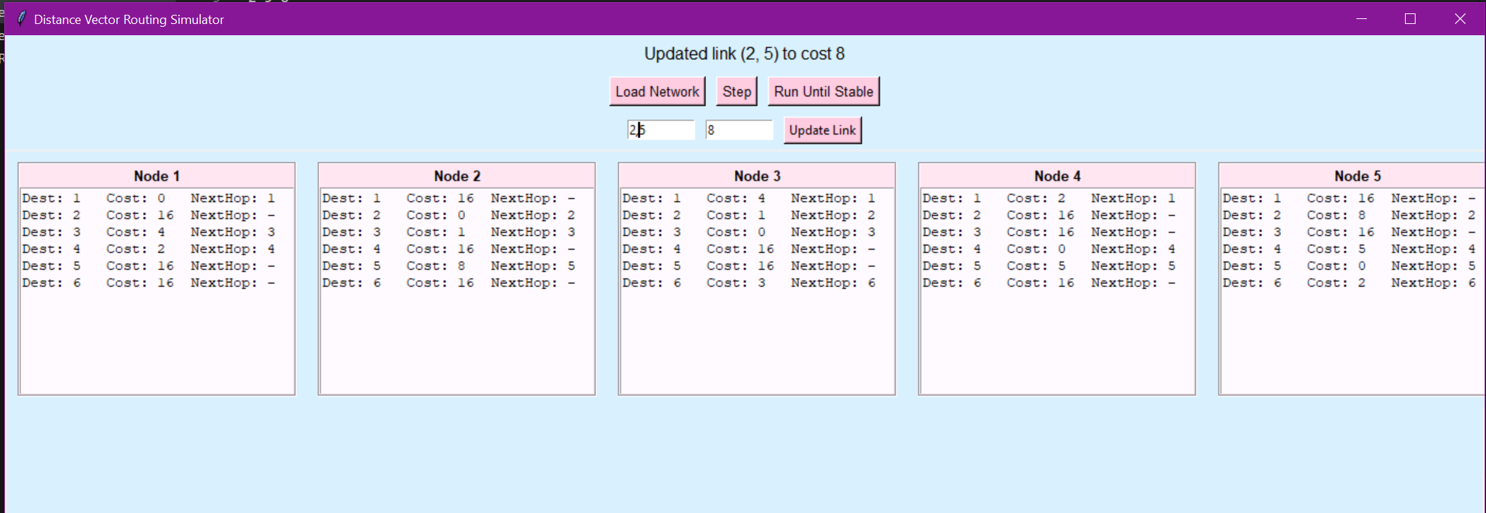
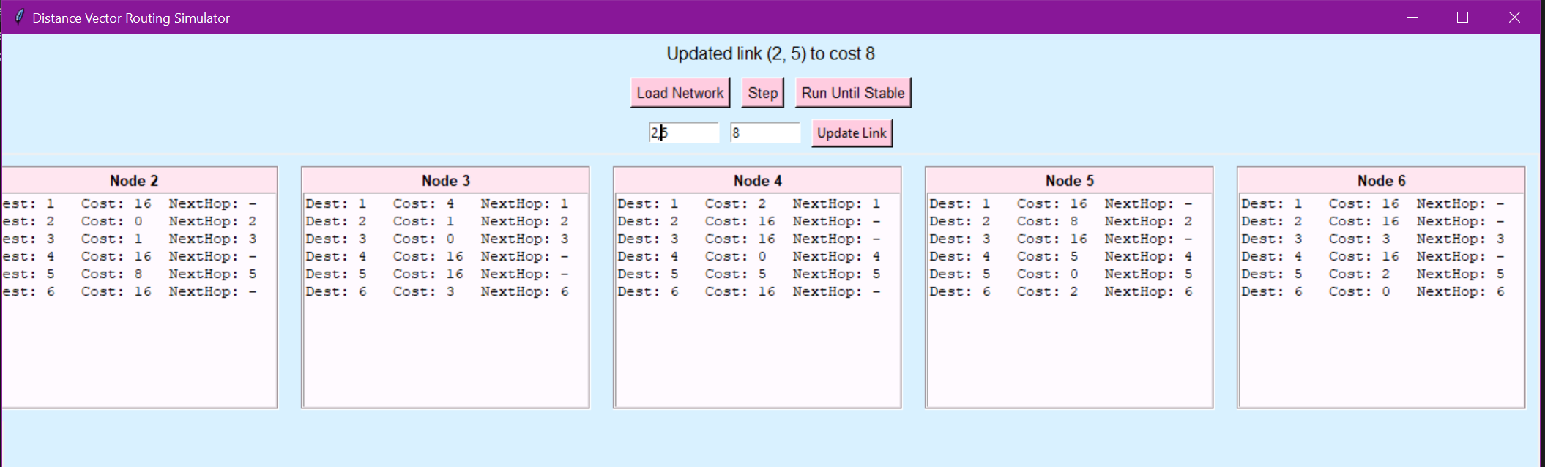
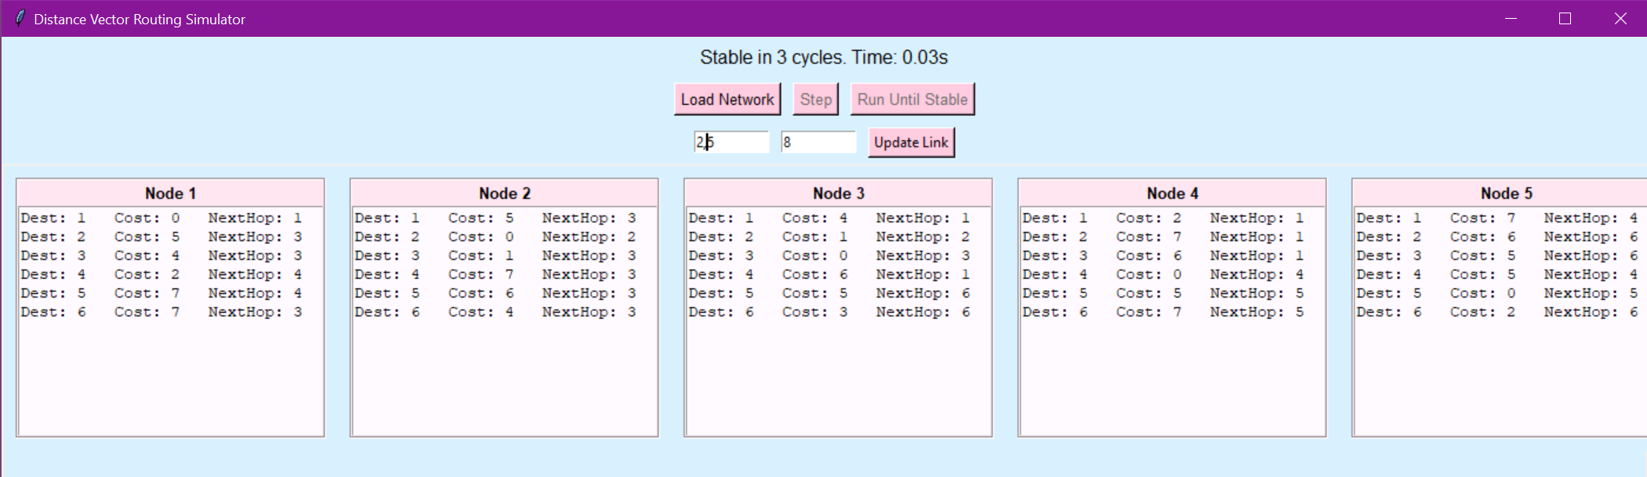
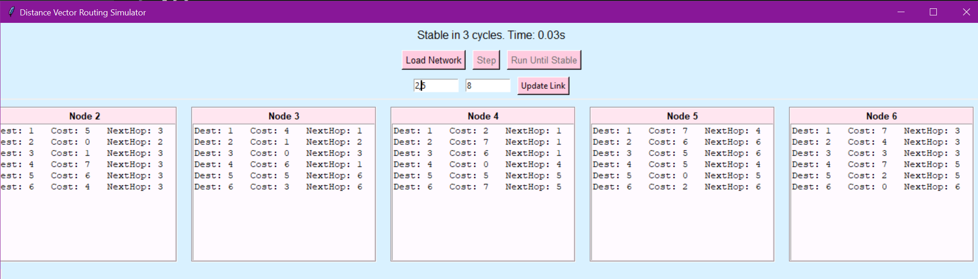
• Re-convergence cycles: 3
• Time: 0.03 seconds
Observation:
Reintroducing the link between Node 2 and Node 5 triggered an immediate recalculation of optimal paths. Within three cycles, most nodes reverted to using the newly available direct route. This showed that DV routing doesn’t just handle failure well. It’s also quick to bounce back when network conditions improve.

Summary of Findings

Action | Cycles: | Time: | Comment
Initial Converge | 3 | 0.04 | Network quickly converged to shortest paths.
Link Failure (2-5 ) | 3 | 0.01 | Nodes rerouted to avoid the failed link.
Link Failure (2-5 Repaired) | 3 | 0.03 | Nodes reverted to using the restored link.

Conclusion
Working on this project gave me a better understanding of how Distance Vector routing actually works under the hood. Instead of just reading about how routers exchange information, I had to simulate the behavior myself. This made concepts like convergence, neighbor updates, and link cost recalculations way more tangible. The GUI helped visualize each node’s decision-making process, and being able to interactively fail and repair links made debugging and learning way more intuitive. Honestly, seeing the network “heal” after a link failure was kind of satisfying. Overall, this lab didn’t just check the boxes — it made the DV algorithm feel real.

