CSE 4344-001-Computer Network Organization- Project 1
Professor: Dr. Yonghe Liu
Semester: Spring 2025
Author: Mary-Rose Tracy
Student ID: 1001852753

1. Introduction
This lab focused on building a simple yet functional multi-threaded web server capable of handling multiple HTTP requests at the same time. Through this project, I gained hands-on experience with socket programming, the HTTP request-response cycle, and network traffic analysis using Wireshark. The web server, named TracyServe, runs locally on 127.0.0.1:8080 and serves static HTML pages along with media content. A key part of this project was implementing and handling specific HTTP status codes:
- 200 OK – Successfully delivering requested files.
- 301 Moved Permanently – Redirecting users from /secret.html to /page2.html.
- 404 Not Found – Displaying a custom error page for missing files.
To ensure everything worked correctly, I used Wireshark to monitor HTTP traffic, capturing requests and responses to verify that the server handled them as expected.

2. Project Specifications
Functional Requirements
- The server must successfully serve static webpages stored locally.
- It should run on port 8080 and accept multiple connections at the same time.
- The server should correctly process:
  - Requests for existing files (index.html, page2.html).
  - Redirects (/secret.html → /page2.html).
  - Requests for non-existent files (custom 404.html).
- Multi-threading must be used to handle multiple clients simultaneously.

3. Implementation Details
3.1. Server Configuration (TracyServe.py)
- The server initializes by binding to 127.0.0.1:8080 and it has to listen for the incoming requests.
- It uses multi-threading to process requests concurrently.
- The web root directory contains HTML files, images, and an error page.
3.2. Handling HTTP Requests
- The server extracts the requested file path from the HTTP request.
- If the file exists, it responds with 200 OK and serves the requested content.
- If the request is for /secret.html, it sends a 301 Moved Permanently response and redirects to /page2.html.
- If the file is not found, it returns a custom 404 error page.
3.3. Response Handling
- It includes appropriate HTTP headers such as Content-Length and Location (for redirects).
- The server dynamically determines the Content-Type using mimetypes.guess_type().
3.4. Multi-Threading
- Each incoming request spawns a new thread, ensuring efficient handling of multiple users.

4. Running the Server
4.1. Prerequisites
- Python 3.10
4.2. Steps to Run
- Place TracyServe.py in a directory with the necessary HTML and image files.
- Open a terminal and navigate to the directory.
- Run:
  - python TracyServe.py
- Open a web browser and visit:
  - Homepage: http://127.0.0.1:8080/
  - Page 2: http://127.0.0.1:8080/page2.html
  - Missing Page (404 Error): http://127.0.0.1:8080/nonexistent.html
  - 301 redirect: http://127.0.0.1:8080/secret.html

5. Wireshark HTTP Traffic Analysis
To validate that the server is correctly handling requests, Wireshark was used to capture the network traffic.
5.1. HTTP 200 OK Response
- The 200 OK status indicates that index.html was successfully retrieved and displayed by the server without any issues.
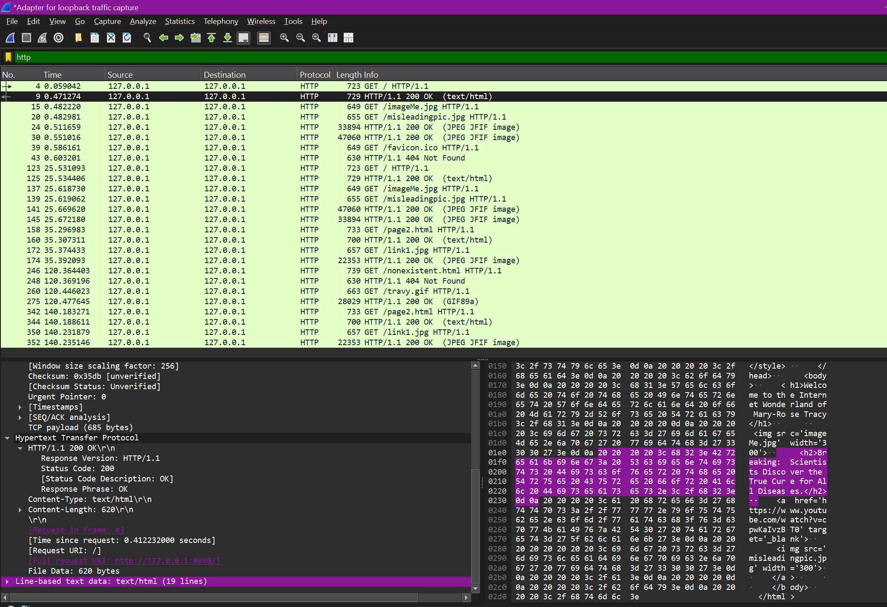
5.2. HTTP 301 Moved Permanently Response
- The 301 redirect shows that /secret.html was properly redirected to /page2.html.
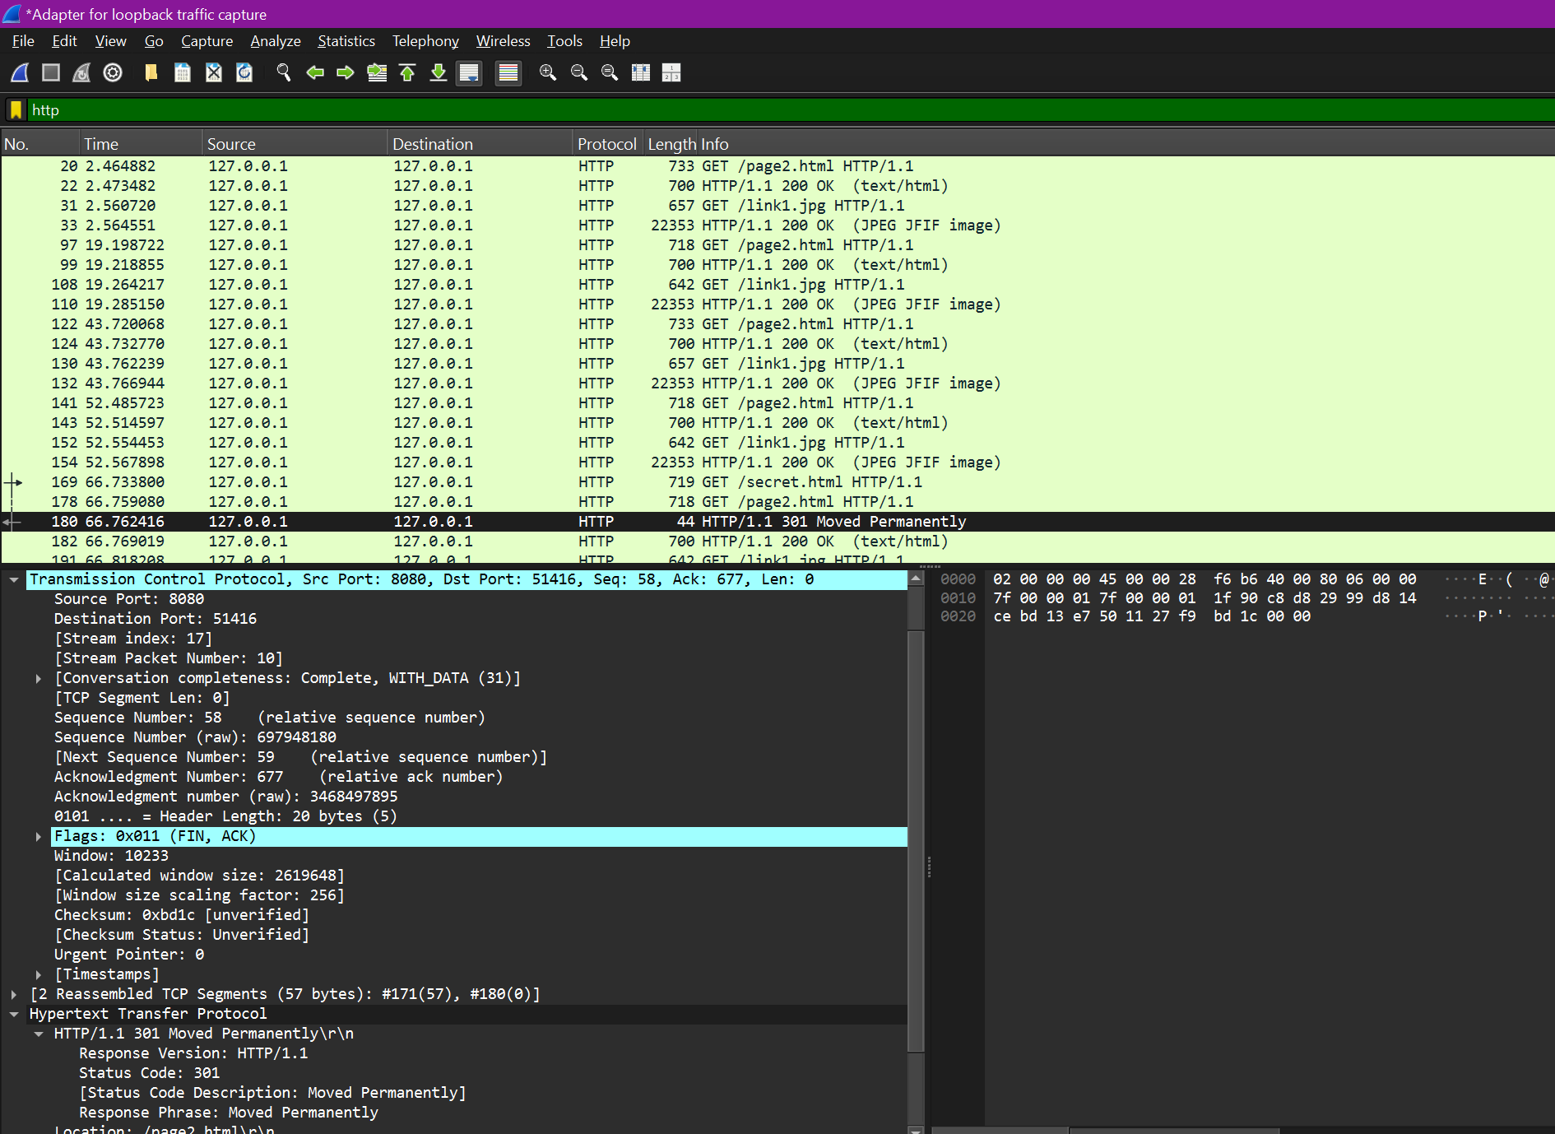
5.3. HTTP 404 Not Found Response
- If a user attempts to access a file that doesn’t exist (e.g., /nonexistent.html), the server responds with a custom 404 error page, informing them that the requested content is unavailable.
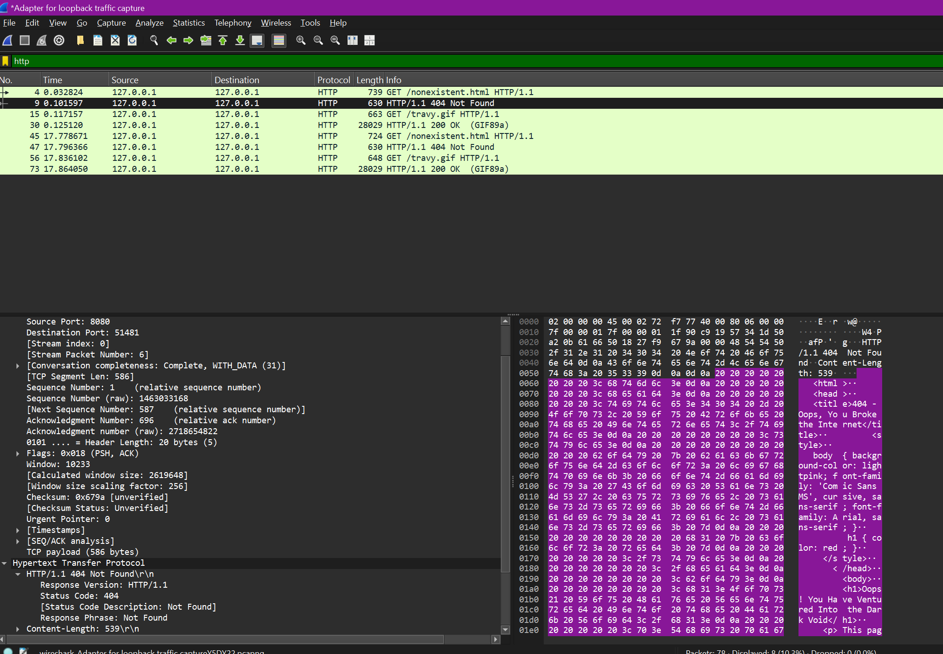

6. Known Issues & Limitations
- Only Serves Static Files: No support for dynamic content (e.g., PHP, databases).
- No HTTPS Support: The server only runs over the HTTP.
- No Keep-Alive Support: The server closes the connection after each request.

7. Conclusion
This project was a great hands-on experience in building a multi-threaded web server that serves static web pages, handles redirects, and delivers a custom 404 error page when needed. Along the way, I got a deeper understanding of socket programming, how the HTTP protocol works, and how to analyze network traffic using Wireshark. To make sure everything functioned properly, I tested the server using a web browser and captured network requests to verify the responses. Overall, this project helped me strengthen my knowledge of networking and web server functionality in a practical way.

8. References
- Python socket programming: https://docs.python.org/3/library/socket.html
- HTTP status codes: https://developer.mozilla.org/en-US/docs/Web/HTTP/Status
- W3Schools HTML basics: https://www.w3schools.com/html/html_basic.asp
- YouTube Wireshark Tutorial: https://www.youtube.com/watch?v=byL8VMEMC0M

