**EXPERIMENT – 3**

**PLOTTING IN R PROGRAMMING**

1. **Scatterplot**

# scatter plot

x <- c(1,2,3,4,5)

y <- c(3,7,8,9,12)

plot(x,y,main = "SCATTERPLOT")

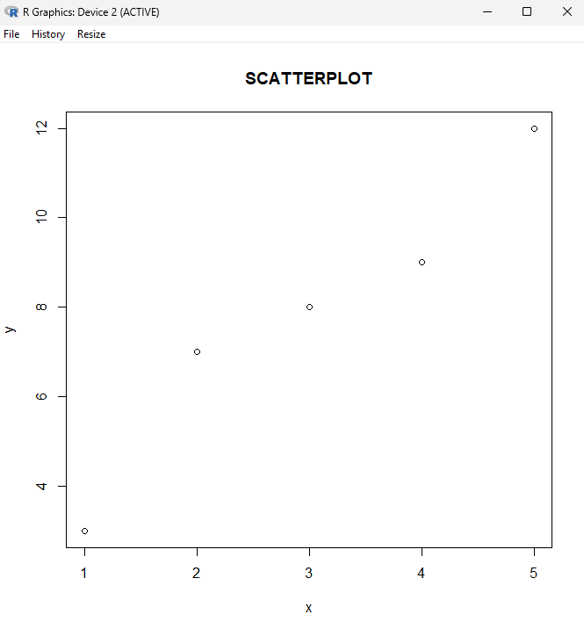

1. **Line Graph**

# line graphs

    # lines() function is used to plot multiple lines in the same graph.

l1 <- c(1,2,3,4,5,)

l2 <- c(3,7,8,9,12)

plot(l1, type = "l", col = "blue

lines(l2, type="l", col = "red")

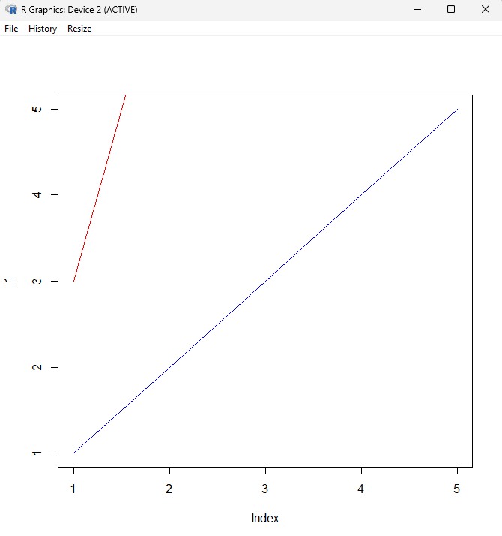

1. **Pie Chart**

x <- c(10,20,30,40)

# Create a vector of labels -- not mandatory

mylabel <- c("Maths", "Science", "Social Studies", "English")

# Display the pie chart with labels

pie(x,init.angle = 45, label = mylabel, main = "Subjects")

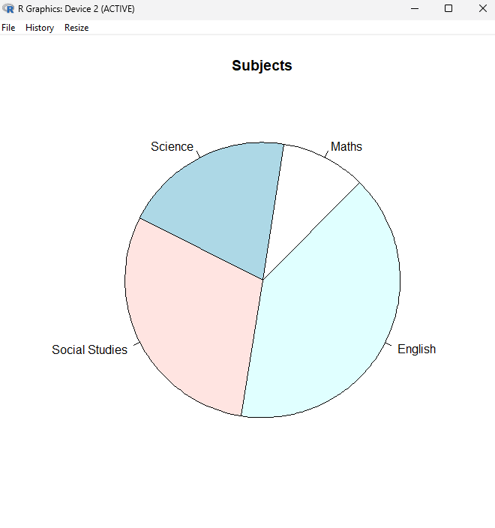

1. **Bar Chart**

x <- c("Maths", "Science", "History", "English")

y <- c(67, 89, 91, 92)

barplot(y, names.arg = x, col = "green")

