**DEPI-JAVA Final Project**

**Library Management System**

**Team:**

* Tasneem Abdeltawab Abdelaziz Kotb
* Nadin Mokhtar Elsaid Elbadwy kandil
* Aya Ebrahim Mohamed Shehawy
* Yasmeen Khaled Mohammed Abd Elhafez

**Email:**

* [tasneemabdeltawab205@gmail.com](mailto:tasneemabdeltawab205@gmail.com)
* [nadinkandil19@gmail.com](mailto:nadinkandil19@gmail.com)
* ayai65291@gmail.com
* [jassmmin2003@gmail.com](mailto:jassmmin2003@gmail.com)

**Instructor name:** Dr/Mina Younan

**Main scenario:**

Library Management System

Develop an application to manage Library borrowing and returns activities. Consider the following information gathered during the analysis process

**Design:**

* **Basic Classes**: Library, Contents, Books, Articles, Digital Media, Subscribers, Borrowing Records, and have the following relationships:
* **A library** content can be a book, an article in a journal, or digital media.
* **A subscriber** can borrow any of the library contents, for three weeks, golden subscribers can borrow for three months, after the lease time is over, a fee accrue on the subscriber until the borrowed item is returned.
* **A Librarian/administrator** can print a report about all borrowed books and rank them according to audience interest rates, can save/load data on and from files.
  1. **Your extra suggestions are welcome, especially to organize main function,** display a menu to the user to:
  + Adding/editing/deleting instances belonging to each class,
  + Subscriber browsing library contents and select items to borrow.
  + Subscriber returning borrowed item and check his balance and pay any late fee if any.
  + Admin can print reports of overdue borrowed items. 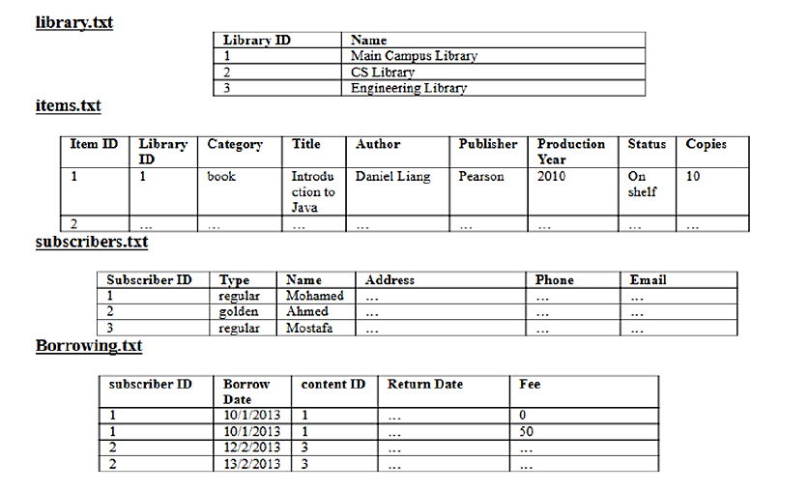

**Extra Features:**

* Library view made as interface, and UserMainPage and AdminMainPage are made from it.
* All contents can be borrowed using the same function “borrow” (Polymorphism)
* Search for Contents using filters
* Add Contents to wish list “to_read_list”
* Get notified before the end of the borrowing period by email.

**Source code:**

[Tasneem205/Library_Management_System: Library Management System as a DEPI project (github.com)](https://github.com/Tasneem205/Library_Management_System)

* 1. **note**: not all the team used GitHub, so some edits are made by someone and committed by Tasneem205.