Year 10 and 11 feedback form

ive done the same questions but different forms so you can see how the different ages and year groups think of the system and shows how each thought about it and would intract with it

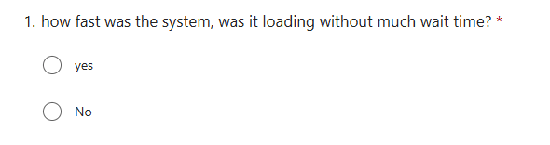
this question is about the speed of the system, as the system is likely to have lots of users using it at one time it needs to be able to handle lots of people on it as well as genraly be able to load fast, this is important so it dosnt waste time for students as they if its loads for awhile they may get distracted or not be able to do enough work in the time they have. so for a more efficient system and happier students it must be fast.

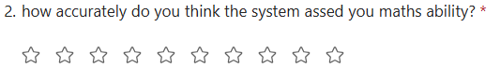

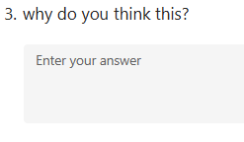

What id done here is allow students to rate how well they think there maths ability was assesd this will give a good idea allows a quick veiw oh how well its assesing students without having to dig though all comments then students have the option to expand and add to this so then comments are more useful pointers of whats wrong and whats good with the overall veiw of how its doing, ive asked this question so we can see if students think they got a real idea.
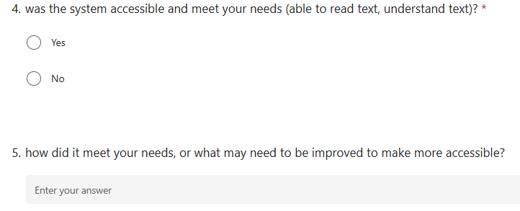

This question is framed simmilar to the prevous where users are asked if the system was accesible to there needs giving a basic yes or no aswer which will be easier to show if users did think it was accessible or not overall as this is easy to represent then is users did have any issues or impovements they can add in the text box bellow how to improve. This question is important to make sure its accessible to everyone esspley with speicl needs, users must be able to read it or have other ways to interprat information, it must be clear and make sure all users are bale to use the system to ful extent to make it fair, so if students with needs struggle and would like a feature added to help impove there experince and make it more accesible making sure it meets all needs.

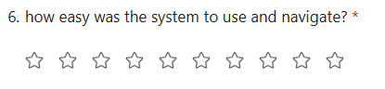

As this question is more of a question of how easy they found it to use a rating is the best question form, this allows a genral overveiw of how well the system has been layed out and how easy student found it it find different thing and use the system, ive used 10 stars instead of 5 as its prvides a more accurate show of the students thoughts. Once its represented you then know if the system needs to be better layed out or if its ok how it is and genraly users found it easy to use.

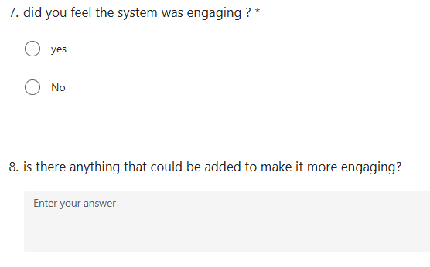

Ive done the same thing allowing a overall veiw if it was engaing and then allowing an option for any commets about how to make the system more engaging that could be used if needed. We need to see how engaging the system is so stendents want to use the system and are more inclinded to do work and stay focused. The more engaing the more students will want to use and study with it making for happier customers and more retention and recommedations to a freind

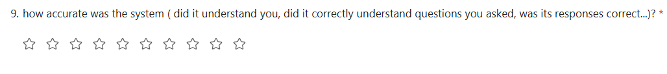

this is again a question where we want to asses the accuracy of the system if its not accurate then the system will need to be edited to understand and answer correctly, however its important we assess how accurate the system is to make sure we are giving the best quality teaching and correct teaching to get students the best grades and the best improvements, so accuracy is super important to the system and the students learning.

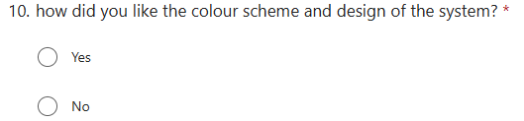

This is just a simple yes or no question, this allows an idea of if the colours work with what the system is, if they work with people who are colourblind, and if they are appliing making the website look proffinal and appeling to customers. This can make usres feel more attrcted to try the systema nd feel more calm while using. As well as the disgin attracting people because it looks proffecninal and appeling to users so they are more likley to check out the system or use it.

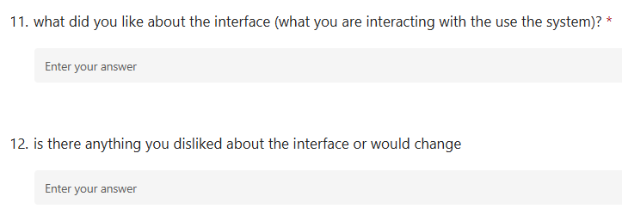

These questions are genraly questions about the overall interface which follows on. It askes students what they liked about the interface this allow a good idea on what users are liking about the system this make sure we keep the things users like in the system to make sure that is kept in the system and to give an idea of what should be in the sytem and what part of the system are most wanted

then users can state what they dislike, this again alows users to have a say on what parts of the system should be changed or removed, it will give us ideas about what users dislike in a system and what they are acutuly looking for or even if featuers are uneeded or not used. These comments can be very helpful to ajust the design to the students who are actully using it and make sure its fitted to them and what they know how to use and design in a way that is clear and aimed towards them.
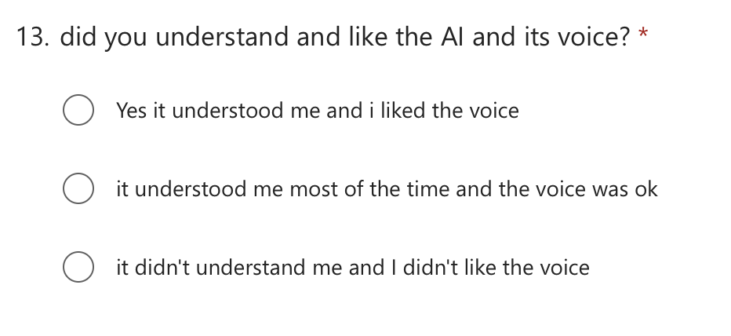

This is a question with short answers where they can say if they understood and liked the AI and to what extent they did, this is really important as the AI will be tutoring them and guiding them through there learning plan. Ive done 3 clear answers of yes, mostly and no. it will give a clear estimate of how much people liked the AI as if most people put yes the liked it then we know that there likely isnt any issues with the AI but if they put mostly then it may need some impovement and if they didn’t like it or understand then it clearly needs changing, this is then easy to show on a gragh and gives a clear simple answer for students of what they thought on it and how well it has worked.

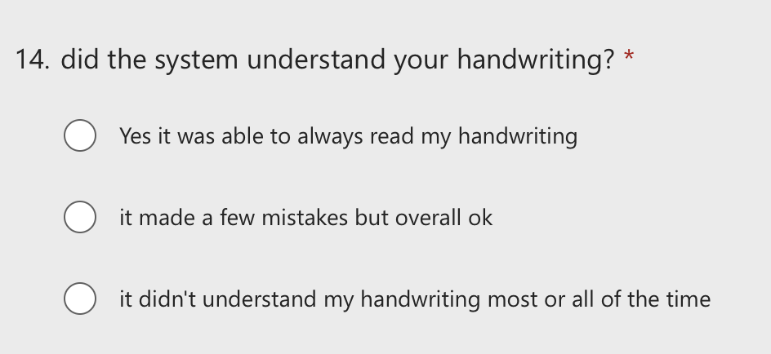

Another clear important question is if the system or AI understood the users handwriting, again this is a question where it did or mostly did but may need some impovement or just didn’t understand the user. This is vital to the system as users will be writing all there answers to be checked and if the AI cant read users handwritting well most or all the time the its not an accurate refelection of that users math ability or learning as it could be saying they got questions wrong that they didn’t and it just didn’t understand what they wrote, its super impostant we check this and get one of these clear answers and see a clear display of this because its very important to the system for it to get this right otherwise users will not be able to use and will be unhappy with the product.
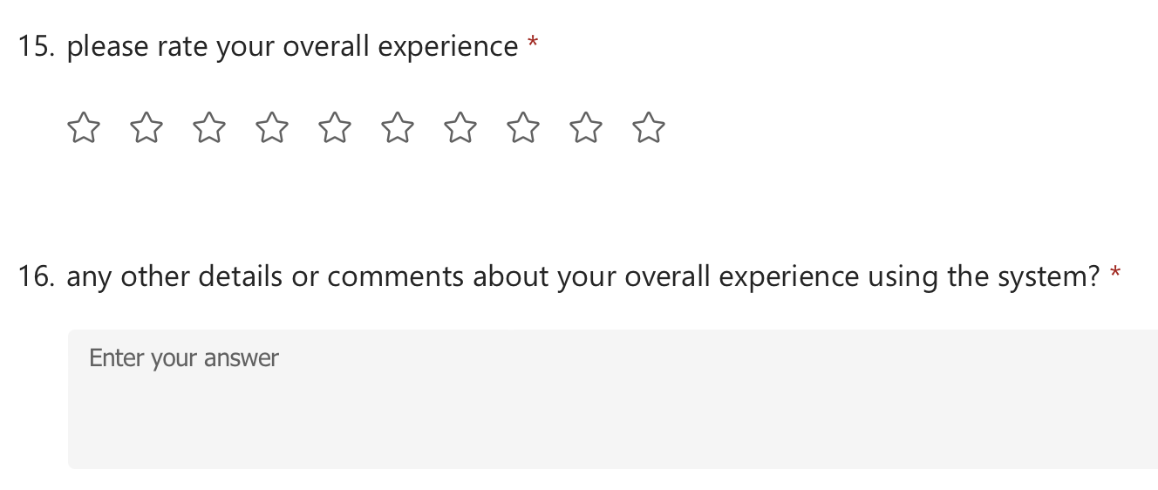

This is a rating Of the users overall experince out of ten so its accurate, it will give a quick veiw of overall how much did it help the students and work as inteded and did the users like it, this gives a great show of users experince by looking at it, it allows a quick acurate look at overall rating without looking through all the comments. The next questions lets students then expand apon what they rated the system so we can see why its was rated that way giving overall veiw of the system and what needs changing and what is good about it, so you can get a quick easy overall veiw of what people thought then all the comments of wht they thought it and how to change or impove it, allowing for the best feedback overall
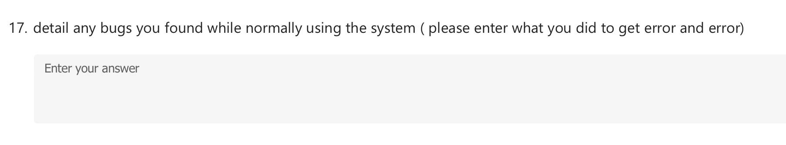

this question is added in the form for year 10s and 11s just asking if they found any bugs while using. Its not required and they are not aiming to break it but if a bug dose occur then it must be reported and detailed so it can be fixed, it tell then it say how they got the bug and what the bug is which allows quick and easy finding on whats causing the bug and why its happening. Its also there for yr 12 and 13 so if they are just using it and a bug occures it can be deatiled as a bug from just normally using the system.

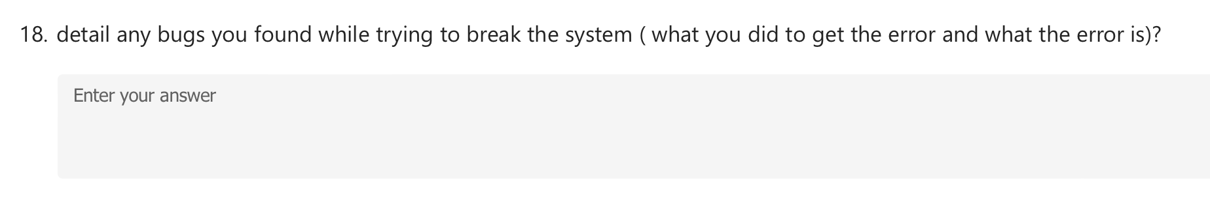
This question is only given to year 12s and 13s and as they are trying to break the system if they do mange to find a way to break it then that may be a security issues and needs resolving this allows them to write down what they do to get a bug and what to bug is while they are testing, a text box must be used for these as the users must clearly state any issues and errors that occure and there may be a few so they need a big text box to enter in unpredtedcted issues.

