Design document for med system

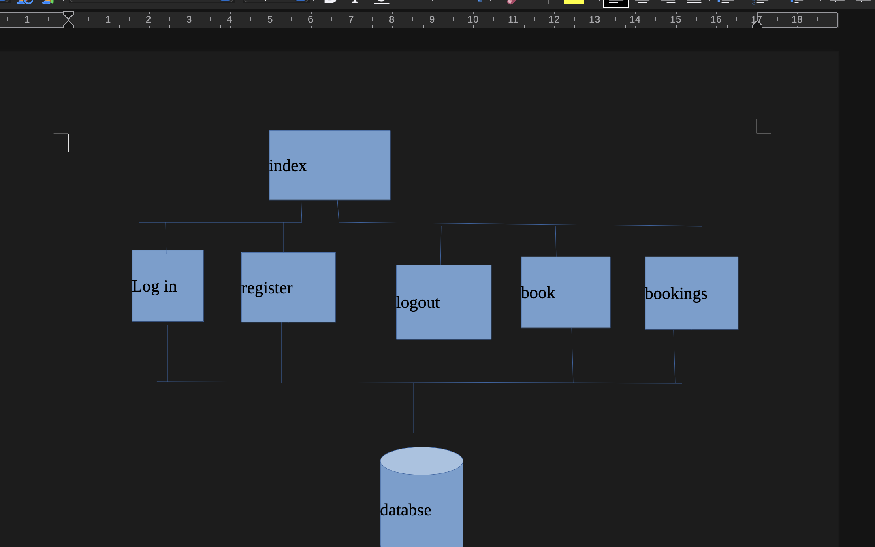
this is my design for my system index will be the home page it will have a basic show of what the websites about and if you log out you can be sent back to this. Then it will have log in and register which you will have to loh in or register before the other pages can be accessed. Once logged in you will be able to chose to log out or book a appiment which will allow you to see and select appiments to have, you will also be able to then veiw your booking and see who they are with and when they are, any of the pages accesssing the database have been linked so they can access and pull or add data to it. As refrnces in my preposle document for FR 1.1 and 1.3 and 1.6 twe can see here how the use of the pages and accessing the database will help meet the requirements

ER diagram

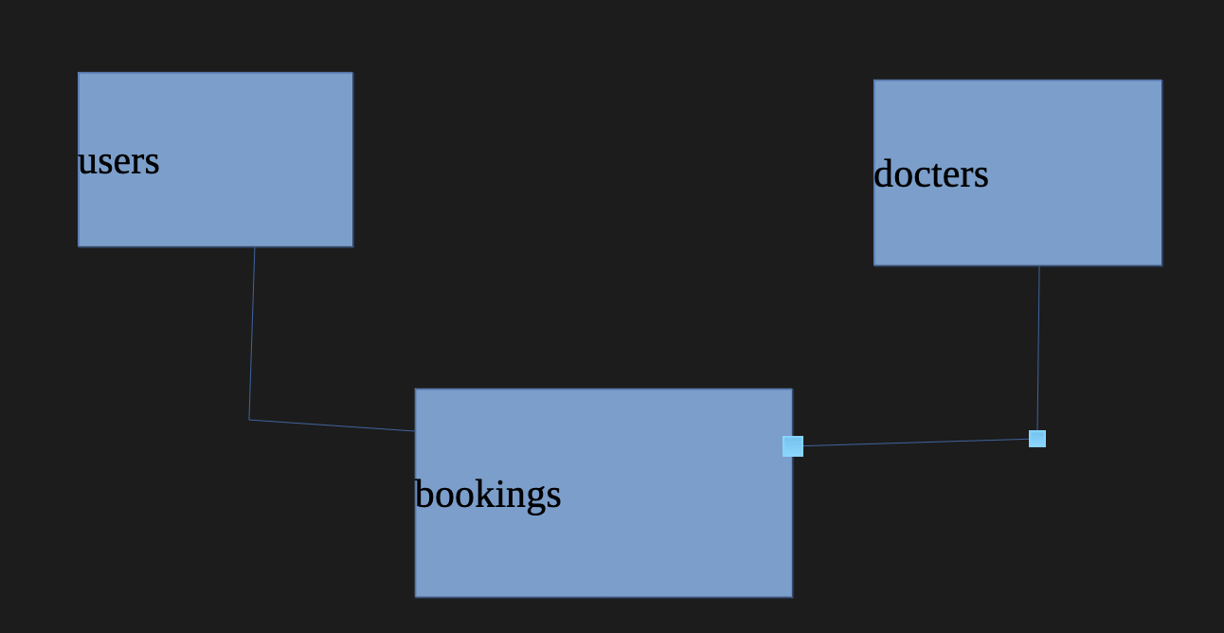
here is what each table of my database will be, the users will have a user_id which will be the primary key in the users database and forgan key in the bookings database, in docters you will have the docters_id which will be prmary key in the docters table and a fogran key in the bookings tables and a booking id in the bookings table will be a primary key so we can refrence to each booking, this all means its not a meny to meny realatonship of docters and users which is not possible so we have the link table of bookings allowing us to use a user and docter id to refrence a booking.

Table structure:

users :

user_id- this is a primary key its auto incremented and just assines each user a number
first name- the users first name as docters may need to know this
surname- users sur name as admin and docters may need to know this
username- this allows users to make a username to sign into there accont with as it make it easier to verify
password- a password to log into accont with, making it easy to verify
date of birth- this may be useful for docters and admin to know to give the correct docters esspley if the paint is younger and with a perent
address- this needs to be known to make sure there is the area at the right docters

docter :

docter_id- this is a primary key its auto incremented and just assines each docter a number
first name- this will need to be know so paients know who they are booking with and they can be idetifyed
surname- this will need to be know so paients know who they are booking with and they can be idetifyed

bookings:

docter_id – this is a forgin key in the link table which allows us to connect tables
user_id- this is a foragin key allowing to connet tables to find users
booking_id- this allows each booking to have an id so they can be assined easierly this will be a primary key
time – this will be needed for the time of each appiment, its important the users know what time there bookings are
date – date of appaiments so we know what dates appoiments are to attend
appoiment notes- allows users to give notes about why they are seeing a docter that can be preread to help idetify the problems

colour schemes

for this I will be using a very simple colour scheme, it will have the classic nhs colours of blue and white for the top bar a bold blue so if colour blind people look at it and its gray it wont make a diffrece they can still see the logo. For the top bar I will simply be putting it as black and white to make the words and bar as clear, readable and accessible as possible as its impoartant people can navage the website. And for any other buttons or the show of the bookings ill just be using a light gray to show where to click and make it stand out without relying on colour so its accessible and the words still being readable but still knowing where to click, this all will keep the website proffinal as you are just booking a docters appoiment so its dosnt need to be colourful, it also fovuses on it being simple and accessible as ist very imprtant for this website to be as accesible to everyone so everyone can get help from the docter, the blue also will give a calmer feel so people using the website don’t feel up tight and can relax as they are getting a docters appiment quick and simply, while staying calm, it also makes it feel like a docters as tehys the colours we assoeate with medical and NHS.
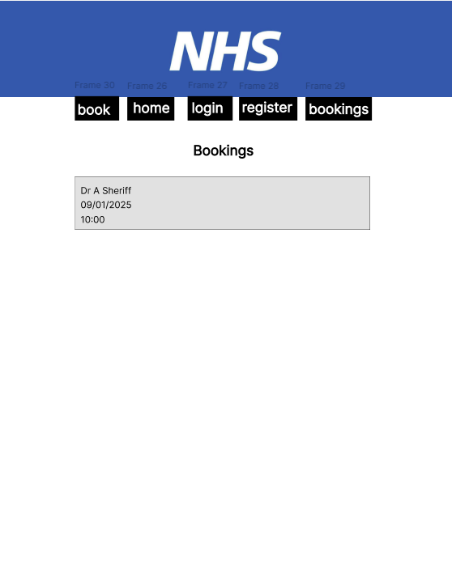
This is the page where you will be able to make bookings this page will show avlible bookings, you will be able to press them to book once booked it will be removed from here and show up in bookings, it will be assined to that user. All appiments will be shown heere in a list, I have made it very simpley so its clear and easy to use and accecible.its clear where to click for the appiment as its in a box, its clear what the page is doing as well because of the heading and no extra bit to confuse
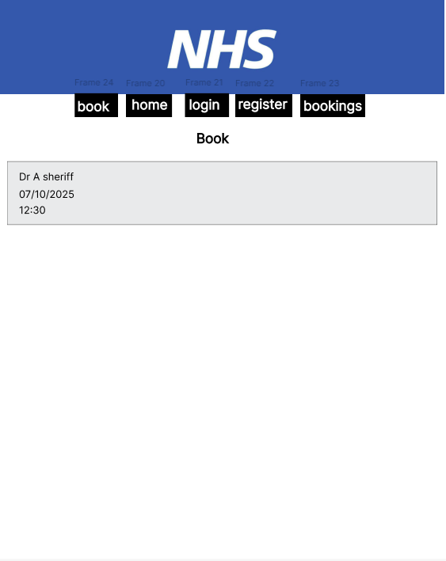
this is where customers are going to book there appiments it will show each appiment with the dovters name the date and time they are avlible each are in a box in gray making it clear whwre to press for that appiment, one booked it will be taken off and show in bookings. Its clear and simple without any fuss, its only got the information you may need and its easy to click and book making it accessibale as possible as its gray not reling on colour and with the colour scheme.
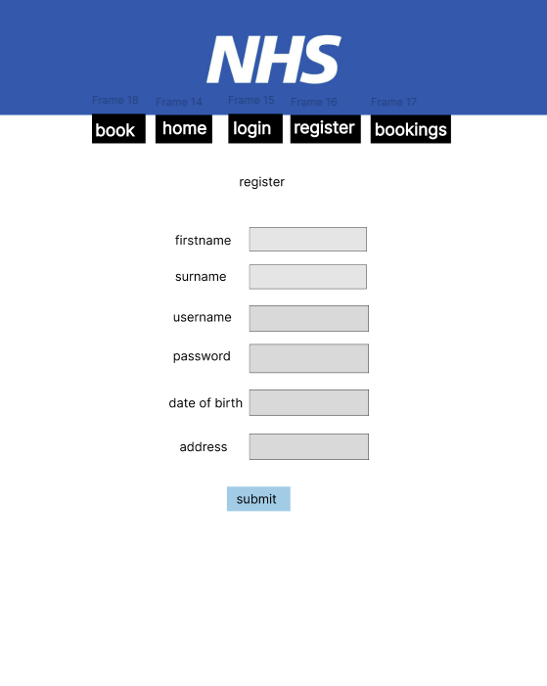
This allows users to register for an account this gose with my fuctinal requements 1.1 allowing users to regiser there details will be stored in the database so they can access sthere accont, it only asked for details that are likely going to be needed by the docters or to sign in, its alows you to create a username and password to log in with and all other details will be for admin and docters to look at to make sure your getting the right care at the right place by the correct docter and have your records. It also has a submit button which is a light blue its obvuls and eay to click it also means if your colour blind it can still be read, the boxes are gray so ist clear where to enter your details and each are clearly laybled.
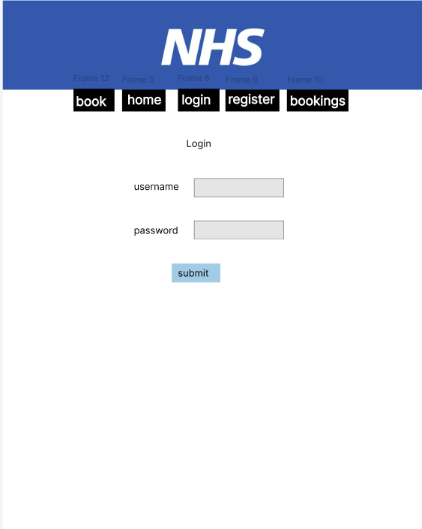
This allows users to log in to there accont there details will be stored in the database so they can access sthere accont easley and there details, bookings will be saved, it allows you to enter both your username and password both have to be correct to log in so we know your accont is secure, they can be easley remberd and verifyed. It also has a submit button which is a light blue its obvuls and eay to click it also means if your colour blind it can still be read, the boxes are gray so ist clear where to enter your details and each are clearly laybled,
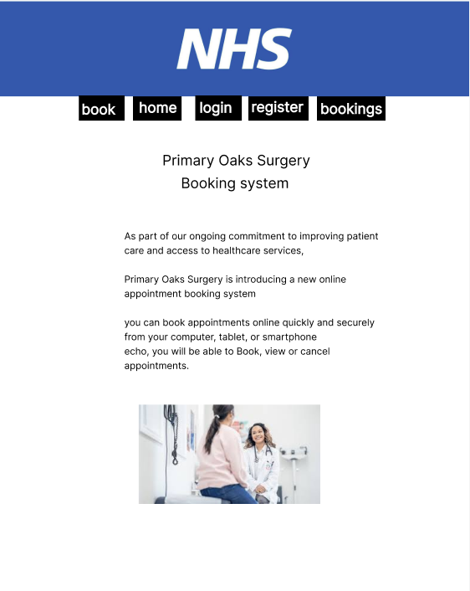
this is the booking system main page or home page, this is where you will be directed if you log out, it had simple text just stating what the booking system is what it dose and that its easy to use and made for users, it has a picter at the bottem to make it more visulay apperly so it looks more freidly and less intemidating and full of words which eases people in, and make it seem for freidnly, the words are also easy to have a reader to read and its not too much or a lot of words it just gives and overveiw of what the website is about.

Algorithm design

Regitering a user
FUNCTION new_user(conn, post)
TRY
sql = "INSERT INTO user (first_name, surname, username, password, d_o_b, address) VALUES (?, ?, ?, ?, ?, ?)"
stmt = conn.prepare(sql)

stmt.bindValue(1, post['first_name'])
stmt.bindValue(2, post['surname'])
stmt.bindValue(3, post['username'])

hashed_password = password_hash(post['password']) // use a secure hash
stmt.bindValue(4, hashed_password)

stmt.bindValue(5, post['d_o_b'])
stmt.bindValue(6, post['address'])

stmt.execute()
conn = null // close connection
CATCH DatabaseException e
log_error("Audit database error: " + e.message)
RAISE Exception("Audit database error: " + e.message)
CATCH Exception e
log_error("Audit error: " + e.message)
RAISE Exception("Audit error: " + e.message)
END FUNCTION
Pseudocode — user_message()
In this fuction we are prossesing the form and the values to add to the user database to register the user so we atrt with an SQL qury just saying what we are adding too, then we bind the values to securly put them in the database, before getting rid of the connection to stop anyone from getting in and stop any access points, we will the try exicute it to the database however if this dosnt work it will then catch the rror and print it out

formatting messages for user

FUNCTION user_message()
IF session contains 'usermessage' THEN
message = "<p>" + session['usermessage'] + "</p>"
REMOVE session['usermessage']
RETURN message
ELSE
RETURN "" // empty string when no message
END IF
END FUNCTION
It checks the value passed is in usermessage, before formatting the message as paragh text and removing any session before returning the message to be echod out to the user, if this dosnt work or there is an issue it will just print a empty string.

checking the username is avlible

FUNCTION username_check(conn, username)
TRY
sql = "SELECT username FROM user WHERE username = ?"
stmt = conn.prepare(sql)
stmt.bindValue(1, username)
stmt.execute()
result = stmt.fetch_one() // fetch associative row or null
conn = null // close connection

IF result IS NOT NULL THEN
RETURN true
ELSE
RETURN false
END IF
CATCH Exception e
log_error("Audit error: " + e.message)
RAISE e
END TRY
END FUNCTION

This function checks th eusername entered in avalible so we don’t have repats of data and issues with data reducdny, we do this by selecting the database and the going into users tablbe towe then prepare the sql and bind the username entered to a value to compare againt the usrenames in the database, if it find any that are the same it will retuen that the username isnt allowed, if its not already used it will allow the username to be used and just return it.

This allows the user to log in
function login(conn, post):
try:
conn = connect_to_database_for_insert()
sql = "SELECT * FROM users WHERE username = ?"
stmt = prepare_statement(conn, sql)
bind_value(stmt, 1, post['username'])
execute_statement(stmt)
result = fetch_single_result(stmt)
close_connection(conn)

if result exists:
return result
else:
set_session_message("User not found")
redirect_to("login.php")
exit_program()
catch database_exception as e:
set_session_message("User login error: " + e.message)
redirect_to("login.php")
exit_program()
This function allows a user to log in by checking to see if the username matches the username that is entered, we do this by getting the usres table and preparing the SQL we then bind the entered username to then go execute and check if it matches any of the usernames in the database if it dose it will retuen back that the user is verifyed, if not it will give an error message

audits user activity to database

function auditor(conn, userid, code, long):
sql = "INSERT INTO audit (date, user_id, code, longdesc) VALUES (?, ?, ?, ?)"
stmt = prepare_statement(conn, sql)
date = get_current_date_in_format("YYYY-MM-DD")
bind_value(stmt, 1, date)
bind_value(stmt, 2, userid)
bind_value(stmt, 3, code)
bind_value(stmt, 4, long)
execute_statement(stmt)
close_connection(conn)
return true
This allows data about what a user has done to be put into audit in the database, it first uses SQL to prepare the table, then we format the date and bind all the values so they can be entered in the database, we ten exute this to add all the details about the user activity into the database close the connection and return this has been done.

gets user ID

function getnewuserid(conn, username):
sql = "SELECT user_id FROM users WHERE username = ?"
stmt = prepare_statement(conn, sql)
bind_value(stmt, 1, username)
execute_statement(stmt)
result = fetch_single_result(stmt)
close_connection(conn)
return result["user_id"]

When putting data into the aduit table we need to know what user by saying there user id, this fuction looks in the user table send the users username and brings back that users ID to put in audit so we know what user is doing what, it will return this to be used

