Medicine tracker,
primary oaks surgery,
occupational specialism,
Ava sheriff

Table of Contents
Origination overview 3
Description of business 3
Who are the buissness and what do they do? 3
Problem overview 4
Understanding of project 4
Impact of problems and currect system issues 4
User groups 4
Admin 4
Doctors 5
patients/users 5
Scope 5
Empty maps 5
User stories 6
Laws, guidance and legislation 8
8
Alternative systems 8
Risks 11
Data and security 11
finance 11
other risks 12
Decomposition 12
User acceptance critra 13
fuctinal and non-fuctional requeremnts 14
Functional requrements: 14
non functinal requremnts 14
description of preposed solution 14

​​
​
​

Origination overview

Description of business
This business is a doctors surgery looking to provide a better way of tracking medication. Here is a brief provided:
The project is to orgnise student medical records the project brief states:
Many doctors surgeries are transitioning to an online booking system for appointments. Your local doctors Surgery ( Primary Oaks Surgery) has contacted the organisation you work for to design and develop a bespoke booking system for them. An account system can and is used to track users choices, usages of the site and to grant or prevent access to materials. To facilitate this, users need to be able to register to a website and have their details stored in a database.
From this we see this buissness is a doctors serugery, they will be looking at people fo health resions and store privart data on there systems, they will have reseptions that will do admistrive work within the docters office and have docters who will be the ones having the appiments and doing the medication and checks of people. There may even be different types of docters for different issues and they may need to update data or request data to be changed based off what happens and whats wrong. Users wil also come to be looked at in there appiment and want to book appiments with staff.

Who are the buissness and what do they do?
They are a docters surgry, they will be providing medication and allowing to repeat and get there prescription when needed, and other docters duties as well like looking at patenints to percribe. they will have to keep track of all there paients and medication, they will want a easy and effective way to do this. they could even require check ups before perscrption is allowed.
What are they looking for?
They are looking for a way to facilitate this, users need to be able to register to a website and have their details stored in a database. They need to be able to have different accounts with different permissions, they want to see the different medications and the orginal and current dose, and any expiry dates,it need to be a safe effective and secure system because docters have lots of jobs and not much time so having a good working system is important. They want to be able to update any information and recive or see any notifications to show when someone may need more of there medication.

Problem overview

Understanding of project
My understanding of this project is that this docters surgery wants to provide an online system to track appintments. They want to be able to grant privalages and have different types of acconts that can log in to do different things like seeing the users usage and to see matrail on the site, users should be able to log in dependant on there privalges depends what they can see and do, they can see matrails and some can edit and add users or information to the database. They should be able to see any medication, and all information should be in a secure database. Appinments should be able to be changed by serten staff if needed as well as users being able to look at there own appoinments and when they are. Painets or users should be able to book appintments, when avalible and see avalible appinemts. But should not access any other information within the system.
It should store any users data such as date of birth so correct docters can be assined to each painent. Its important that any change request are secure for any change sof this information.

Impact of problems and currect system issues
if they are asking for a system that can handle appintment booking and admin of system. This means the orgnisation will currently not have a syatem in place. This will mean they ether have to do this on paper or on a worse system that may not be doing everything they need. This will impact the organisation and accuracy of the system, they may not be able to track users appoinments or make users appointments easy this could cause data redundancy and could lead to issues such as double booking, this can cause disturbances and insecurities within the system, data may also not be help properly as it may be on paper or on a insecure system which could be really dangerous system its a doctors office, they will need sensitive information. If this data is leaked or insecure and ends up being hacked or looked at it could go against serval laws. This could get them in lots of legal trouble or be very dangerous for the users. They may also end up keeping data they shouldn’t or struggling with the organisation of the system.

User groups

Admin
Admin people will be the receptionists or people that can manage the system, they will want to be able to make bookings, see data about people, see available appointments, and they will have to mange a lot of senstive data. This means they will have to very trusted and have experice working in this area, this allows us to know they are trusted and know they know how to work systems and handle working with data. So likely they will be between 30 and 50 as they will have experince, know how to handle people, can use these systems, and can be trusted.

Doctors
Docters will be using this syetm to see what appiment they have in there diary, or see peoples data if they need. This should mostly just be what the docters use it for maybe if someone need to come back they can book an appiment for them or be able to rearage if something comes up. Docters will likely be in the rage of 30 to 60 as they would have had to finnsh med school and training, and over 60 will retier or wont be able to work as a docter. They will likely be ok with technolgy as they will be smart and have some sort of computer system knowlage as thats what they will likely be working with alot

patients/users

The patients that are likely to aged between 16-65 as kids below this age will likely not be making appimets for themselves as there parents will be doing so for them, this is mostly because they are not adults and may not be bale to do so or even know how, and users above 65 will not know how to use technolgy like this and will likely still prefer phoning up as they know how to and it will be easy for them. People over 16 and in 20s will likely try and find the quickest easiest ways to do things and a lot of people even older people will be busy and have a job so they cant sit around on the phone for an appintment. So the quekest and esiet way for them will be booking system, older people may have carers make appiments for them as well who will be younger. However some may just call up as they may not understand as they don’t have the technical ability and they have the time to call.

Scope
The scope of this project is for a very small scope, we are just creating a booking system that will just do the basic booking system roles but will not be there to do a hole system for storing records or connecting or doing any of the main NHS systems, this a smaller project to make a system that allows people to book docters to see who has booked and the damin to mange and see booking from the system, only the basic data for this will be stored

Empty maps

Says | Thinks | Does | Feels
"I need to manage bookings efficiently." | "This data is sensitive, so I must be very careful." | Manages bookings, updates patient records, handles appointments | Responsible, cautious, sometimes stressed
"We have to keep everything organized." | "I hope no mistakes happen with the data." | Reviews appointment availability, handles sensitive info | Trustworthy, focused, sometimes overwhelmed
"I want to make sure patients get the help they need." | "I must be accurate and professional." | Coordinates with doctors and patients | Professional, confident, diligent
"How can I make the system easier to use?" | "I need to balance security and ease of use." | Trains or supports other staff if needed | Caring but sometimes frustrated with system limits

Says | Thinks | Does | Feels
"I need to see my appointments quickly." | "Patient data must be accurate and up-to-date." | Checks daily diary, reviews patient info as needed | Focused, sometimes busy, responsible
"If a patient needs a follow-up, I can book it." | "I don’t want to waste time on admin tasks." | Re-schedules appointments when necessary | Efficient, sometimes pressured
"Technology should support my work, not slow me down." | "I trust this system but need it to be reliable." | Uses system for quick access to data | Pragmatic, confident with tech, occasionally frustrated
"Patient confidentiality is critical." | "I have to be careful with sensitive information." | Follows protocols for data access and updates | Ethical, conscientious

Says | Thinks | Does | Feels
"I want to book an appointment quickly and easily." | "I don’t have time to wait on the phone." | Uses online booking system or asks a carer to book | Impatient, busy, sometimes anxious
"I hope my data is safe and private." | "If I don’t understand the system, I might call instead." | May call reception or use the online portal | Cautious, sometimes confused with tech
"It’s easier if someone helps me book." | "I want reminders so I don’t forget." | Relies on reminders or carers for help | Supported, sometimes dependent
"I want to quickly find available appointments." | "This should be as simple as possible." | Searches available slots, completes bookings online | Efficient, goal-oriented

User stories
As a (patient) | I want | So that | Acceptance criteria
As a busy working paient | To be able to book appiments quick and easly | I don’t have to spend time on the phone that I may not have or be able to do? | needs be quick and easy to use with easy naviagtion
As a painent who worrys about secruity | To know my data will be secure | others cant hack in and access it | The data must be secure and code must be reliable and robut to make sure no one can find a way to steal or access any data from the database
As a older patiant with disabiltys | The system to be accessible and easy to navage | I can navaget and use it myself without any struggle | Needs to be accessible by using clear fonts and a simple system so those who have disabitlys can still use and access it

As a (docter) | I want | So that | Acceptance criteria
As a full time docter | To be able to know my schedule for the day | so I know what my day looks like and when I can take my breaks | Easy to see avlible sessions for each docter so they don’t get overbooked and can see avaliblity
As a overbooked docter | I want to be able to have the time to fully examan each paient | I make sure im giving the best care and diagnoses for each paient with less stress of time | Having long enough slots to make sure docters can fully exam and care fo paients without as much stress of time

As a admin | I want | So that | Acceptance criteria
As a busy admin | To not have to always be backed up with calls and having to cosistantly keep track of bookings | I have more time freed up to be able to keep ontop of everything and be bale to take more time with paients | Needs to be able to see and orgnise booksing this allows them to veiw an dmange them without as much worry as they know who has made a booking for when imdetly and be able to make appiments for people so they can book by phone.
As a busy admin | Make sure all data is kept and orgnised. | So I don’t make a mistake and lose or cause redundacy. | System must be easy to veiw and see data, this makes it easy to keep track off and orgnise

Given | when | Then

Laws, guidance and legislation

Here will be what laws are going to be related to this senario and website and around this system,
one law that will definatly apply to this system is UK GDPR and the data protection act this is really important, this law protects pernonal and medical data, which in our system is very relivent, peoples privart and confidentual infomationm will be stored and used in this system, the data can be very privarte as well as its medical information about the perosn, this law is broken you have caused risk and problems to the paients and users, as this confidentual information it can be used againt or cause harm to paitents. It wil also cause loss of reputation and fines.

They will also have to look at health and social care act, this atc ensures healthcare data is controlled and approprate, this will alpy a lot to the admin and docters when gathering information, its important the information that gats gatherd is only what is needed and apprtate for this system and in appiments, otherwise it can cause security issues because id you store more data then you need you if there is a security breach they will be letting out senstive data that was not needed, also inaved people privarcy and puts them at risk.

The computer misuse act will have to be thought about, this prevents unathrused access to compuetr systems, we need to cosider this as someone could gain usernames and passwords to get unauthrused access to the system or get acess to privages they should not have, this can mean they can get access and take data and cause securty issues to the system. So making it illaige will mean people are less likely to do so and can give then fines and jail time depending on what they do, it also mean the admins will make sure there details are kept safe and they r aware

WCAG is a act on which it needs to be accessible, because it NHS is very very imporant everyone can access there services and docters services so making it accessible is vital for this system if its not then someone is missing out on there right to health care.

Alternative systems

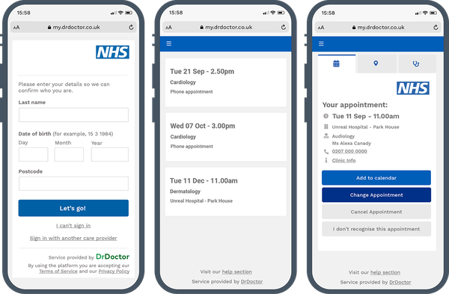
This is the NHS booking system, which will be useful and simmiler to the booking system, its simmple and only asks for details it needs, this booking system will only be for people who are at the docters surgry, we don’t need to know there postcode as that should have already been checked when they joined the surgry, it shows the avalible appintments and then what your sppitment is, this is hopefully what this system will do as well and make sure your able to veiw your bookings as well, so this could be used however this is for the wider nhs and not spific to this surgry or system, we may also want other details about the painents like why they are going and they should just be able to log in and get access to book and see appiments and there data so sysnce this is for a wider audince ours will be more spific to the seniro however this still could be a altertitive.

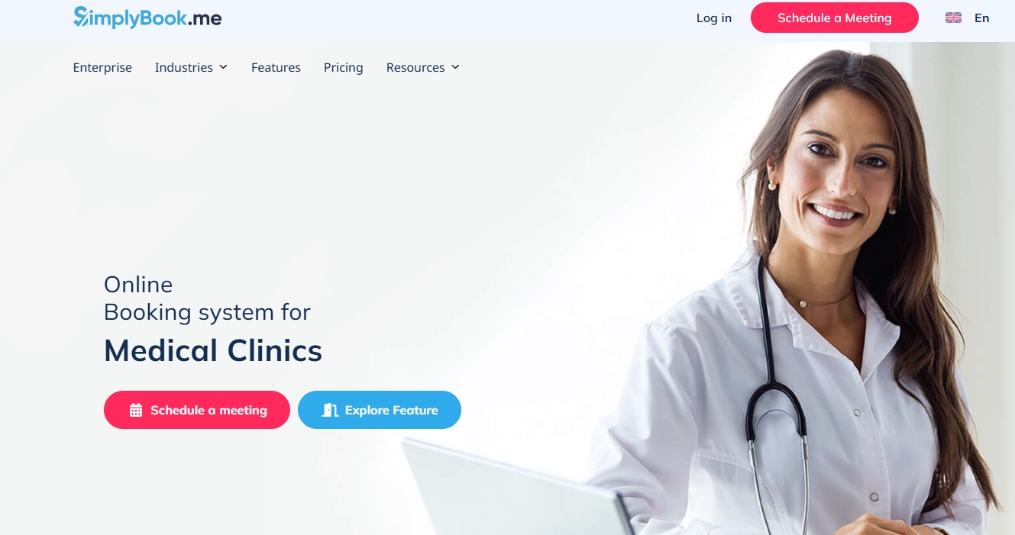
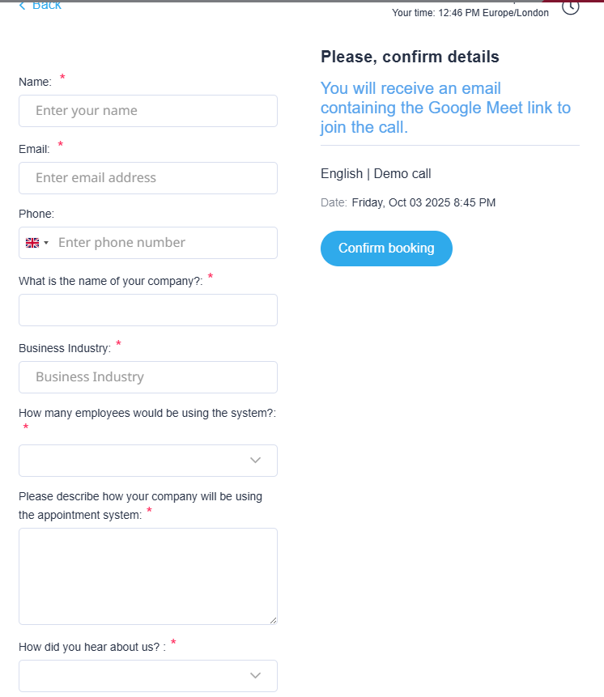

This system is for medical bokkings at all sorts of places, it allows people to design a booking system and use theres to book a appiment with them. It allows you to press book the brings up a sreen with lots of details, I like the fact that means you can enter details when you book an appoinment, here it is about what you will use the system for but we can say why are you booking this appiment, so the docter can use this to understand the problem better and know why they are coming, but this is an alternitive as they desing booking systems for you and your purpuse.

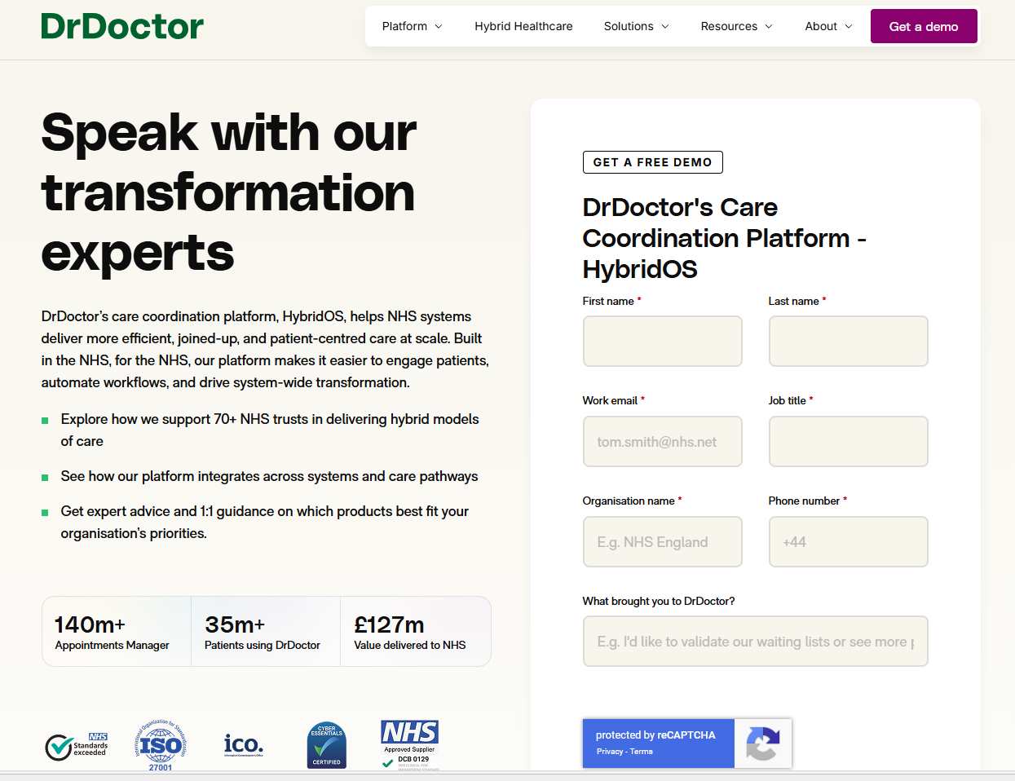
This is a people who diliver good booking and coradination platfroms for medical clinics, at the sid eof the page we have text this allows us to see they have good show at the side of the page of why they should be trusted which is good I may put some text saying we keep the data safe ect, however they could be an alternitive as they want to book spific booking systems that are effinct and work for the user, I like there booking system as well they only requer needed information which is good and its a submit form. Its a good trusted altervtive for who can make a booking system and have a good scale and level of trust, however they may be too large and expensive or too much for the small booking system we are looking for.

Risks

Data and security

The main risks to this system will be making sure data is secure, its important because if data is breached it can leeds to loss of repuation and fines and problems around the persons whos data was lost, its also imposrtant from the meny laws around this.
You also need to make sure staff are trained and credetials are kept secure

finance
- Development and Implementation Costs Overrun
- The budget for developing this system might be underestimated.
- Unexpected complexities (like integration with existing systems or compliance with health regulations) could increase costs.
- Hiring qualified developers, especially with healthcare IT experience, can be expensive.
- Ongoing Maintenance and Support Costs
- After launch, the system will require continuous updates, bug fixes, and technical support.
- Costs can increase if the system needs to scale or adapt to new regulations.
- Training and Change Management Costs
- Admins, doctors, and patients will need training to use the system effectively.
- Older staff or less tech-savvy users might require additional help, increasing costs.
- Resistance to change can delay adoption, increasing the need for support resources.
- Cost of Data Breach or Compliance Failures
- Even though you asked to exclude security risks, a breach or regulatory non-compliance can lead to hefty fines (e.g., GDPR or HIPAA fines).
- This also includes the cost of legal actions, loss of reputation, and compensations.

other risks
- Data Accuracy and Integrity Risks: Mistakes in appointments or patient data can harm care quality.
- User Role Mismanagement: Incorrect privileges could allow unauthorized access or restrict needed access.
- System Downtime: If the system is unavailable, appointments can’t be booked or changed, disrupting service.

Decomposition

This digram shows the structure of my system we can see index is the main page that will let you log in or register, ths will then allow you access to the other parts of the system, all of which use the database in some way, some of the pages may be only accessed by serten accounts like view details only for admin. I have put the line to othe log in and out and register seprately as you can only access after you have logged in.
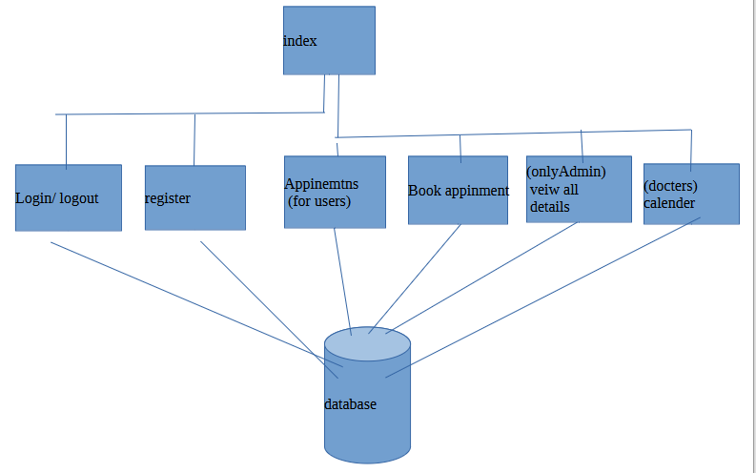

User acceptance critra

1. paients
1.1 – system should be easy to use and naviaget
1.2 - system should be simple and use proffentail nhs colours
1.3 – system should be accesible
1.4 – should be able to book and see appinemts
1.5 – make that there data is secure and we tell them about the laws we are making sure we abide to
1.6 – should only take data that is nessery for the appitment and no more
2. docters
2.1 – they must be able to see there appiments in there claender
2.2 – must have enough time with each paient
2.3 – system should still be easy to username
2.4 – information should be shown clearly
2.5 – must be able to see data about painets
3. admmin
3.1 – system should be clear and show information well
3.2 – they should be able to still book appiments for people eho call
3.3 – should be able to see detials and appoiments for people,
3.4 – should be easy to use and navage
3.5 – should allow them to create or delet people so less data reduncy

fuctinal and non-fuctional requeremnts

Functional requrements:
- 1.1 allow users to register
- 1.2 have a nav bar
- 1.3 book appiments
- 1.4 see appiments
- 1.5 be secure
- 1.6 store data for each user

non functinal requremnts
- 2.1 pages are accessible
- 2.2 easy to naviage
- 2.3 load fast
- 2.4 information is layed out so its easy to read
- 2.5 see appitments
- 2.6 page looks nice and proffitnal
- 2.7 key performance indicators
- 2.8 improved customer reviews
- 2.9 paientat being happier so less complaits and calls

description of preposed solution

the proposed solution is to build a booking system that allows painets to log in or register securely with this infomatin in a datadase (only collecting needed data and sercuirly made) once logged in users will be able to navage by a bar to book and look at appitments, admin will be able to veiw people calinders make bookings for people and veiw peoples details, docters can veiw details and look at there calenders. This allows each user to only have privlges to do serten thinsg so data nd the system stays secure. It will abided by all the laws that relate and will ensre users that there data is being kept safe and securely. The design of the website will be simple clear and accessible as everyone needs to be able to use the system from a very big rage of people.

