Design document

Ava sheriff

Rolsa Technologies
Table of Contents
Reminder of functional and non functional requirements 3
Functional Requirements (F): 3
1 - Users (Customers): 3
2 - Staff: 3
3 - General: 3
Non-Functional Requirements (NF): 3
1 – Users: 3
2 – Staff: 4
3 – General System: 4
Decomposition 4
ER Diagram 5
Table structures 6
Bookings 6
Users 7
Staff 7
User audit and staff audit 7
Variable list 8
Test strategy 8
Colour scheme 11
Interface design 13
Algorithm design 16
Registering a user 16
formatting messages for user 17
Checking the username is available 17
User log in 18
Audits user activity to database 20
Gets user ID 21
Committing a booking to database 22

Reminder of functional and non functional requirements

Functional Requirements (F):

1 - Users (Customers):
1.1: Users should be able to register for an account securely
1.2: Users should be able to log in securely using their registered details
1.3: Users must be able to book a consultation or installation appointment
1.4: Users must be able to cancel a booking they have made.
1.5: Users must have access to information about how to reduce their carbon footprint and the company’s green products.
1.6: Users must be able to edit or reschedule a booking they have made.
1.7: Users must be able to view a list of their bookings
1.8: Users must be able to log out of their account securely.
1.9: Users should be able to see green products

2 - Staff:
2.1: Staff must be able to log in to the system securely.
2.2: Staff must be able to register new staff accounts
2.3: Staff must be able to view their assigned appointments and see booking details
2.4: Staff must be able to update or edit appointment information if necessary.
2.5: Staff must be able to cancel appointments if required
2.6: Staff must be able to log out securely after use.

3 - General:
3.1: The website should have clear navigation for easy access to main pages
3.3: The homepage must display general information about the company and its environmental mission.

Non-Functional Requirements (NF):

1 – Users:
1.1: There must be a users table and user audit table in the database to store account and activity data.
1.2: The system must connect to the database to retrieve and verify usernames and passwords securely.
1.3: Passwords must meet strength requirements to make sure account is secure
1.4: Error handling must be implemented when a user registers or logs in
1.5: The login system must prevent malicious input with sanitisation

2 – Staff:
2.1: There must be a staff table and staff audit table in the database.
2.2: The system must connect to the database to verify staff credentials securely.
2.3: Error handling must be implemented when registering or logging in staff members.
2.4: The login and registration pages must validate input and prevent misuse or hacking attempts.

3 – General System:
3.1: The system must use an efficient relational database to store all data (users, staff, bookings, products, logs).
3.2: Sensitive information must be encrypted or hashed to ensure data security.
3.3: The system must be able to connect to and retrieve information from the database quickly and reliably.
3.4: Users should not be able to access booking or account pages without logging in.
3.5: Logged in users should not be able to access login or register pages again unless logged out.
3.6: The system must prevent duplicate accounts using the same email or username.
3.7: All error handling must be implemented correctly to make the code stable and robust.
3.8: The colour scheme and layout should be accessible, with clear contrast for navigation buttons and text.
3.9: information and text should be clear, simple, and easy to understand for users aged 30–60.

Decomposition
In my decomposition diagram the database is at the top which everything connects to as most pages will be using the database from what they are doing, the pages you can access before you log in are the login page, the register page and the index. These are all shown and linked bellow as you can navigate between them. Once a user is logged in they can access the other pages shown underneath, so booking appointments and being able to see the appointments you have booked, as well as the calculator and viewing products they offer. You can also change you appointment which would take you to a different page to see and change details of an already made appointment. You could also delete an appointment in the booking page. Lastly you can log out taking you back to the login page.

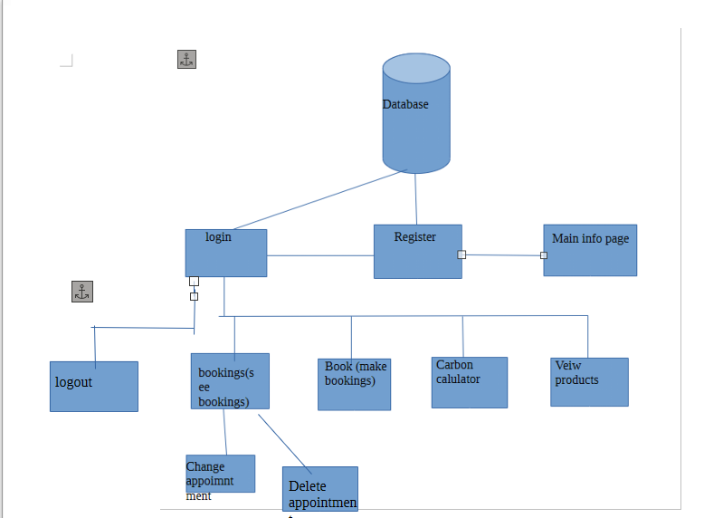

ER Diagram
Bellow is my ER diagram, this is how all the databases will be connected. We have lots of users and staff so are link table will be our booking table, it store user and staff id as foreign keys to be able to connect to the user table and staff table with a primary key, the bookings will store other information like the booking ID, time and date for each appointment, this will all be connected and stored in this table. Then we have our user table, this stores the users details and information about each user and connects to other tables using the primary key, it will store other details like username, password, date of birth, address etc. the staff table will be similar with using the primary key and having the staff information like username, password, role, etc. next are the audit tables we have a staff and a user audit table which do the same thing of tracking what users are doing, they connect using one of the keys and will store information like user id, time, date, code and long description of what action the user has taken, this is just so we can keep track for security, so if there is any strange activity the user can be removed or identified. This structure allows a good structured flow that is simple and efficient, all table are linked correctly and have the right relationships between them. This meets NF 3.1, and makes it easy to retrieve data NF 3.3, meeting my requirements.

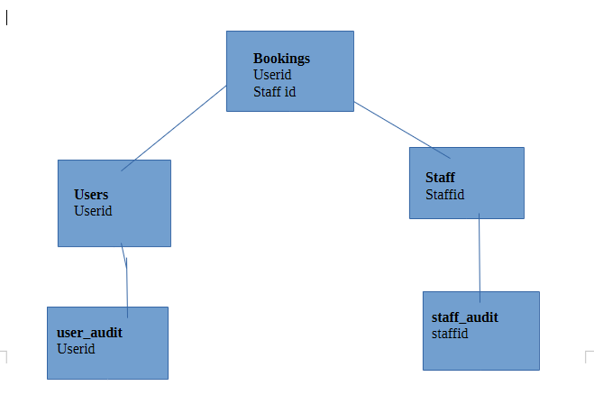

Table structures

Bookings
The bookings table is the link table between staff and users, its where user and staff id are stored as foreign keys to link the tables, it will have a booking id as well and store the data about each booking.
The fields will include:
- user id- foreign key e.g. 1
- staff id – foreign key e.g. 2
- booking id – primary key e.g. 3
- aptdate– the time and date of the appointment in epoch time to make it easier to calculate
- booked on – when the appointments was book
- type - what type of appointment they want is it a consultation or an installation

Users
The users table, this will store all the user details from when they register, and be able to have the users log in details. It has the main user ID primary key, and will hold sensitive information about each user.
The fields will be:
- first name – the user first name will be stored here e.g. James
- surname – the users surname will be stored here e.g. smith
- username – the users personal username, e.g. Jsmith
- passwords – users checked password that will be used to log in will be hashed and stored e.g. password123 (NF 1.2)
- user id – auto incremented user id e.g. 1
- date of birth
- address

Staff
The staff table, this table will store the details needed about each staff member, this is so staff are able to log in and they can be assigned to appointments showing there names so users know who is coming. It has the staff ID primary key.
The fields will be:
- staff ID – the primary key that allows tables to be linked e.g. 2
- first name – the first name of the staff to identify them e.g. lucy
- surname – the surname of the staff to identify them as well as show the customer who’s helping them- e.g. green
- username – the username is what the staff will be using the log in and will be different for each staff member e.g. Lgreen
- password – what the staff will be using to log in will be hashed and stored e.g. hello12345
- role – this is going to be a field to show what type of staff each person is it can show if they do consolations or installations, so you can book the correct person for your needs.

User audit and staff audit
(NF 1.1 and 2.1) there will be audit tables, one for staff auditing and one for user auditing, these tables will just log the activity of the users, so we if a user has suspicious activity we can be aware and take steps to prevent security breaches, or back track if an issue occurs.
The fields will be:
audit Id / staff audit id – this allows us to identify each audit it will be auto incremented
user ID / staff ID – shows the ID of the person who has taken the action so they can be identified
code – the code that was executed to complete the action
longdesc – this is going to be the long description of what the action was e.g. the user successfully logged in
date – the date the action was done on e.g. 1/12/2026

Variable list
Variable name | Type | Description
$conn | Local variable | This is the connection and allows a connection to the database so data can be put in and out
$_SESSION | Super global | This is a global variable that allows you to pass data safely around pages
$_message | Local variable | This stores any message that will be sent to show the user
$_POST | Local variable | Store the form data the user has entered in variable in this array
$result | Local variable | This stores the result of a given subroutine to be sent back elsewhere to allow checks
$stmt | Local variable | A statement for the database that will store the values and can insert into the data base
$sql | Local variable | Stores the sql statement to be run and be prepared to send to the data base with the correct information
$tmp | Local variable | This is a temporary variable that allows us to hold data for a short time in a subroutine to action with it

Test strategy
Date of test | Component to be tested | Type of test to be done and test data | Prerequisites and dependencies | Description
Written on 17/11/2025 | index | Normal  no test data | Website must load | This test needs to be run to make sure the index shows correctly without errors, showing all information and pictures in the correct format
Written on 17/11/2025 | Nav bar | Normal  no test data | Correct Pages exist for non logged in users | Nav bar displays correct pages (F-3.1)
Written on 17/11/2025 | Register | Normal  test data:  first name: john  surname : smith  username: Johnsmith  password: Green123?e  date of birth: 13/07/2007  address: AG6 WY7 | Should say account created successfully and add the users details to the data base | (F 1.1) should allow users to register securely and successfully
Written on 17/11/2025 | register | invalid  test data:  first name:  surname : sm!<th  username: Johnsmith(duplicate)  password: GREEN  date of birth: 2/30/199  address: Reallylongaddress | This should be rejected with message output | the system should be able to see that it dose not meet requirements after check and a message back to user to say invalid and nothing is added to database
Written on 17/11/2025 | register | erroneous  test data:  first name: 4  surname : 5  username: 23 <>  password:  date of birth: fourth  address: @@@ | This should be rejected and message outputted | the system should be able to see that it dose not meet requirements after check and a message back to user to say invalid and nothing is added to database
Written on 17/11/2025 | Log in page | Normal  test data:  username: Johnsmith  password: Green123?e | User must be able to log in with there correct details | (F1.2) users must be able to log in with there details must allow them into the other pages in the website
Written on 17/11/2025 | Log in page | invalid  test data:  username: persondosentexist  password: hi | These details must be rejected with a message to user | The details should get checked and no one in the database will have the username or password so a message should be given to user (NF1.2 and 1.3)
Written on 17/11/2025 | Log in page | Erroneous  test data:  username: @<l>  password: | These details should be rejected and error message should occur | These details should be checked and rejected immediately with an error message
Written on 17/11/2025 | Logged in nav bar | Normal  no test data | Correct pages for logged in users | Should show pages that only logged in users can see(NF 3.5)
Written on 17/11/2025 | Book page | Normal  pick details for an appointment | Details are entered and users appointment is booked successfully | This page should not have any boxes you can enter data in only boxes where you pick an item so items will be picked submitted and appointment should be made with a user message (F 1.3)
Written on 17/11/2025 | Book page | Invalid  no data picked | Should give an error message | Should give an error message and not allow the user to book an appointment
Written on 17/11/2025 | Bookings | Normal  no test data | Should show list of all bookings made for that user | See full list of booking for that user only (F 1.7)
Written on 17/11/2025 | Bookings | Normal  press cancel appointment | Should be able to cancel appointment and no longer see it | Press cancel button appointment and it cancel so you can no longer see it (F 1.4)
Written on 17/11/2025 | bookings | Normal  should be able to change and submit if there are any changes to original | Should be able to change appointment with new details shown | User should be able to just pick other details and it show there old details to be able to pick a new date and time shown in boxes (F 1.6)
Written on 17/11/2025 | Products | Normal no test data | Should be able to see list of products available | Any products that are available that can help with green energy will be listed with there details bellow (F 1.9)
Written on 17/11/2025 | Log out | Normal  press log out in top bar | Should be able to log out and be taken back to home and logged out pages | Log out button should take you back to home page and logged out menu(F 1.8)


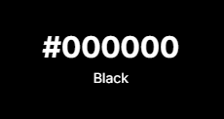
Colour scheme
For this website I’m going to be using simple bold colours, I have picked black to do the navigation bar and text as it provides the most contrast and make sit very readable. It means that people who are colour blind or have difficulty reading are able to clearly see the words and where the navigation bar is. You also don’t have any issue if you are colour blind as its just clear black so everyone can see. This means users don’t have to get frustrated because they cant read text, meaning customers are more happy and likely to stay on the website, as they can navigate and read text easy Its also a professional colour that draws attention, meaning users are likely to take it more serourly, and feel more directed to read and use the website as its clear and directs there attention It will be suited to the age group as well as they are professional working people.
Green is a very natral colour, its really fits the senrio of what we are building which is about green energy. Ive picked this dark green because if someone if colour blind they will still be able to have a darker gray contrast so they can still see the logo and any wording, this colour will likely only be used near the top bar, as its a great colour to signify the compney and what its about. It makes people feel more aware of its pupouse, and theymay see the coour and think of nature, making them more likely to feel towards using green engry products because they feel resposible and conncted to nature. It also give a pop of colour, its makes people feel more happy and calm meaning they are more likely to continue to use the website and think about what it offers.

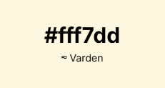

This is simply going to be a background colour to my website, I have chosen to use a subtle tinted background because it calms from the bold white that can be bright and in your face, it means people with visual problems and learning problems like dyslexia are more able to read it as the words will not be moving around as much because its harsh on the eyes, it makes it more accessible and calmimg, so users using the website feel calmed making them feel better about what there doing and slowing them down to be able to read and use the website without it overswelling them especially if they have busy working days. This means they will spend longer on the website and are more likely to come back.

Interface design

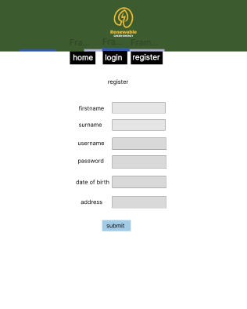
Here is my home page, this page is where people will start when they enter the website and has all the information about green energy and how people can reduce there carbon footprint. Ive done a clear heading so people know the company name and a short bit of clear text, the text says how green technology will help and some short bullet pointes on how to help, Ive only include a small amount of text because users can get overwhelm and a big chunk of text will not be read and will be skipped over, so Ive kept it short informative and simple. There is also an image at the bottom of the page to draw attention and to make users feel calmer and less overwhelmed with the text. The top bar is green with a logo I have found online if I was really doing this I should find a logo that royalty free or make one so there is no copy write but for now this simple logo is a good example of what the company may have and is relevant.
This is the register page its simple with clear text boxes, it has labled beside each box clearly lablying what to enter into each box, its clear at the top what the page is and why they are entering details there is also a submit button which I will change to black to make sure colour blind people can see it more clearly.
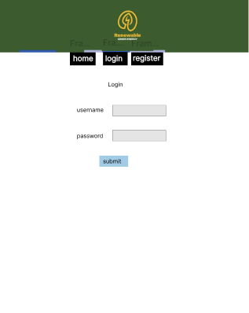
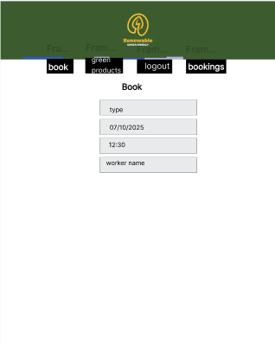
This is the log in page, its got a title of log in so you know what page your on, ive then got 2 clear and laybled boxes easy to click on and accessible for anyone to enter there details, ive then got a laybed submit button and any messages from errors can be despayed bellow, its clean and simple and no overwleming information.
This is the book page where users can make bookings, onced logged in a new nav bar will come up with the different options, when booking there is some information needed like the type of appointment they want which they will be able to chose as well as chosing the date on little drop down menus, time and the worker they want to do the job, this is clear and secure as no typed inputs are done, and its got clear boxes so people know exatly what they are booking and what day.
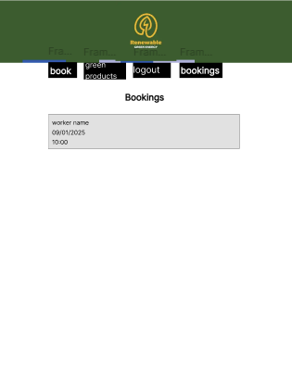
In this bookings page we will be able to see all appointments that user has booked in a list like this, with the details shown for each, there will also be buttons at the side that will say change or cancle appointment so users are able to ajust appointment to there needs, its clear simple and easy to understand without any colour so colour blind users are able to use and its quick and easy to check for busy people

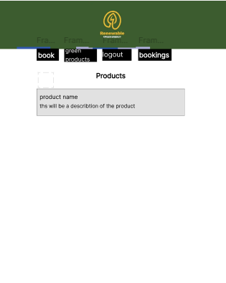
The poducst page will be simmilar to the bookings page it will have products that are avalible named as well as a descrption of what the product dose and how it helps, this allows users to see what they can purches and consult about having, its also a clear easy format for any users making it accessible.

Algorithm design

Registering a user
FUNCTION new_user(database_connection, form_input)
// Function to create a new user record in the database

// Prepare an SQL INSERT statement with placeholders
DEFINE sql_query =
"INSERT INTO users (first_name, surname, username, password, d_o_b, address)
VALUES (?, ?, ?, ?, ?, ?)"

// Prepare the SQL statement to protect against SQL injection
PREPARE statement FROM sql_query USING database_connection

// Hash the user's password for secure storage
hashed_password = HASH(form_input.password)

// Bind user input values to SQL parameters
BIND parameter 1 TO form_input.first_name // first name
BIND parameter 2 TO form_input.surname // surname
BIND parameter 3 TO form_input.username // username
BIND parameter 4 TO hashed_password // encrypted password
BIND parameter 5 TO form_input.d_o_b // date of birth
BIND parameter 6 TO form_input.address // address

// Execute the prepared SQL statement
EXECUTE statement

// Close the database connection for security
CLOSE database_connection

// Return success
RETURN true
END FUNCTION

In this function we are prepossessing the form and the values to add the user to the database, to register the user, so we start with an SQL query just saying what we are adding too, then we bind the values to securely put them in the database, before getting rid of the connection to stop anyone from getting in and stop any access points.

formatting messages for user
FUNCTION user_message()
// Function to display a stored user message and then clear it

IF session variable "usermessage" exists THEN
// Wrap the stored message in paragraph tags
message = "<p>" + session.usermessage + "</p>"

// Remove the message from the session so it doesn't repeat
UNSET session.usermessage

// Return the formatted message
RETURN message
ELSE
// No message stored, return an empty string
message = ""
RETURN message
END IF

END FUNCTION

It checks that a value is passed in usermessage, before formatting the message as paragraph text and removing any session before returning the message to be echoed out to the user, if this doesn’t work or there is an issue it will just print an empty string.

Checking the username is available

FUNCTION username_check(database_connection, username)
// Function to check if a username already exists in the database

// SQL statement to select a username that matches the input
DEFINE sql_query =
"SELECT username FROM users WHERE username = ?"

// Prepare the SQL statement to prevent SQL injection
PREPARE statement FROM sql_query USING database_connection

// Bind the username parameter securely
BIND parameter 1 TO username

// Execute the prepared statement
EXECUTE statement

// Fetch one matching record (if any)
result = FETCH_ONE_RECORD_AS_ASSOC_ARRAY(statement)

// Close the database connection for security
CLOSE database_connection

// If a record was found, the username exists
IF result EXISTS THEN
RETURN true
ELSE
RETURN false
END IF

END FUNCTION

This function checks the username entered in available so we don’t have repeats of data and issues with data redundancy, we do this by selecting the database and the going into users table then prepare the sql and bind the username entered to a value, to compare against the usernames in the database, if it find any that are the same it will return that the username isn’t allowed, if its not already used it will allow the username to be used and just return it.

User log in

FUNCTION login(database_connection, form_input)
// Function to check login details and return user data if found

// Connect to database (using a helper function)
database_connection = dbconnect_insert()

// SQL query to find a user with the given username
DEFINE sql_query =
"SELECT * FROM users WHERE username = ?"

// Prepare the query to avoid SQL injection
PREPARE statement FROM sql_query USING database_connection

// Bind the username provided in the login form
BIND parameter 1 TO form_input.username

// Execute the query
EXECUTE statement

// Fetch a single user record (if any exists)
result = FETCH_ONE_RECORD_AS_ASSOC_ARRAY(statement)

// Close database connection for security
CLOSE database_connection

// If a matching user was found
IF result EXISTS THEN
RETURN result // Return user data for further checks (e.g., password)
ELSE
// Set an error message to show on the login page
session.usermessage = "User not found"

// Redirect the user back to the login page
REDIRECT TO "login.php"

EXIT PROGRAM

This function allows a user to log in by checking to see if the username matches the username that is entered, we do this by getting the users table and preparing the SQL we then bind the entered username to then go execute and check if it matches any of the usernames in the database, if it dose it will return back that the user is verified, if not it will give an error message.

Audits user activity to database
FUNCTION auditor(database_connection, user_id, code, long_description)
// Function to log an action into the audit table

// SQL query to insert data into the audit table
DEFINE sql_query =
"INSERT INTO audit (date, user_id, code, longdesc) VALUES (?, ?, ?, ?)"

// Prepare the SQL statement to prevent SQL injection
PREPARE statement FROM sql_query USING database_connection

// Get the current date in YYYY-MM-DD format
date = CURRENT_DATE()

// Bind the parameters to the SQL statement securely
BIND parameter 1 TO date
BIND parameter 2 TO user_id
BIND parameter 3 TO code
BIND parameter 4 TO long_description

// Execute the statement to insert the audit record
EXECUTE statement

// Close the database connection for security
CLOSE database_connection

// Return success
RETURN true

END FUNCTION

This allows data about what a user has done to be put into audit in the database, it first uses SQL to prepare the table, then we format the date and bind all the values so they can be entered in the database, we then execute this to add all the details about the user activity into the database close the connection and return this has been done.

Gets user ID

FUNCTION getnewuserid(database_connection, username)
// Function to retrieve the user ID for a given username

// SQL query to get the user ID from the users table
DEFINE sql_query =
"SELECT user_id FROM users WHERE username = ?"

// Prepare the SQL statement to avoid SQL injection
PREPARE statement FROM sql_query USING database_connection

// Bind the username parameter securely
BIND parameter 1 TO username

// Execute the query
EXECUTE statement

// Fetch the result as an associative array
result = FETCH_ONE_RECORD_AS_ASSOC_ARRAY(statement)

// Close the database connection for security
CLOSE database_connection

// Return the user ID from the result
RETURN result["user_id"]

END FUNCTION

When putting data into the audit table we need to know which user by saying there user id, this function looks in the user table send the users username and brings back that users ID to put in audit so we know what user is doing, it will return this to be used

Committing a booking to database

