Proposal document

Ava sheriff

Rolsa Technologies
Table of Contents
Organisation overview 3
Problem overview 3
Understanding of the project 3
Impact of problem and current system potential issues 3
User groups 4
Admin 4
Staff 4
Customers/users 4
Scope 5
Empathy maps 5
Admin 5
Staff 6
Users 6
User stories 6
Admin 6
Staff 7
User 7
Laws, guidance and legislation 7
Computer misuse act 7
General Data Protection Regulation 7
Web Content Accessibility Guide 8
User acceptance criteria 8
1- admin 8
2-staff 8
3- Users 8
Alternative system 9
Risks 10
External risks and delays 10
resources and skill risks 11
other risks 11
Decomposition 11
Functional Requirements (F): 12
1 - Users (Customers): 12
2 - Staff: 13
3 - General: 13
Non-Functional Requirements (NF): 13
1 – Users: 13
2 – Staff: 13
3 – General System: 13
Key performance indicators 14
Description of proposal 14

Organisation overview

This organisation is called Rolsa Technology they are a local green technology company that specialise in solar Pannal installation and maintenance, electric vehicle charging stations and smart home energy management systems. They want to crate this digital solution to show people how to reduce there carbon footprint and provide the technology and information to do so. Making the system easy and give users what they want and need. At the moment they may not have a well made, accessible and system that dose what they need, they will be storing some sensitive information, such as address of the users to be able to do the installations, this needs to be kept private and securely.
They want to be able to allow users to see information about green energy products on the market and how they can reduce there carbon footprint, I think this should be available to all to make use of. They want customers to be able to book consultations and installations to make there home have less of a carbon footprint in the area, and for customers to calculate there carbon footprint, this can allow them to see how Rolsa technologies has helped.

Problem overview

Understanding of the project
My understanding of this project is that this local company wants to help there area reduce there carbon footprint, they want to provide the information about how to do this as well as showing there green energy products on the market available to help the users reduce it. This can be a detailed page on some ways people can reduce there footprint saying what a footprint is and why it needs reducing as well as some simple ways to do this anyone could do. This may be available for only users logged in but we could show the green products available. This can just be a list saying the product and a description of how it works and helps for users to look at. They will need to be able to register and log into the system to be able to make and adjust booking for consultations and installations. There should be a calculator to allow users to calculate there carbon footprint in some way, this can mean they can see how much there carbon footprint has been reduced by using the solutions and make users want to reduce it more. The information about users in the system must remain secure as some information may include address and when logging in there passwords. This information can be stored in a secure database that can be access to see, change and delete appointments, for users and staff to see there appointments and get user information.

Impact of problem and current system potential issues
There issue seems to be they currently don’t have a good or even just a booking system, this would limit them to who in the area sees and is able to view what they offer and who they are, especially people who have jobs and travel or are busy, because they wont see or have the time to try and navigate a bad website or look at a shop or poster to see about the company. This could limit the amount of customers they could have or reach. The bookings if not done via a booking system website may have to hold information about customers on paper, this is much harder to keep track of and can lead to problems like data redundancy, keeping data longer then they should or incorrect data, meaning they could face legal issues and security issues so people will not want to sign up or use there service in case there data is lost or stolen. It could bring the problem of not being able to see or be able to keep track of appointments, so bad service and reviews may come from this. We also don’t know if they do have a website how secure it is. If the website is not currently secure, like not encrypting passwords, not having a secure database, user and staff information and log ins can be easily found and hacked, causing data loss, loss of reputation and this would mean legal issues like fines and could be dangerous for users.

User groups

Admin
Admin people will be the receptionists or people that can manage the system, they will want to be able see data about people, see available appointments, and they will have to mange a lot of sensitive data. This means they will have to very trusted and have experience working in this area, this allows us to know they know how to work systems and handle working with users data. Data such as the users address and audit logs of users actions So likely they will be between 30 and 50 as they will have lots experience, know how to handle people, can use these systems, and can be trusted.

Staff
The main staff could includes the consultants, people who can install the technology, and any other reception staff, they will want to see appointments in there diary and maybe some information about it like where to go. They should be able to cancel the appointment if needed and be able to log in and register for there staff account, they could be in the range of 20-60, as you may have younger people who have done apprenticeships in areas so they know to install specific technology and older more experienced workers who can do a winder range and more fiddly or harder installation, as well as the consultants because they will be needing experience to be able to do the consulting for the customer. All of these people will have some form of knowledge with computer systems and will have a better idea of how to use them but will not be experts so it still needs to be easy to navigate.

Customers/users
Customers using the system will likely need a house or flat, car or business to be able to buy and install the technology it would be more aimed at people who owned the buildings a they will have the permission to build on the property and install the systems. So there likely age will be at least 30 – 60, they need a stable job and that would come after education and some experience before they can own a car or house. People over 60 will likely not be as aware about the issues or be able to navigate the internet as well as others, and older people may be in a retirement home. So the website can be made for more mature people so professorial and have an idea about how to navigate system. But since they need to be earning money they will likely have busy jobs and will want a system that is quick and easy to use because they don’t have much time.

Scope
The scope for this project is going to be quite small, I will just be creating the main pages logins registration and booking systems for this local company. We have limited time and one person, without much time to build skill. working on this meaning it will not be able to go beyond what has been asked so it could link to be able to allow more of a senior admin for the system, or a system that allows staff to navigate to bookings but in this scope I will just being doing the booking system with the information and products. This could be a lot larger or add other sections too it but this is out of scope for many reasons so I am keeping it small and realistic for what I have to work with.

Empathy maps

As I cant fully empathise with these users I will be using ChatGPT to help me make these maps. Here is the prompt I used:
for this scenario i want some empathy maps but i cant fully empathise with these users can you give me one empathy map for each user and i can make more from there: (here I put the overview and user groups text I have written above)
I have then used one edited ChatGPT example and then done one of my own :

Admin
says | Thinks | Dose | feels
“I need to see all customer appointments in one place.” | “If the system is slow or unclear, it’ll make my job harder.” | Updates bookings, cancellations, or staff assignments.  Communicates with customers and staff about upcoming appointments. | Responsible and cautious — doesn’t want to risk a data breach. Wants clarity, control, and confidence in the system.
“We must keep users’ data private and secure.” | “I cant afford to make mistake with user data, I am responsible for company reputation and customer safety” | Checks user profiles and appointment logs daily. | Responsible and cautious, doesn’t want to risk a data breach. So feels in control that they can check audit logs and data.

Staff
says | thinks | Dose | feels
“I just need to see where I’m going and what to bring.” | “I need clear information — address, contact details, and what’s being installed.” | Checks schedules and travel routes. | Gets frustrated by confusing navigation or missing info. So is happy to have clear ordered information about each customer.
“I need to cancel one of my jobs quickly” | “I need a system I can navigate and tells me the appointment has been cancelled So the customer is not mad.” | Cancels and checks that appointment has been cancelled | Sure that the system has actually cancelled his appointment, and the customer will be able to see.

Users
says | thinks | dose | feels
“I want to make my home greener, but I don’t know where to start.” | “Will this actually save me money and help the planet?” | Uses the carbon footprint calculator.  Browses green technology products and reads descriptions. | Curious and motivated to be eco-friendly.
“I want to use green technology but Im too busy to have to look though the internet to make bookings and find products.” | “is this quick, clear and easy? I don’t have much time” | Browses green technology products and reads descriptions on the website.  Books consultations and tracks installation progress. | Want simplicity and is feeling pleased that all the information is in one place and is easy to navigate.

User stories

Admin
As a.. | I want.. | So that...
Responsible admin | To know who has been doing what on the website | I can make sure there are no unauthorised or suspicious activity
Given | when | then
The admin checks the audit accounts | There is a user with suspicious activity | They can remove the user to stop any harm to the system

Staff
As a.. | I want... | So that...
Busy member of staff | A system that makes it easy to see the information about my bookings | I can turn up in the right place on time
Given | When | Then
The staff can see the bookings | The staff member has an issue and needs to cancel | They can cancel quick and easily

User
As a.. | I want.. | So that...
Working customer | A system that is easy to navigate | I don’t need to spend time searching or trying to work a website
Given | When | Then
The customer is trying to quickly book a consultation | They are travelling to work | It should be quick and easy to book

Laws, guidance and legislation

As I am not fully aware of all the legislation that may apply to this scenario so I will be using ChatGPT and I will just tell it the scenario I have written above and then ask it to give me some laws that may apply I will then write and expand on this on how it can affect.

Computer misuse act
The computer misuse act will have to be thought about, this prevents unauthorised access to computer systems, we need to consider this as someone could gain usernames and passwords to get unauthorised access to the system or get access to privileges they should not have, this can mean they can get access and take data and cause security issues to the system. So making it illegal will mean people are less likely to do so and can give then fines and jail time depending on what they do, it also mean the admins will make sure there details are kept safe and they r aware

General Data Protection Regulation
This governs how a business collects, used, and stores personal data in the UK. This can include details like passwords and addresses. It means this data needs to be secure and confidential so its only used where needed and only to the user. It also states that we may have to tell the users how there data is being used which we could do in the registration section to make sure we are compliant to there rules, they also have a right to there data so they need to be able to at least contact to remove

Web Content Accessibility Guide
This act means the content of a website need to be accessible for everyone, this is very important so people can access and navigate the website and access all services and information otherwise its not fair access. If its not accessible it could mean less customers and more complaints which leads to having a bad reputation. So making this website accessible is important

User acceptance criteria

1- admin
1.1. set secure login page
1.2. able to view all appointments and bookings
1.3. able to change any bookings
1.4. able to view user details in a secure readable format
1.5. able to view staff details
1.6. able to view audit logs
1.7. clear navigation bar
1.8. admin should be able to log out
1.9. If incorrect credentials are entered, an error message must appear without revealing which part was wrong.

2-staff
2.1. a clear login page secure
2.2. a clear register page
2.3. a clear navigation bar with what they need
2.4. a bookings pages with a list of there bookings
2.5. a button to cancel the bookings
2.6. a clear massage when actions are done
2.7. Staff should only be able to view their own bookings, not other staff’s appointments.

3- Users

3.1 users can register
3.2. users can log in securely with details
3.3. Users can view information about carbon footprints and green products without logging in.
3.4. Users can make a booking for a consultation or installation and can select date and time
3.5. can view carbon footprint calculator
3.6. Users can view, edit, or cancel their own bookings from their account page.
3.7. must clearly show messages to users based on actions
3.8. The interface must be simple and quick to use on desktop and mobile, with clear navigation.

Alternative system
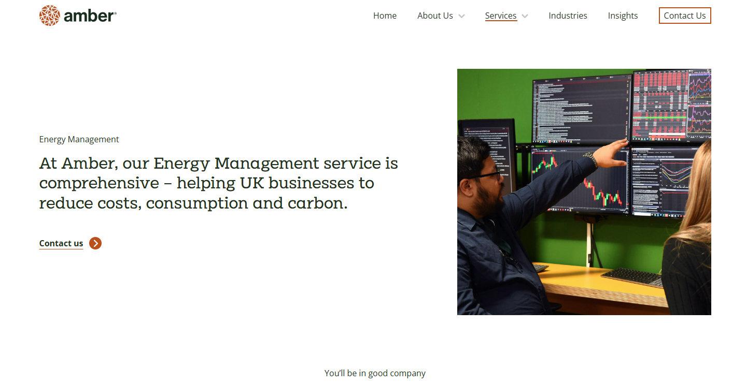

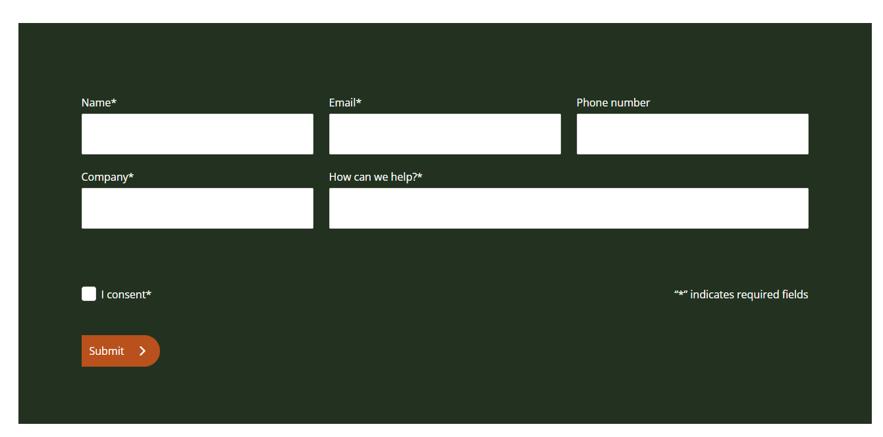
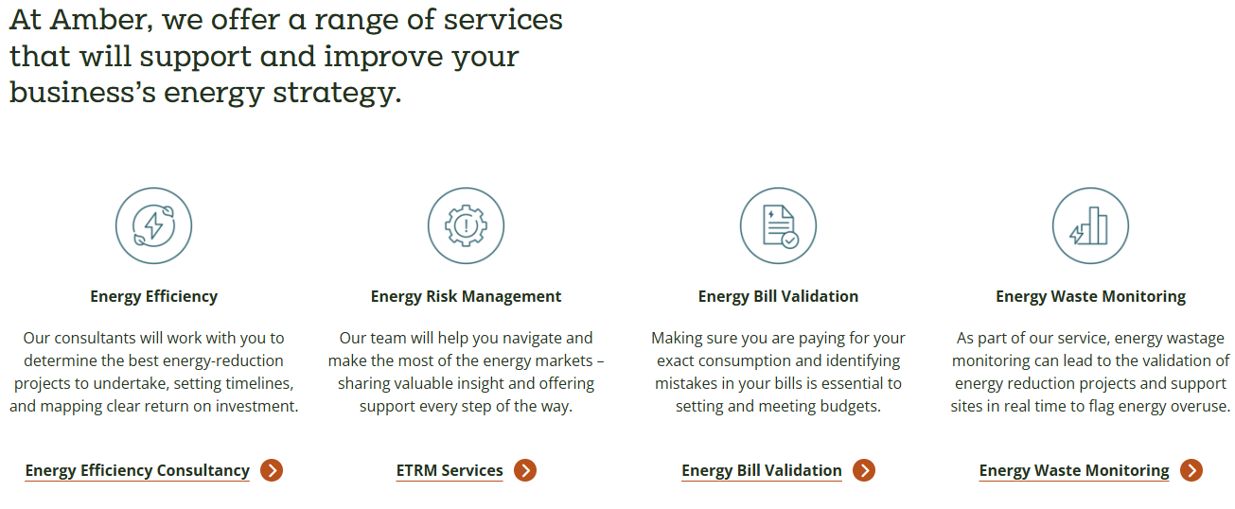
This is one alternative system I have found, its got all of this on its main page as well as a top logo and navigation bar at the top, at the top it shows what the business are and do with a nice visual not too much text as its broken up and has got the right info about the business, next it has a registration box where you can register to get in contact with the company and how they can help you, then further down they have information about what they offer and even form insights into products and research which we may use something like this in our system. Its got the correct colours and layout as well as being simple and easy to use and read and navigate. This is a great look and how I would like the system to feel on the different pages.

Risks

Here will be some of the main risks to getting this system completed and made.

External risks and delays
this risk could include the client delaying the project being made or launched from any issues on there side, they may not be clear or approve which will stop the project from moving forwards. They may even require redesigns because of law changes or changes within the business. All slowing down development

resources and skill risks
one issue we may have might be the lack of skill to complete certain parts of the project, it could lead to mistakes or unsecure practices, it may mean we fail to meet all user requirements for the system. There could even be staff turnover that changes on how its developed and take time to catch up to where they where.

other risks
• Data Accuracy and Integrity Risks: Mistakes in appointments or patient data can harm care quality.
• User Role Mismanagement: Incorrect privileges could allow unauthorised access or restrict needed access.
• System Downtime: If the system is unavailable, appointments can’t be booked or changed, disrupting service.

Decomposition
In my decomposition diagram the database is at the top which everything connects to as most pages will be using the database from what they are doing, the pages you can access before you log in are the login page, the register page and the index. These are all shown and linked bellow as you can navigate between them. Once a user is logged in they can access the other pages shown underneath, so booking appointments and being able to see the appointments you have booked, as well as the calculator and viewing products they offer. You can also change you appointment which would take you to a different page to see and change details of an already made appointment. You could also delete an appointment in the booking page. Lastly you can log out taking you back to the login page.

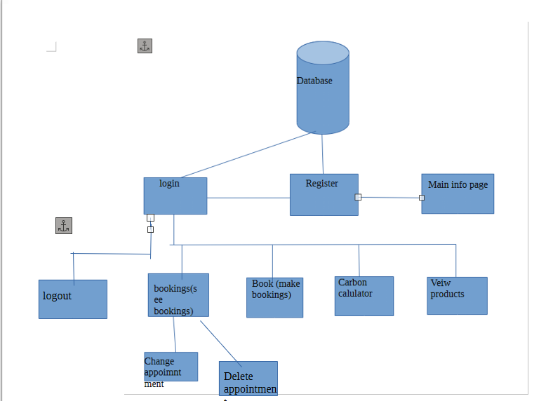

Functional Requirements (F):
(Written out by me and put through ChatGPT to spell check and just make it clear and specific to scenario on wording on my requirements, has been checked by me to make sure it sounds the same)

1 - Users (Customers):
1.1: Users should be able to register for an account securely
1.2: Users should be able to log in securely using their registered details
1.3: Users must be able to book a consultation or installation appointment
1.4: Users must be able to cancel a booking they have made.
1.5: Users must have access to information about how to reduce their carbon footprint and the company’s green products.
1.6: Users must be able to edit or reschedule a booking they have made.
1.7: Users must be able to view a list of their bookings
1.8: Users must be able to log out of their account securely.
1.9: Users should be able to see green products

2 - Staff:
2.1: Staff must be able to log in to the system securely.
2.2: Staff must be able to register new staff accounts
2.3: Staff must be able to view their assigned appointments and see booking details
2.4: Staff must be able to update or edit appointment information if necessary.
2.5: Staff must be able to cancel appointments if required
2.6: Staff must be able to log out securely after use.

3 - General:
3.1: The website should have clear navigation for easy access to main pages
3.3: The homepage must display general information about the company and its environmental mission.

Non-Functional Requirements (NF):

1 – Users:
1.1: There must be a users table and user audit table in the database to store account and activity data.
1.2: The system must connect to the database to retrieve and verify usernames and passwords securely.
1.3: Passwords must meet strength requirements to make sure account is secure
1.4: Error handling must be implemented when a user registers or logs in
1.5: The login system must prevent malicious input with sanitisation

2 – Staff:
2.1: There must be a staff table and staff audit table in the database.
2.2: The system must connect to the database to verify staff credentials securely.
2.3: Error handling must be implemented when registering or logging in staff members.
2.4: The login and registration pages must validate input and prevent misuse or hacking attempts.

3 – General System:
3.1: The system must use an efficient relational database to store all data (users, staff, bookings, products, logs).
3.2: Sensitive information must be encrypted or hashed to ensure data security.
3.3: The system must be able to connect to and retrieve information from the database quickly and reliably.
3.4: Users should not be able to access booking or account pages without logging in.
3.5: Logged in users should not be able to access login or register pages again unless logged out.
3.6: The system must prevent duplicate accounts using the same email or username.
3.7: All error handling must be implemented correctly to make the code stable and robust.
3.8: The colour scheme and layout should be accessible, with clear contrast for navigation buttons and text.
3.9: information and text should be clear, simple, and easy to understand for users aged 30–60.

Key performance indicators
1. The website should be available and operational at least 98% of the time over a one-month period.
2. trust pilot rating should go up
3. number of people registering should increase
4. the number of people referring a friend should improve
5. limited number of errors of issues with bookings for both staff and users
6. successful bookings rate
7. number of bookings should increase
8. number of people who book again with the company
9. page loading time should improve
10. less security issues or breaches
11. increase in staff happiness
12. increase in staff productivity

Description of proposal
The proposed solution building a website that will have user login and register mentioned in F-1.1 and 1.2 it should be secure and easy to use, this should also have a page with information about how to reduce your carbon footprint and on the company (F-1.5). Once logged in users should not be able to access these other pages and should be able to access bookings, book appointments, calculate carbon footprint, and be able to log out all in requirements F 1.3, 1.7, 1.8, 1.9. in the bookings you should be able to see and mange your appointment, so delete and change the appointments (F, 1.4 and 1.6). the same is needed for staff to be able to log in and register, as well as being able to view there appointments and cancel if needed all mention in my functional requirements section 2, its should be accessible and easy to navigate so everyone can use(F-3)
this should all be done securely and have a database in the back storing the information and have audit logs to track user activity (NF- 1.1, 1.2, 2.1 and 2.2). all inputs should be verified and checked before any action is taken with them, and any information entered must be hashed.
This should lead to the company having much better review and an increase in business and help staff and the company have less fuss and more room to grow.

