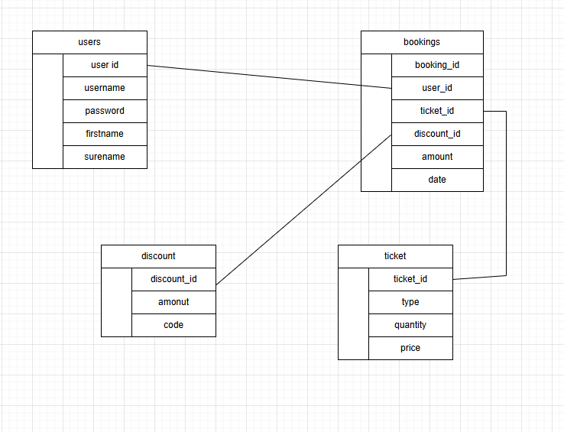

data dictionary
list all the things in each table then list the
users table
Field name | Data type | Validation rules | Example data | Justification
discount_id | intger | Validate its an integer or a hole number with no letters or speical charters | 1 | This is assinged to each discount to have a unquiqe idetifyer that allows us to pull the info from the database
amount | decimal/float | Validate that the numbers are just a number with no letters or speical charters | 0.20 | This is the amount that I will times the input by to get the correct discount.
code | Text/ string | Make sure there are no sql inputs I and filter it | discount23 | This is the code the suer will enter to get that discount

Field name | Data type | Validation rules | Example data | Justification
ticket_id | intger | Validate its an integer or a hole number with no letters or speical charters | 1 | This is assinged to each ticket to have a unquiqe idetifyer that allows us to pull details from the database
price | intger | Validate that the numbers are just a number with no letters or speical charters | 0.20 | This is the amount that a customer will have to pay per a certen ticket
quantity | interger | Filter to make sure there are no latters or speical charters | 4 | This is how meny tickets can be sold of that type per day
Type | Text/ string | Make sure there are no sql inputs I and filter it | family | The type of ticket they are paying for

(pre make)

Veriable list

Variable name | scope | Data type | Where used | Example data | Description
$conn | Local variable | database connection object | Everywhere exept index | n/a | This is the connection and allows a connection to the database so data can be put in and out
$_SESSION | Super global | array | On all pages | user_id = 1, | This is a global variable that allows you to pass data safely around pages
$_message | Local variable | string | All pages | “user has been logged out” | This stores any message that will be sent to show the user
$_POST | Local variable | Associative array | All pages except post | Any form data, date : 01/02/2026 | Store the form data the user has entered in variable in this array
$result | Local variable | Associative array | In common, and returned to main pages to be used where there is a form | user_id= 1,  firstname= john  surname= smith | This stores the result of a given subroutine to be sent back elsewhere to allow checks
$stmt | Local variable | database connection object | In all functions in common | Any bound pramiters | A statement for the database that will store the values and can insert into the data base
$sql | Local variable | string | All functions in common | “john” | Stores the sql statement to be run and be prepared to send to the data base with the correct information
$tmp | Local variable | string | In pages requirening dates or changes in variables. | Epoch time= “01,02,2026” | This is a temporary variable that allows us to hold data for a short time in a subroutine to action with it

