Handwritten Digit Classifier

* Project Details :

The goal of this project is to develop a machine learning model that can accurately classify handwritten digits (0-9) using the MNIST dataset. The MNIST dataset is a well-known benchmark in the field of machine learning, consisting of 70,000 grayscale images of handwritten digits, each 28x28 pixels.

* Challenges & Solutions :
* Data Preprocessing

Challenge: Ensuring that the data is in the correct format and normalized.

Solution: Preprocess the images by normalizing the pixel values to a range of 0 to 1. This helps in faster convergence during training.

* Team :
* Karthik R S
* Y Madhav
* Visuals :
* Display Custom Input Image with Predicted Label

Input image:



Prediction :

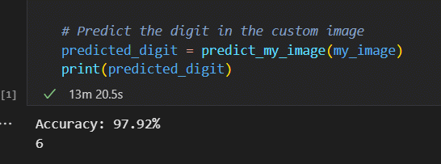

* References :
* The MNIST Database
* Online courses on machine learning