prac 

ACM,VISAKHAPATNAM

Nexus – Group Discussion

EVENTREPORT

# Summary

ACM, GITAM in collaboration with the Toastmaster’s Club, has conducted the event "Nexus – The Group Discussion".The event started with the introduction of ACM and the Toastmaster’s Club and then the participants were made aware of the rules of the group discussion. The participants were then divided into breakout rooms where the first round of GD took place; the top two performers from each breakout room were shortlisted for the final round.In the final round, the participants were judged on various aspects and the top three performers were announced.

The publicity and registrations for the event started two days before the event, and students weresent the event's details through the club's official mail id. A WhatsApp message was also circulatedbriefing about the event, and all the details of the event were mentioned there. The posters andvideos regarding the event were shared on various social media handles such as Instagram andLinkedIn.44participantsattendedtheevent.

By the end of the event, the attendees enhanced their communication skills and critical thinking through and this helped the participants to express their views and prepare themselves for various recruitment processes. It promoted outgoing discussions. Attendees appreciated the event, and the event was a great success. The top performers are given t-shirts by DOSL, Gitam.

 

# Photographs

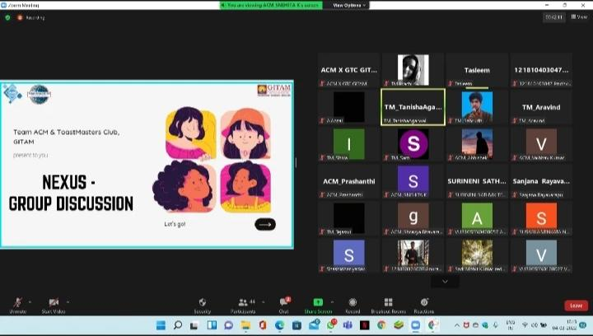

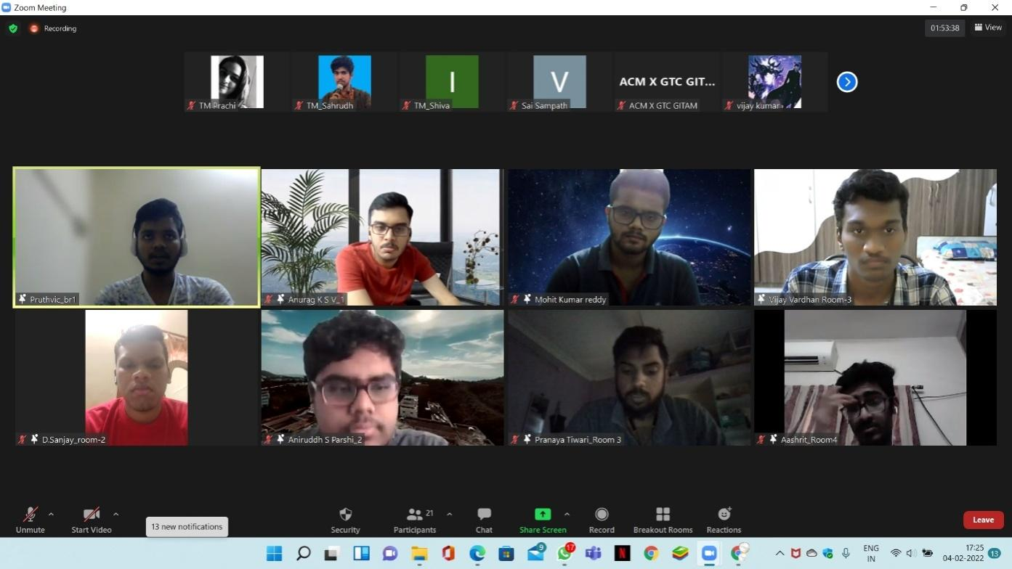

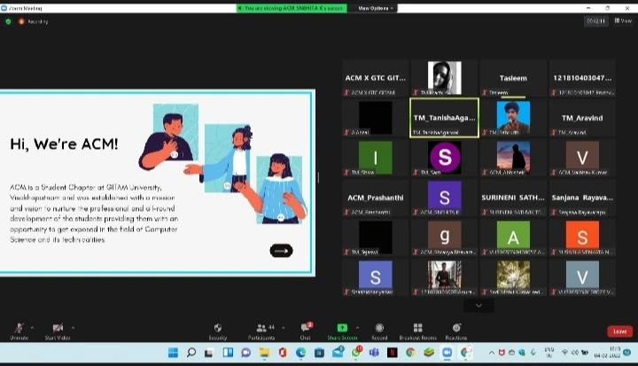

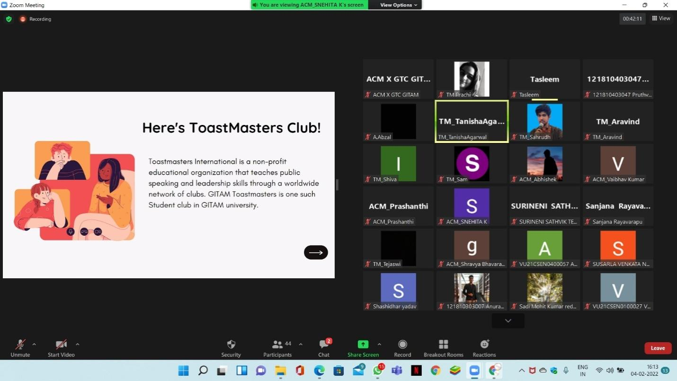

 

 

ACM,VISAKHAPATNAM

Nexus – Group Discussion

# EventSnapshot

| **EVENTSNAPSHOT** | |
| --- | --- |
| EventName: | Nexus – Group Discussion |
| OrganizingClub: | ACM |
| EventDate: | 04-02-2022 |
| EventTime: | 04:00 PM – 05:00 PM |
| EventMode/Venue: | Online/Zoom |
| Socialmediareach: | Instagram:@gitam_acm  LinkedIn:https://[www.linkedin.com/company/acm](http://www.linkedin.com/company/acm)  -gitam-association-for-computing-machinery/mycompany/ |
| Registrations: | 100 |
| NumberofParticipants/Attendees: | 50 |
| Winners(ifany):Name-RegdID-EmailID | Sadi mohit kumar  Anurag ksv  Anirudh |
| Faculty-Judge-GuestSpeaker: | NA |
| EventReportAuthor-Designation: | Sejal Reddy–EventManager  Sravya Bhavaraju –EventManager |