ACM, VISAKHAPATNAM

TECHPEN – EVENT REPORT

Summary

The event “Tech Pen” was conducted by ACM, GITAM in collaboration with the Creative Arts Club. It was held from 2nd February, 2022 to 6th February, 2022. During this period, the participants were required to write an article or a blog on a topic of their choice, given that the topic is tech-oriented. They were provided with a link to submit their write-ups upon completion. A panel of two judges, marked the submissions on various criteria and came out with the top 3 articles. The event was conducted in online mode and 15 students participated in the event.

The publicity for the event started two days before the event, and the students were sent event details through the club’s official mail id. A WhatsApp message was circulated briefing about the event, and all the required details of the event were mentioned there. The posters and videos regarding the event were shared on various social media handles such as Instagram and LinkedIn. WhatsApp groups were also created to engage with the participants.

By the end of the event, participants were able to showcase and improve their content writing skills. This event also helped them in enhancing their technical knowledge as writing a tech article or blog requires clear understanding and research of the topic. The top three articles were presented with the opportunity to be featured in the ACM’s Annual Magazine. The participants appreciated the event and the event was a great success.

Photographs

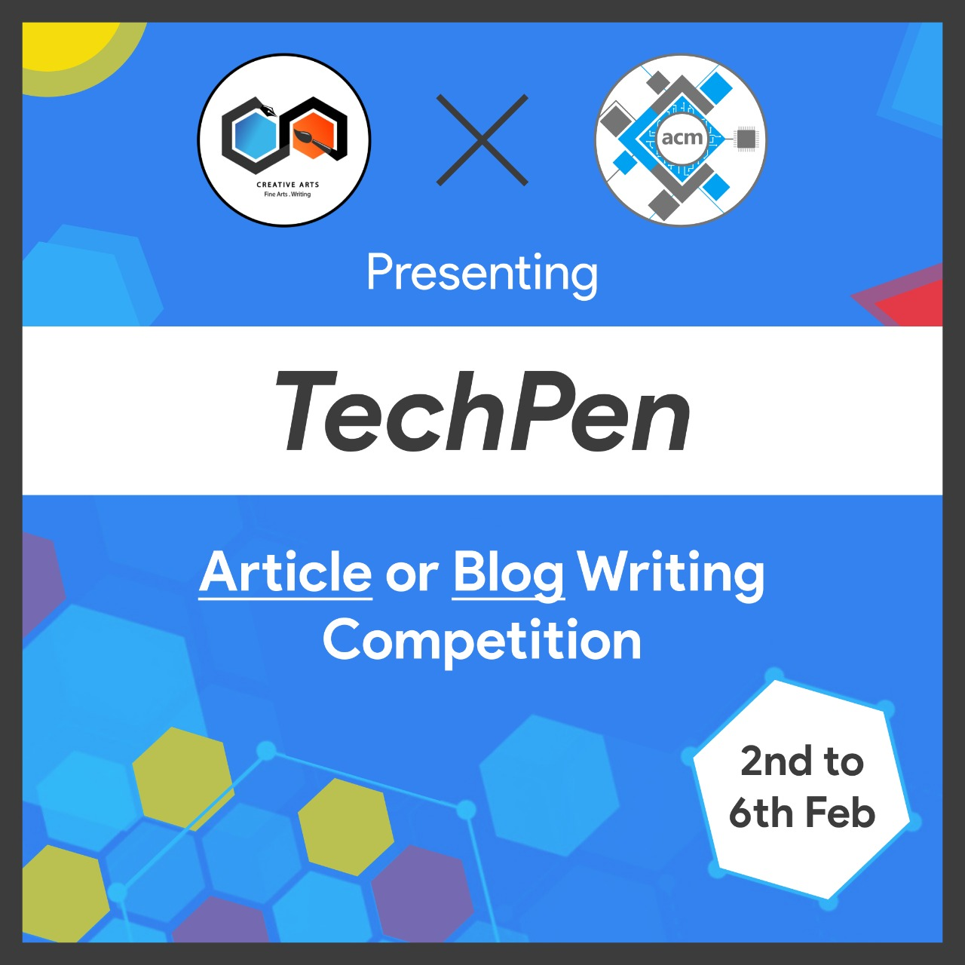

Event Snapshot

|  |  |
| --- | --- |
| Event Name: | TechPen |
| Organizing Club: | Creative Arts x ACM |
| Event Date: | 02/02/2022 – 06/02/2022 |
| Event Mode/ Venue: | Online |
| Social Media Reach: | Instagram: @gitam_acm  LinkedIn: https://www.linkedin.com/company/acm  -gitam-association-for-computing- machinery/mycompany/ |
| Number of Participants/Attendees: | 15 |
| Winners (if any): Name - Regd ID - Email ID | 1.Bolleddu Joethsah & Madipally Sai Krishna Sashank  2.Divyasree Attaluri  3.Peddinti Sriram Bharadwaj. |
| Faculty - Judge - Guest Speaker: | Shaun Chapala and Sneha Dange |
| Event Report Author - Designation: | Shreesh Verma |