Crit-bit Tree概述和实现 2013-06-10 19:01:34
分类： C/C++

Crit-bit tree是一种特别的树结构，一般用于存放字符串。Critbit tree是一种BitWise tries，其树的深度为O(longest-length)，有点像二叉树，不过对于字符串做分支检测的时候代价很小。
Crit-bit快速高效的支持下面的一些操作：
- 插入一个字符串
- 测试一个字符串是否在树里
- 删除一个字符串
- 查找出树中所有以某个字符串开始的所有字符串
在插入过程
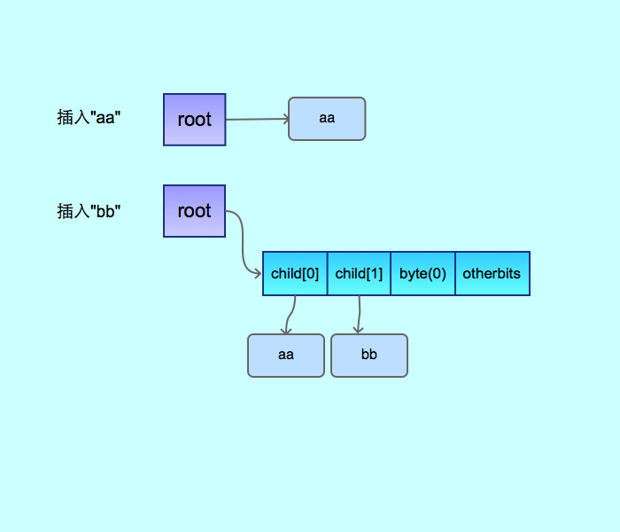
然后再继续插入后的结构变化是:
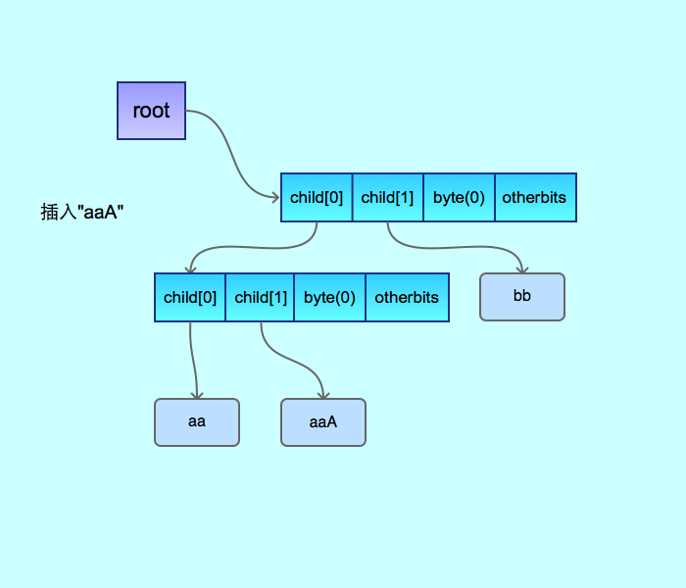
代码基于varnish, 并添加列出相同prefix字符串功能

#include <stdio.h>
#include <stdlib.h>

#include <stdio.h>
#include <stdlib.h>
#include <sys/types.h>
#include <sys/time.h>
#include <unistd.h>
#include <unistd.h>
#include <inttypes.h>

/*---------------------------------------------------------------------
* Table for finding out how many bits two bytes have in common sequentially,
* counting from the MSB towards the LSB.
* ie:
* hcb_bittbl[0x01 ^ 0x22] == 2
* hcb_bittbl[0x10 ^ 0x0b] == 3
*
*/

#define DIGEST_LEN 32
static unsigned char hcb_bittbl[256];

static unsigned char hcb_bits(unsigned char x, unsigned char y) {
return hcb_bittbl[x ^ y];
}

static void hcb_build_bittbl(void) {
unsigned char x;
unsigned y;

y = 0;
for (x = 0; x < 8; x++)
for (; y < (1U << x); y++)
hcb_bittbl[y] = 8 - x;
}

/*---------------------------------------------------------------------
* For space reasons we overload the two pointers with two different
* kinds of of pointers. We cast them to uintptr_t's and abuse the
* low two bits to tell them apart, assuming that Varnish will never
* run on machines with less than 32bit alignment.
*
* Asserts will explode if these assumptions are not met.
*/

struct hcb_y {
int num;
//节点代表的字符串的数量

unsigned short critbit;
unsigned char ptr;
unsigned char bitmask;
volatile uintptr_t leaf[2];
};

#define HCB_BIT_NODE (1<<0)
#define HCB_BIT_Y (1<<1)

struct hcb_root {

volatile uintptr_t origo;
};

static struct hcb_root hcb_root;

/*---------------------------------------------------------------------
* Pointer accessor functions
*/
static int hcb_is_node(uintptr_t u) {
return (u & HCB_BIT_NODE);
}

static int hcb_is_y(uintptr_t u) {
return (u & HCB_BIT_Y);
}

static uintptr_t hcb_r_node(uintptr_t n) {
return (HCB_BIT_NODE | (uintptr_t) n);
}

static uintptr_t hcb_l_node(uintptr_t u) {
return (u & ~HCB_BIT_NODE);
}

static uintptr_t hcb_r_y(struct hcb_y *y) {
return (HCB_BIT_Y | (uintptr_t) y);
}

static struct hcb_y *hcb_l_y(uintptr_t u) {
return ((struct hcb_y *) (u & ~HCB_BIT_Y));
}

/*---------------------------------------------------------------------
* Find the "critical" bit that separates these two digests
*/

static unsigned hcb_crit_bit(const char *oh1, const char *oh2,
struct hcb_y *y) {
unsigned char u, r;
for (u = 0; u < DIGEST_LEN && oh1[u] == oh2[u]; u++)
;

r = hcb_bits(oh1[u], oh2[u]);
y->ptr = u;
y->bitmask = 0x80 >> r;
y->critbit = u * 8 + r;
return (y->critbit);
}

/*---------------------------------------------------------------------
* Unless we have the lock, we need to be very careful about pointer
* references into the tree, we cannot trust things to be the same
* in two consequtive memory accesses.
*/

static char *hcb_insert(struct hcb_root *root, char *oh) {
volatile uintptr_t *p;
uintptr_t pp;
struct hcb_y *y, *y2;
char *oh2;
unsigned s, s2;

p = &root->origo;
pp = *p;
if (pp == 0) {
*p = hcb_r_node((uintptr_t) oh);
return (oh);
}

while (hcb_is_y(pp)) {
y = hcb_l_y(pp);
s = (oh[y->ptr] & y->bitmask) != 0;
p = &y->leaf[s];
pp = *p;
}

if (pp == 0) {
/* We raced hcb_delete and got a NULL pointer */
return (NULL);
}

/* We found a node, does it match ? */

oh2 = (char*) hcb_l_node((uintptr_t) pp);
if (!memcmp(oh2, oh, DIGEST_LEN))
return (oh2);

/* Insert */

y2 = (struct hcb_y *) malloc(sizeof(struct hcb_y));
if (y2 == NULL)
return NULL;
(void) hcb_crit_bit(oh, oh2, y2);
s2 = (oh[y2->ptr] & y2->bitmask) != 0;
y2->leaf[s2] = hcb_r_node((uintptr_t) oh);
s2 = 1 - s2;

p = &root->origo;

while (hcb_is_y(*p)) {
y = hcb_l_y(*p);
if (y->critbit > y2->critbit)
break;

s = (oh[y->ptr] & y->bitmask) != 0;
p = &y->leaf[s];
}
y2->leaf[s2] = *p;
*p = hcb_r_y(y2);
return (oh);
}

static void hcb_delete(struct hcb_root *r, char *oh) {
struct hcb_y *y;
volatile uintptr_t *p;
unsigned s;

if (r->origo == hcb_r_node((uintptr_t) oh)) {
r->origo = 0;
return;
}

p = &r->origo;
y = NULL;
while (1) {
y = hcb_l_y(*p);
s = (oh[y->ptr] & y->bitmask) != 0;
if (y->leaf[s] == hcb_r_node((uintptr_t) oh)) {
*p = y->leaf[1 - s];
free(y);
return;
}

p = &y->leaf[s];
}

}

static void hcb_start(void) {
memset(&hcb_root, 0, sizeof hcb_root);
hcb_build_bittbl();
}

static char *hcb_lookup(struct hcb_root *root, char *noh) {
volatile uintptr_t *p;
uintptr_t pp;
struct hcb_y *y, *y2;
char *oh2;
unsigned s, s2;

p = &root->origo;
pp = *p;
if (pp == 0) {
return NULL;
}

while (hcb_is_y(pp)) {
y = hcb_l_y(pp);
s = (noh[y->ptr] & y->bitmask) != 0;
p = &y->leaf[s];
pp = *p;
}

if (pp == 0) {
/* We raced hcb_delete and got a NULL pointer */
return (NULL);
}

/* We found a node, does it match ? */

oh2 = (char*) hcb_l_node((uintptr_t) pp);
if (!memcmp(oh2, noh, DIGEST_LEN))
return (oh2);

return (NULL);
}

static void recur_print(uintptr_t pp) {
if (pp == 0)
return;

if (hcb_is_node(pp)) {
char *oh2 = (char*) hcb_l_node((uintptr_t) pp);
printf("%s\n", oh2);
return;
} else {
struct hcb_y *y = hcb_l_y(pp);
recur_print(y->leaf[0]);
recur_print(y->leaf[1]);
}
}

static char *hcb_get_prefix(struct hcb_root *root, char *prefix) {
int prefix_len = strlen(prefix);
if (prefix_len == 0)
return NULL;

volatile uintptr_t *p;
uintptr_t pp;
struct hcb_y *y, *y2;
char *oh2;
unsigned s, s2;

p = &root->origo;
pp = *p;
if (pp == 0) {
return NULL;
}

while (hcb_is_y(pp)) {
y = hcb_l_y(pp);
if (y->ptr >= prefix_len)
break;

s = (prefix[y->ptr] & y->bitmask) != 0;
p = &y->leaf[s];
pp = *p;
}

if (pp == 0) {
/* We raced hcb_delete and got a NULL pointer */
return (NULL);
}

recur_print(pp);

return (NULL);
}

int main() {
hcb_start();

char t1[DIGEST_LEN] = "test";
hcb_insert(&hcb_root, t1);

char t2[DIGEST_LEN] = "test1";
hcb_insert(&hcb_root, t2);
hcb_insert(&hcb_root, t2);
hcb_insert(&hcb_root, t2);

char t3[DIGEST_LEN] = "test2";
hcb_insert(&hcb_root, t3);

int i = 0;
while (i < 100) {
char *t4 = (char *) malloc(DIGEST_LEN);
memset(t4, 0, DIGEST_LEN);
sprintf(t4, "test%d", i);
hcb_insert(&hcb_root, t4);
i++;
}

if (hcb_lookup(&hcb_root, t1)) {
printf("find itn\n");
} else {
printf("can not find itn\n");
}

printf("begin to deleten\n");
//hcb_delete(&hcb_root, t1);

if (hcb_lookup(&hcb_root, t1)) {
printf("find itn\n");
} else {
printf("can not find itn\n");
}

hcb_get_prefix(&hcb_root, "test");

return 0;
}

