Table 1 Best approximations to the data x-φ-w, where the weights w are set equal to unity. The local maxima of an approximation are displayed with bold characters and the local minima with underlined ones. The best approximation for k=6 coincides with that when k=7, and for every k≥8, it coincides with the data.

Data |  |  | Best approximations with k monotonic sections
x | φ | w | k=1 | k=2 | k=3 | k=4 | k=5 | k=6 | k=7 | k8
1.00 | –0.10 | 1 | –0.1000 | –0.1000 | –0.1000 | –0.1000 | –0.1000 | –0.1000 | –0.1000 | –0.1000
2.00 | 0.71 | 1 | 0.0178 | 0.0320 | 0.0320 | 0.7000 | 0.7000 | 0.7000 | 0.7000 | 0.7100
3.00 | 0.69 | 1 | 0.0178 | 0.0320 | 0.0320 | 0.7000 | 0.7000 | 0.7000 | 0.7000 | 0.6900
4.00 | 0.87 | 1 | 0.0178 | 0.0320 | 0.0320 | 0.8700 | 0.8700 | 0.8700 | 0.8700 | 0.8700
5.00 | –1.00 | 1 | 0.0178 | 0.0320 | 0.0320 | –1.0000 | –1.0000 | –1.0000 | –1.0000 | –1.0000
6.00 | –1.11 | 1 | 0.0178 | 0.0320 | 0.0320 | –1.1100 | –1.1100 | –1.1100 | –1.1100 | –1.1100
7.00 | 1.00 | 1 | 0.0178 | 1.0000 | 1.0000 | 1.0000 | 1.0000 | 1.0000 | 1.0000 | 1.0000
8.00 | 1.00 | 1 | 0.0178 | 1.0000 | 1.0000 | 1.0000 | 1.0000 | 1.0000 | 1.0000 | 1.0000
9.00 | –1.00 | 1 | 0.0178 | 0.1017 | –1.0000 | 0.1017 | –1.0000 | –1.0000 | –1.0000 | –1.0000
10.00 | –1.00 | 1 | 0.0178 | 0.1017 | –1.0000 | 0.1017 | –1.0000 | –1.0000 | –1.0000 | –1.0000
11.00 | 0.68 | 1 | 0.6525 | 0.1017 | 0.6525 | 0.1017 | 0.6525 | 0.6800 | 0.6800 | 0.6800
12.00 | 0.73 | 1 | 0.6525 | 0.1017 | 0.6525 | 0.1017 | 0.6525 | 0.7300 | 0.7300 | 0.7300
13.00 | 0.70 | 1 | 0.6525 | 0.1017 | 0.6525 | 0.1017 | 0.6525 | 0.7000 | 0.7000 | 0.7000
14.00 | 0.50 | 1 | 0.6525 | 0.1017 | 0.6525 | 0.1017 | 0.6525 | 0.5000 | 0.5000 | 0.5000
Sum of squares of residuals (1): |  |  | 7.9986 | 7.6374 | 3.9964 | 3.6735 | 0.0325 | 0.0002 | 0.0002 | 0.0000

Table 2 Best weighted approximations to the data x-φ-w, where the weights w are calculated by formulae (10). The notation of Table 1 is used.

 | Data |  |  | Best weighted approximations with k monotonic sections
i | x | φ | w | k=1 | k=2 | k=3 | k=4 | k=5 | k=6 | k=7 | k8
1 | 0.0021 | –0.10 | 0.0714 | –0.2341 | –0.2341 | –0.1298 | –0.1298 | –0.1000 | –0.1000 | –0.1000 | –0.1000
2 | 0.7338 | 0.71 | 0.0116 | –0.2341 | –0.2341 | –0.1298 | –0.1298 | 0.7055 | 0.7055 | 0.7055 | 0.7100
3 | 3.2849 | 0.69 | 0.0033 | –0.2341 | –0.2341 | –0.1298 | –0.1298 | 0.7055 | 0.7055 | 0.7055 | 0.6900
4 | 4.2757 | 0.87 | 0.0086 | –0.2341 | –0.2341 | –0.1298 | –0.1298 | 0.8700 | 0.8700 | 0.8700 | 0.8700
5 | 4.6491 | –1.00 | 0.0227 | –0.2341 | –0.2341 | –0.1298 | –0.1298 | –1.0000 | –1.0000 | –1.0000 | –1.0000
6 | 7.1108 | –1.11 | 0.0034 | –0.2341 | –0.2341 | –0.1298 | –0.1298 | –1.1100 | –1.1100 | –1.1100 | –1.1100
7 | 8.2084 | 1.00 | 0.0077 | –0.2341 | –0.2341 | 1.0000 | 1.0000 | 1.0000 | 1.0000 | 1.0000 | 1.0000
8 | 8.7843 | 1.00 | 0.0147 | –0.2341 | –0.2341 | 1.0000 | 1.0000 | 1.0000 | 1.0000 | 1.0000 | 1.0000
9 | 9.2829 | –1.00 | 0.0170 | –0.2341 | –0.2341 | –1.0000 | –1.0000 | –1.0000 | –1.0000 | –1.0000 | –1.0000
10 | 9.5207 | –1.00 | 0.0356 | –0.2341 | –0.2341 | –1.0000 | –1.0000 | –1.0000 | –1.0000 | –1.0000 | –1.0000
11 | 9.6939 | 0.68 | 0.0489 | 0.5188 | 0.6800 | 0.5188 | 0.6800 | 0.5188 | 0.6800 | 0.6800 | 0.6800
12 | 11.1139 | 0.73 | 0.0060 | 0.5188 | 0.7300 | 0.5188 | 0.7300 | 0.5188 | 0.7300 | 0.7300 | 0.7300
13 | 11.4583 | 0.70 | 0.0246 | 0.5188 | 0.7000 | 0.5188 | 0.7000 | 0.5188 | 0.7000 | 0.7000 | 0.7000
14 | 11.4700 | 0.50 | 0.7244 | 0.5188 | 0.5000 | 0.5188 | 0.5000 | 0.5188 | 0.5000 | 0.5000 | 0.5000
Weighted sum of squares of residuals (1): |  |  |  | 0.1085 | 0.1059 | 0.0422 | 0.0395 | 0.0026 | 1.03E–06 | 1.03E–06 | 0.0000

-----------------------------------------
RETURN FROM L2WPMA WITH MODE = 1
NUMBER OF DATA (F) = 14
NUMBER OF MONOTONIC SECTIONS = 4
NUMBER OF LOCAL MINIMA IN F = 5
NUMBER OF LOCAL MAXIMA IN F = 4
-----------------------------------------

INDICES OF EXTREMA AT OPTIMUM
Increment Data index
(J) (ITHETA)
0 1
1 4
2 6
3 7
4 14

INDICES OF ACTIVE CONSTRAINTS AT OPTIMUM
Increment Active constraint Lagrange mult
(I) (IACT) (PAR(IACT))
1 3 0.02
2 10 -2.20
3 11 -4.41
4 12 -3.25
5 13 -1.99
6 14 -0.80

INDICES OF KNOTS AT OPTIMUM
Increment Knot index Spline coeff
(I) (IAKN) (Y(IAKN))
1 1 -0.1000
2 2 0.7000
3 4 0.8700
4 5 -1.0000
5 6 -1.1100
6 7 1.0000
7 8 1.0000
8 9 0.1017
9 14 0.1017

Data points Measurements Data weights Best appxmtn Lagrange mult
(X) (F) (WF) (Y) (PAR)

1 1.0000 -0.1000 1.0000 -0.1000
2 2.0000 0.7100 1.0000 0.7000 0.00
3 3.0000 0.6900 1.0000 0.7000 0.02
4 4.0000 0.8700 1.0000 0.8700 0.00
5 5.0000 -1.0000 1.0000 -1.0000 0.00
6 6.0000 -1.1100 1.0000 -1.1100 0.00
7 7.0000 1.0000 1.0000 1.0000 0.00
8 8.0000 1.0000 1.0000 1.0000 0.00
9 9.0000 -1.0000 1.0000 0.1017 0.00
10 10.0000 -1.0000 1.0000 0.1017 -2.20
11 11.0000 0.6800 1.0000 0.1017 -4.41
12 12.0000 0.7300 1.0000 0.1017 -3.25
13 13.0000 0.7000 1.0000 0.1017 -1.99
14 14.0000 0.5000 1.0000 0.1017 -0.80

Value of objective function at the optimum= 0.3673483610E+01

Fig. 1 Output of software package L2WPMA due to a driver program presenting the termination status, the number of data, the number of monotonic sections, the number of data extrema counting possibly the end point indices I1 and N (as follows from the definition of L and U), the optimal values of the integer variables (namely the positions of the turning points of the fit), the indices of active constraints and the corresponding Lagrange multipliers, the knot indices and the coefficients of a spline representation of the best fit and, Y, the best fit to the data, together with X, F, WF and PAR.

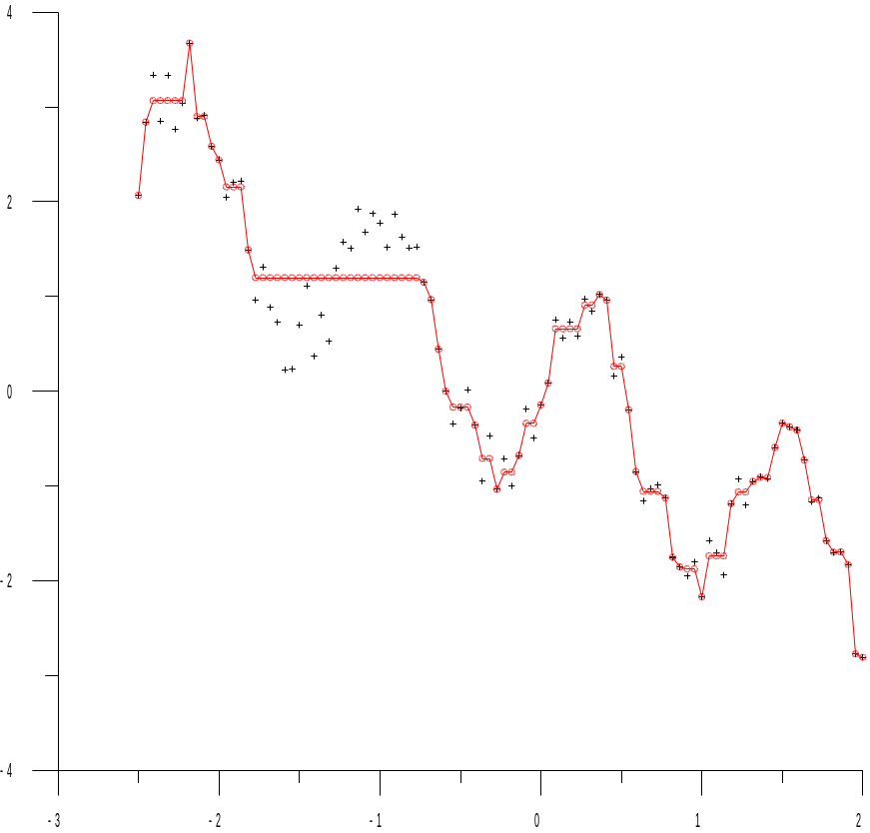

Fig. 2 Best least squares approximation with k=6 or k=7 monotonic sections to 100 data points generated by adding uniformly distributed random numbers from the interval (–0.5,0.5) to the measurements of f(x)=sin(5x)–x at equally spaced abscissae. The data are denoted by (+), the best approximation by (o) and the piecewise linear interpolant to the smoothed values illustrates the fit. The first decreasing section suggests that a better approximation is possible by increasing k.

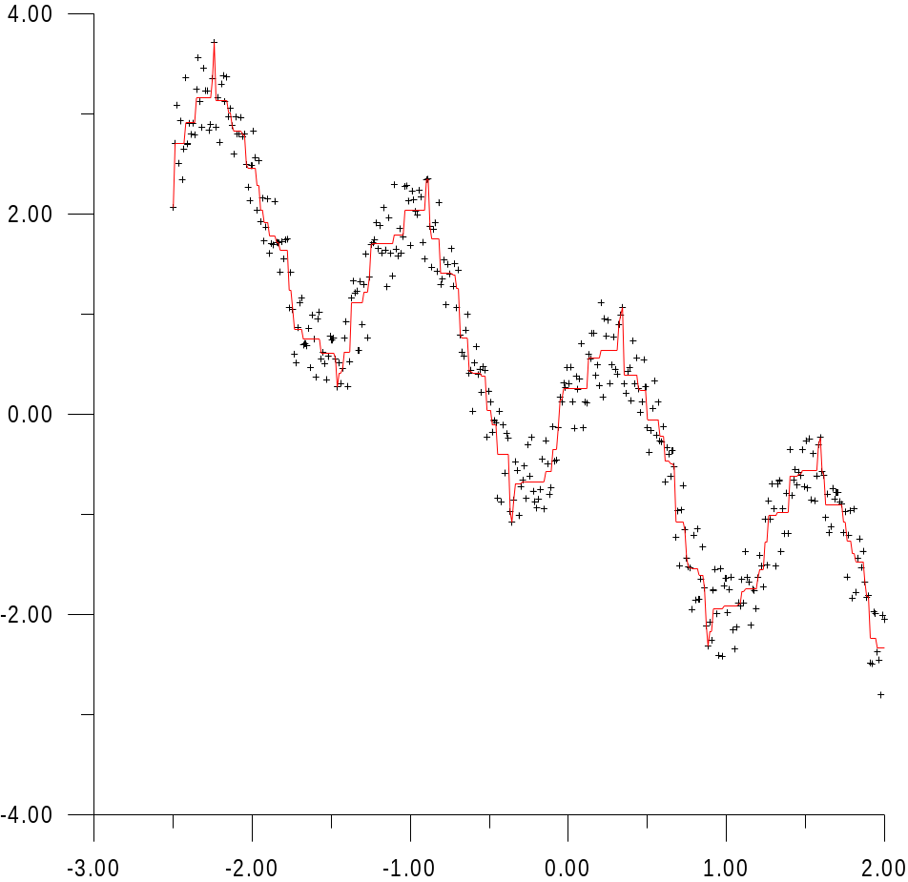

Fig. 3 Best least squares approximation with 8 monotonic sections to 200 data points generated as in Fig. 2. The data are denoted by (+) and the piecewise linear interpolant to the smoothed values illustrates the fit.

