OpenCV 3.3 was officially released, bringing with it a highly improved deep learning ( dnn ) module. This module now supports a number of deep learning frameworks, including Caffe, TensorFlow, and Torch/PyTorch.
While we cannot train deep learning models using OpenCV (nor should we), this does allow us to take our models trained using dedicated deep learning libraries/tools and then efficiently use them directly inside our OpenCV scripts.

net = cv2.dnn.readNet reads the model and stores it in variable net

layer_names = net.getLayerNames()
output_layers = [layer_names[i[0] - 1] for i in net.getUnconnectedOutLayers()]
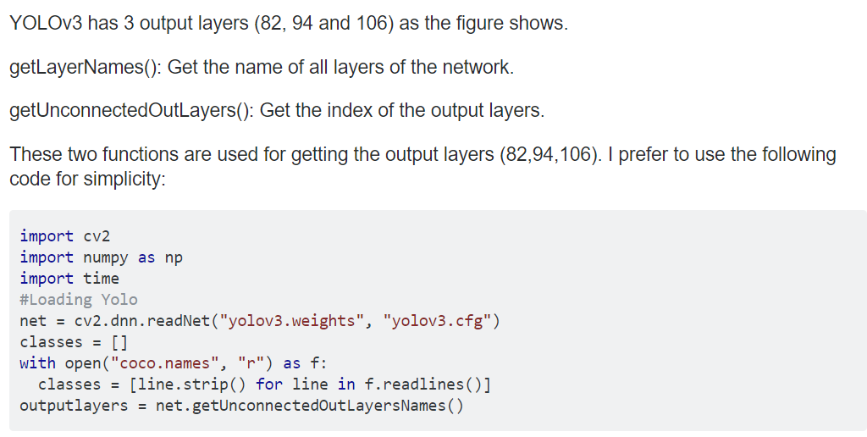
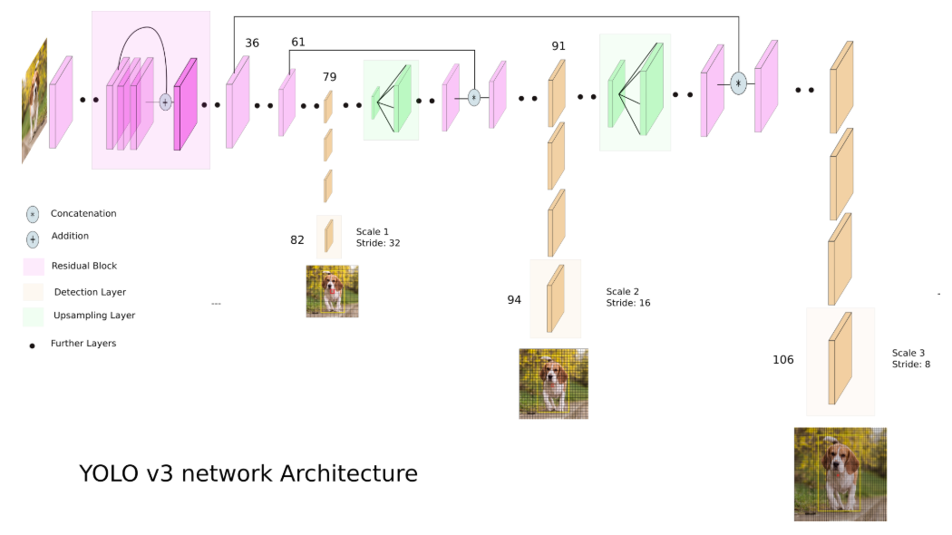

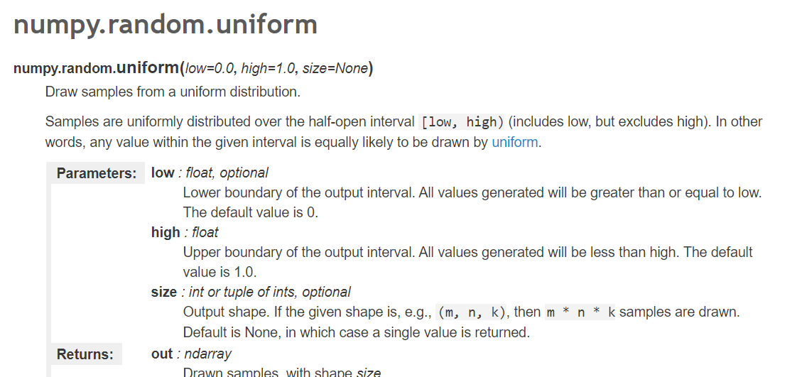
np.random.uniform(0, 255, size=(len(classes), 3))

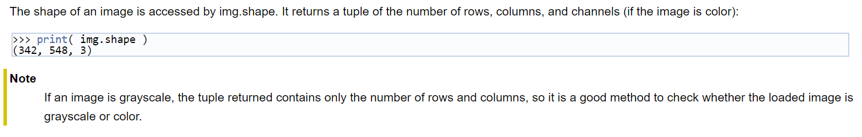
img.shape

blob = cv2.dnn.blobFromImage(img, 0.00392, (416, 416), (0, 0, 0), True, crop=False)
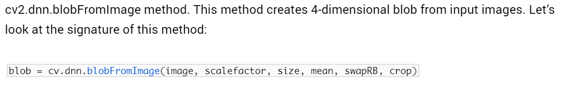
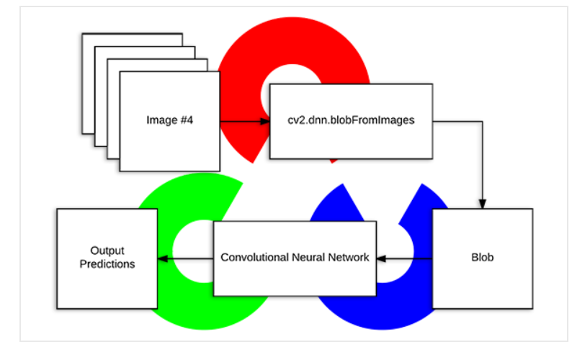

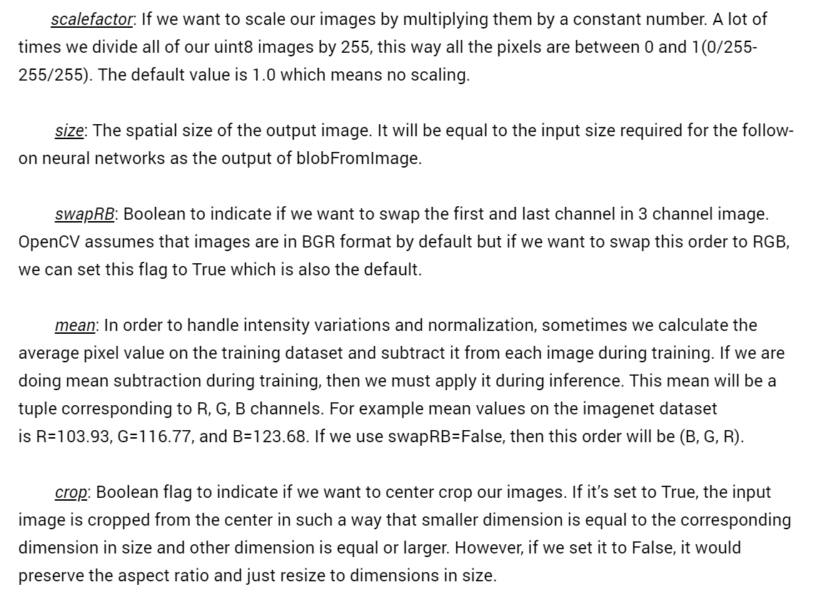
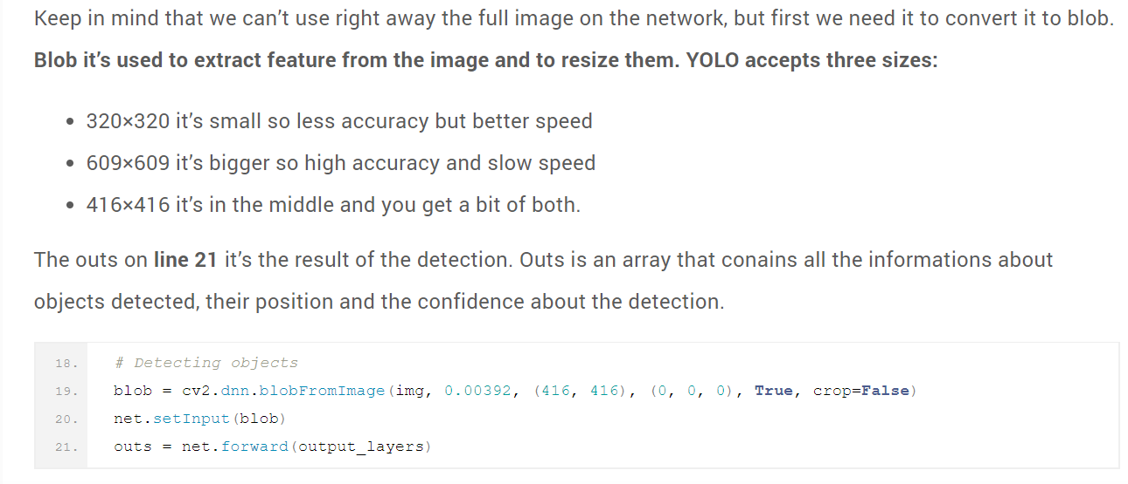
outs = net.forward(output_layers)

class_id = np.argmax(scores)

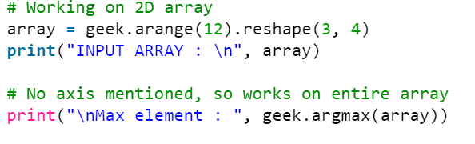
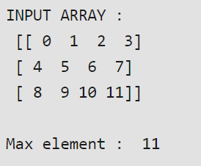

GOOD EXPLAINATION OF THE ENTIRE CODE
https://pysource.com/2019/06/27/yolo-object-detection-using-opencv-with-python/

confidence = scores[class_id]

