


ACMAD Website Modernization, Product Migration and Digital Services Integration Under the ClimSA Project Report
ACMAD now has an integrated digital-service platform spanning automated product publication, RCC and programme services, public engagement, staff operations, and maintainable infrastructure. The next phase is operational consolidation, adoption, measurement, and continuous improvement.
Prepared for | ACMAD management and operational successors
Reporting date | 28 October 2026
Website | https://acmad.org
Project Duration | 3 months (3 August 2026 – 2 November 2026)
Reporting expert | Yusuf Habu YUSUF

Document purpose and reporting scope
This report presents a comprehensive account of what the ACMAD Website Modernization, Product Migration and Digital Services Integration project has achieved, the value created for ACMAD and its users, the repository and documentation evidence supporting those achievements, and the next outcomes that should be pursued. It is an achievement and forward-planning report.
The inherited ClimWeb repository begins on 3 February 2023. For consistent measurement, this report uses 3 August 2026—as the starting point. The reporting cut-off is 28 October 2026. The report distinguishes an implemented repository capability from a service independently verified in the running environment.

Executive summary
The work has developed the existing ClimWeb application into an integrated digital-service platform for ACMAD. The work brings together automated climate-product publication, Regional Climate Centre services, specialised projects sites, public communications, subscriptions and notifications, institutional content, event and application workflows, staff and HR operations, and the technical foundations required to deploy, secure, monitor, back up, and maintain the service.
The central achievement is not a single website redesign. It is the establishment of a shared operating platform in which scientific products, programme communications, institutional information, public engagement, and internal workflows can be managed through one governed content and service environment. This reduces repeated manual work, supports more timely publication, improves traceability, and gives ACMAD staff greater editorial and operational control.
Available repository evidence records 548 unique commits and 167 pull-request merge commits across all available references between the project implementation baseline and the reporting cut-off. The activity spans three connected delivery waves: product automation and public-platform foundations in August; RCC services, data workflows, events, and ENSO expansion in September; and programme consolidation, staff operations, integrations, and documentation in October. Commit volume is included only as evidence of delivery scale; the achievements themselves are described by capability and outcome below.
The next phase should concentrate on operational consolidation: verifying the exact deployed service, completing end-to-end testing of priority workflows, reconciling migrated content, confirming institutional ownership of accounts and external services, rehearsing recovery, training each user group, and establishing a measured roadmap for continued improvement.

Delivery evidence at a glance
Evidence | Recorded result | What it demonstrates
ACMAD implementation reporting baseline | 3 August 2026 | Consistent starting point for the ACMAD delivery analysis
Reporting cut-off | 2 November 2026 | Date to which the work is to be completed according to the TOR
Unique commits across available references since baseline | 548 | Scale of implementation activity across integrated and continuing work
Pull-request merge commits since baseline | 167 | Evidence of repeated review and integration activity
Initial documentation expansion | 25 files | Breadth of operational, editorial, technical, and continuity guidance produced
Primary evidence sources | Git history, application modules, configuration, tests, and project guides | Traceable basis for the achievement statements in this report

Project evolution and delivery approach
The project evolved the inherited ClimWeb and Wagtail foundation through incremental feature branches and reviewed integration work. This allowed product operations, RCC services, project website (ClimSA), staff workflows, and infrastructure changes to develop in parallel while continuing to use shared platform services such as authentication, search, content management, task queues, storage, and deployment configuration.
The delivery approach consistently combined three layers:
- public experiences for visitors, partners, applicants, subscribers, and scientific users;
- controlled interfaces for editors, product operators, project teams, HR reviewers, and administrators; and
- background services for imports, schedules, notifications, file handling, integrations, backup, and deployment.
That layered approach is important because it turns visible pages into maintainable services. A product catalogue, for example, is backed by import configuration, task execution, progress information, publication history, subscriptions, and operator documentation—not only by a public page.
Achievements

Public homepage and service discovery
The public homepage was redesigned into a configurable institutional front door. Work includes configurable visual themes, a product carousel, featured-product ordering, news and events presentation, service and partner sections, the Director General's message, an African RCC map, and a directory of African national meteorological and hydrological services.
Editors gained control over more homepage selections and ordering without requiring a code deployment. Visitors gain clearer entry points into products, programmes, events, institutional information, and continental services. This work strengthens both everyday discoverability and ACMAD's presentation as a regional institution.
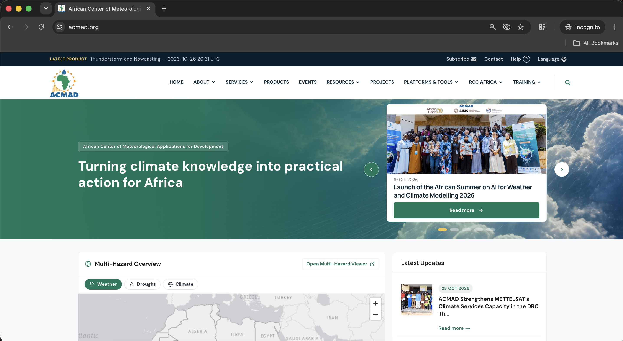
Figure 1: ACMAD website homepage

Product migration and automated publication
The project created a reusable framework for importing historical products and publishing new products on a schedule. The framework supports configurable source locations, product-specific parsing, controlled task execution, progress and failure information, stop and retry actions, publication history, and operator-facing configuration. This work moves a substantial portion of product administration away from repeated manual uploading and toward observable, repeatable workflows.
Product coverage developed across ACMAD and RCC families, including dekadal and monthly bulletins, policy briefs, atmospheric analysis, heat-stress products, ITD and ITCZ monitoring, thunderstorm rapid developing thunderstorm, climate and health products, seasonal forecasts, monthly climate products, onset products, climate-change products, annual climate products, Climate Watch outputs, rainfall exceedance, cryosphere monitoring, five-day rainfall, seasonal verification, and model-performance products.
The operational value created includes faster publication, more consistent metadata, clearer source provenance, reduced repetition, and a shared method for extending the catalogue to future product families. The supporting guides explain the migration model and the importer controls [R1, R2].
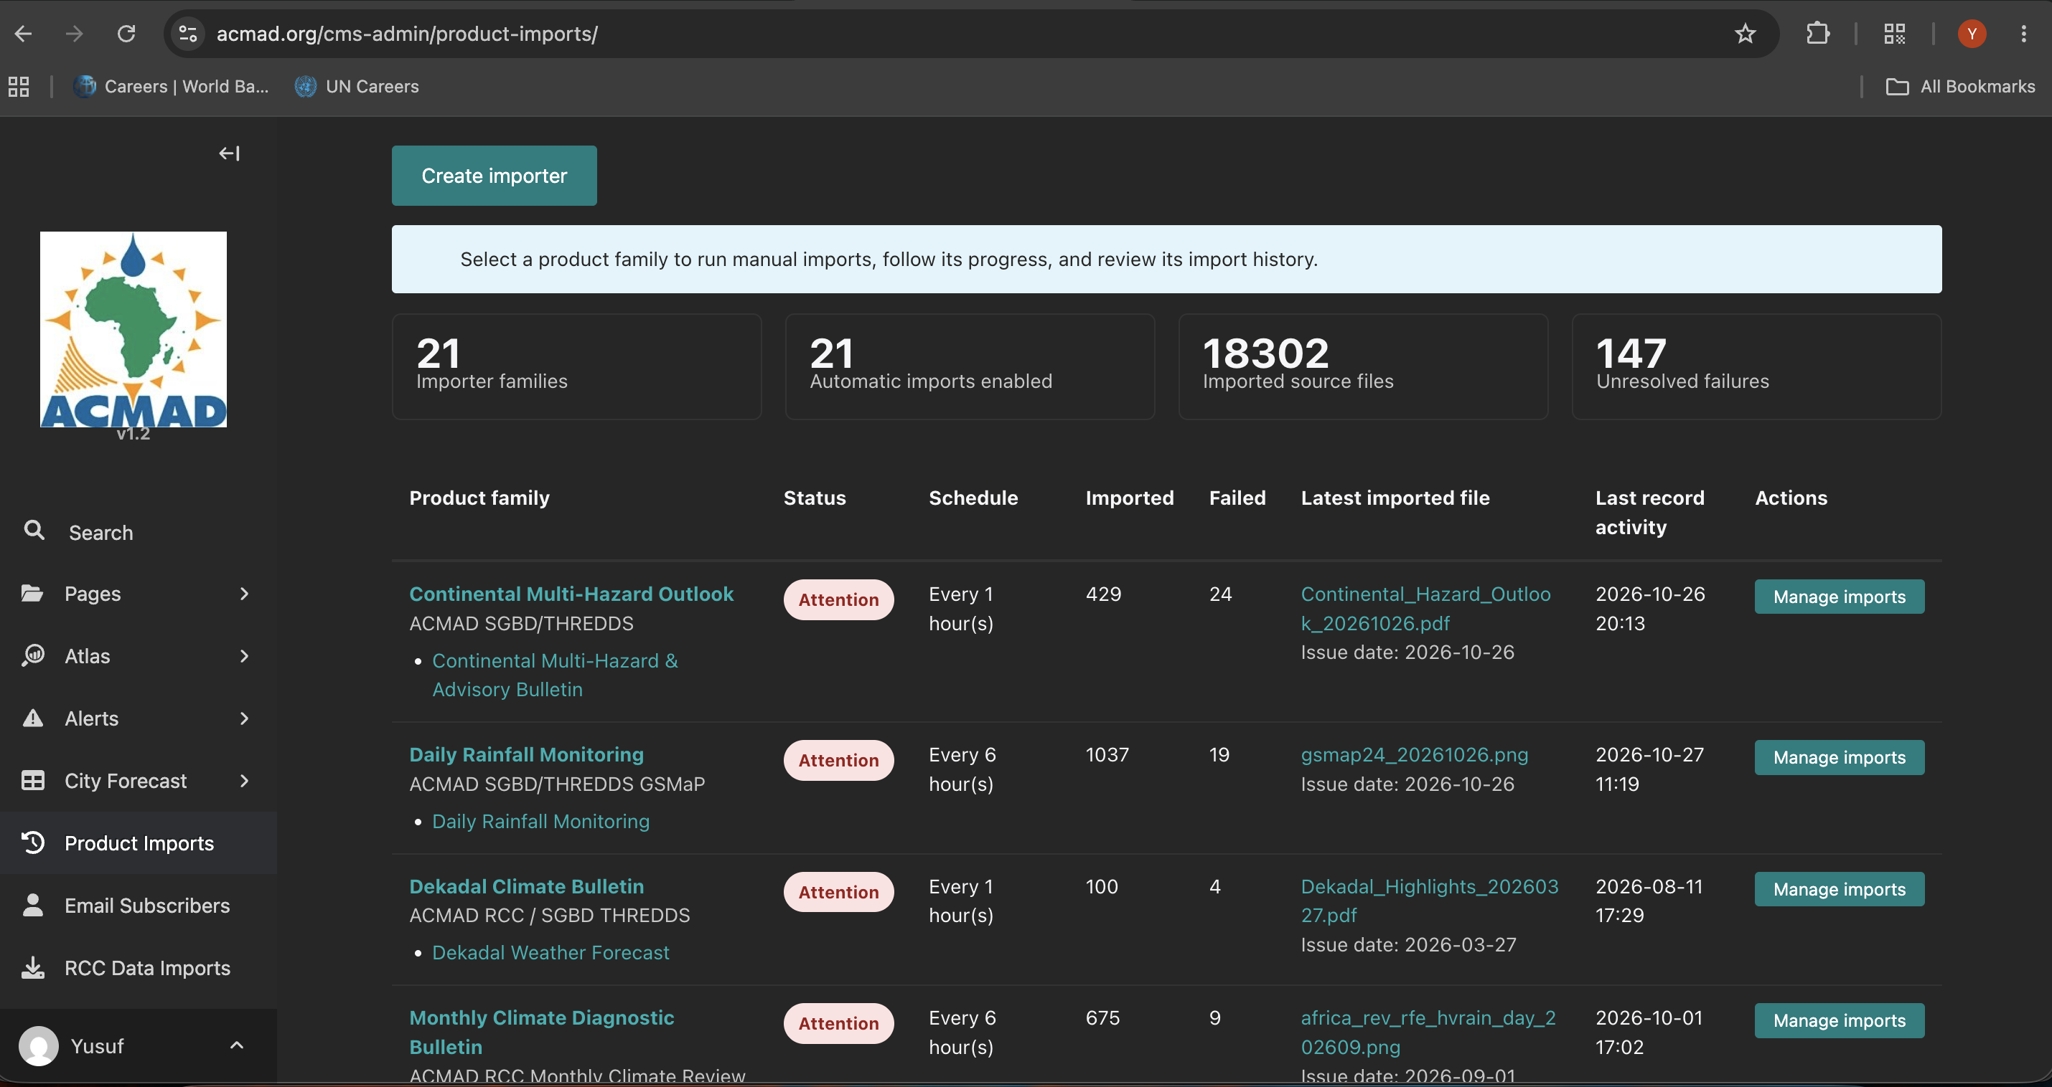
Figure 2: Products Import interface

Product subscriptions, notifications, and audience reach
The project extended product publication into an audience service. Users can subscribe to relevant product updates, manage their interests through a subscriber dashboard, receive notification emails, and unsubscribe through a controlled process. Subscription information was expanded to support sector and organisation context, and authorised staff can export subscriber records for analysis and engagement activities.
Notification templates, product validity and descriptive information, and publication-triggered delivery improve the usefulness of alerts. Together, these capabilities enable ACMAD to build a more direct relationship with users of its climate services and to understand demand across sectors. The design and operational workflow are documented in the subscription and notification guide [R3].
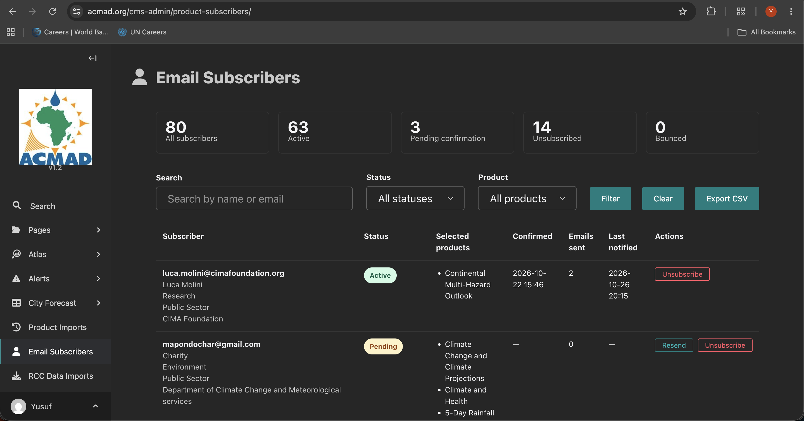
Figure 3: Email subscription management interface

Regional Climate Centre digital service
The RCC implementation established a coherent digital destination rather than a collection of disconnected pages. It includes a dedicated landing experience, RCC navigation, product and data-service catalogues, climate monitoring resources, training and coordination content, long-range forecasting material, and programme-specific presentation and routing.
Data-oriented work includes ARC2 storage and imports across multiple countries, country and station browsing, CPC rainfall data, seasonal forecast maps, EIN15, climate indices, reference climatologies, Climate Watch information, Climsoft resources, and monitoring interfaces. Long-range forecasting forums and galleries, capacity-development content, and coordination information broaden the RCC service beyond file distribution.
The result is a stronger foundation for ACMAD's RCC mandate: scientific information can be organised by service and geography, updated through defined workflows, and presented through a recognisable RCC environment. Editorial and operational instructions are consolidated in the RCC management guide [R4].
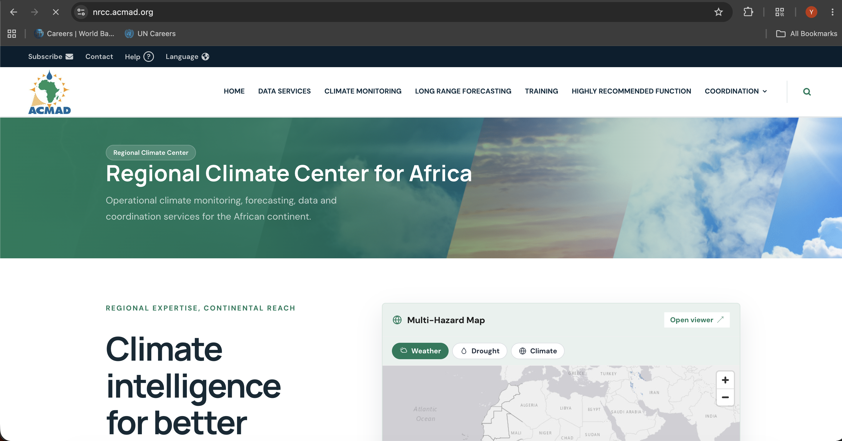
Figure 4: RCC website homepage

Africa-focused ENSO information service
The work created an Africa-focused El Niño–Southern Oscillation experience that combines current information with explanatory and contextual content. It includes a thematic landing page, bulletin presentation, an ENSO explanation, an explainer image, related news and events, partner activities, homepage integration, pagination, and mobile presentation refinements.
This gives non-specialist and specialist audiences a clearer route from the climate phenomenon to its African relevance, current ACMAD information, and related institutional activity. It also gives editors a structured way to maintain the service as conditions and bulletins change. The content model and editor workflow are documented in the ENSO management guide [R5].
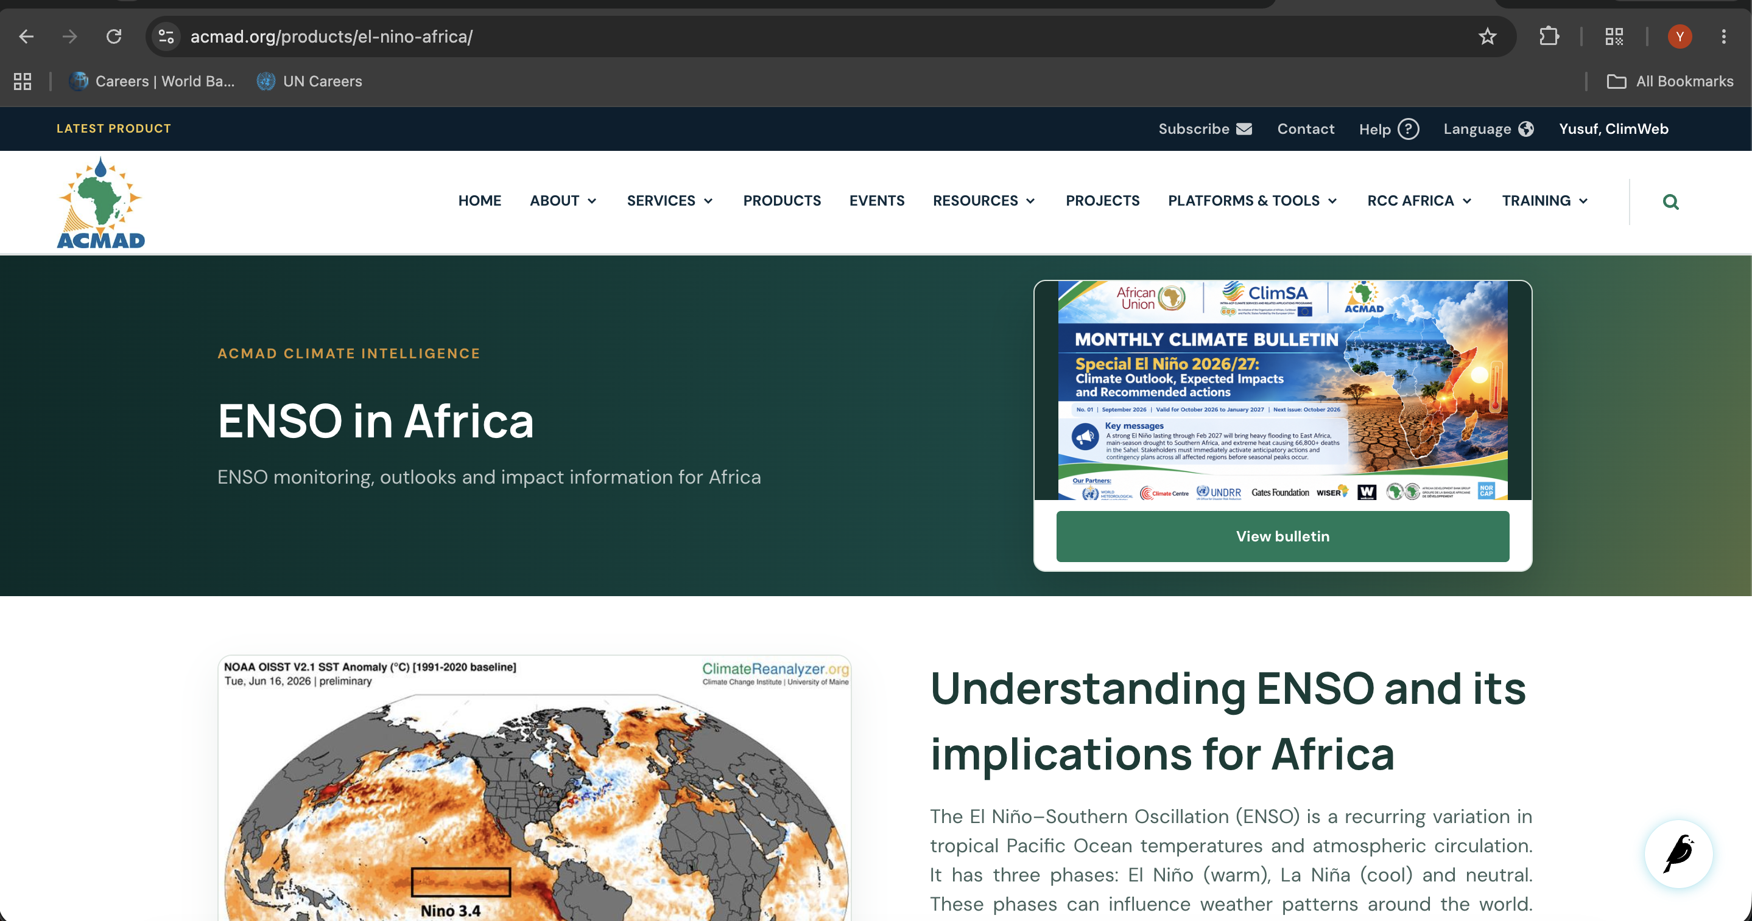
Figure 5: ENSO information service landing page

CLIMSA programme presence
The work delivered a dedicated CLIMSA project site within the shared platform. The implementation includes a programme homepage, navigation, About content, output and product presentation, publication selection, news and events, programme-specific interface treatments, and subdomain configuration.
This creates a distinct public identity for CLIMSA while retaining shared publishing, infrastructure, search, and maintenance capabilities. ACMAD staff can present results and updates without operating a separate technology stack. The CLIMSA guide records the principal content and management workflows [R6].

Summer School information and application experience
The Summer School work created a richer programme and participation experience. Achievements include dedicated edition pages, homepage promotion, application opening and deadline controls, manual closing, an online-joining call to action, daily activities, participant-facing information, reviews, galleries, and improved news and media presentation.
These capabilities support the full communication cycle—from promotion and application through delivery and post-event storytelling. Explicit deadline and closure behavior also reduces ambiguity for applicants and programme staff. The editor and programme workflow is documented in the Summer School management guide [R7].

Institutional information and governance content
The project expanded the site's institutional record through a Director General profile, Board of Governors content, an organisational timeline with supporting documents, service and organization-page improvements and configurable institutional content.
These additions make governance, leadership, history, and service responsibilities easier to find and maintain. They also reduce reliance on static page layouts by giving authorised editors structured management controls. Relevant editor workflows are described in the institutional-content guide [R8].

News, publications, galleries, and media presentation
Public communications were strengthened through improved news and event presentation, publication metadata, multilingual publication support, video and gallery components, quotation blocks, and richer media handling. These features allow ACMAD to communicate scientific work, institutional activity, partnerships, and programme outcomes in formats better suited to different audiences.
The result is a broader editorial toolkit and more consistent reuse of media across the site. The media and news management guide provides supporting instructions [R9].

Event migration, registration, and collaboration services
The project introduced tools to migrate ACMAD event records, download associated images and documents, preserve unpublished material where appropriate, sanitise or repair imported HTML, and present events through an updated public experience. Registration workflows gained clearer closing-date enforcement and improved export handling.
Google Meet and Calendar integration enables authorised event workflows to create and communicate online meeting details through institutional services. These changes connect event publishing, participation, collaboration, and record management more effectively than a standalone event listing.

Forms and controlled data collection
General form behavior was improved through deadline handling, closed-state presentation, validation refinements, and background ZIP exports for larger response sets. The same principle was applied to programme and event application flows: users receive a clear state, while staff have more reliable controls over collection and export.
This supports time-bound calls, registrations, surveys, applications, and other institutional data-collection needs without requiring a separate form platform for each activity.

Staff profiles and secure account lifecycle
The project developed invitation-only staff profiles with secure setup, links to existing accounts, self-service updates, review and publication, bulk invitations and reminders, protected portraits, and formal offboarding. Public staff presentation is therefore connected to a controlled internal identity and review process rather than managed as unrelated page content.
The account lifecycle reduces unmanaged access and gives staff responsibility for maintaining their information while retaining institutional oversight. Detailed workflows, roles, and controls are documented in the staff workspace guide [R10].

Staff workspace, activities, reports, and HR review
Beyond profiles, the project created a staff operations workspace. It supports activity assignment, training and report workflows, multiple supporting documents, submission and review, workflow notifications, authorised downloads, bulk staff actions, and HR oversight.
This consolidates recurring internal processes that would otherwise be spread across email, shared folders, and individual records. It also creates a foundation for clearer activity history, reporting accountability, and management follow-up. Because these workflows involve personal and operational information, protected storage and role-based access were incorporated into the design [R10].
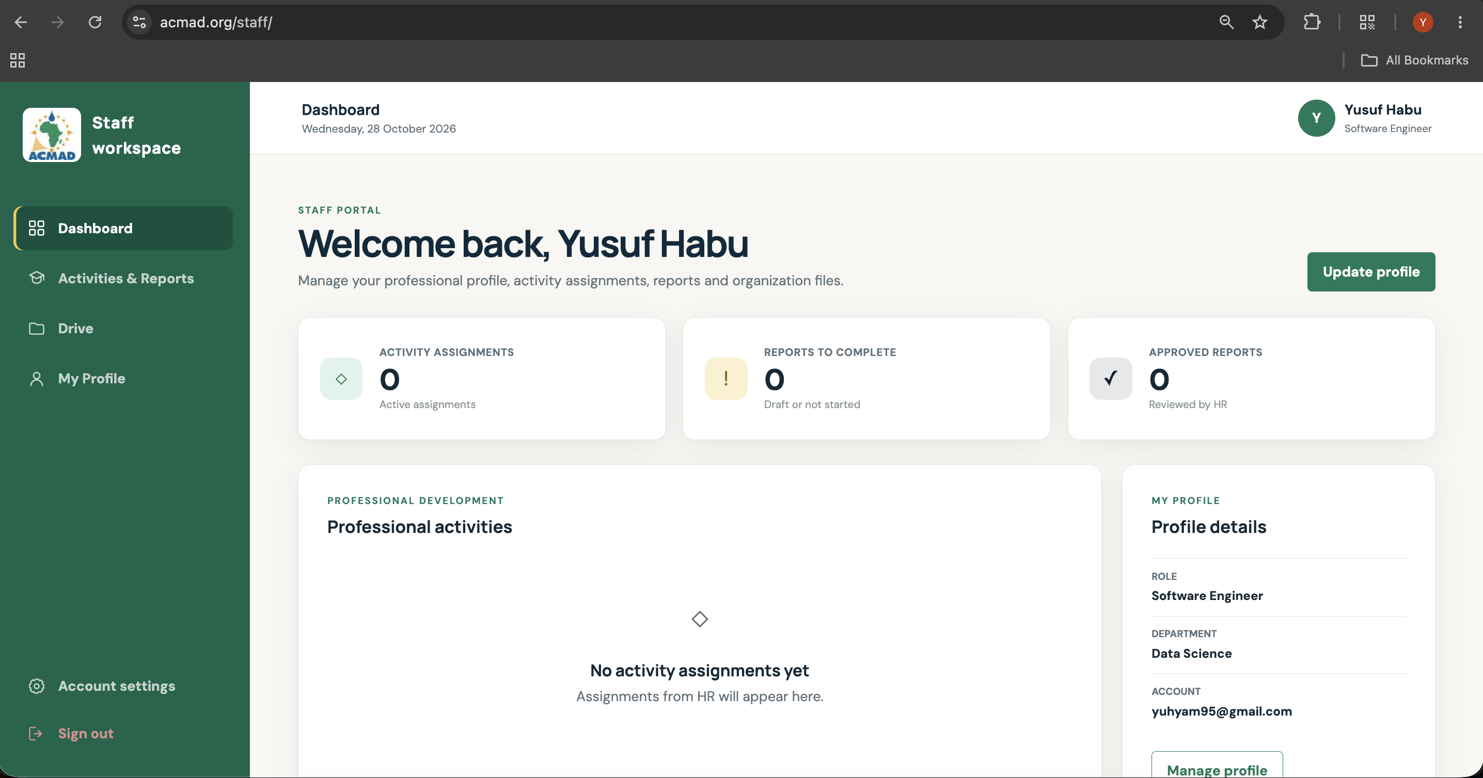
Figure 6: Staff workspace dashboard

Google Shared Drive and institutional integrations
Google Shared Drive integration supports controlled creation or use of staff folders and synchronisation of report documents when the integration is enabled. Together with Google Meet and Calendar support, this connects the website workflows to institutional collaboration tools while keeping the platform as the operational point of reference.
The value is continuity and reduced duplication: staff can work with familiar institutional storage and meeting services while workflow state remains visible in ClimWeb. Configuration, account ownership, and operating procedures for Drive are documented separately [R11].

Deployment, multi-site routing, and release foundations
The repository now defines development and production Docker profiles, PostgreSQL with PostGIS, Redis, Celery workers and scheduling, nginx routing, and configuration for the main site and programme subdomains. Deployment guidance covers environment preparation, application services, static and media handling, database migrations, and controlled release activities [R13, R14].
Subdomain and TLS guidance supports distinct public identities for services such as RCC and CLIMSA without creating independent application estates. This shared architecture reduces duplicated operational overhead while preserving clear public routing [R14, R15].

Security, privacy, backup, and operational continuity
Public authentication exposure was reduced, sensitive staff material was separated from ordinary public media, and role and access guidance was expanded. Backup and restore procedures address application data and media, while monitoring guidance identifies the services, queues, schedules, storage, and public routes that operators should observe [R16, R17].
Disaster-recovery, release-management, access-transfer, and content-migration guidance now provide a stronger basis for continuity beyond the original implementation team [R17, R18, R19]. These measures do not remove the need for regular exercises; they establish the documented method by which ACMAD can operate and test continuity.

Documentation and knowledge transfer
The project produced a structured set of product, programme, editorial, staff, infrastructure, release, and continuity guides under the docs/ tree. The documentation covers routine use as well as higher-risk activities such as deployment, TLS, backup, restore, access transfer, release management, and content reconciliation.
This documentation is itself a major project outcome. It converts implementation knowledge into institutional knowledge, gives different user groups task-specific instructions, and provides stable reference points for training, maintenance, and future procurement or enhancement work. A repository-evidence snapshot and detailed project report supplement this executive report [R20, R21, R22].

Outcomes

More timely and repeatable climate services
Automated importers, scheduling, progress visibility, and publication history reduce the effort needed to keep product collections current. Operators have a common pattern for managing varied data sources, and users have clearer access to product families and updates.

Stronger public and stakeholder engagement
Subscriptions, improved email notifications, programme sites, richer events, structured institutional information, and better media presentation give ACMAD more direct and varied ways to serve users, partners, applicants, and the public.

Greater editorial independence
Configurable homepage content, structured programme pages, product controls, media components, and Wagtail-based workflows allow authorised staff to manage significantly more of the public service without requiring a software release for routine changes.

An integrated programme platform
RCC, ENSO, CLIMSA, Summer School, public institutional content, and staff services use shared infrastructure and platform capabilities. This reduces fragmentation and creates a clearer basis for common governance, security, monitoring, and support.

Improved internal process visibility
Invitation-based staff accounts, activity assignments, reports, reviews, notifications, and controlled documents turn previously dispersed interactions into visible workflows with defined roles and status.

Better maintainability and continuity
Containerised environments, task queues, multi-site routing, operational guides, recovery procedures, and a broad documentation set make the platform easier for a successor team to understand, operate, and extend.
Delivery progression
Period | Delivery emphasis | Principal achievements
6–31 August 2026 | Product automation and public-platform foundations | ACMAD importers; importer monitoring and schedules; product subscriptions; homepage redesign; RCC landing service; staff-profile workflows; form controls; institutional-content improvements
September 2026 | RCC, data services, events, and thematic expansion | RCC datasets and importers; climate indices and climatologies; training and coordination content; subdomain and TLS work; event migration; Google Meet support; Board content; OJT and participant mapping; Africa-focused ENSO service
1–28 October 2026 | Project consolidation, internal operations, and continuity | ENSO refinements; CLIMSA project site; Summer School enhancements; configurable editorial controls; staff and HR workspace; Google Drive support; leadership and media improvements; operational and project documentation

Evidence and reference register
The references below point to evidence records and version-controlled project guides. Documentation paths are relative to the GitHub repository root and can be reviewed alongside the Evidence URL.
Ref. | Evidence URL | Documentation | Principal coverage
R1 | https://acmad.org/products/ | https://github.com/ACMAD-Niamey/climweb/blob/develop/docs/_docs/products/acmad-product-migrations.md | Historical product migration scope, commands, and validation
R2 | https://acmad.org/cms-admin/product-imports/ | https://github.com/ACMAD-Niamey/climweb/blob/develop/docs/_docs/products/product-importer-feature.md | Import configuration, scheduling, progress, retries, and operations
R3 | https://acmad.org/cms-admin/product-subscribers/ | https://github.com/ACMAD-Niamey/climweb/blob/develop/docs/_docs/products/product-subscriptions-and-notifications.md | Subscriber workflow, notification delivery, exports, and unsubscribe behavior
R4 | https://nrcc.acmad.org/ | https://github.com/ACMAD-Niamey/climweb/blob/develop/docs/_docs/manage_pages/Manage-RCC.md | RCC pages, datasets, service content, and operator workflows
R5 | https://acmad.org/products/el-nino-africa/ | https://github.com/ACMAD-Niamey/climweb/blob/develop/docs/_docs/manage_pages/Manage-ENSO.md | ENSO content structure and editorial management
R6 | N/A | https://github.com/ACMAD-Niamey/climweb/blob/develop/docs/_docs/manage_pages/Manage-CLIMSA.md | CLIMSA programme content and management
R7 | https://acmad.org/cms-admin/pages/119/ | https://github.com/ACMAD-Niamey/climweb/blob/develop/docs/_docs/manage_pages/Manage-Summer-School.md | Summer School content, applications, activities, and media
R8 | https://acmad.org/cms-admin/pages/5/ | https://github.com/ACMAD-Niamey/climweb/blob/develop/docs/_docs/manage_pages/Manage-Institutional-Content.md | Leadership, governance, timeline, organisation, and service content
R9 | https://acmad.org/cms-admin/pages/20/ | https://github.com/ACMAD-Niamey/climweb/blob/develop/docs/_docs/manage_pages/Manage-News-and-Media.md | News, galleries, video, quotations, and media workflows
R10 | https://acmad.org/cms-admin/staff-profiles/ | https://github.com/ACMAD-Niamey/climweb/blob/develop/docs/_docs/manage_settings/Manage-Staff-Workspace.md | Staff accounts, profiles, activities, reports, HR review, and offboarding
R11 | https://acmad.org/cms-admin/settings/events/googlemeetsettings/1/ | https://github.com/ACMAD-Niamey/climweb/blob/develop/docs/_docs/manage_settings/Manage-Staff-Google-Drive.md | Shared Drive configuration, folder ownership, and report synchronisation
R12 | https://github.com/ACMAD-Niamey/climweb/blob/develop/docs/_docs/technical/acmad-architecture.md | https://github.com/ACMAD-Niamey/climweb/blob/develop/docs/_docs/technical/acmad-architecture.md | Application components, dependencies, data flows, and trust boundaries
R13 | https://github.com/ACMAD-Niamey/climweb/blob/develop/docs/_docs/technical/deployment.md | https://github.com/ACMAD-Niamey/climweb/blob/develop/docs/_docs/technical/deployment.md | Development and production deployment workflow
R14 | https://github.com/ACMAD-Niamey/climweb/blob/develop/docs/_docs/technical/subdomain-deployment.md | https://github.com/ACMAD-Niamey/climweb/blob/develop/docs/_docs/technical/subdomain-deployment.md | Main-site and programme subdomain routing
R15 | https://github.com/ACMAD-Niamey/climweb/blob/develop/docs/_docs/technical/tls-certificates.md | https://github.com/ACMAD-Niamey/climweb/blob/develop/docs/_docs/technical/tls-certificates.md | TLS certificate provisioning, renewal, and verification
R16 | https://github.com/ACMAD-Niamey/climweb/blob/develop/docs/_docs/technical/operations-monitoring.md | https://github.com/ACMAD-Niamey/climweb/blob/develop/docs/_docs/technical/operations-monitoring.md | Service health, queues, schedules, logs, storage, and alerts
R17 | https://github.com/ACMAD-Niamey/climweb/blob/develop/docs/_docs/technical/disaster-recovery.md | https://github.com/ACMAD-Niamey/climweb/blob/develop/docs/_docs/technical/disaster-recovery.md | Backup coverage, restoration, recovery roles, and exercises
R18 | https://github.com/ACMAD-Niamey/climweb/blob/develop/docs/_docs/technical/release-management.md | https://github.com/ACMAD-Niamey/climweb/blob/develop/docs/_docs/technical/release-management.md | Release preparation, verification, rollback, and records
R19 | https://github.com/ACMAD-Niamey/climweb/blob/develop/docs/_docs/technical/content-migration-acceptance.md | https://github.com/ACMAD-Niamey/climweb/blob/develop/docs/_docs/technical/content-migration-acceptance.md | Content reconciliation, evidence, exceptions, and owner review
R20 | https://github.com/ACMAD-Niamey/climweb/blob/develop/docs/_docs/technical/handover/repos itory-evidence-2026-10-27.md | https://github.com/ACMAD-Niamey/climweb/blob/develop/docs/_docs/technical/handover/repos itory-evidence-2026-10-27.md | Reproducible repository evidence at the reporting cut-off
R21 | https://github.com/ACMAD-Niamey/climweb/blob/develop/docs/_docs/technical/handover/project-handover-report.md | https://github.com/ACMAD-Niamey/climweb/blob/develop/docs/_docs/technical/handover/project-handover-report.md | Detailed project scope, achievement register, open work, and evidence needs
R22 | https://github.com/ACMAD-Niamey/climweb/blob/develop/docs/_docs/technical/handover/operations-command-runbook.md | https://github.com/ACMAD-Niamey/climweb/blob/develop/docs/_docs/technical/handover/operations-command-runbook.md | Safe operational commands for discovery, testing, deployment, backup, and recovery

Maintenance and Scalability Plan
The next phase should protect the value already created and convert the implemented capabilities into consistently measured operations. Actions are grouped by desired outcome rather than by document completion.

Complete content, recovery, and user adoption
- Reconcile migrated products, datasets, events, publications, news, programme content, staff records, media, and institutional pages against agreed source counts and named content owners [R19].
- Exercise an isolated restoration of the database, public media, private staff documents, and critical configuration; record actual recovery times, gaps, and corrective actions [R17].
- Validate importer schedules and source reliability for every high-priority product family, including clear owner response when a source is late, unavailable, or changes format.
- Conduct role-based practical training for infrastructure operators, product operators, editors, programme teams, event administrators, HR reviewers, and account owners using real workflows.
- Confirm email delivery, bounce handling, subscription preferences, Google Meet and Calendar behavior, and Shared Drive ownership through controlled tests.
- Agree retention and deletion rules for applications, exports, subscriber records, staff reports, protected images, and operational logs.

Stabilize service management
- Resolve the highest-impact defects and usability issues found through real operation, testing, training, and content review; maintain one prioritized backlog with owners, target dates, and verification criteria.
- Activate or refine monitoring for public availability, worker and scheduler health, importer failures, email delivery, certificate expiry, storage growth, database health, and backup completion.
- Measure key service indicators such as product-publication timeliness, importer success rate, notification delivery, form completion, editorial turnaround, incident resolution, and restore performance.
- Establish regular permission reviews, inactive-account checks, backup verification, dependency updates, and content freshness reviews.
- Run a support and incident exercise so each responsible staff knows how to identify, escalate, communicate, and resolve a service interruption.

Improve capability and sustainability
- Use operational metrics and stakeholder feedback to prioritise improvements to product discovery, data access, mobile usability, multilingual content, accessibility, and subscriber segmentation.
- Reduce importer fragility by documenting source contracts, adding automated source checks, improving failure notifications, and maintaining representative test fixtures.
- Expand analytics around which products, regions, sectors, events, and programmes users engage with, while applying appropriate privacy controls.
- Review infrastructure capacity, database and media growth, task-queue throughput, email volume, and backup costs against actual usage.
- Formalise a release calendar, maintenance window, dependency-update routine, and quarterly recovery exercise.
- Maintain the documentation as part of each change: every new feature should include operator instructions, owner, monitoring expectations, test evidence, and recovery implications.

Recommendations

Transition to the acmad.int domain

ACMAD should transition its primary digital services from the current domain to acmad.int. The .int domain would reinforce ACMAD’s identity as an international intergovernmental institution, improve global recognition, and provide a consistent digital identity for its programmes and services.

The transition should cover the main website, programme subdomains, staff email addresses, product links, APIs, and other public-facing services. Existing domains should remain active during a defined transition period, with permanent redirects to preserve search rankings, bookmarks, external references, and links contained in previously published products.

This initiative should include:

Confirming ACMAD’s eligibility and completing the formal .int domain registration process.

Establishing a domain and subdomain structure for the website, RCC services, geoportal, programmes, APIs, and future mobile services.

Migrating institutional email addresses and external-service accounts.

Updating certificates, DNS records, analytics, search-engine registrations, and product templates.

Communicating the transition to partners, staff, national meteorological services, and users.

Monitoring broken links, email delivery, redirects, and search visibility after migration.

Transition from ClimWeb to a streamlined core Wagtail platform

ACMAD should assess a gradual transition from the broader ClimWeb distribution to a streamlined implementation built directly on core Wagtail and the Django ecosystem. The current service uses only part of ClimWeb’s available functionality, while ACMAD increasingly requires institution-specific product workflows, programme sites, staff services, integrations, and presentation controls.

A focused Wagtail platform would reduce unused components, simplify maintenance, and give ACMAD greater freedom to customise its data models, editorial interfaces, APIs, templates, and digital-service architecture. Because ClimWeb itself is Wagtail-based, this should be treated as a controlled simplification and refactoring programme rather than a complete platform replacement.

The transition should:

Identify the ClimWeb components ACMAD actively uses and those that can safely be removed.

Preserve the existing content, URLs, products, importer workflows, user accounts, permissions, and programme services.

Extract ACMAD-specific functionality into clearly maintained Django and Wagtail applications.

Reduce dependency complexity and improve upgradeability, security patching, testing, and developer onboarding.

Establish a modular design system and reusable page components for ACMAD projects.

Maintain compatibility with relevant climate-data standards and useful open-source improvements from the wider ClimWeb community.

Proceed in phases, with migration tests, performance comparisons, rollback arrangements, and no interruption to critical product publication.

Responsible integration of Artificial Intelligence

ACMAD should introduce artificial intelligence as an assisted information and support layer across its digital services. Initial use cases should include an intelligent FAQ service, a support chatbot, and tools that help users understand climate-product documents.

The FAQ and support assistant should answer questions using approved ACMAD content, guide visitors to the correct products and services, and escalate unresolved requests to responsible staff. The product-document service should generate plain-language summaries, explain technical terminology, identify key messages, and help users explore long bulletins and reports by topic, geography, sector, and forecast period.

Implementation should include:

A retrieval-based assistant grounded only in approved ACMAD documents and structured content.

Direct references to the source document, publication date, relevant page, and product owner.

Clear warnings that generated explanations do not replace official warnings, forecasts, or expert interpretation.

Human review for high-impact content, especially early warnings and operational guidance.

Multilingual support, initially prioritising English and French.

Protection of confidential, personal, and unpublished information.

Monitoring of unanswered questions, incorrect responses, usage, cost, and user satisfaction.

Feedback controls allowing users and subject-matter experts to report inaccurate or unclear answers.

Establish a unified ACMAD geoportal

ACMAD should harmonise the Climate Hub, Multi-Hazard Hub, Heat Early Warning Systems, and Drought Advisory services into a unified geoportal. Users should be able to access climate monitoring, hazard information, warnings, advisories, maps, datasets, and supporting documents through one consistent public platform.

The geoportal should provide a shared map interface, unified search, common geographic boundaries, standard metadata, and reusable data services. Users should be able to move between hazards, countries, time periods, products, and impact information without learning a different interface for each platform.

The initiative should:

Inventory the datasets, technologies, hosting arrangements, APIs, and ownership of the existing platforms.

Define common data, metadata, geographic, and publication standards.

Create a shared geospatial catalogue and API layer.

Support interactive maps, time-series analysis, downloads, comparisons, and embeddable map products.

Design for mobile access and lower-bandwidth environments.

Apply consistent accessibility, multilingual, security, and data-governance standards.

Provide modular services so new hazards, programmes, and datasets can be added without creating another standalone platform.

Establish named scientific, technical, and operational owners for every dataset and service.

Develop the “African Weather” mobile platform

ACMAD should develop an “African Weather” mobile platform to strengthen last-mile weather and climate-service delivery across the continent. The platform should serve the public as well as professional users, including national meteorological services, emergency managers, humanitarian organisations, agricultural advisers, transport operators, health agencies, media organisations, and local authorities.

Core capabilities should include:

Location-based early warnings and severe-weather alerts.

Interactive weather, climate, and multi-hazard maps.

Current conditions, short-range forecasts, seasonal information, and relevant advisories.

User-selected locations, sectors, hazards, languages, and notification preferences.

Low-bandwidth operation, cached information, and graceful use in areas with unreliable connectivity.

Links to official warning authorities and clear identification of the issuing institution.

Accessible presentation using maps, text, colour-safe symbols, audio, and simplified explanations.

A feedback and incident-reporting facility through which users can submit information about floods, heat impacts, drought conditions, storms, and other weather-related disasters.

Controlled submission of photographs, location, time, and impact information, with consent, verification, moderation, and privacy safeguards.

Professional dashboards and APIs for authorised institutional users.

Development should begin with user research and partnerships with national meteorological and hydrological services. A pilot should be conducted in a representative group of countries before continental expansion. The platform should use the proposed unified geoportal and shared ACMAD data services as its backend, preventing duplication and ensuring that the website, mobile application, alerts, and professional services communicate consistent information.

Conclusion
The ACMAD website project has delivered a broad and connected digital capability. Its achievements span scientific product operations, RCC data and services, thematic and programme communication, public engagement, institutional content, event and application workflows, internal staff processes, external collaboration tools, and the infrastructure and documentation needed to sustain them.
The most important next step is consolidation, not reinvention. ACMAD should verify the service as operated, embed clear institutional ownership, complete content and recovery exercises, train each user group, measure performance, and direct future development through a prioritised evidence-based roadmap. Doing so will turn the implementation already achieved into a dependable and continuously improving institutional service.

