* Enable the SIM Lock

Step 1: Make sure the device in the FTM mode.

If the device doesn’t show the FTM screen, please click the Force FTM button to enter FTM mode. Please make sure that the device has entered the FTM mode.

If the device has been FTM mode, skip this step. You can repeat to do SIM Lock and Unlock SIMLock.

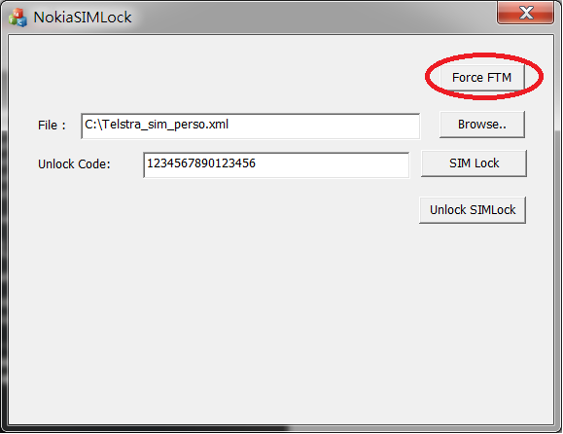

Device Screen

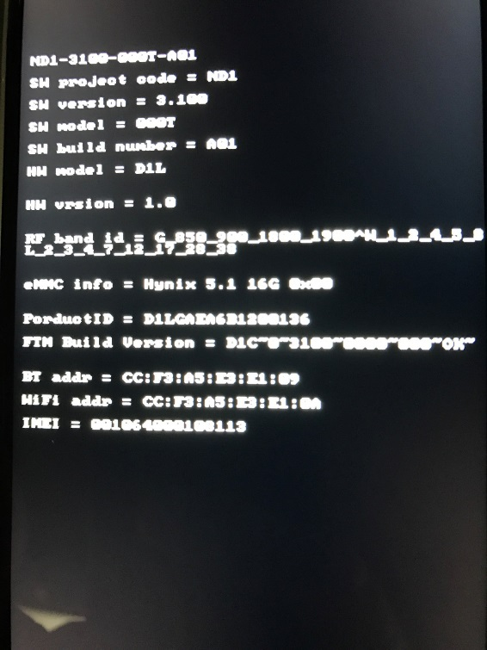

Step 2: Select SIM Perso XML file

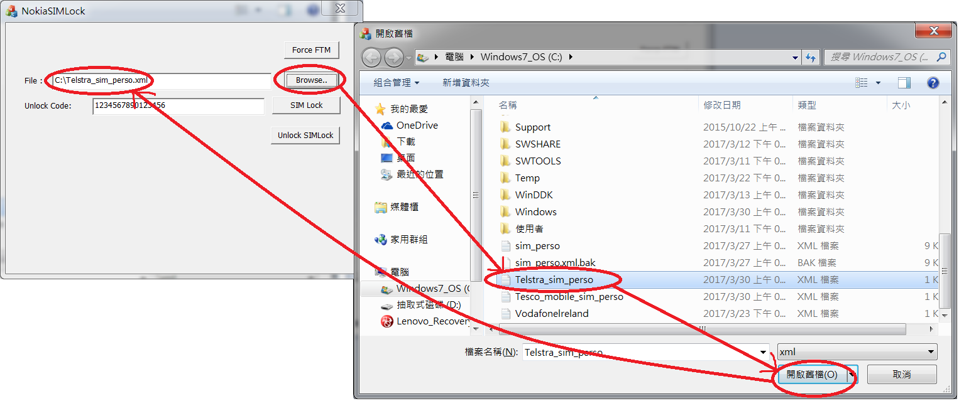

Step 3: Set the Unlock Code

If you don’t have any special request, you can keep this default value to avoid you forget the unlock code.

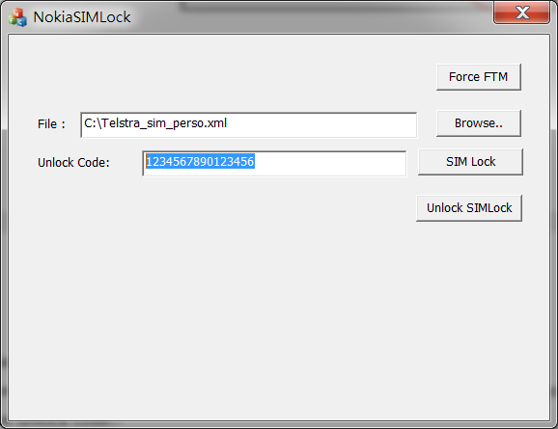

Step 4: Enable SIM Lock

Please click the SIM Lock button to enable the SIM Lock setting with the unlock code.

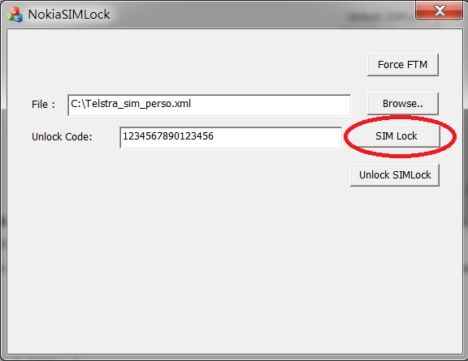

* Unlock SIMLock

Step 1: Make sure the device in the FTM mode.

If the device doesn’t show the FTM screen, please click the Force FTM button to enter FTM mode. Please make sure that the device has entered the FTM mode.

If the device has been FTM mode, skip this step. You can repeat to do SIM Lock and Unlock SIMLock.



Device Screen



Step 2: Set the Unlock Code

If you don’t have any special request, you can keep this default value to avoid you forget the unlock code.



Step 3: Enable SIM Lock

Please click the SIM Lock button to enable the SIM Lock setting with the unlock code.

