Python

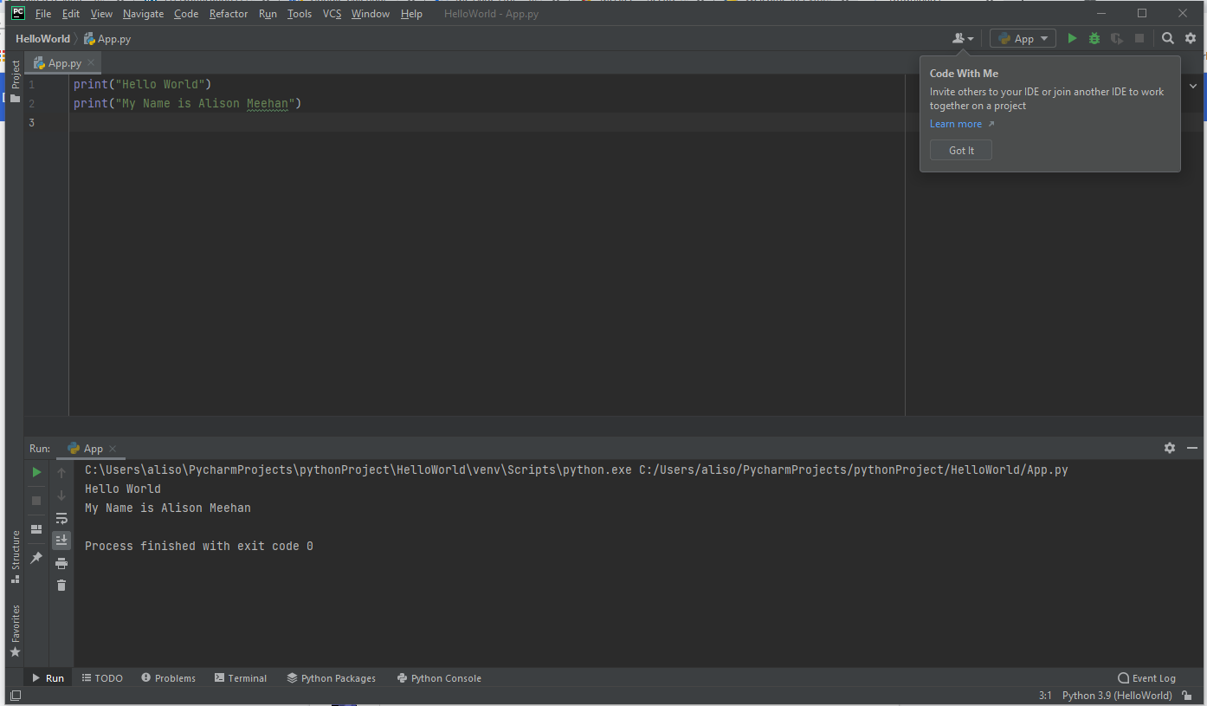

Inputs:

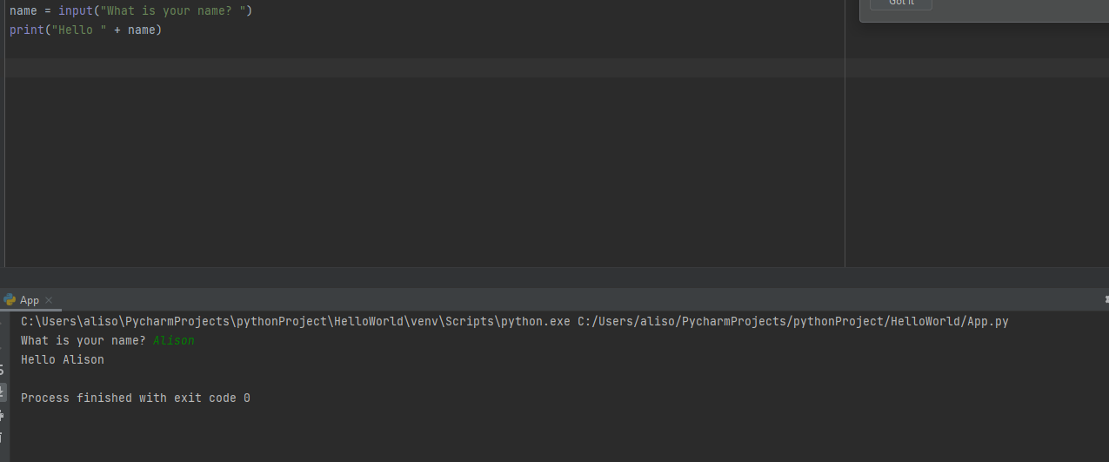

Calculating Age:

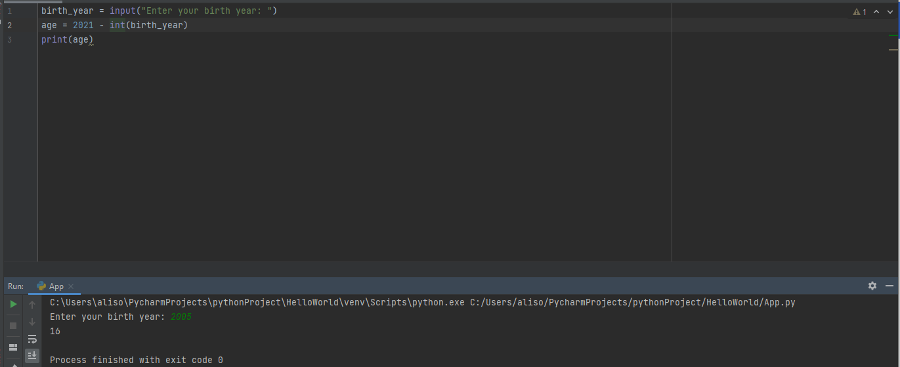

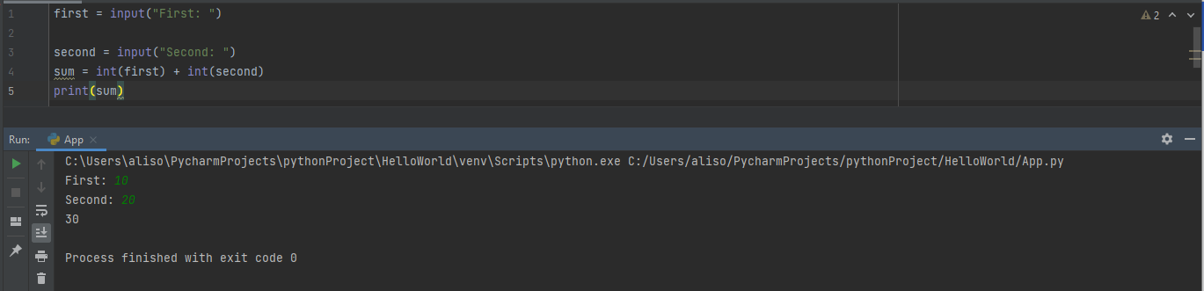

Calculations:

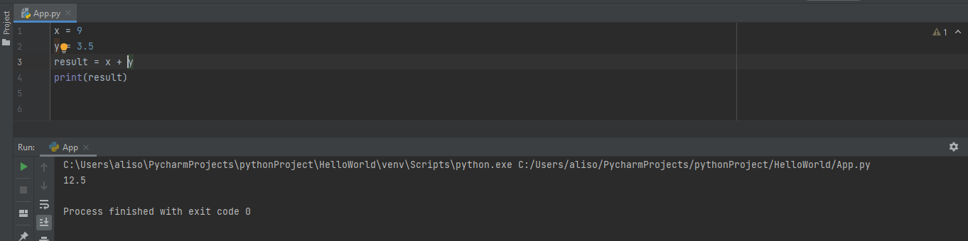

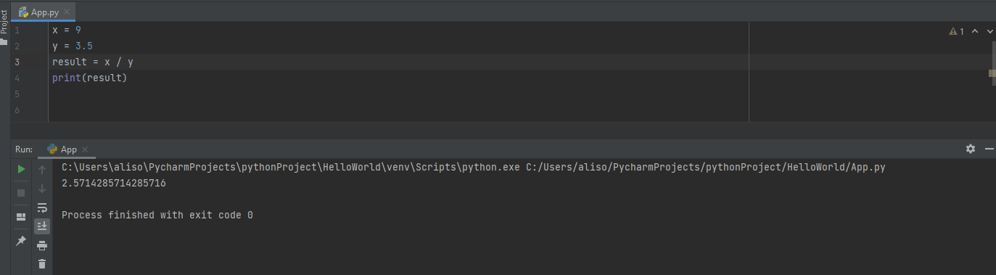

Exponents:

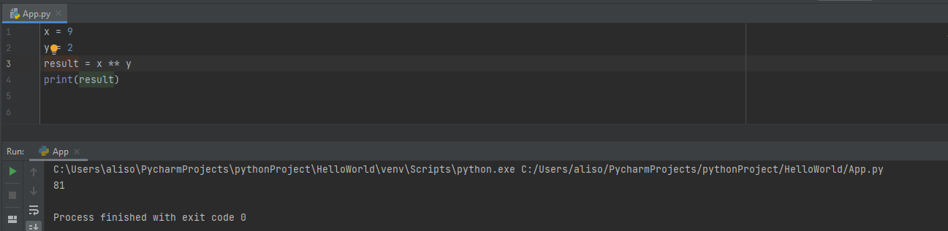

Floor Division:

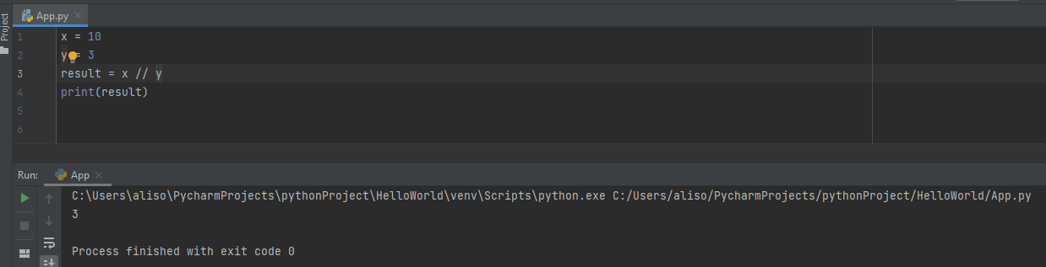

Equations:

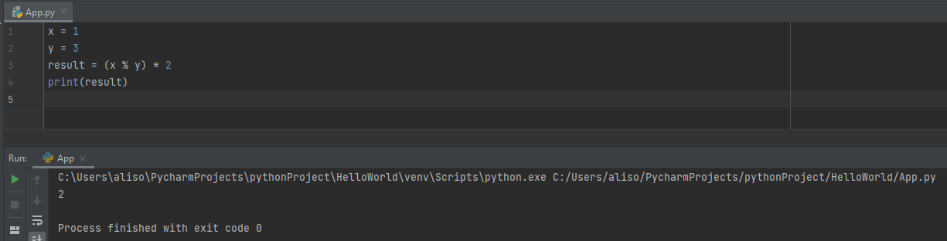

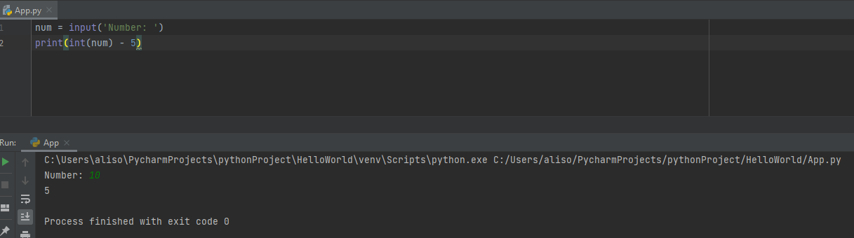

Uppercase Font:

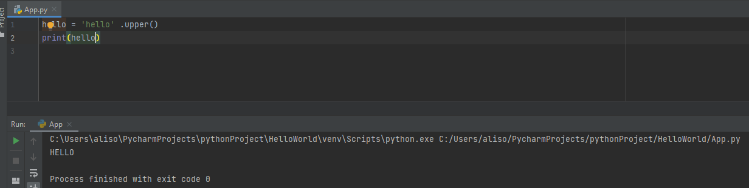

Lowercase:

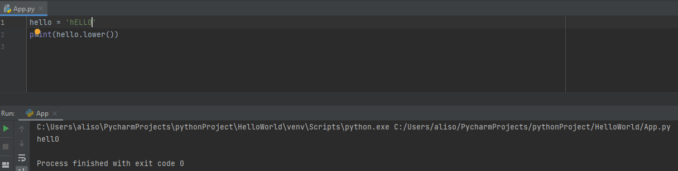

Count string:

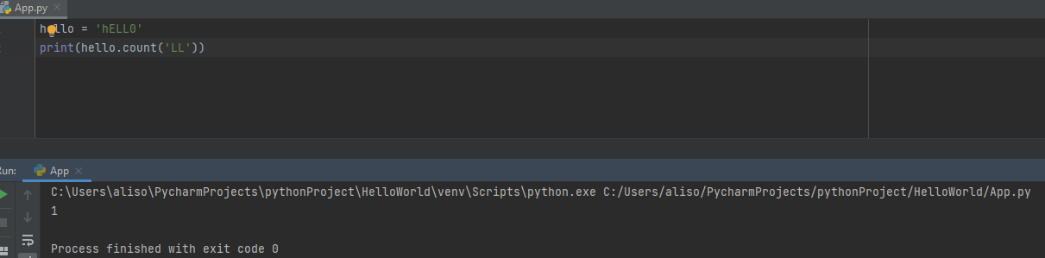

Printing Multiples of a String:

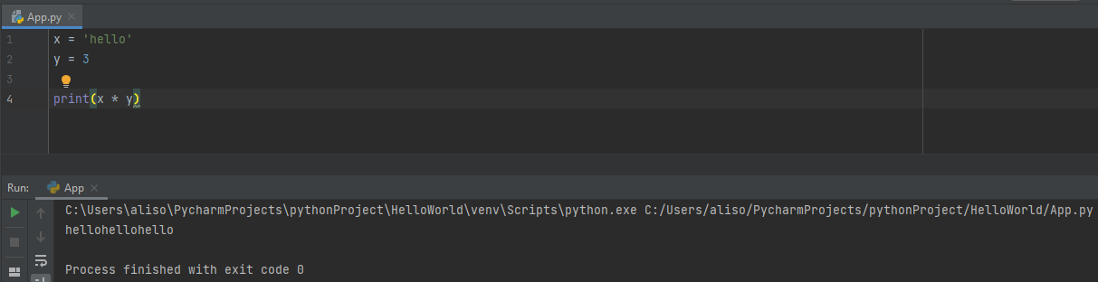

Adding Strings:

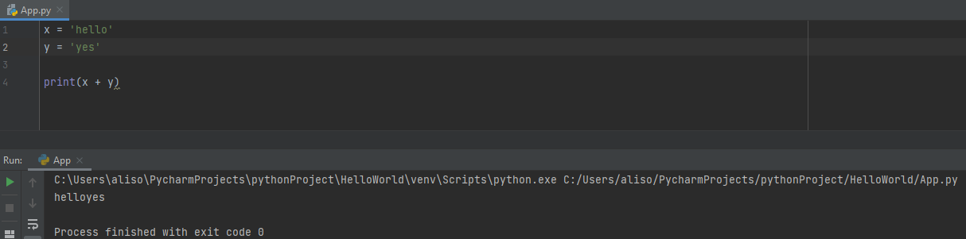

Conditional Operators

Are Two Values Not Equal:

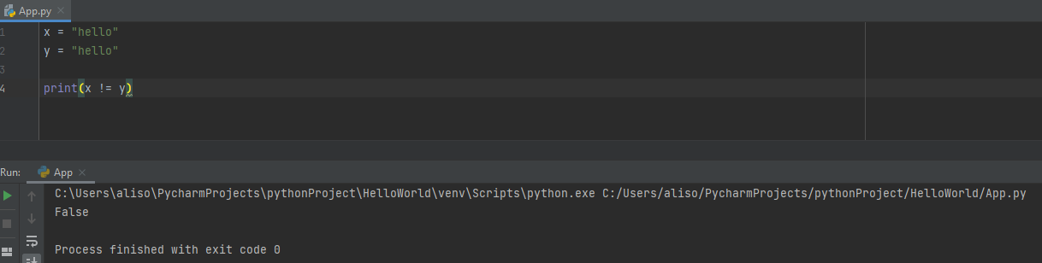

Are Two Values Equal:

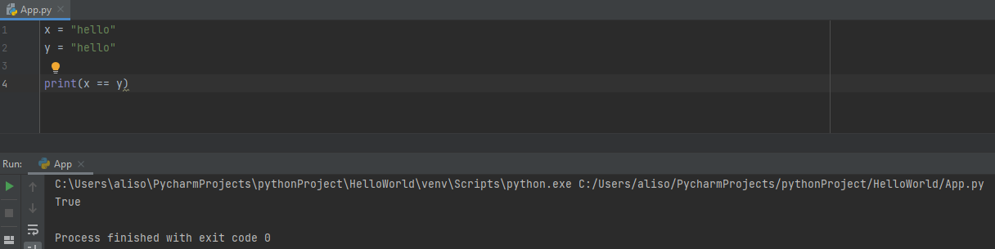

Comparing Ordinal Value of Strings:

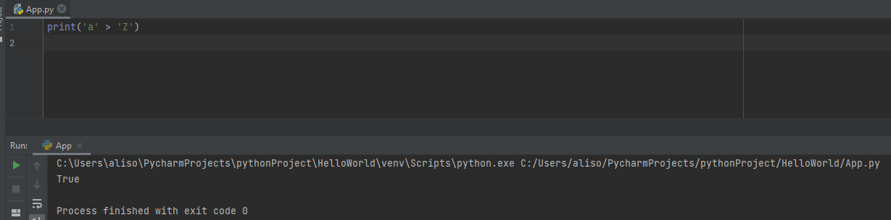

* a = 97, z = 90

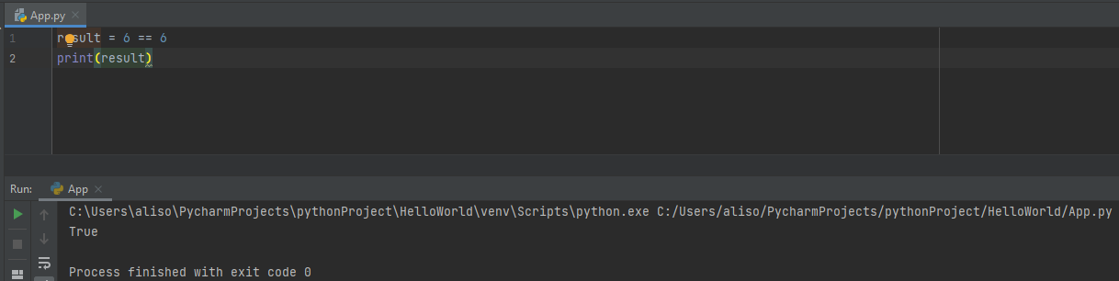

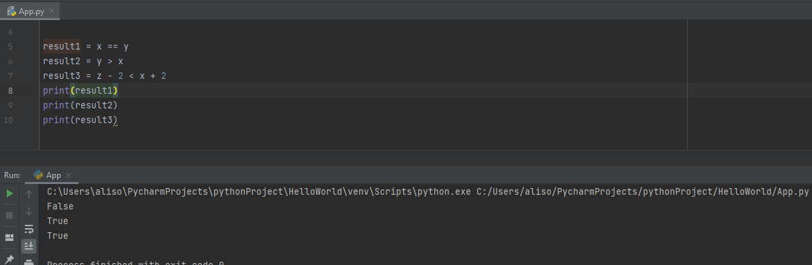

Chained Conditionals:

Or:

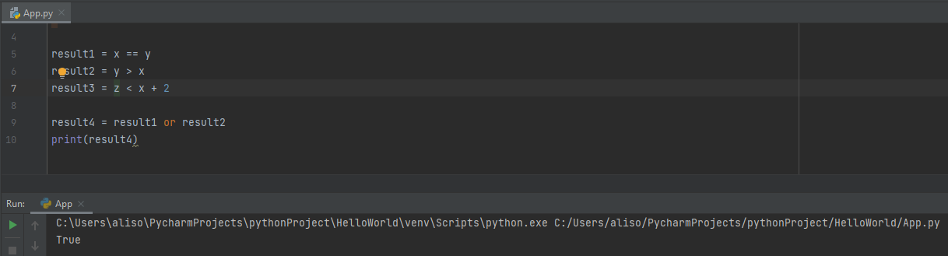

Or Not:

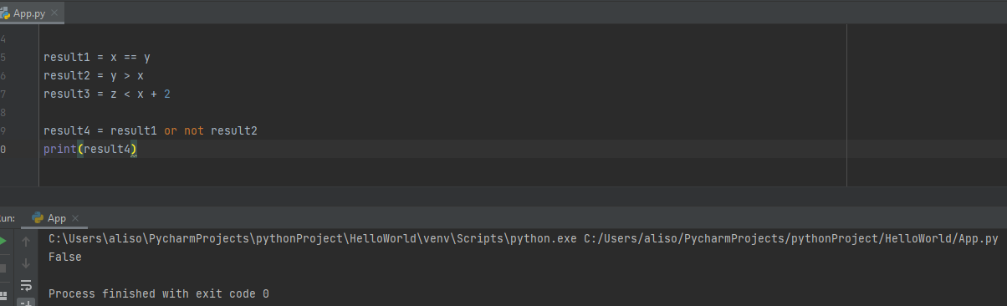

Not False:

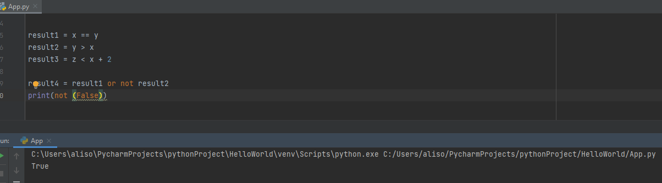

Not True:

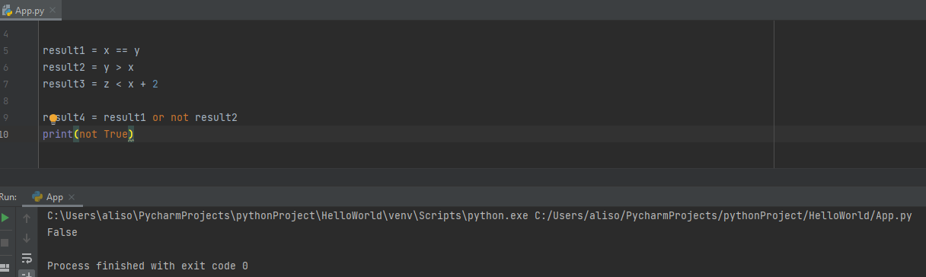

Not False or True:

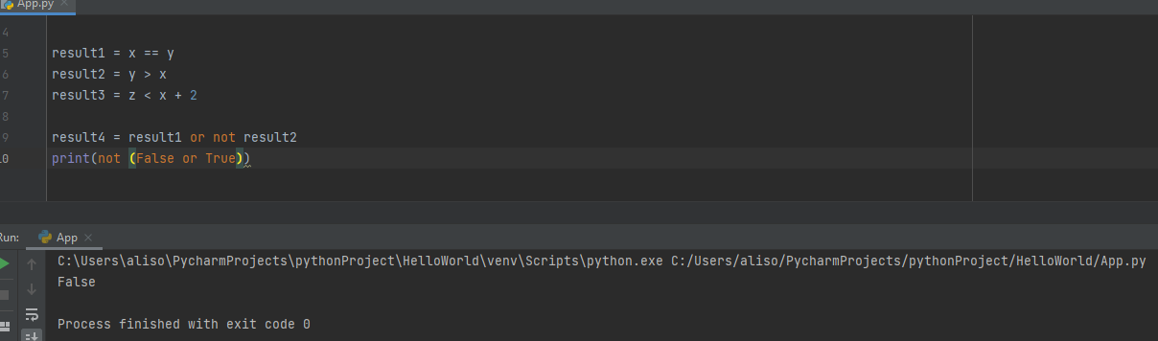

Not False and True:

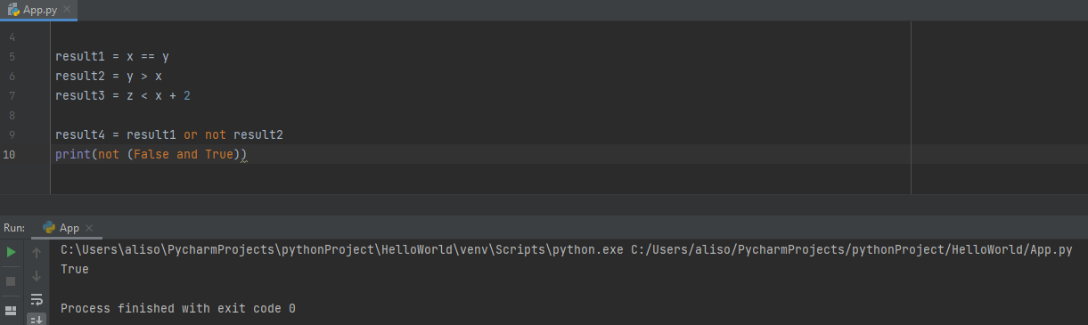

Not, And, Or:

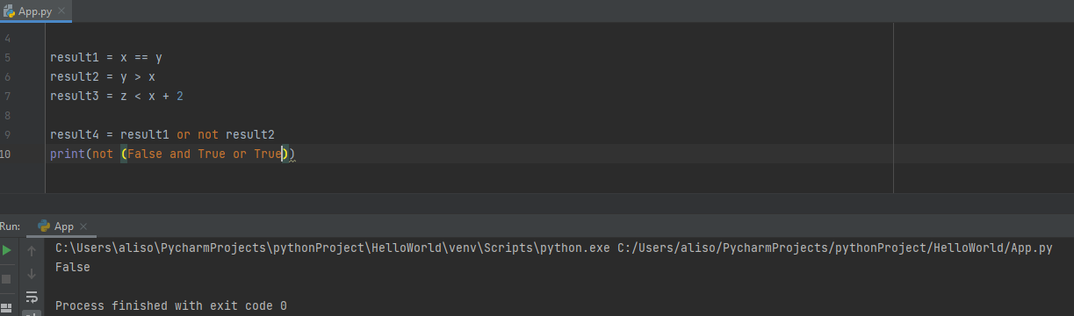

Not is run first, then And, then Or.

If Statement:

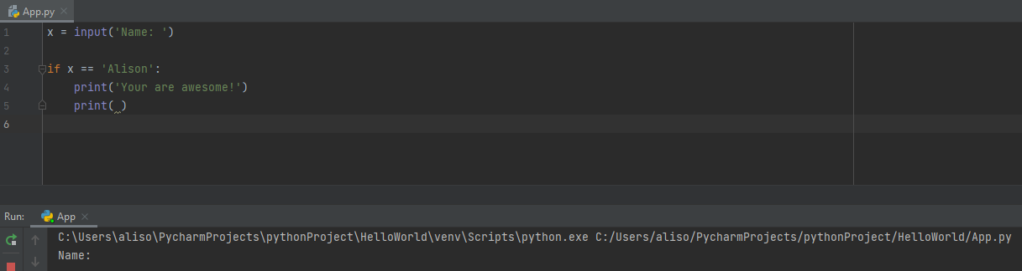

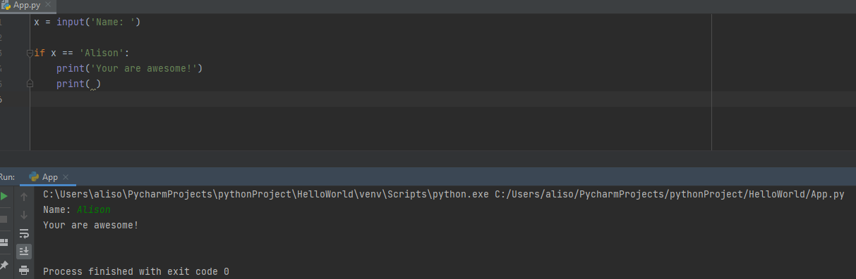

If, Else:

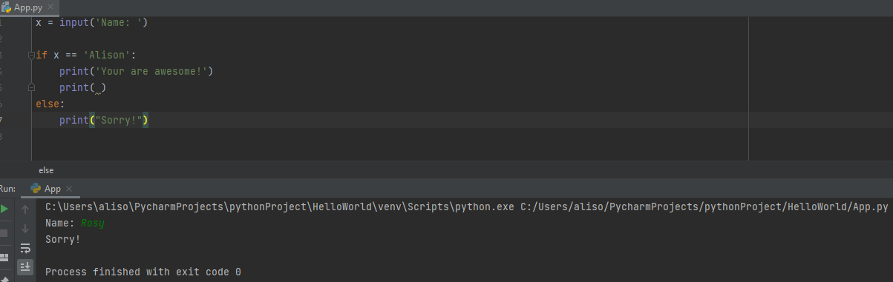

Elif:

