Steps to follow the testing work. I have added necessary setup in postman collections. Below are the steps:
php artisan migrate

php artisan db:seed

php artisan serve

server will start at port 8000 by default.
Postman currently using http://127.0.0.1:8000/
–

- During migration and seed, admin user, user roles and task status will be created.
Admin user: admin@test.com, password: admin@123
- In postman collection “User registration” is responsible to create new users. Please note that, the “role_id” which will be created by “migration”. The role_id’s are “1=> Admin, 2=>Product owner, 3 => Team member” which you have to add in json input. Example:
{
"name": "Test User",
"email": "test22@gmail.com",
"password": "test@123",
"role_id": 2
}
- “User login” collection used to login a user. Please note that, in postman two global variable is declared. The variables are “ADMIN_SESSION_JWT” for all admin access, “USER_SESSION_JWT” is for product owner access. So, while login, you have to copy the token and update those variables current value accordingly to access admin/product_owner level checking.
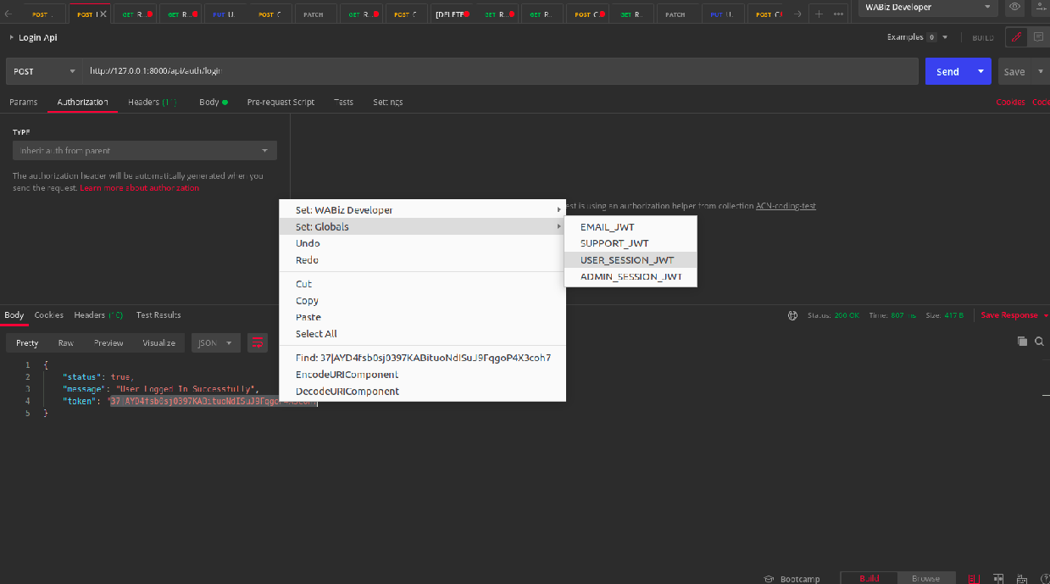
- The collection “Implement Pagination On Project” to be under 2 role. While you check please note the global variable for admin and product owner. Admin can view all projects and product_owner only can view his projects. So please make the token is accurate for each.

