How we collected feedback: We posted a Facebook post on a fisher’s group. The post said that we need 20 survey responses and that it was for a high school class. By alluding to the fact that we are high schoolers doing a school project in finals week, we were able to get 68 responses and flew by the goal of 20.

Visualizations:
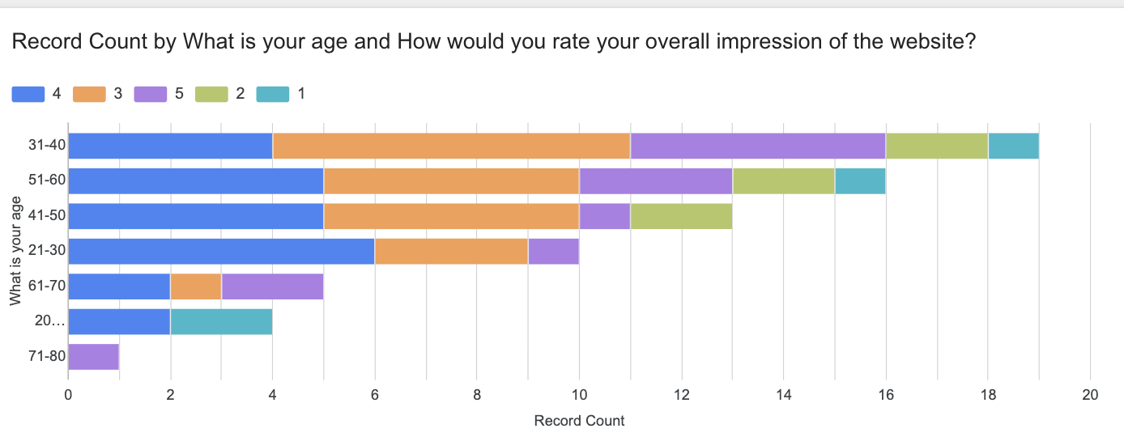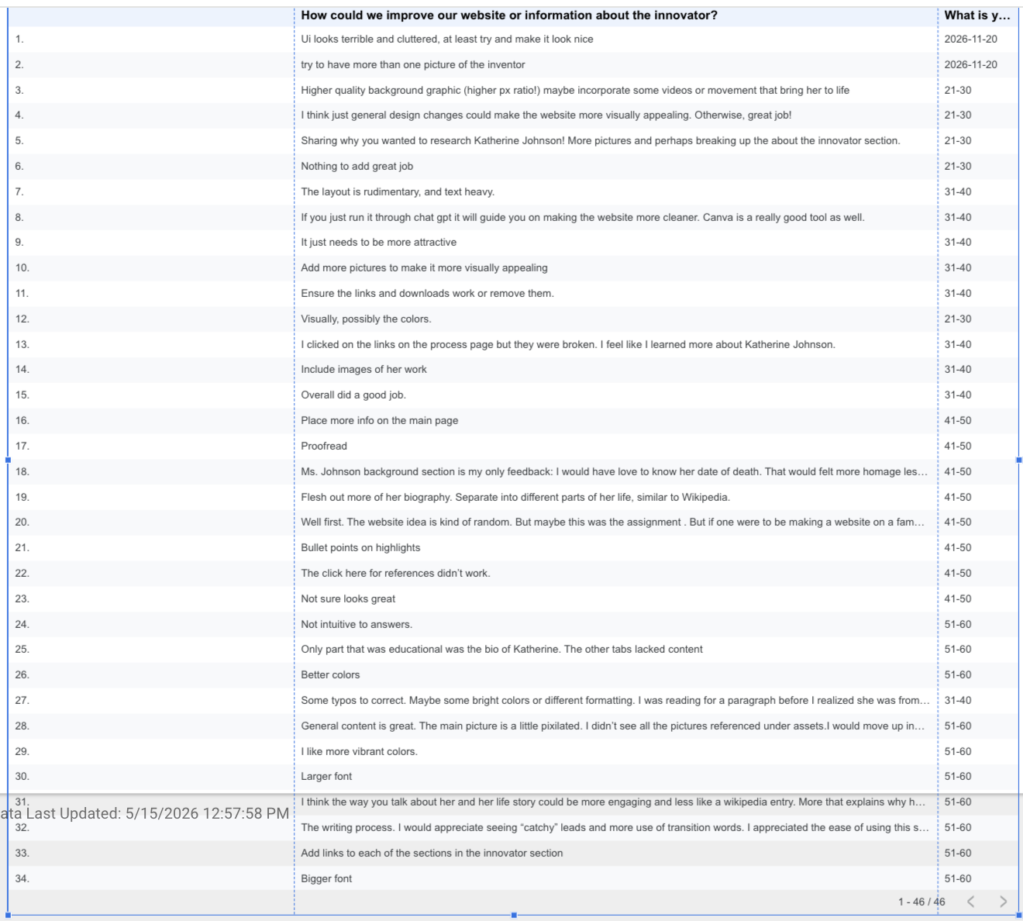

Planned revisions:
The following is changes that we are going to make, because of user feedback we got from survey responses and personal interviews:
-change the colors (interview with Sam)
- add a home button(Multiple Interviews)
- Fix the links(“Ensure the links and downloads work or remove them.”)
- Make text boxes look the uniform(“Well first. The website idea is kind of random. But maybe this was the assignment . But if one were to be making a website on a famous person who was an innovator, i would word and title the website to reflect that. Such as Katherine Johnson one of history s great innovators. The below the title have the tabs that yoh already do. Those were finr. Maybe on the front also include an interesting quote. To go along with her pictures. I would write more, but for some reason when i am typingmy response, i can not see what im typing. The keyboard is coveringit so i apologizes about all the typos! The information youbwrote about her seemed fine. Good luck!”)
- Fix spelling (“Check sentences for grammar and spelling.”)
- Add images(“Include images of her work”)
- Larger font(“Some typos to correct. Maybe some bright colors or different formatting. I was reading for a paragraph before I realized she was from hidden figures! So maybe a catchier opening as well.)”
- Fix UI(“Ui looks terrible and cluttered, at least try and make it look nice”)
- Clear picture(“The main picture is a little pixilated”)
- Citations(“Consolidating info about innovator providing significant relevant details”)
- Break up info(“Break up paragraphs more to make reading easier.”)
- Highlights(“Bullet points on highlights)

https://docs.google.com/spreadsheets/d/1rs4GRpZkRYijFT1NbYLxP7j2He4L6JScijqnILFj_mg/edit?usp=sharing

