Rmarkdown

Sungpil

2017-05-10

# Rmarkdown에 대하여

## Text formatting

문자 모양을 결정합니다

*italic* or *italic*  
**bold** **bold**  
code  
위첨자2 아래첨자2

## Headings

# 1st Level Header

## 2nd Level Header

### 3rd Level Header

## Lists

* Bulleted list item 1
* Item 2
  + Item 2a
  + Item 2b

1. Numbered list item 1
2. Item 2. The numbers are incremented automatically in the output.

## Links and images

<http://rpubs.com/shanmdphd/274885>

[Rpubs](http://rpubs.com/shanmdphd/274885)



피카츄

## Tables

|  |  |
| --- | --- |
| First Header | Second Header |
| Content Cell | Content Cell |
| Content Cell | Content Cell |

## Head of Theoph

knitr::kable(head(Theoph))

|  |  |  |  |  |
| --- | --- | --- | --- | --- |
| Subject | Wt | Dose | Time | conc |
| 1 | 79.6 | 4.02 | 0.00 | 0.74 |
| 1 | 79.6 | 4.02 | 0.25 | 2.84 |
| 1 | 79.6 | 4.02 | 0.57 | 6.57 |
| 1 | 79.6 | 4.02 | 1.12 | 10.50 |
| 1 | 79.6 | 4.02 | 2.02 | 9.66 |
| 1 | 79.6 | 4.02 | 3.82 | 8.58 |

## Plot of Theoph

plot(Theoph$Time, Theoph$conc)

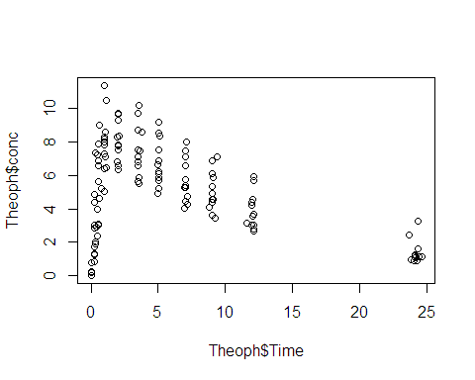

## Rendering

rmarkdown::render("1-example.Rmd")

## Navigation

Ctrl + Alt + J