FEDERATED BIOMEDICAL
COMPUTATION
REFERENCE ARCHITECTURE
A contract-driven, implementation-neutral architecture for distributed biomedical data discovery and local computation
Architecture intent
Enable organizations to reuse open-source building blocks, replace individual implementations, or implement the architecture independently while preserving interoperability through shared contracts.

Version 1.0 | August 2026

Document Control
Field | Value
Document title | Federated Biomedical Computation Reference Architecture
Version | 1.0
Status | Reference architecture and open-source asset catalog
Audience | Enterprise architects, platform engineers, data stewards, security teams, and biomedical informatics leaders
Scope | Federated metadata discovery, job orchestration, local execution, status monitoring, result return, and the open-source reference assets that support implementation
Example implementations | Existing operational platforms (ACR Connect, AI-LAB, and DART) along with new open-source components are used to illustrate the end-to-end workflow. Neither the proprietary platforms nor the open-source components are required to implement the architecture

Executive Summary
This document serves two complementary purposes: it defines a modular reference architecture for coordinating computational workflows across distributed biomedical data environments, and it catalogs the open-source reference assets available to implement or extend that architecture. The architecture keeps operational responsibility for source data and local execution within participating organizations while enabling a central service to define federated jobs, track execution, and receive contract-defined outputs.
The document is intentionally product neutral while also providing a practical implementation resource. Section 5 identifies the published open-source components, metadata index, examples, and supporting utilities, with links to the public sources in Appendix B. ACR Connect, AI-LAB, and DART illustrate how these assets and contracts can be assembled with existing enterprise software into an end-to-end workflow. Conformant alternatives may replace any illustrative platform or open-source component.
Core architectural proposition
Contracts define interoperability. Components implement capabilities. Products assemble those capabilities into operational platforms. New implementations should be able to participate without adopting the complete ACR product stack.

1. Purpose and Scope
The purpose of this reference architecture is to provide a common vocabulary, logical model, integration pattern, and set of contract boundaries for federated biomedical computation. It is designed to support data discovery and algorithm execution across multiple participating sites without making a particular central platform, local platform, repository, runtime, or transport mechanism mandatory.

1.1 In scope
- Creation and ingestion of conformant biomedical metadata indexes.
- Central definition and decomposition of multi-site federated jobs.
- Retrieval of site-specific jobs by trusted local agents.
- Local policy enforcement and execution of approved workloads.
- Continuous status reporting and contract-defined result return.
- Replaceability of implementations through shared metadata, job, status, result, error, and algorithm-package contracts.
- Cross-cutting security, privacy, provenance, governance, audit, and operational controls.

1.2 Out of scope
- A requirement to deploy ACR Connect, AI-LAB, or DART.
- A complete production security design or authorization policy for every deployment.
- A universal biomedical data model beyond the referenced ARPA-H-BDF metadata specification.
- A single mandated transport protocol, message broker, repository, cloud provider, or execution runtime.
- Transfer of source clinical data to a central environment unless separately authorized and designed.

1.3 Definitions
- DART (Data Archive and Research Toolkit) - is a resource managed by the ACR to conduct research. DART hosts a variety of open source and commercial tools for multi-modal research. In the context of creating federated jobs, DART is used as the Central Orchestrator.
- ACR CONNECT – is an infrastructure managed by the ACR that includes a variety of cloud and local components designed to facilitate bi-directional communication including local data ingestion, data processing, data upload, etc. In the context of federated learning, ACR Connect serves as an interface to local systems and a “host” for the relevant workflow applications (e.g. AI-Lab, Federated Learning).
- AI-LAB – is an application hosted on ACR Connect in the context of Federated Learning. It serves as the local performer that receives and executes federated jobs on behalf of a Central Orchestrator.
- Federated Network – is an application designed to index and manage local data repositories for use in federated workflow. The Federated Network application servers the roles of index creation and metadata ingestion.

For additional terminology, see Appendix A.

2. Reference Architecture Overview
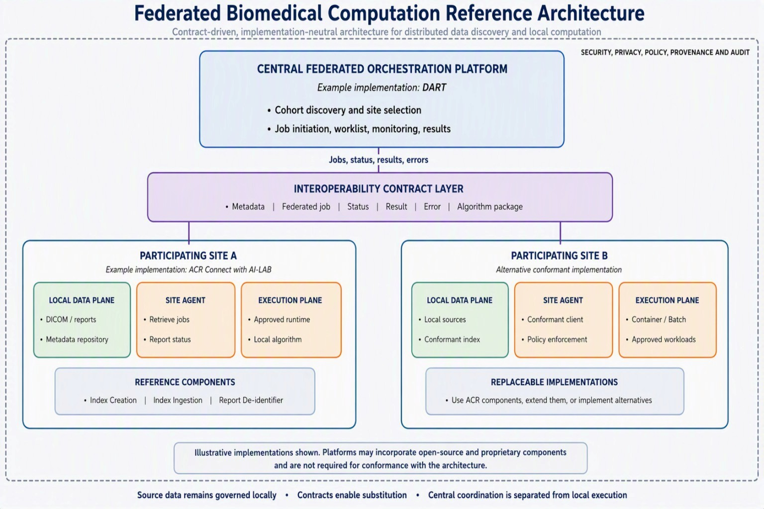

Figure 1. Logical reference architecture. Product names are shown only as example implementations.
The logical architecture separates central coordination from site-level data access and execution. The contract layer defines the information exchanged between independently governed implementations. The security and governance plane applies across all components and interfaces.

3. Architectural Principles
Principle | Implication
Contract-first interoperability | Shared schemas and behavior are governed independently from individual implementations.
Implementation neutrality | Central platforms, local agents, repositories, and runtimes are replaceable when they conform to the applicable contracts.
Locality of governed data | Source imaging and clinical data are processed within the participating environment unless an approved design explicitly permits movement.
Separation of planes | Metadata handling, orchestration, execution, and governance responsibilities remain distinguishable even when implemented in one product.
Least necessary exchange | Interfaces expose only the job instructions, status, errors, provenance, and results required for the authorized workflow.
Versioned evolution | Contracts carry explicit versions and compatibility rules so that producers and consumers can evolve independently.
Observable operation | Job state, execution state, errors, provenance, and audit events are visible enough to support operations and accountability.
Policy at the site boundary | Each participating organization retains the ability to validate, approve, reject, or constrain work before local execution.

4. Architecture Planes and Responsibilities

4.1 Data plane
The data plane prepares, indexes, locates, transforms, and supplies authorized local data to approved computational workloads. The data plane includes source systems, metadata extraction, metadata conformance, index ingestion, searchable repositories, local cohort resolution, and optional de-identification or transformation services.
- Access local DICOM objects, reports, and other approved biomedical sources.
- Extract and normalize metadata into a shared specification.
- Store and query metadata within a locally governed repository.
- Resolve cohort criteria against local indexes.
- Provide approved inputs to local execution environments.
- Produce only the result outputs authorized for return.

4.2 Central control plane
The central control plane coordinates federated work. It defines a federated job, identifies participating sites, creates site-specific work items, tracks state, receives contract-defined outputs, and presents status and results to authorized users.
- Cohort and site selection.
- Federated job definition and validation.
- Site-specific job generation.
- Job state and status management.
- Result receipt, validation, and aggregation.
- User-facing search, worklist, monitoring, and result presentation.

4.3 Local control plane
The local control plane is the trusted mediation layer between the central service and the participating environment. A site agent retrieves or receives jobs, validates instructions, applies local policy, initiates execution, reports status, and packages permitted results.

4.4 Execution plane
The execution plane runs an approved workload near the governed data. Implementations may use containers, batch systems, locally installed executables, or other approved runtimes. The architecture requires a defined invocation and result boundary but does not prescribe a single runtime.

4.5 Security and governance plane
Security and governance are cross-cutting responsibilities rather than a standalone product. Deployments should define identity, authentication, authorization, site policy, workload approval, artifact integrity, secrets handling, network controls, logging, audit, retention, incident response, and privacy review. Specific controls are deployment decisions and should be documented in a solution architecture.

5. Open-Source Components
This section is the implementation asset catalog that accompanies the reference architecture. It identifies the published open-source components, metadata index and examples, and supporting utility that correspond to the architecture’s data, control, contract, and local-processing capabilities. The source package or asset in each row links to the applicable public reference in Appendix B.
Public-facing capability | Current package or asset | Architectural role
DICOM Metadata Index Creator | Index-Creation (Appendix B, Ref. 4) | Reads DICOM files and produces JSON metadata conforming to the ARPA-H-BDF metadata specification.
BDF Metadata Index and Examples | ARPA-H-BDF index and sample submissions (Appendix B, Ref. 2) | Publishes the BDF index definition with example clinical, imaging-study, and image-series submissions to illustrate the metadata structure and support implementation and validation.
Metadata Index Ingestion Pipeline | Index-Ingestion (Appendix B, Ref. 4) | Parses a conformant JSON index and prepares records for a searchable JSON repository such as Elasticsearch or MongoDB.
Federated Orchestration Core | Federated-Central-Orchestration (Appendix B, Ref. 4) | Provides representative central business logic for federated job creation, site-specific work, status tracking, and result receipt.
Federated Job Contracts | Federated-data-contracts (Appendix B, Ref. 4) | Defines the shared data structures exchanged between central orchestration and local site orchestration.
Federated Site Agent | Federated Client Processing (Appendix B, Ref. 4) | Demonstrates job polling or retrieval, local execution initiation, status updates, and final payload return.
Radiology Report De-identification Utility | MIDRC/ACR radiology report deidentifier (Appendix B, Ref. 3) | Provides an optional local privacy transformation for CSV, XLSX, or JSON report inputs, with container and Windows executable packaging.

Naming guidance
Keep existing repository and package names for compatibility. Use the capability-oriented titles above in public architecture material so readers understand the role of each component without assuming adoption of an ACR product.

6. Contract Architecture
The contract layer is the stable interoperability boundary. Contracts should be machine-readable, versioned, testable, and governed separately from individual codebases. The following contract families are recommended.
Contract | Purpose | Representative content
Metadata contract | Represents indexed biomedical data consistently across sites and repositories. | Identifiers, imaging and clinical metadata, data types, permitted values, provenance, required and optional fields, schema version.
Federated job contract | Expresses the work the central orchestrator asks a participating site to perform. | Federated and site job identifiers, site, algorithm reference, cohort criteria, parameters, output specification, timestamps.
Job status contract | Communicates lifecycle state and operational progress. | State, percent or stage when supported, timestamps, safe diagnostics, retryability, correlation identifiers.
Result contract | Defines the permitted output returned from a site. | Aggregate result, metrics, derived metadata, artifact references, provenance, completion state.
Error contract | Provides predictable failure handling across heterogeneous implementations. | Category, code, message, source, retryability, identifiers, safe diagnostic context.
Algorithm package contract | Defines how an approved executable artifact is identified and invoked. | Artifact identifier and version, runtime type, entry point, expected inputs and outputs, parameters, integrity information, resource expectations.

6.1 Illustrative federated job payload
{
"contractVersion": "1.0",
"federatedJobId": "job-123",
"siteJobId": "site-job-456",
"siteId": "site-a",
"algorithm": {
"identifier": "algorithm-id",
"version": "1.2.0",
"executionType": "container"
},
"cohort": {
"definitionId": "cohort-789",
"criteria": {}
},
"parameters": {},
"outputSpecification": {},
"submittedAt": "ISO-8601 timestamp"
}
Illustrative only. Final fields and semantics should be reconciled to the actual open-source contract classes and published as a versioned schema.

6.2 State model
A production contract should distinguish the federated job, site job, local execution, and result-transfer states. Suggested states include Available, Retrieved, Accepted, Rejected, Queued, Running, Completed, Failed, Cancelled, and Result Submitted. These are recommended design terms, not assertions about the current libraries.

7. Representative Interaction Flow
Step | Control or data-plane activity | Primary contract
1 | A user or authorized service defines a cohort and federated job in the central platform. | Metadata and federated job
2 | The central orchestrator validates the request and creates site-specific jobs. | Federated job
3 | The local site agent authenticates and retrieves an eligible site job. | Federated job
4 | The site validates the instruction, applies local policy, and accepts or rejects the job. | Status and error
5 | The site resolves cohort criteria against the local metadata index. | Metadata
6 | The site prepares authorized inputs and invokes the approved workload. | Algorithm package
7 | The site reports lifecycle updates while execution proceeds. | Status
8 | The site validates, packages, and returns the permitted output. | Result or error
9 | The central orchestrator updates federated status and aggregates or presents results. | Status and result
10 | Both environments retain applicable provenance and audit records. | Audit events defined by deployment

8. Example Implementation Mapping
Reference capability | Open-source or replaceable element | Illustrative ACR implementation
DICOM metadata extraction | Index-Creation or conformant alternative | ACR Connect data preparation workflow
Metadata ingestion | Index-Ingestion NiFi flow or alternative adapter | Local searchable repository pipeline
Metadata repository | Elasticsearch, MongoDB, or another conformant repository | Deployment-specific repository
Central orchestration logic | Federated-Central-Orchestration or alternative service | DART
Shared job and result models | Federated-data-contracts | DART-to-site interface
Local orchestration agent | Federated Client Processing or alternative client | ACR Connect Remote Job Manager
Local execution | Approved runtime satisfying the algorithm package contract | AI-LAB and associated container services
Report de-identification | MIDRC/ACR utility or approved alternative | ACR Connect utility deployment
User interaction | Replaceable central user experience | DART search, worklist, initiation, monitoring, and results

Important distinction
ACR Connect, AI-LAB, and DART illustrate how the capabilities can be assembled. The products are not prerequisites for conformance, and the architecture does not imply that the products are open source.

9. Conformance Model
Conformance should be assessed at explicit boundaries rather than declared for an entire product without qualification. A component may conform to one or more contracts and roles.
Conformance profile | Minimum evidence
Metadata producer | Produces documents that validate against the designated metadata schema and declared version.
Metadata consumer | Accepts conformant metadata, handles required and optional fields correctly, and reports validation failures predictably.
Central orchestrator | Produces conformant site jobs and consumes status, result, and error messages according to declared versions.
Site agent | Consumes conformant jobs and produces conformant status, result, and error messages.
Execution adapter | Invokes approved algorithm packages according to the declared package contract and captures defined outputs.
End-to-end implementation | Demonstrates interoperable operation across at least one central orchestrator and one independently governed site implementation.

9.1 Recommended conformance assets
- Published JSON Schema, OpenAPI, or equivalent machine-readable definitions.
- Positive and negative example payloads.
- Contract validation test suites.
- Compatibility and deprecation policy.
- Reference error catalog and lifecycle state model.
- Implementation-neutral sequence diagrams.
- A conformance matrix showing required, optional, and conditional capabilities.

10. Quality Attributes and Design Considerations
Quality attribute | Architecture consideration
Interoperability | Use explicit schemas, enumerations, identifiers, versions, and compatibility rules.
Security | Authenticate services, authorize jobs, protect credentials, validate artifacts, and minimize exposed interfaces.
Privacy | Keep identifiable source data within approved boundaries and define result disclosure controls.
Reliability | Use idempotent operations, correlation identifiers, retries with limits, and durable state where appropriate.
Scalability | Separate federated-job state from site-job state and support independent scaling of central and local services.
Observability | Capture structured logs, metrics, traces or correlation identifiers, lifecycle events, and safe diagnostics.
Portability | Avoid embedding product-specific assumptions in contracts; isolate repository and runtime adapters.
Maintainability | Govern contracts, reference code, and product implementations as separate release concerns.
Reproducibility | Record algorithm version, configuration, cohort definition, execution context, and result provenance.
Usability | Present federated and site-level state clearly; distinguish incomplete, failed, and completed-with-partial-results outcomes.

11. Governance and Lifecycle
The architectural value of the contracts depends on disciplined governance. Contract ownership should be distinct from ownership of any central or local product implementation. Release decisions should consider compatibility, migration, validation assets, and operational impact across independently governed sites.
Governance concern | Recommended practice
Ownership | Name accountable stewards for each contract family and for the reference architecture.
Versioning | Use explicit semantic or equivalent versioning and publish compatibility expectations.
Change control | Review proposed additions, removals, and semantic changes with producer and consumer representatives.
Deprecation | Publish replacement paths and a defined support policy before removing contract elements.
Testing | Maintain automated schema validation, reference payloads, and cross-implementation interoperability tests.
Security review | Review new job capabilities, payload fields, result types, and artifact mechanisms for security and privacy impact.
Documentation | Keep conceptual architecture, contract specifications, examples, and implementation guidance synchronized.
Provenance | Record the contract version, component version, and algorithm version used for each job and result.

12. Adoption Patterns
Pattern | Description | Best fit
Reuse | Deploy one or more ACR open-source reference components with limited adaptation. | Organizations seeking a faster implementation path.
Extend | Build adapters, new repositories, or new execution environments around the shared contracts. | Organizations with established local platforms.
Replace | Substitute independently developed central or local components that honor the same contracts. | Vendors and institutions requiring product choice.
Implement independently | Use the planes, roles, and contracts as the blueprint for a separate implementation. | Consortia or programs standardizing interoperability without adopting ACR products.

Appendix A. Terminology
Term | Definition
Central federated orchestrator | A service that defines and coordinates work across participating sites and maintains federated job state.
Participating site | An independently governed environment that holds data or compute resources and executes authorized site-specific work.
Site agent | A trusted local component that mediates between the central orchestrator and local execution services.
Federated job | A centrally coordinated unit of work that may be decomposed into site-specific jobs.
Site job | The portion of a federated job addressed to one participating site.
Contract | A machine-readable definition of the structure, semantics, behavior, and obligations at an interface.
Data plane | Capabilities that prepare, index, query, transform, and process biomedical data.
Control plane | Capabilities that define, dispatch, monitor, and complete federated jobs.
Execution plane | Capabilities that invoke and monitor approved algorithms within a participating environment.
Conformance | Demonstrated adherence to a defined contract, role, or profile.
Reference component | Reusable code that demonstrates or implements a capability without defining the only valid implementation.
Example implementation | A product or deployment used to illustrate the architecture but not required for conformance.

Appendix B. Public References
1. ARPA-H Biomedical Data Fabric Toolbox. Describes the program goal of connecting biomedical research data across disparate sources and advancing data collection, multi-source analysis, exploration, privacy-preserving access, and generalizability.
https://arpa-h.gov/explore-funding/programs/arpa-h-bdf-toolbox
2. ACR GitHub repository. Contains the BDF index workbook, sample clinical and imaging submissions, an end-to-end workflow PDF, and a project white paper.
https://github.com/ACRCode/ARPA-H-BDF
3. MIDRC/ACR Radiology Report De-identifier. Describes accepted CSV, XLSX, and JSON inputs and container and Windows executable usage.
https://devhub.acr.org/home/midrc-acr-radiology-report-deidentifier
4. ACR Developer Hub Federated Network Components. Documents the open-source federated network assets, including the C#/.NET Index-Creation, Federated-Central-Orchestration, Federated-data-contracts, and Federated Client Processing libraries.
https://devhub.acr.org/home/federated-network-components

