canakinumab (97) 8836

Structure

Light chain / Chaîne légère / Cadena ligera

1 EIVLTQSPDF QSVTPKEKVT ITCRASQSIG SSLHWYQQKP DQSPKLLIKY ASQSFSGVPS
61 RFSGSGSGTD FTLTINSLEA EDAAAYYCHQ SSSLPFTFGP GTKVDIKRTV AAPSVFIFPP
121 SDEQLKSGTA SVVCLLNNFY PREAKVQWKV DNALQSGNSQ ESVTEQDSKD STYSLSSTLT
181 LSKADYEKHK VYACEVTHQG LSSPVTKSFN RGEC*

Heavy chain / Chaîne lourde / Cadena pesada

1 QVQLVESGGG VVQPGRSLRL SCAASGFTFS VYGMNWVRQA PGKGLEWVAI IWYDGDNQYY
61 ADSVKGRFTI SRDNSKNTLY LQMNGLRAED TAVYYCARDL RTGPFDYWGQ GTLVTVSSAS
121 TKGPSVFPLA PSSKSTSGGT AALGCLVKDY FPEPVTVSWN SGALTSGVHT FPAVLQSSGL
181 YSLSSVVTVP SSSLGTQTYI CNVNHKPSNT KVDKRVEPKS CDKTHTCPPC PAPELLGGPS
241 VFLFPPKPKD TLMISRTPEV TCVVVDVSHE DPEVKFNWYV DGVEVHNAKT KPREEQYNST
301 YRVVSVLTVL HQDWLNGKEY KCKVSNKALP APIEKTISKA KGQPREPQVY TLPPSREEMT
361 KNQVSLTCLV KGFYPSDIAV EWESNGQPEN NYKTTPPVLD SDGSFFLYSK LTVDKSRWQQ
421 GNVFSCSVMH EALHNHYTQK SLSLSPGK*

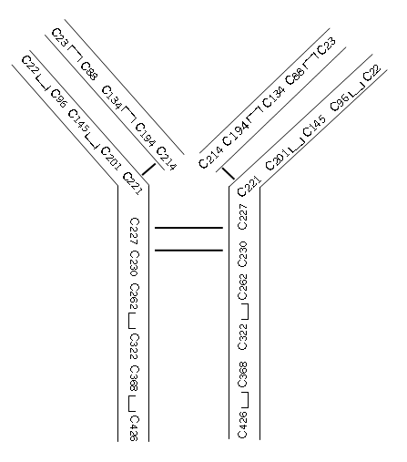

Molecular formula C₆₄₅₂H₉₉₅₈N₁₇₂₂O₂₀₁₀S₄₂

Description
immunoglobulin G1, anti-[Homo sapiens interleukin 1, beta (IL1B)] human monoclonal ACZ885; gamma1 heavy chain (Homo sapiens VH-IGHG1*03) (221-214’)-disulfide with kappa light chain (Homo sapiens V-KAPPA-IGKC*01); (227-227’’:230-230’’)-bisdisulfide dimer

