Flocking

Alex Coli

University of St Andrews

17/01/2025

Supervisor: Simon Dobson
Abstract

An investigation into simulating animal flocking behaviour.
I’m looking to experiment with topological distance rather than metric distance for how birds react to each-other in hopes of more accurately capturing bird behaviour and also look into how limiting birds field of view affects the ease with which flocks form.

Declaration

I declare that the material submitted for assessment is my own work except where credit is explicitly given to others by citation or acknowledgement. This work was performed during the current academic year except where otherwise stated.
The main text of this project report is 3107 words long, including project specification and plan.
In submitting this project report to the University of St Andrews, I give permission for it to be made available for use in accordance with the regulations of the University Library. I also give permission for the title and abstract to be published and for copies of the report to be made and supplied at cost to any bona fide library or research worker, and to be made available on the World Wide Web. I retain the copyright in this work.
Contents

- Introduction
- Context Survey
- Ethics
- Design
- Implementation
- Testing
- Evaluation
- Conclusion
- Bibliography
Introduction

Many animals display synchronised behaviour where large swarms will work together to achieve
some goal. Examples include bird flocks and fish shoals, fireflies blinking in sync, ants forming
roads etc.
How they achieve this without a unifying leader using only relatively simple instructions at the
individual level is of great interest for multiple purposes, such as ecology as well as synchronising
and automating drone swarms. For space missions for example singular independent crafts are
vulnerable to random failures and strikes from micrometeorites incentivising the use of a swarm of
crafts that can work together. It’s also of interest to animation and creating realistic good looking flocks.
Context Survey

Flocking in animals is coordinated group behaviour arising from many individuals working together for some larger goal. It happens naturally without organisation by any leader or such based on simple instructions known by each individual. In casual language flocking typically refers to birds but for our purposes here it will refer to any leaderless synchronised behaviour in animals.

Examples include the aforementioned birds moving in large synchronised groups such as murmurations of starlings flying in large patterns, fish shoals which move together for protection against predators, some firefly species flashing their lights in sync to attract mates and many others, including land bound animals moving in herds.

The focus of this research is the simulation of this behaviour and so naturally the question arises: how to simulate this? The obvious starting point is to look to how the animals do it.

Closest Neighbours and Topological Distance

In 1995 a paper by Tamas Vicsek et al [3] introduced a simple model for self organising systems made up of simple particles, such as a flock of animals but also physical systems such as the spin of atoms in a magnet. I will discuss this paper further elsewhere but for now one limitation of this model in the context of birds is that it uses the physical distance between birds: individuals track all birds within a certain radius of themselves resulting in a loss of cohesion at lower densities. This is however not the case for real birds, where flocks can swell and contract with no change in cohesion.

This brings us to a 2008 field study on starling flocks [1]. Starlings are very social birds which form huge flocks of thousands of birds. These "murmurations" then take on different shapes. The researchers in this study captured footage of large murmurations at their roosting site of Termini railway station in Rome, Italy. Analysing these recordings they found that birds actually track only a limited number of their closest neighbours, 6 to 7, not all birds in a certain radius, and that rather than metric distance the birds use topological distance, tracking the closest birds regardless of metric distance.
They also found that the birds largely did not track closest neighbours in the direction of motion, most likely due to starlings having a lateral field of view (their eyes are on the sides of their heads). This introduces interesting room for experimentation in the simulator: seeing how differing fields of view affect the ability to maintain a flock, the much narrower field of view of forward facing eyes in particular.

Simulation

The Vicsek paper mentioned prior [3] is a simple starting point when considering simulation.
In this model all particles move with constant absolute velocity (constant speed) and time progresses in discrete increments, with each individual's movement calculated at each increment.

The Position of a particle i is updated in time t according to the following formula:
x_{i}(t+1) = x_{i}(t) + v_{i}(t)Δt
where the velocity of a particle has an absolute value v and a direction given by the angle θ(t+1) which is obtained by:
θ(t+1) = <θ(t)>_{r} + Δθ
where <θ(t)>_{r} is the average angle of the birds in radius r around the given particle. Δθ represents noise and is a random number chosen in the interval [-n/2, n/2].
The adjustable variables in this system are n (noise), p (density of particles) and v (absolute velocity of particles).
p is given by
p = N/L²
where N is number of birds and L is the linear size of the area

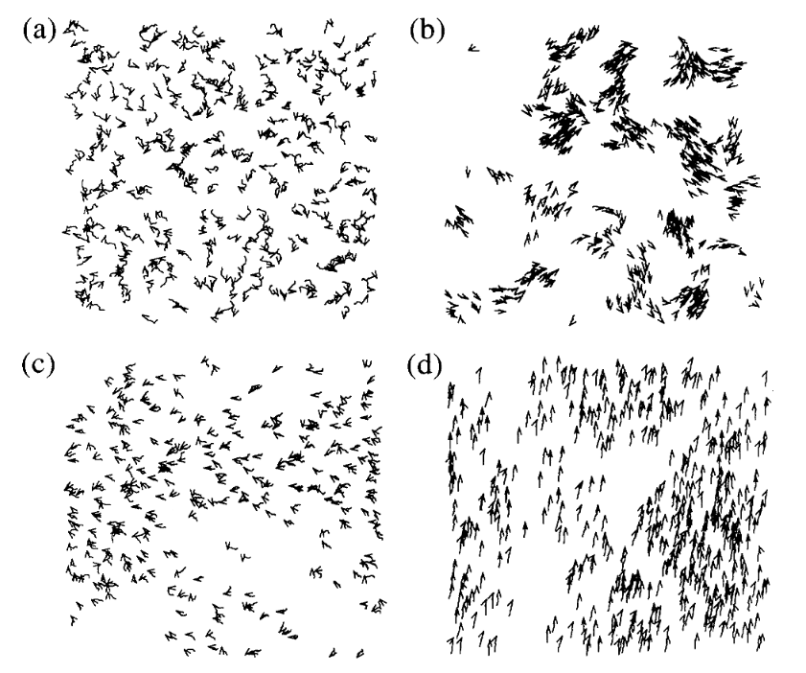Figure 1:[3] Simulator results. (b) shows low density where full coordination fails to form

As seen from the results in figure 1, this simulator is capable of producing coordinated behaviour, but it is not quite identical to what you would expect of birds, crucially lower density prevents complete order from being achieved.
For my simulator, topological distance needs to be used.
Additionally, this simulation is 2 dimensional, where I'm interested in a full 3 dimensional simulation.

3D Simulation

A 1987 paper by Craig Reynolds [4] also focuses on simulating a bird flock, however Reynolds comes at it from the direction of an animator, creating flocks of birds to act as background set dressing.

Reynolds refers to the individual members of his flock as “boids”, short for “bird-oid” and this terminology will also be used throughout the rest of this paper.

Reynolds identifies three behaviour rules that lead to flocking:
“1. Collision Avoidance: avoid collisions with nearby
flockmates
2. Velocity Matching: attempt to match velocity with nearby
flockmates
3. Flock Centering: attempt to stay close to nearby flockmates” [4]

As Reynolds paper predates Vicsek’s, let alone the study on starling murmurations, his simulator once again relies on metric distance, though he identifies that this is unlike real birds, who should be able to group together over larger distances. He points out that this is more like fish shoals, as fish occupy a less transparent medium and thus are more limited by metric distance.

Ethics

There are no relevant ethics concerns for this project. The self assessment form is included in the appendix
Design and Implementation

A class diagram is available in the supplemental material with the code. Note that the diagram represents Godot’s node hierarchy, not inheritance.

Software

When it came to designing the simulator, the first concern was what software to use to make it. The first consideration, as suggested by my supervisor was epydemic, a Python library intended for simulating processes over networks, with a focus on simulating the spread of infectious diseases, as the name suggests. It allows for setting up a process and running it many times, including in parallel.
Upon looking into it however I found it to be a bit unsuitable for my purposes. Firstly there would be the necessary step of figuring out how to apply epydemic to this non disease example. Additionally one of my goals for the simulator was the ability to visualise the simulation, observing the flock directly. Epydemic’s focus on simplicity and high speed made it a bit too much of a black box for my purposes, giving results but not steps in between. There would would have been a significant degree of reverse engineering and work to extract this data to visualise it and in the process any advantage of using epydemic would be eliminated as well.

I then considered using a game engine, which would make the visualisation step trivial as well as coming with in built physics. As one of the existing applications of these simulations is background scenery in things such as animation and video games, a video game engine felt suitable. These upsides of course come at the cost of being immensely slower.
I decided upon Godot, an open-source game engine that I have some experience with.

Godot works through building “Scenes” out of “Nodes” that represent objects, such as shapes, collision objects, meshes, sprites, a camera, buttons and many more. Scripts can be attached to these nodes and contain code, written either in C# or GDScript, a language built for Godot using Python like syntax. I use GDScript, being far more familiar with Python than C#.

The Boids

The main part of the simulator is the boids themselves. The point of this simulation is to investigate the emergence of synchronised behaviour between separate independent entities so all flocking behaviour should be within the boids.

The boids are made up of a CharacterBody3D node, which is used for moving entities. It contains a rectangular collision shape node for collisions and several mesh nodes arranged in a triangular prism to make it visible.
I use three meshes of different colours to give the boid a distinctive top (red), bottom (blue) and front (green). This allows a boids orientation to be clearly visible.
One further mesh is a transparent sphere extending around the boid. This is hidden by default and is used to highlight a boid that has been selected.

Boids are initialised with parameters defining their start position and movement as well as the minimum distance to another boid they aim for, their field of view and such things.
These parameters can be adjusted in the Parameters node, either through the Godot editor inspector or through editing the parameters.gd file.

At the start of the simulation each boid will to acquire a set number of neighbours (default 7). This is done by looping through the list of all boids and identifying those within that boid’s field of view, calculated using Godot’s inbuilt Quaternion class. Possible neighbours are then chosen randomly.

Every second, a boid will try to reacquire neighbours. If it has room for more neighbours or any boids have ended up out of view it will try to select new neighbours.
Boids only reacquire neighbours every second, and they do so out of phase with each-other, this is because it’s not necessary to check every frame and this drastically reduces performance costs.

After having decided its neighbours, a boid must choose what direction to go. This is inspired by the method described in Reynolds [4], summing and weighting different priorities to get an overall target velocity.
This consists of three steps: matching with its neighbours, avoiding collisions and moving towards neighbours.

Matching with its neighbours consists simply of averaging the velocity of all neighbours.

Avoiding collisions consists of checking all boids within a certain distance that are visible to the boid (can’t avoid something it can’t see). If the boids are too close it then calculates a repulsive force pointing away from the boid.
This repulsion is calculated as: y = -4(x/a)+5
where y is the repulsion and >= 0, x is the distance and a is the minimum distance.
This produces a repulsive force that grows as the distance shrinks (and negative values are forbidden).
Additionally, if a boid is too close to the ground a large upward force is applied.

Finally, for attraction it is similar to alignment, except average position of neighbours is found, rather than average velocity and a force points towards this average position.

These target velocities are all averaged together based on a weighting (set in parameters), the vertical axis of the target is reduced by a tenth, this is so the boids will tend to flying horizontally, else the movement to avoid the ground forces the entire flock upwards.

The boid is then rotated towards their target direction (limited by rotation speed) and moves in the direction they’re facing. A simple air resistance multiplier slows the boid down each frame. This overall results in the boids not perfectly being able to move exactly where they want instantly, needing to turn and account for some momentum.
The main issue with this is that the boids can’t change their speeds, and can’t slow down or speed up.

Additionally, a selected boid creates indicator objects for each neighbour. These are cylinders which are updates every frame to point from the selected boid to its neighbours to make this data visible to the user should they wish.
The indicator scene is made up of a cylinder that takes source and target points and lines the cylinder up with them end to end. A triangular prism is present to act as an arrow so if a selected boid points at another selected boid it is still visible which way the link is.

User Interface

Code outside of the boids consists of setup such as initialising all the boids, as well as the UI and camera.

The Parameters contain a seed for the random number generator, allowing deterministic results.

The simulation can be navigated using WASD, the space and control keys.
Holding shift will lock the camera and cause the mouse cursor to appear, individual boids can be selected to view what other boids they are currently following. Quality of life buttons are available to select or deselect all boids.

Boids are selected via a raycast sent from the camera when the mouse is clicked.

Pressing “P” will pause the simulation.
Pressing “R” will reset the simulation.

A bounding box is also calculated around the boids, with its volume visible on screen. The maximum and minimum x, y and z coordinates are calculated between all the boids and set accordingly for the bounding box.
A toggle also exists to show or hide the bounding box.
The volume of the bounding box can then be gotten.

Results

Given the many permutations of parameters possible, extensively testing all of them would take a significant amount of time. I have therefore narrowed down my testing to examine the effects of changing the field of view (FOV)

Test 1

I started by testing at 360 degrees FOV. Full parameters below. Note that a seed of 0 will equal a random seed.

seed = 0
no_of_boids = 100
boid_acceleration = 0.3
boid_turn_speed = 0.05
boid_neighbours = 7
boid_min_distance = 20
boid_fov = 360
align_weight = 1
attract_weight = 1
repulse_weight = 1

I ran 8 tests with these parameters and plotted them against time.
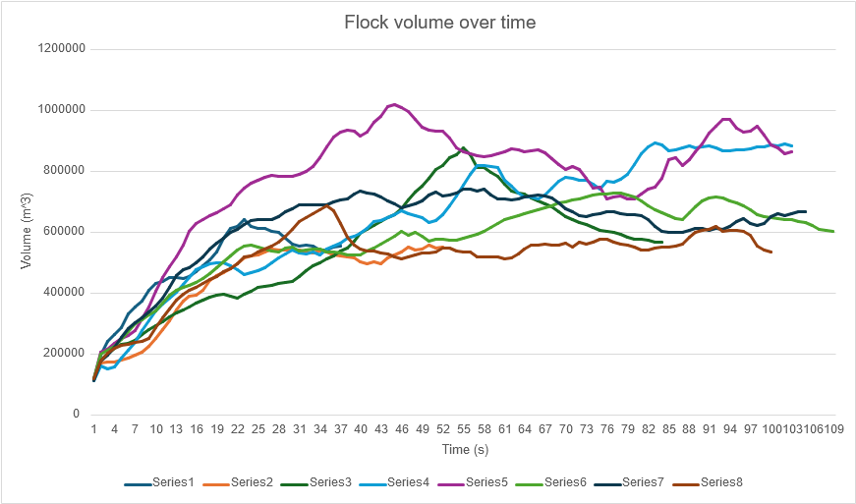Figure 2: Test 1 result graph
(Table available in appendix)

As you can see, the boids consistently formed flocks and after an initial rapid expansion would reach a maximum size, occasionally growing and shrinking again within a certain range.
Test 2

The parameters for this test were identical except for the FOV being set to 180 degrees.

seed = 0
no_of_boids = 100
boid_acceleration = 0.3
boid_turn_speed = 0.05
boid_neighbours = 7
boid_min_distance = 20
boid_fov = 180
align_weight = 1
attract_weight = 1
repulse_weight = 1

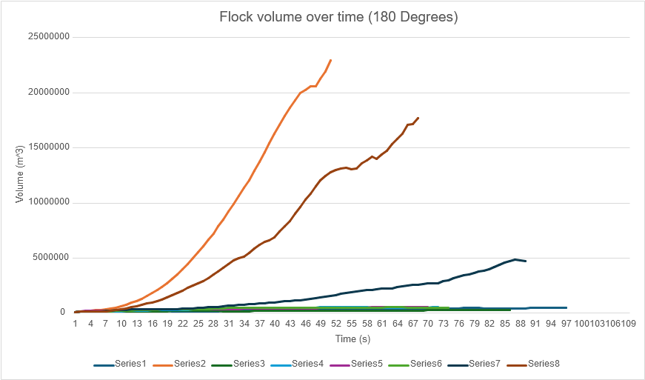Figure 3: Test 2 result graph

As you can see here, a couple of times the volume ballooned massively. These were cases where a flock failed to form and two or more groups flew in opposite directions.

In these cases due to the limited field of view an outlier boid or group of boids lost sight of the rest of the flock.
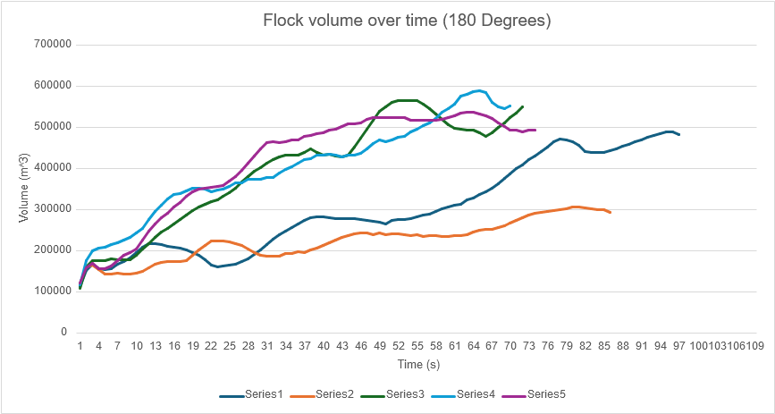Figure 4: Test 2 result graph without failures

Removing these outliers to get a better look at the successful flocks they appear less stable than the 360 degree FOV and take noticeably longer to expand to their desired density.

Test 3

The parameters for this test were identical except for the FOV being set to 90 degrees.

seed = 0
no_of_boids = 100
boid_acceleration = 0.3
boid_turn_speed = 0.05
boid_neighbours = 7
boid_min_distance = 20
boid_fov = 90
align_weight = 1
attract_weight = 1
repulse_weight = 1

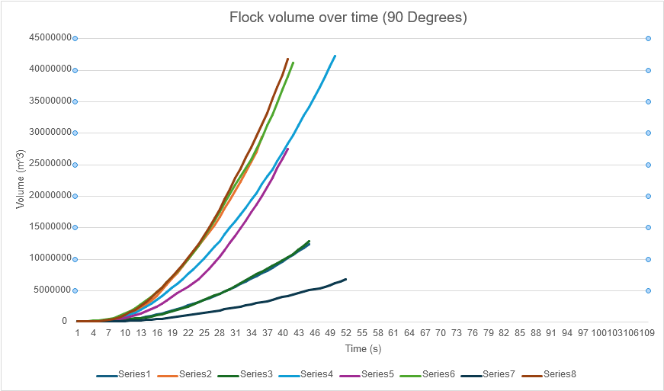Figure 5: Test 3 result graph

In this case, a single cohesive flock was never achieved, indicating that as field of vision narrows, flocking becomes more and more difficult, as a boid has less awareness of its surroundings and the movements of other boids. Logically, a boid that can only see a single degree in front of it will be unable to see all other boids and thus will have no way of flocking.
Evaluation

I have created a simulator that successfully simulates flocking behaviour between simulated animals. Boids will be attracted to each other, align flight direction and avoid collisions.
Parameters may be adjusted to experiment with differences.
I’ve also implemented this using a topological distance between boids, rather than a metric one, meaning the boids are not limited to only “seeing” others within a limited range of themselves. This follows on from the work of Ballerini et al. [1] and is an improvement over Reynold’s [4] use of metric distance in his simulator.

In particular, I have looked into the effect of limiting the boids field of view and discovered that it makes it significantly more difficult for the flock to group up into a cohesive whole.

There are quite a few limitations however.

For one, I have no variable speed among the boids, they always try to go at their max speed, which limits them quite considerably. They can’t speed up to catch up if they’ve fallen behind and similarly they can’t easily slow down to let others catch up.

Additionally, I have no random variation to the boids movements. If the boids fail to flock together, there’s no chance two flocks may turn towards each-other and join up, limiting the ability to determine the feasibility of flocks of boids with small fields of view.

Real birds and flocking animals typically also have eyes on the sides of their head and as discussed in the starling study [1] they found an emphasis on neighbours that were beside a bird, due to this. I have no mechanism simulating this.

There is also in general room for further experimentation regarding other parameters, such as experimenting with neighbour quantity minimum distance and how these affect the time taken to form a stable flock.

Conclusion

A successful but flawed flocking simulator has been completed. Certain further features would have enabled better research and there is room for further experimentation.

It has been concluded that reducing the field of view of the boids significantly increases the difficulty of flocking behaviour.

There is room for further research here, as well as further development of this simulator.
Bibliography

- Ballerini, M., et al. "Interaction ruling animal collective behavior depends on topological rather than metric distance: Evidence from a field study." Proc. Natl. Acad. Sci. U.S.A., vol. 105, no. 4, 29 Jan. 2008, pp. 1232-7, doi:10.1073/pnas.0711437105.

- Satz, Helmut. "The Rules of the Flock." OUP Academic, 14 Feb. 2020, doi:10.1093/oso/9780198853398.003.0006.

- Vicsek, Tamás, et al. "Novel Type of Phase Transition in a System of Self-Driven Particles." Phys. Rev. Lett., vol. 75, no. 6, 7 Aug. 1995, pp. 1226-9, doi:10.1103/PhysRevLett.75.1226.

- Reynolds, Craig W. "ACM Conferences." Flocks, herds, and schools: a distributed behavioral model. Association for Computing Machinery, 1 July 1998, pp. 273-82, doi:10.1145/280811.281008.
Appendix

User Manual

Repository link: https://github.com/ACRULE5/Flocking.git

To run the simulator:

- Download Godot from https://godotengine.org/download for the relevant platform.
- Extract the zip file.
- Run the exe file
- The Project Manager should open, select “import” and navigate to the simulator and select it.
- Once open the scenes and scripts can be opened through the file system in the bottom left (.tscn being scenes and .gd being scripts)
- Parameters can be changed by editing the parameters.gd script or selecting the Parameters Node on the left and then editing the fields in the inspector on the right. (Node that editing the inspector will not update the file, the inspector simply takes priority)
- The buttons to run the simulator are in the top right, alternatively F5 will run it and F8 will stop it.
- WASD keys to move horizontally, space and control keys to move up or down.
- Hold shift to lock the camera and reveal the mouse cursor, which can be used to select individual boids or click the buttons in the top right.
- “P” to pause the simulation, “R” to reset the simulation.
Preliminary Ethics Self Assessment Form



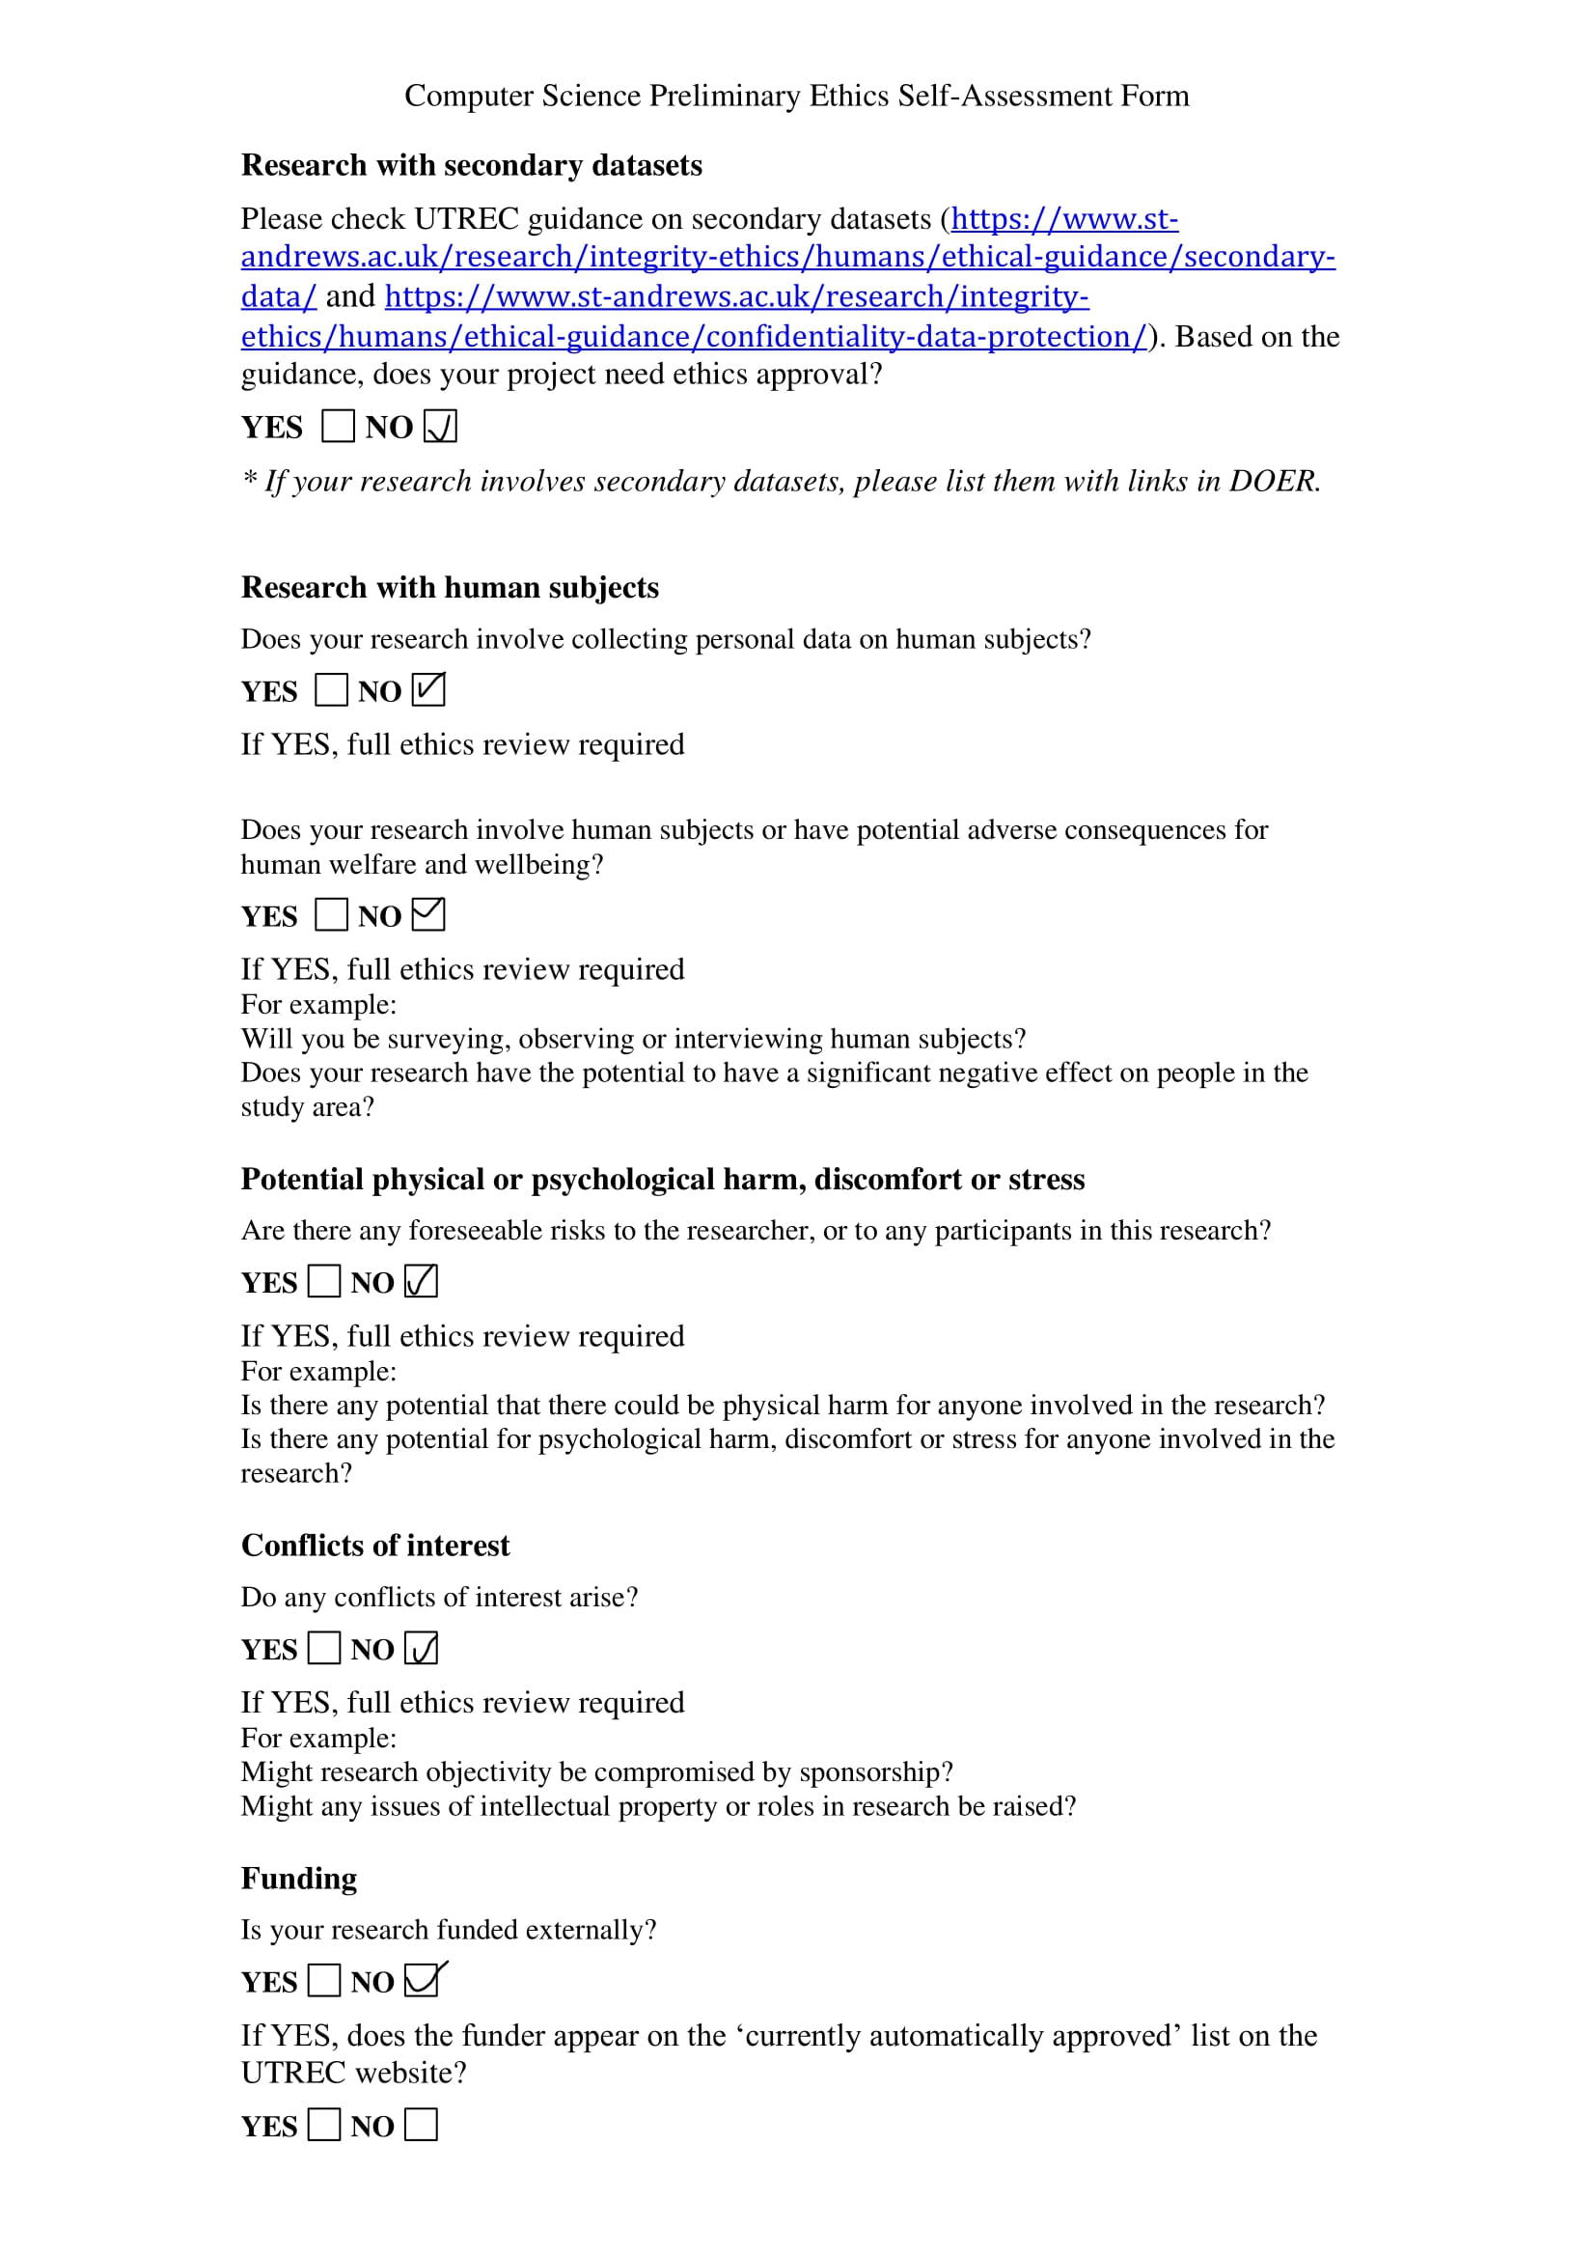



Test 1 Results Table
Flock Volume (m³)
Time (s) | 1 | 2 | 3 | 4 | 5 | 6 | 7 | 8
1 | 116200 | 119175 | 116858 | 114803 | 120342 | 120613 | 114844 | 120824
2 | 197482 | 171825 | 181321 | 161270 | 208450 | 201700 | 179370 | 178590
3 | 241753 | 175154 | 201403 | 152393 | 216977 | 213092 | 198480 | 204447
4 | 267092 | 175218 | 219392 | 157963 | 237485 | 227520 | 223242 | 220378
5 | 286860 | 182759 | 232489 | 187479 | 254097 | 250336 | 255034 | 229779
6 | 332555 | 189541 | 236775 | 214507 | 261613 | 276178 | 284116 | 232546
7 | 357727 | 198667 | 246419 | 241325 | 279122 | 300131 | 305352 | 240594
8 | 376995 | 208748 | 264570 | 278978 | 315925 | 314671 | 320523 | 242551
9 | 410495 | 228201 | 281666 | 311684 | 357429 | 330233 | 341641 | 252823
10 | 432654 | 253312 | 295137 | 343811 | 408380 | 343537 | 359646 | 289688
11 | 441426 | 282065 | 308976 | 364767 | 452821 | 369632 | 385541 | 319438
12 | 454049 | 311530 | 324410 | 385757 | 489756 | 393603 | 422158 | 351048
13 | 453974 | 347296 | 335948 | 404946 | 522255 | 410768 | 459540 | 377672
14 | 450510 | 376506 | 345678 | 429564 | 558063 | 420909 | 477691 | 397335
15 | 457661 | 393232 | 357127 | 454381 | 603105 | 427182 | 485904 | 409823
16 | 472389 | 393541 | 367491 | 479823 | 631292 | 436967 | 502484 | 420214
17 | 491200 | 412590 | 380104 | 489642 | 642848 | 449085 | 521580 | 433163
18 | 511829 | 442976 | 388755 | 496552 | 655167 | 466179 | 545555 | 447150
19 | 537743 | 459393 | 394492 | 500726 | 666810 | 485483 | 565687 | 456494
20 | 582094 | 468518 | 396725 | 500156 | 677801 | 505538 | 583220 | 473532
21 | 614641 | 481833 | 391697 | 492647 | 692605 | 524903 | 601496 | 481503
22 | 620471 | 499681 | 384365 | 477300 | 723894 | 542517 | 610966 | 498062
23 | 642745 | 517359 | 397324 | 463126 | 747563 | 555035 | 625741 | 519441
24 | 621105 | 524615 | 408785 | 468667 | 762241 | 559098 | 639166 | 525405
25 | 613655 | 528181 | 419934 | 475974 | 773905 | 554302 | 642171 | 535926
26 | 612769 | 538243 | 425341 | 486824 | 783094 | 547246 | 644634 | 545833
27 | 605480 | 545439 | 428064 | 500994 | 788305 | 540806 | 642462 | 556404
28 | 602033 | 544657 | 434844 | 518026 | 785566 | 538292 | 651491 | 570706
29 | 582675 | 543641 | 436505 | 531759 | 785175 | 548943 | 667745 | 587296
30 | 561285 | 544401 | 440177 | 544231 | 786304 | 552836 | 680193 | 612476
31 | 555528 | 543370 | 455334 | 533434 | 791966 | 539343 | 691456 | 637055
32 | 560674 | 536736 | 473968 | 530795 | 801900 | 542852 | 692441 | 650506
33 | 557549 | 534548 | 490851 | 536872 | 816719 | 546689 | 690904 | 661159
34 | 542638 | 539676 | 501998 | 526533 | 845976 | 547747 | 693138 | 674344
35 | 543714 | 536176 | 514581 | 547656 | 881193 | 537670 | 692113 | 688436
36 | 553220 | 527716 | 523898 | 554934 | 915596 | 538020 | 700765 | 672690
37 | 557137 | 525270 | 539157 | 564686 | 929959 | 533518 | 706595 | 629891
38 |  | 519284 | 550447 | 580686 | 935909 | 528724 | 710562 | 583840
39 |  | 516016 | 571973 | 587508 | 933964 | 526489 | 725720 | 559468
40 |  | 504577 | 596802 | 598583 | 915971 | 528227 | 735921 | 546489
41 |  | 497750 | 611953 | 613844 | 929371 | 538624 | 731836 | 540041
42 |  | 505936 | 623998 | 638016 | 962044 | 549398 | 726637 | 538579
43 |  | 499160 | 636074 | 641294 | 981464 | 563554 | 717769 | 534972
44 |  | 516741 | 648759 | 649746 | 1013471 | 574453 | 704996 | 529374
45 |  | 527876 | 660033 | 660813 | 1020432 | 589224 | 695435 | 521528
46 |  | 535812 | 680350 | 671084 | 1010451 | 604159 | 682543 | 515401
47 |  | 552280 | 709223 | 661166 | 997782 | 592553 | 688394 | 521923
48 |  | 542356 | 732390 | 656561 | 972220 | 599859 | 695042 | 525798
49 |  | 548054 | 754272 | 650436 | 946150 | 589708 | 704628 | 534621
50 |  | 558958 | 780415 | 633484 | 936122 | 573759 | 723912 | 533545
51 |  | 548608 | 808341 | 638492 | 933310 | 577434 | 734639 | 537794
52 |  | 551953 | 819471 | 661048 | 933806 | 577807 | 721803 | 550544
53 |  |  | 848149 | 688286 | 911094 | 576477 | 723625 | 549140
54 |  |  | 857762 | 719687 | 878153 | 576450 | 730424 | 539943
55 |  |  | 877324 | 754846 | 866670 | 580606 | 744637 | 538221
56 |  |  | 855524 | 792367 | 858392 | 587752 | 742167 | 536284
57 |  |  | 814988 | 820389 | 853755 | 596486 | 736364 | 521521
58 |  |  | 812864 | 821954 | 850916 | 605991 | 743765 | 519880
59 |  |  | 798825 | 817791 | 853181 | 616427 | 722927 | 521344
60 |  |  | 784378 | 814333 | 858474 | 631097 | 711810 | 521499
61 |  |  | 759073 | 772259 | 866796 | 642173 | 710228 | 515823
62 |  |  | 737656 | 752101 | 874257 | 650642 | 708427 | 517325
63 |  |  | 731994 | 729815 | 873743 | 657357 | 711433 | 531136
64 |  |  | 726589 | 716540 | 865924 | 663559 | 716173 | 545045
65 |  |  | 714592 | 716209 | 868203 | 670656 | 720932 | 559089
66 |  |  | 705334 | 709699 | 871564 | 674789 | 724355 | 559035
67 |  |  | 695938 | 722371 | 863625 | 680746 | 720618 | 561145
68 |  |  | 684026 | 746996 | 842014 | 689151 | 713024 | 557833
69 |  |  | 669133 | 768625 | 822728 | 696866 | 697411 | 559114
70 |  |  | 653386 | 781092 | 808138 | 702303 | 680212 | 566758
71 |  |  | 641848 | 779799 | 815970 | 708804 | 669412 | 554426
72 |  |  | 634709 | 772100 | 808943 | 710370 | 655044 | 568337
73 |  |  | 627462 | 772916 | 779764 | 717608 | 654110 | 562003
74 |  |  | 616825 | 758883 | 748160 | 724086 | 658790 | 570393
75 |  |  | 609405 | 744361 | 750556 | 725792 | 662843 | 579915
76 |  |  | 603109 | 768111 | 711852 | 728091 | 668997 | 578225
77 |  |  | 601385 | 767144 | 718053 | 729126 | 669173 | 568593
78 |  |  | 596528 | 775836 | 720375 | 728885 | 663770 | 562555
79 |  |  | 583838 | 793098 | 711927 | 725219 | 659951 | 560207
80 |  |  | 578856 | 823168 | 711416 | 717524 | 660539 | 551919
81 |  |  | 578678 | 860556 | 727952 | 703786 | 656518 | 543725
82 |  |  | 574971 | 882915 | 744235 | 688804 | 644069 | 543574
83 |  |  | 570276 | 894274 | 750563 | 676199 | 619560 | 548339
84 |  |  | 568196 | 888278 | 779651 | 666556 | 603939 | 553150
85 |  |  |  | 869750 | 841086 | 656179 | 601900 | 553789
86 |  |  |  | 872688 | 847158 | 646313 | 600949 | 556033
87 |  |  |  | 878159 | 819757 | 644681 | 601855 | 562478
88 |  |  |  | 884441 | 839780 | 664464 | 608169 | 585305
89 |  |  |  | 880237 | 865758 | 685950 | 614857 | 601216
90 |  |  |  | 881566 | 893251 | 703786 | 614103 | 607606
91 |  |  |  | 884901 | 928703 | 715106 | 609071 | 609938
92 |  |  |  | 878393 | 950320 | 719113 | 614000 | 620854
93 |  |  |  | 870444 | 970977 | 715006 | 610895 | 603489
94 |  |  |  | 869408 | 973006 | 704998 | 620416 | 607102
95 |  |  |  | 873978 | 943357 | 696900 | 637111 | 607890
96 |  |  |  | 873911 | 931477 | 688334 | 646493 | 605623
97 |  |  |  | 874158 | 934394 | 675287 | 629262 | 592522
98 |  |  |  | 881628 | 950433 | 660388 | 623681 | 556586
99 |  |  |  | 882642 | 920318 | 653776 | 630604 | 542994
100 |  |  |  | 887974 | 888821 | 651164 | 651936 | 535535
101 |  |  |  | 886668 | 879247 | 647932 | 662470
102 |  |  |  | 890189 | 859741 | 644915 | 657527
103 |  |  |  | 886483 | 865798 | 642111 | 663931
104 |  |  |  |  |  | 636415 | 669493
105 |  |  |  |  |  | 634853 | 670469
106 |  |  |  |  |  | 624800
107 |  |  |  |  |  | 612358
108 |  |  |  |  |  | 609150
109 |  |  |  |  |  | 605626

Test 2 Results Table

Flock Volume (m³)
Time (s) | 1 | 2 | 3 | 4 | 5 | 6 | 7 | 8
1 | 114182 | 114993 | 119781 | 109270 | 117910 | 121769 | 119632 | 110397
2 | 153489 | 157647 | 161987 | 162434 | 177605 | 160533 | 159876 | 130388
3 | 168215 | 188850 | 165066 | 176728 | 201508 | 170213 | 175865 | 157157
4 | 157101 | 230532 | 154780 | 177353 | 206911 | 158171 | 194075 | 155785
5 | 154388 | 274430 | 145107 | 177335 | 208810 | 157157 | 192713 | 164234
6 | 157417 | 307776 | 144700 | 180667 | 216245 | 163895 | 192621 | 179216
7 | 167493 | 355117 | 146848 | 178805 | 220564 | 176636 | 210248 | 189073
8 | 174953 | 431459 | 144402 | 178706 | 226209 | 189524 | 247125 | 229659
9 | 183157 | 524134 | 145245 | 179085 | 234480 | 197503 | 285151 | 297457
10 | 197629 | 640278 | 145838 | 191119 | 245080 | 205971 | 305754 | 372518
11 | 210603 | 787772 | 150144 | 206161 | 255704 | 228061 | 319435 | 459932
12 | 217560 | 934678 | 159218 | 218767 | 276979 | 247939 | 331371 | 548844
13 | 218121 | 1101888 | 168570 | 232563 | 295624 | 265562 | 345389 | 644625
14 | 215092 | 1332123 | 173049 | 245511 | 312059 | 280783 | 359713 | 753618
15 | 211810 | 1592130 | 175231 | 255010 | 326874 | 293233 | 373042 | 874698
16 | 209842 | 1820360 | 174760 | 266480 | 338416 | 306377 | 380934 | 988465
17 | 207649 | 2098800 | 175870 | 277191 | 340824 | 318920 | 385974 | 1117775
18 | 204019 | 2379104 | 178011 | 288126 | 346550 | 332823 | 384035 | 1268803
19 | 196144 | 2705882 | 189561 | 298361 | 352847 | 344260 | 369987 | 1438095
20 | 189626 | 3091457 | 202912 | 306724 | 352148 | 350128 | 376251 | 1625947
21 | 178824 | 3533495 | 214823 | 313607 | 350340 | 352454 | 393625 | 1837584
22 | 165905 | 3977948 | 224390 | 319438 | 343820 | 354426 | 410546 | 2059115
23 | 161978 | 4480582 | 224733 | 325221 | 349694 | 356518 | 429194 | 2306296
24 | 163030 | 4981210 | 225558 | 333183 | 351353 | 360663 | 451451 | 2489243
25 | 165371 | 5540014 | 222864 | 342234 | 356802 | 370001 | 476738 | 2715009
26 | 167746 | 6079539 | 217688 | 353875 | 366561 | 381188 | 502781 | 2941888
27 | 174095 | 6654830 | 212956 | 368558 | 366559 | 396037 | 532540 | 3211359
28 | 180606 | 7239300 | 204594 | 382188 | 374182 | 412912 | 561320 | 3523164
29 | 191322 | 7863931 | 195994 | 394099 | 375720 | 431081 | 589992 | 3807159
30 | 202271 | 8527396 | 190307 | 403528 | 374049 | 448662 | 633257 | 4124372
31 | 215839 | 9211648 | 187317 | 413231 | 379487 | 463932 | 672848 | 4481043
32 | 229074 | 9923819 | 188071 | 421595 | 379936 | 466581 | 717460 | 4831219
33 | 240733 | 10660137 | 188189 | 428747 | 389131 | 464126 | 757714 | 4978542
34 | 249236 | 11407874 | 193997 | 433272 | 399149 | 466548 | 793123 | 5141866
35 | 257230 | 12087150 | 194384 | 432905 | 406091 | 469701 | 829996 | 5490668
36 | 266253 | 12921048 | 197646 | 433542 | 414459 | 471601 | 858747 | 5857063
37 | 274801 | 13716746 | 196649 | 440021 | 422793 | 479063 | 897077 | 6180491
38 | 280662 | 14613713 | 202138 | 447785 | 425463 | 482078 | 928735 | 6463951
39 | 283413 | 15399426 | 208070 | 440857 | 432637 | 484863 | 959270 | 6642637
40 | 283659 | 16276211 | 213380 | 434258 | 434268 | 488734 | 1000912 | 6861993
41 | 282050 | 17107442 | 219873 | 435118 | 436006 | 493454 | 1036178 | 7419014
42 | 279706 | 17881163 | 226530 | 430504 | 433797 | 496126 | 1086930 | 7889956
43 | 278256 | 18619881 | 233740 | 429901 | 428494 | 502800 | 1131298 | 8377573
44 | 278239 | 19326419 | 237426 | 434185 | 433083 | 509080 | 1167663 | 9004778
45 | 278488 | 19957745 | 242842 | 453315 | 432864 | 510136 | 1198248 | 9626123
46 | 276898 | 20287151 | 244486 | 474947 | 438812 | 512653 | 1236653 | 10305004
47 | 274990 | 20620640 | 244216 | 496973 | 449354 | 519996 | 1304696 | 10874899
48 | 272660 | 20583323 | 239710 | 519035 | 462879 | 524562 | 1372497 | 11495254
49 | 269703 | 21274357 | 243672 | 540969 | 469690 | 524779 | 1446916 | 12053489
50 | 266082 | 21939144 | 239199 | 550477 | 465576 | 525144 | 1509292 | 12435334
51 | 274948 | 22915129 | 242556 | 562899 | 469448 | 525887 | 1581558 | 12811648
52 | 277545 |  | 241651 | 567260 | 477314 | 524692 | 1671162 | 13015258
53 | 276971 |  | 240514 | 566336 | 479655 | 524787 | 1757417 | 13163208
54 | 279356 |  | 238343 | 565663 | 490213 | 518028 | 1837927 | 13187173
55 | 283761 |  | 239264 | 565913 | 495996 | 517275 | 1922042 | 13059108
56 | 287716 |  | 236428 | 557425 | 505805 | 517610 | 1988792 | 13158541
57 | 290874 |  | 238359 | 546929 | 512870 | 518421 | 2050723 | 13605353
58 | 297101 |  | 238646 | 533981 | 523487 | 519026 | 2101553 | 13876519
59 | 304028 |  | 235219 | 521568 | 538872 | 520005 | 2129632 | 14209780
60 | 307326 |  | 235551 | 507351 | 545882 | 525315 | 2177116 | 14026451
61 | 312215 |  | 237326 | 498331 | 557242 | 530031 | 2223936 | 14443581
62 | 314761 |  | 237320 | 496693 | 576269 | 536112 | 2259165 | 14746910
63 | 324322 |  | 240938 | 494564 | 582468 | 537513 | 2270694 | 15341997
64 | 329480 |  | 246175 | 494689 | 588269 | 538781 | 2351122 | 15838889
65 | 336880 |  | 250143 | 488583 | 589831 | 533965 | 2438124 | 16275695
66 | 344428 |  | 252095 | 478752 | 585719 | 530191 | 2502118 | 17074503
67 | 352029 |  | 253696 | 487835 | 560954 | 521937 | 2548799 | 17139238
68 | 364788 |  | 257948 | 500824 | 550301 | 511318 | 2582819 | 17694943
69 | 376959 |  | 261482 | 512555 | 546685 | 502916 | 2672940
70 | 388238 |  | 267629 | 524904 | 552992 | 494039 | 2692249
71 | 399854 |  | 274224 | 536492 |  | 495130 | 2737481
72 | 410150 |  | 280875 | 551428 |  | 490222 | 2735941
73 | 422542 |  | 288394 |  |  | 495359 | 2884410
74 | 431429 |  | 292065 |  |  | 495314 | 2991806
75 | 441376 |  | 294398 |  |  |  | 3164106
76 | 453561 |  | 297161 |  |  |  | 3344243
77 | 465397 |  | 299129 |  |  |  | 3483779
78 | 471984 |  | 300805 |  |  |  | 3549251
79 | 471591 |  | 303943 |  |  |  | 3659771
80 | 466593 |  | 306706 |  |  |  | 3760181
81 | 456623 |  | 307393 |  |  |  | 3869944
82 | 441420 |  | 305312 |  |  |  | 4012237
83 | 440258 |  | 303285 |  |  |  | 4219253
84 | 439151 |  | 301999 |  |  |  | 4416662
85 | 440553 |  | 299861 |  |  |  | 4601457
86 | 444760 |  | 294997 |  |  |  | 4752558
87 | 449266 |  |  |  |  |  | 4840583
88 | 454617 |  |  |  |  |  | 4825148
89 | 459749 |  |  |  |  |  | 4709828
90 | 465470
91 | 471493
92 | 476774
93 | 481667
94 | 486380
95 | 489438
96 | 490191
97 | 484376

Test 3 Results Table

Flock Volume (m³)
Time (s) | 1 | 2 | 3 | 4 | 5 | 6 | 7 | 8
1 | 119079 | 119272 | 114870 | 115250 | 119620 | 120328 | 111363 | 116360
2 | 154872 | 148328 | 151181 | 150728 | 162403 | 168221 | 164068 | 157604
3 | 168900 | 155087 | 163955 | 164380 | 176286 | 205212 | 139883 | 178864
4 | 166365 | 157142 | 172728 | 193542 | 157676 | 245607 | 125142 | 179097
5 | 148645 | 175466 | 163157 | 271589 | 174100 | 271253 | 117373 | 199818
6 | 159519 | 253450 | 173736 | 335094 | 201509 | 413080 | 122720 | 232900
7 | 185570 | 396897 | 205351 | 430394 | 251106 | 480807 | 126003 | 353139
8 | 235905 | 543581 | 245994 | 586752 | 339971 | 695277 | 141437 | 563954
9 | 314563 | 747160 | 318565 | 742586 | 489636 | 981130 | 167842 | 833071
10 | 399537 | 1015138 | 401568 | 944615 | 663945 | 1349623 | 197233 | 1169614
11 | 488815 | 1357850 | 495883 | 1223598 | 876860 | 1769615 | 233293 | 1571608
12 | 580944 | 1785954 | 593412 | 1528991 | 1136594 | 2248717 | 276752 | 2040096
13 | 690932 | 2282261 | 696292 | 1946140 | 1419028 | 2796670 | 322888 | 2583640
14 | 850202 | 2844915 | 795688 | 2428614 | 1745307 | 3391290 | 368365 | 3208335
15 | 1024642 | 3469336 | 916586 | 2961608 | 2098135 | 4043485 | 421846 | 3931604
16 | 1211378 | 4196220 | 1080478 | 3560623 | 2492747 | 4749887 | 492399 | 4723237
17 | 1416669 | 5076140 | 1254963 | 4160170 | 2937005 | 5486627 | 575164 | 5484873
18 | 1644658 | 5986289 | 1471705 | 4776513 | 3421474 | 6318114 | 674446 | 6299814
19 | 1873213 | 6901158 | 1703036 | 5449254 | 4008184 | 7159942 | 775757 | 7195265
20 | 2122691 | 7826998 | 1956632 | 6138792 | 4647172 | 8034895 | 882097 | 8142361
21 | 2368755 | 8828017 | 2214230 | 6863843 | 5144946 | 9009856 | 990285 | 9140836
22 | 2657599 | 9939909 | 2493911 | 7663605 | 5629945 | 9980240 | 1104580 | 10190163
23 | 2928765 | 11057246 | 2787625 | 8451924 | 6182268 | 11021181 | 1226659 | 11289780
24 | 3225916 | 12131819 | 3174231 | 9272052 | 6863827 | 12174875 | 1355359 | 12439215
25 | 3537515 | 13213602 | 3535872 | 10139725 | 7664623 | 13432147 | 1486955 | 13662050
26 | 3857120 | 14281619 | 3868012 | 11057267 | 8532644 | 14765978 | 1620526 | 15045225
27 | 4195300 | 15404998 | 4227252 | 11972727 | 9447199 | 16095444 | 1759022 | 16488610
28 | 4542189 | 16692801 | 4532526 | 12909500 | 10418565 | 17560448 | 1904017 | 17986899
29 | 4897786 | 18060076 | 4896109 | 13932686 | 11452134 | 18891921 | 2055496 | 19528221
30 | 5260686 | 19465552 | 5285820 | 15006201 | 12588101 | 20397279 | 2202817 | 21128222
31 | 5649153 | 20892711 | 5690957 | 16015154 | 13747765 | 21818359 | 2350487 | 22905384
32 | 6042856 | 22355357 | 6160092 | 17140683 | 14896172 | 23185568 | 2502335 | 24384968
33 | 6454343 | 23860293 | 6659843 | 18234489 | 16177876 | 24477440 | 2682106 | 26159879
34 | 6888369 | 25408614 | 7173818 | 19391110 | 17417027 | 25768057 | 2857918 | 27712203
35 | 7302262 | 27050790 | 7628225 | 20553250 | 18713419 | 27563638 | 3028415 | 29624006
36 | 7760709 | 29410830 | 8085734 | 21925504 | 20068542 | 29236759 | 3194141 | 31430664
37 | 8201929 |  | 8532290 | 23128632 | 21484164 | 31220854 | 3357346 | 33257646
38 | 8679849 |  | 8973047 | 24279617 | 22946639 | 33013062 | 3558791 | 35534406
39 | 9163221 |  | 9386485 | 25636164 | 24432918 | 34823867 | 3781104 | 37359935
40 | 9655561 |  | 9828804 | 26948311 | 25926225 | 36904847 | 4006759 | 39253563
41 | 10161233 |  | 10306111 | 28365121 | 27471322 | 39004968 | 4222516 | 41758845
42 | 10742455 |  | 10869654 | 29748059 |  | 41150600 | 4437488
43 | 11274036 |  | 11499620 | 31233222 |  |  | 4664890
44 | 11814395 |  | 12180514 | 32779720 |  |  | 4890560
45 | 12382683 |  | 12880076 | 34191924 |  |  | 5098973
46 |  |  |  | 35761755 |  |  | 5305761
47 |  |  |  | 37325363 |  |  | 5392672
48 |  |  |  | 38999853 |  |  | 5602521
49 |  |  |  | 40601687 |  |  | 5877280
50 |  |  |  | 42325293 |  |  | 6162613
51 |  |  |  |  |  |  | 6457765
52 |  |  |  |  |  |  | 6794967

