Contents

- Introduction
- Context Survey
- Design
- Implementation
- Testing
- Evaluation
- Conclusion
- Bibliography
Context Survey

Flocking in animals is coordinated group behaviour arising from many individuals working together for some larger goal. It happens naturally without organisation by any leader or such based on simple instructions known by each individual. In casual language flocking typically refers to birds but for our purposes here it will refer to any leaderless synchronised behaviour in animals.

Examples include the aforementioned birds moving in large synchronised groups such as murmurations of starlings flying in large patterns, fish shoals which move together for protection against predators, some firefly species flashing their lights in sync to attract mates and many others, including land bound animals moving in herds.

The focus of this research is the simulation of this behaviour and so naturally the question arises: how to simulate this? The obvious starting point is to look to how the animals do it.

Closest Neighbours and Topological Distance

In 1995 a paper by Tamas Vicsek et al [3] introduced a simple model for self organising systems made up of simple particles, such as a flock of animals but also physical systems such as the spin of atoms in a magnet. I will discuss this paper further elsewhere but for now one limitation of this model in the context of birds is that it uses the physical distance between birds: individuals track all birds within a certain radius of themselves resulting in a loss of cohesion at lower densities. This is however not the case for real birds, where flocks can swell and contract with no change in cohesion.

This brings us to a 2008 field study on starling flocks [1]. Starlings are very social birds which form huge flocks of thousands of birds. These "murmurations" then take on different shapes. The researchers in this study captured footage of large murmurations at their roosting site of Termini railway station in Rome, Italy. Analysing these recordings they found that birds actually track only a limited number of their closest neighbours, 6 to 7, not all birds in a certain radius, and that rather than metric distance the birds use topological distance, tracking the closest birds regardless of metric distance.
They also found that the birds largely did not track closest neighbours in the direction of motion, most likely due to starlings having a lateral field of view (their eyes are on the sides of their heads). This introduces interesting room for experimentation in the simulator: seeing how differing fields of view affect the ability to maintain a flock, the much narrower field of view of forward facing eyes in particular.

Simulation

The Vicsek paper mentioned prior [3] is a simple starting point when considering simulation.
In this model all particles move with constant absolute velocity (constant speed) and time progresses in discrete increments, with each individual's movement calculated at each increment.

The Position of a particle i is updated in time t according to the following formula:
x_{i}(t+1) = x_{i}(t) + v_{i}(t)Δt
where the velocity of a particle has an absolute value v and a direction given by the angle θ(t+1) which is obtained by:
θ(t+1) = <θ(t)>_{r} + Δθ
where <θ(t)>_{r} is the average angle of the birds in radius r around the given particle. Δθ represents noise and is a random number chosen in the interval [-n/2, n/2].
The adjustable variables in this system are n (noise), p (density of particles) and v (absolute velocity of particles).
p is given by
p = N/L²
where N is number of birds and L is the linear size of the area

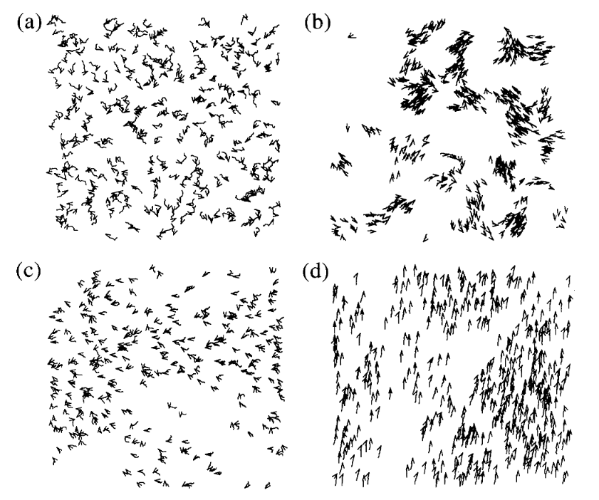Figure 1:[3] Simulator results. (b) shows low density where full coordination fails to form

As seen from the results in figure 1, this simulator is capable of producing coordinated behaviour, but it is not quite identical to what you would expect of birds, crucially lower density prevents complete order from being achieved.
For my simulator, topological distance needs to be used.
Additionally, this simulation is 2 dimensional, where I'm interested in a full 3 dimensional simulation.
Bibliography

- Ballerini, M., et al. "Interaction ruling animal collective behavior depends on topological rather than metric distance: Evidence from a field study." Proc. Natl. Acad. Sci. U.S.A., vol. 105, no. 4, 29 Jan. 2008, pp. 1232-7, doi:10.1073/pnas.0711437105.

- Satz, Helmut. "The Rules of the Flock." OUP Academic, 14 Feb. 2020, doi:10.1093/oso/9780198853398.003.0006.

- Vicsek, Tamás, et al. "Novel Type of Phase Transition in a System of Self-Driven Particles." Phys. Rev. Lett., vol. 75, no. 6, 7 Aug. 1995, pp. 1226-9, doi:10.1103/PhysRevLett.75.1226.

