Logging Client User’s Manual
Released by: | Signature:
Institute: | Date:

Keywords:
Approved by: | Signature:
Institute: | Date:

Author Signature: | Date:

Software Manual

Ales Pucelj (ales.pucelj@kgb.ijs.si)
KGB Team, Jozef Stefan Institute
Igor Verstovsek (igor.verstovsek@ijs.si)
KGB Team, Jozef Stefan Institute

Change Record
REVISION | DATE | AUTHOR | SECTIONS/PAGES AFFECTED
REVISION | REMARKS
1.0 | 2002-02-15 | Ales Pucelj | All
1.0 | Created.
1.1 | 2002-11-25 | R. Georgieva
1.1 | Updated for ACS 2.0. Updated the menu items available in 3.2.
1.2 | 2003-11-24 | A. Caproni
1.2 | Updated for ACS 3.0
1.3 | 2004-08-11 | A. Caproni
1.3 | Updated filters and menus
1.4 | 2005-05-04 | A. Caproni
1.4 | Updated for ACS 4.1
1.5 | 2005-07-18 | A. Caproni
1.5 | Added the description of the search dialog
1.6 | 2005-12-02 | A. Caproni
1.6 | Updated for ACS 5.0. Added a better description of Additional Info
1.7 | 2006-01-10 | A. Caproni
1.7 | Revised the Additional Info section; added a paragraph for the command line parameters
1.8 | 2006-07-26 | A. Caproni | All
1.8 | Revised for ACS 5.0.4
Table Of Contents

1 Introduction 4
2 Requirements 4
3 Basics 4
3.1 Functional overview 4
3.2 Menu 5
3.3 Log table 6
3.4 Field Chooser 7
3.5 Filters 8
3.5.1 Creating and modifying filters 8
3.5.2 Loading and saving filters 9
3.6 Aditional log information 10
3.7 Status bar 11
3.8 Toolbar 11
3.9 Search for logs 12
4 Statistics 15
5 Connection icon 15
6 Command line 16

Introduction
Logging Client (LC) is the ACS specific tool for displaying event logs received through the CORBA protocol. Its primary intention is to offer an easy to use interface that simplifies reviewing and monitoring of the logs.

Requirements
Logging Client is written entirely in Java and therefore requires Java Runtime Engine (JRE). Since ACS 5.0 the client needs jdk 5 and is not anymore compatible with previous java version.

Basics

Functional overview
Once Logging Client starts it tries to connect to the control system. If the connection failed LC works offline: the user can load and browse an xml file previously saved. If the connection succeeded or the user selects “Connect” from the File menu, LC connects to CORBA Notify Service "LoggingChannel" and creates an event consumer on it. This consumer then sends all the received logs to the GUI part of LC, where the logs are displayed in a table.
While working online, the client monitors the status of the connection every 15 secs. If the connection is lost then a message dialog is shown and the world “Offline” is added to the title of the main window. An icon is also present in the main window showing the status of the connection. The user can connect and disconnect for the logging service at any time by selecting the an apposite item of the File menu.
The logs are stored internally in a chronological order; they can be however also displayed using many other criteria. Should any errors or problems occur during use, they will be displayed in the status bar at the bottom. All the features, such as sorting, grouping and filtering by any of the fields are described in detail in the following sections.
LC stores the logs using a two levels cache. The first level stores the logs in a file, keeping an index in memory to access the file randomly. In this way the logging client is able to manage long file of logs: it has been successfully tested with more to 400000 logs.
The second level is a memory cache to reduce the number of disk operations. A subset of the logs is stored in memory using a policy to enhance the probability to have always in memory the most referenced logs.
The Main Window
The main window of the logging client is divided into three areas:
- the main panel i.e. the table containing the logs
- detailed log information, in the right side
- the status panel at the bottom
A status bar displays messages to the user. There is also the toolbar to quickly perform the most useful and requested operations.
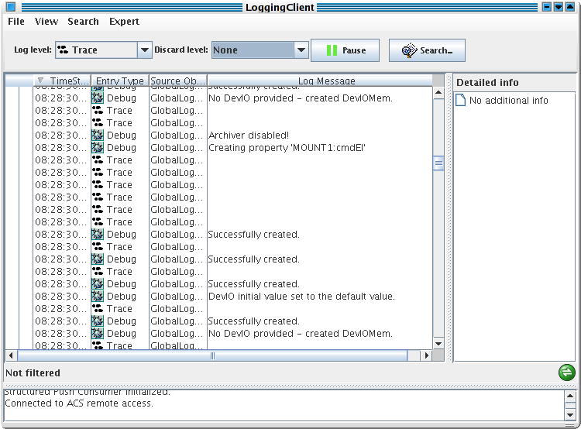
The size of the three areas can be adjusted, by dragging the separators.

Menu
The menu bar is composed of four items: File, View Search and Expert.
- File\Connect File\Diconnect: this menu item allows the user to connect/disconnect for the server. If the client is not connected then Connect is shown otherwise Disconnect is shown. The progress of the process will be displayed in the status panel. If LC is not connected to the server the client works offline; in this case the title of the main window hast the Offline world appended at the end (see the picture above). The icon in the bottom right side of the main window is green when the application is connected to the logging channel and becomes red in case of disconnection.
- File\Auto reconnect: if the check box is selected LC tries to reconnect to the logging channel if the connection has been lost (defaults unchecked).
- File\Load: loads an xml file containing logs into the log table.
- File\Save File As: saves the log entries that are currently displayed in an xml file.
- File\Clear All: clears the log table from the logs.
- File\Exit: disconnects from the server and closes the application.
- View\Fields: opens the window where you can choose visible columns
- View\Toolbar:shows or hides the toolbar
- View\Detailed log info:shows or hides the detailed log info frame at the right side of the main window
- View\Short date format: the date in the time stamp column of the table of logs are displayed as hh:mm:ss.mmm; the long format comprises the date and the time.
- View\Filters: opens the log entry filter configuration window
- View\Statistics: opens the statistic dialog
- Expert\Suspend: the suspend menu item causes a sospension of the ingestion of logss. When LC is suspended it does not listen from incoming logs (i.e. the logs loaded or received from the logging channel are discarded). Setting LC in suspend mode do not cause the disconnection from the logging channel.

Log table
This is the central area of the Logging Client. Any log received by the application is displayed here. The view is highly configurable to allow filtering and sorting. The default view on startup is set to be unsorted and unfiltered.
The table shows the logs one per row. If the user selects a lin, all the field of the logs are displayed in the Detailed info panel.
If a log has additional informations added programmatically or by the logging client user, these informations are also displayed in the Detailed Info panel . See the section Additional Info for further info about this topic.
Display configuration is available by left or right clicking the table header.
- Left-clicking the header will sort the logs by that column in ascending or descending order
- By pressing the left button and dragging the header the order of the columns can be changed
- Right-clicking the header shows the pop-up menu with more options.
Options in the pop-up menu always apply to the column the user clicked on.
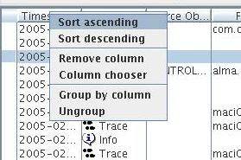

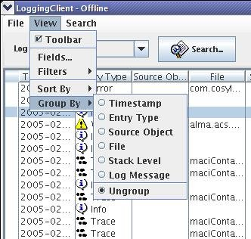
- Sort ascending/descending has the same effect as left-clicking on the column
- Remove column hides the selected column
- Column choosers shows the dialog that can be used to show or hide the columns

Field Chooser
Field chooser is opened by selecting the View\Field chooser option in the menu or by right-clicking on the table header.
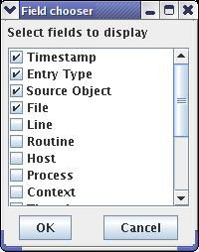
Field chooser is used to show or hide different log entry fields. When a column is added to the table it is always displayed as the left-most and if the column is removed, all remaining will shift automatically to fill its position. In the field chooser checking a check box before the column name means it will be shown, and un-checking it means it will be hidden. All changes occur after pressing the OK button.
A full explanation of all the fields may be found in Logging and Archiving (http://www.eso.org/projects/alma/develop/acs/Releases/ACS_4_1/Docs/Logging_and_Archiving.pdf)

Filters
Filters allow displaying only log entries which match specified criteria. The engine does not discard the messages that do not match with the filters. It instead hide those messages to the user in such a way when the filters are disabled all the messages will be displayed again in the table.
The dialog contains a list with all the currently defined filters (a filter for the timestamp is shown in the picture).. Each entry in the list is composed of a check box to enable or disable the filter together with a brief description of the filter itself.
Caution should be used when enabling filters, since some combinations may filter out all the entries and the table will appear empty. As said before, the filters on the entry type are evaluated in AND with the log level selected in the toolbar.
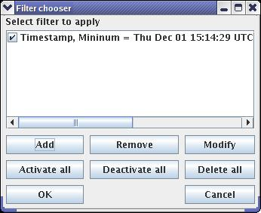
The buttons below it are used to modify the entries:
- Add: presents a dialog window to define a new filter
- Remove: remove the selected filter
- Modify: show a panel to edit the selected filter
- Activate all: enable all the filters
- Deactivate all: disable all the filters
- Delete all: remove all the filters

Creating and modifying filters
To create a filter, click the Add button in the Filters dialog. This will open a new window, the Filter properties.
The upper list box allows selecting the log field to filter by. The rest of the display automatically adjusts to the type of the field: there is a date/time editor, a string editor, a number editor and an entry type editor. All of these editor are quite intuitive and do not need more explanations.
The Apply as Not field signals the engine that the filter has to be applied in such a way the messages to be filtered out are those that do NOT respect the criteria. For example, the filter in the following picture says that only the files generated after the first of December will be shown in the table. If the Apply as NOT is checked, then all the files that are NOT genereted after the first od December will be shown (i.e. All the logs generated before the date).
For string values it is possible to define a regular expression to match.
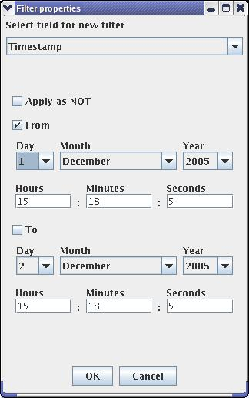
To define a filter, simply check the conditions to validate and click OK. Clicking the Cancel button will close this window without making any modifications.
The same window is shown when modifying a filter. This can be done by selecting a filter in Filters window and clicking the Modify button. The only difference from creating a new filter is that the fields will already be filled in.

Loading and saving filters
A set of filters may be saved and load in a XML file. The filters menu shows the usual items for this kind of operations: Load, Save and Save As...
By selecting Load or Save As menu item a file chooser dialog is shown to allow the user to select an existing file or to create a new one.
The Save item is enabled only after a file has been chosen for loading or saving.
By selecting the Load item and if a set of filters is already defined, a dialog box asks the user if he/she wants to merge the filters defined in the file with the existing ones.

Additional log information
According to the Logging and Archiving specification (KGB-SPE-01/04) document, each log entry can also contain unspecified amount of additional information. The detailed info panel shows all the fields of a selected log together with its additional informations (if any). The panel itself provides no other functionality.
The icon appears in the left side of each row whose log entry contains additional information. The purpose of this icon is to signal the user that, by selecting the row, additional info will be displayed in the right panel. In the following picture you can see that both the logs in rows 11 and 18 contain additional info.

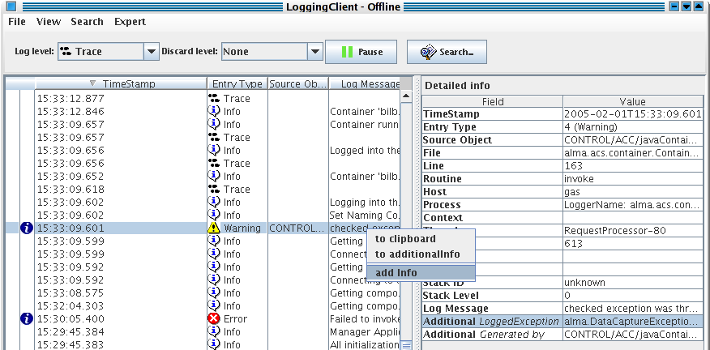
The additional informations are a couple <Name, Value> and a log entry may have none or many information of this type. There are three ways to add information to a log entry:
- programmatically with the addData method specifying the name and the value (the picture show an entry of this type in the first position; the developer added the type of the exception received when the method failed)
- by pressing the right mouse button over a cell of a log and selecting the toAdditinalInfo item. The content of the cell is added in the Value field and “Generated by jlog” will be the Name (it is the second entry in the picture upon). Note that after inserting this entry from the entry type cell of the selected log, the user hided the Entry type column but the information is still visible in the second line of the Additional Info panel.
- By pressing the right mouse button over a log and selecting add Info, a new dialog is shown to the user where he can the <Name,Value> pair to be added in the panel. The third line of the Additional info panel shows the result produced by pressing ok in the panel in the picture.
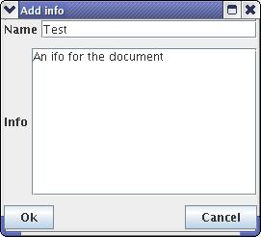
The additional infos of each log entry become part of the log itself and thereafter will be saved together with the logs (File/Save or File/Save as..). This allows the users to add some more details to the snapshot and it is very useful when the same log file is shared by several developers.
In the picture, the detailed info panel is filled by the data of the selected log. In the bottom of that panel the Additional informations are visible, identified by the bold Additional title. The key of the additional data is shown in the first column and the value in the second.

Status bar
If an error occurs or any of the control system components reports a message it will be displayed here. This is just textual information and can be used in troubleshooting.

Toolbar
The toolbar allows to perform some the most useful and requested operations in a short time.

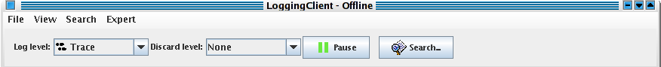
By selecting an item in the left combo box, the user can select the log level so that only the messages with a higher priority then the selected log level will be shown in the main window. The log level functionality is obtained by defining a filter at system level. The user shall keep in mind that it is also possible for him to define filters based on the same property: those filters will be evaluated in AND with the selected log level. If the log level is selected to trace then all the messages appear in the table.
To reduce the load of the application it is possible to define a discard level: the discard level let jlog discard all the logs having a log level equal or less the the selected discard level.
There is a great difference between the log level and the discard level. The log level works like filter, showing or hiding the logs depending of their entry type. The discard level instead causes the application to ignore the incoming logs if their entry level is equal or less then the selected discard level.
There is no way to get back a log it is has been discarded because of the setting in the discard level combo box. The user should use this option carefully. To disable the discard level, select None as shown in the picture.
The log level defaults to Info; the discard level defaults to Debug.
By pressing the Pause button, all the received logs are queued and their insertion in the main table is delayed until the button is pressed again. This feature freezes the table of logs allowing the user to read the status of the system at a given time without dealing with the incoming logs. As the logs are queued, they will be displayed in the table when the user un-pauses the application.
The Suspend item of the Expert menu works in a similar way of the Discard level. Both the features discard logs when they arrive and before being ingested and added in the table of logs. The only difference is that the discard level ignores the logs following a criteria, a kind of filter based on the entry type of each received log. The suspend function instead discard all the logs regardless of their content.
A Search button is in the right side of the toolbar: by pressing this button the search dialog box is shown.

Search for logs
The search feature allows the user to search the logs for a string or a regular expression. The search dialog can be displayed by pressing the button in the toolbar, by pressing CTRL+S in the keyboard or by selecting the Search... menu item as shown in the following figure:
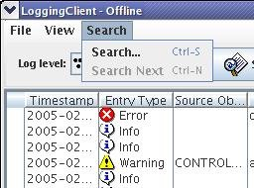
The search dialog box is used to define the parameters of the search. The engine searches for the string or the regular expression inserted in the Find text box. The search is performed in forward or backward order depending by the selected item in the Direction box and starting from the selected row in the log table of the main window.
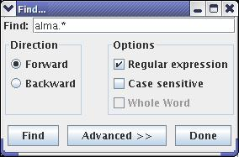
The option pane contains the following switches:
- Regular expression: means that the string inserted in the upper text field is a regular expression instead of a standard string (the picture shows this case)
- Case sensitive: the search is performed comparing or not comparing the cases of the strings
- Whole word: if this item is checked the engine looks for a string equals to the text written in Find otherwise it looks for a string containing the string written in the text field. This field is disabled if the string is a regular expression.
When the user presses the Find button, the engine starts the search from the selected row in the table of the logs of the main window. The search is done by comparing the string or regular expression in the text field with the string in each visible field of the table. A dialog is shown if no log matching the criteria is found otherwise the row of the table containing the matching log is selected and shown in the table of the main window.
The Done button closes the dialog box but the search criteria is not lost i.e. once the user has introduced a search criteria in the dialog box, it is possible to search for a log by pressing CTRL+N even if the dialog box is not visible anymore.
As we said before, the search is performed by looking for the string (or the regular expression) only into the fields of the logs that are visible in the table of the logs: the user can show or hide those fields by selecting the View/Fields menu item. It is possible to explicitly select the fields to look into during the search. This is done by pressing the Advanced button: another panel is shown in the search dialog box:
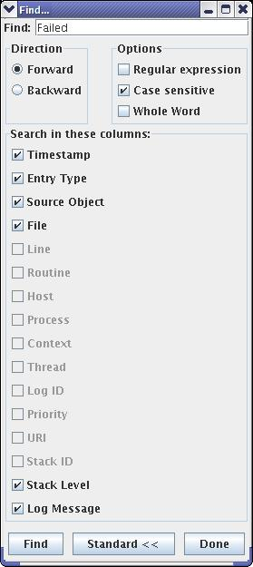
The panel shows all the fields of the logs. The fields that are not visible in the table are disabled because it is not possible to search into these fields. The visible fields instead are all enabled (and checked for default): the string is searched in all and only the checked fields. The user can select the field to search into by checking or unchecking the relative checkbox.
For example, in the figure above if the user wants to search for string into the Source Object column only then he has to uncheck all the fields but the Source Object. If he instead wants to search a string also in the Routine column the he has first to make visible the Routine column in the table and then to check the Routine checkbox in the advanced panel.

Statistics
The statistics dialog appears by pressing the View/Statistics menu item.
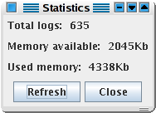
The dialog shows some information about the loaded logs. In the picture upon, you can see that jlog is managing a total of 635 logs. The total and available memory is also shown.
By pressing the Refresh button, the date displayed are updated.
The dialog can stay open during the normal functioning of the logging client.

Connection icon
The status of the connection of the LC is displayed in the status bar as a string. An apposite icon is present in the bottom right side of the application window to show the user the status of the connection with a quick look.
The icon changes the color and/or the picture depending on the status of the connection.
The green icon means that the LC is connected to the logging channel and working properly.
The red icon means that the application is disconnected from the logging client. This is the icon shown while working offline. The green icon becomes red if the connection is lost at run time.
The gray icon is shown when the application is trying to connect to the logging channel. It is usually displayed at startup. It can also be shown if the connection has been lost and the application is trying to reconnect to the channel if the autoreconnect menu item is selected.
The blue icon is shown only when the application is connected to the logging channel and means that there is a delay between the loogs received and the logs displayed in the table. This happen when the number of logs read by the logging channel per second is too high and the application is not able to cope with such a load. The blue icon advise the user that he has to wait some time to see all the received logs displayed in the table.
Please note that even if the blue icon is shown no logs are lost. In case of overload, LC queues the incoming logs in order to insert the logs in the table when the load is acceptable. The icon usually blinks from green to blue during normal operations.

Command line
To launch the logging client use the following command line:
jlog [logFileName] [(-f|--filter) filterFileName]
It is possible to specify in the command line a log file as well as a set of filters to load at startup.
If a set of filters is specified, they will be loaded immediately after startup, before connecting to the logging notification channel or loading a file of logs.
If a file of logs is specified then it will be loaded immediately after loading the filters (if any). In this case the logging client does not connect to the CORBA notification channel but works offline. The user can connect to the logging channel using the apposite menu item at any time.
If a filter file name and a log file name are not in the command in the command line, then the client starts with an empty table of logs, an empty set of filters and tries to connect to the logging notification channel for receiving logs.

If there is no line selected in the table of the logs the engine begins the scan starting from the first or the last row if the direction is forward or backward respectively.
By selecting the View/Fields menu item and making visible the Routine column in the table of logs, the Routine check box in the advanced panel will be enabled.

