Released by: | Signature:
Institute: | Date:

Keywords: ACS, Installation, Overview
Approved by: | Signature:
Institute: | Date:

Author Signature: | Date:

ALMA Common Software
Overview

ALMA Common Software
Overview
(Partially updated for ACS 3.0)

6

Gianluca CHIOZZI
European Southern Observatory
Matej Šekoranja
Jozef Stefan Institute

Gianluca CHIOZZI
European Southern Observatory
Matej Šekoranja
Jozef Stefan Institute

Change Record
REVISION | DATE | AUTHOR | SECTIONS/PAGES AFFECTED
 | REMARKS
1.0 | 2001-09-24 | G.Chiozzi | All.
 | Document created from notes prepared by M. Šekoranja
1.0-Rev.1 | 2001-10-08 | G.Chiozzi | Added
Added section on Environment Variables.
Added minor details and fixed typos.
1.0-Rev.2 | 2001-10-23 | G.Chiozzi | First page
 | Replaced Advanced Common Software with ALMA Common Software
 | 2001-11-13 | G.Chiozzi | Sec. 2 and 3
 | Fixed a few typos.
1.0-Rev.3 | 2001-11-22 | B. Jeram | Sec. 2.3.8 and 2.3.9
 | Added information about ORB ports for maciActivator and maciManager
1.1 | 2002-04-05 | G.Chiozzi | All
 | Modified for ACS 1.1
1.1-Rev.1 | 2002-06-28 | G.Chiozzi | All
 | Updated with suggestions/feedback after first set of installations
2.0 | 2002-12-06 | G.Chiozzi | All
 | Updated for ACS 2.0
2.1 | 2003-06-09 | G.Chiozzi | All
 | Updated for ACS 2.1
2.1.1 | 2003-07-07 | G.Chiozzi | All
 | Updated environment variables section
3.0.0 | 2003-11-15 | G.Chiozzi | All
 | Updated for ACS 3.0
3.0.0.1 | 2003-12-29 | G.Chiozzi | All
 | Updated for ACS 3.0. Fixed errors.
3.0.1.0 | 2004-02-18 | G.Chiozzi | All
Updated for ACS 3.0.1 and according to comments from J.Schwarz.
Added captions.
Removed Alarm Display.
Added instructions to start LCU Containers.
3.1.0 | 2004-05-11 | M.Schilling | Sec. 2.2, 2.3, 3.2
 | Now mentions acsList, and general “–help” option. Adminc now outdated.
5.0.4 | 2006-07-24 | G.Chiozzi | Sec. 6
 | Updated ports usage information.

Table of Contents

1 Summary 4
1.1 Glossary 4
1.2 References 4
2 Overview of ALMA Common Software 4.0 4
2.1 ACS Command Center 5
2.2 ACS Instance 6
2.3 ACS Startup 6
2.4 ACS Shutdown 7
2.5 ACS Processes 8
2.5.1 acsStartContainer 8
2.5.2 acsStopContainer 9
2.5.3 acsStartManager 9
2.5.4 acsStopManager 10
2.5.5 acsStartJava 11
2.5.6 acsLogSvc 11
2.5.7 cdbjDAL 11
2.5.8 CORBA Services 13
2.5.9 loggingClient 14
2.5.10 loggingService 15
3 ACS User Interface utilities 17
3.1 ACS Command Center 17
3.2 Administrator Client 17
3.3 CDB Browser 18
3.4 Logging User Interface 18
3.5 Object Explorer 19
3.6 Event Browser 21
4 Structure of the Configuration Database 22
4.1 Resolving the Configuration Database Reference 22
4.2 Database configuration files 22
4.3 Manager Configuration Database 22
4.3.1 Manager's own CDB branch 22
4.3.2 Component definitions for Manager 23
4.4 Container Configuration Database 23
4.4.1 Container's own CDB branch 23
4.4.2 Component’s definitions for Manager 24
4.5 Characteristic Component Configuration Database 24
4.6 Configuration Database 24
5 ACS Environment Variables 25
5.1 Most Important environment variables 25
5.2 Other environment variables set in .bash_profile.acs and used by ACS: 26
5.3 Environment variables deprecated or not used any more: 29
6 TCP Ports Allocation for ACS 4.0 30

Summary
This is a simple Overview of the ALMA Common Software (ACS) version 43.02.12.0. Read it to get an idea of what is provided and how to get the system up and running. It is also useful to read this manual if you have been using ACS 3.1 and are upgrading to 43.02.12.0.
This document is not intended to be an introduction to ACS features and concepts.
For details on ACS concepts, architecture and APIs look at the main ACS Web Page[1] or directly at the index page of the ACS 43.02.12.0 Online Documentation[2] and pick the documents you are most interested in. The ACS Web Page also contains some introductory papers presented at conferences that provide an overview of ACS concepts.
  - Glossary
http://www.alma.nrao.edu/development/computing/docs/joint/draft/Glossary.htm
  - References
All documents referenced here are available in the online ACS 3.04.02.12.0 documentation
- ACS Web Page: (http://www.eso.org/projects/alma/develop/acs)
- ACS 3.04.02.12.0 Online Documentation: (http://www.eso.org/projects/alma/develop/acs/Releases/ACS_4_0_Docs/index.html)
- ACS Installation Manual - v. 4.0
- ACS Configuration Database, CDB
- VLT Common Software - Installation Manual - VLT-MAN-ESO-17200-0642 v.1.14

- VLT Software - Tools for Automated Testing User Manual - VLT-MAN-ESO-17200-0908 v.1.5

Overview of ALMA Common Software 3.04.02.12.0
The following component diagram shows the processes running in a typical ACS 3.04.02.12.0 session and the main relationships between them.
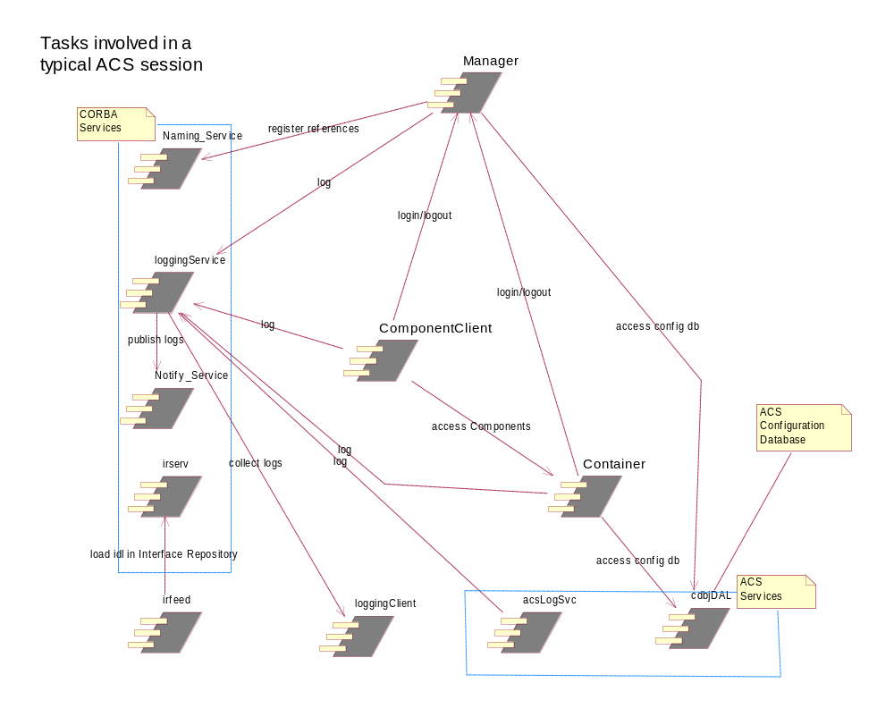
Figure 1- ACS Tasks Diagram
The following sections will provide some introductory details on the functionality covered by these processes and ACS startup/shutdown procedures.
In general, we assume that there will be one ACS Manager and all CORBA services running on the main Linux workstation. As of ACS 4.0, it is also now possible to federate different instances of ACS via ACS Manager federation. There will be one C++ Container per LCU and possibly other Container processes on multiple workstations. Java Containers and Clients can run anywhere including MS-Window PCs.

ACS Command Center
ACS can be started, shutdown and administered from the ACS Command Center GUI.
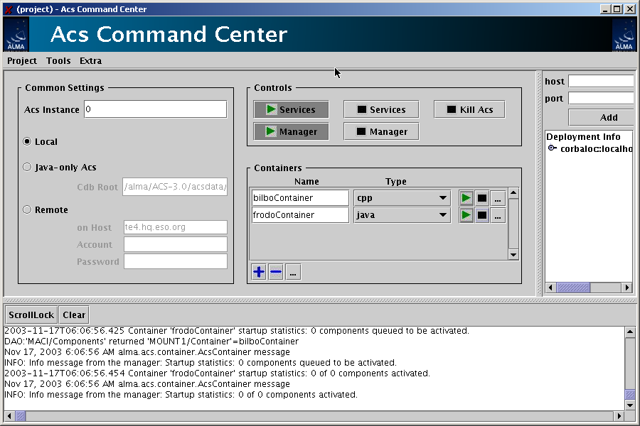
Figure 2- ACS Command Center
Through the Command Center you can start/stop ACS services, Manager and Containers as well as ACS tools like the Object Explorer.
Your preferred configuration can even be saved and reused.
To start the application type the following command:
> acscommandcenter

ACS Instance
In order to allow multiple users to work in completely separate sandboxes on the same machine, we have introduced the concept of “ACS Instance”
The environment variable ACS_INSTANCE can assume the values from 0 (default) to 9.
Based on this environment variable (and/or the –b <ACS_instance #> option for most ACS commands), ports used by ACS services and processes are automatically calculated according to the rules described in section 5.
Users selecting two different values for ACS_INSTANCE will work without interfering with one another. Which instances are currently used on a machine can be determined with the acsList command.

ACS Startup
Command line commands are available to start and stop ACS processes. Invoking most of the commands with --help will provide usage information.
Before Containers can be started, ACS services and Manager must be active. Therefore the following commands must be executed:
- CORBA Services and Manager:
> acsStart
This includes also the IDL server, logging (acsLogSvc), and the Configuration Database (cdbjDAL).
This command returns control when the services and Manager are up and running.

- or
> maciMaerJany needed Container (Activator, for C++):
> acsStartContainer <-cpp|-java|-py> maciActivate <CC++ container name>
- or Java container:
>container name>

- any clients…
We suggest running each command in an independent window/xterm to be able to look at the output produced.
The command acsStart will try to start everything according to the value of the ACS_INSTANCE variable (0 by default). Since there can be only one ACS instance running for a given value of ACS_INSTANCE, if acsStart finds out that ACS processes are already running with the selected value, it will automatically select a new one and print the choice to standard output.
Both acsStart and acsStartContainer, like most other ACS commands, accept the command line option:
-b <acs instance #>
This overrides the value of the ACS_INSTANCE environment variable.
It should be noted that the time allowed for most of the ACS startup commands to complete can be increased by increasing the value of the ACS_STARTUP_TIMEOUT_MULTIPLIER environment variable (an integer greater than 0). The same behavior can be duplicated by using the following command-line option available in most startup and shutdown scripts:
-t <integer timeout multiplier value>
This overrides the value of ACS_STARTUP_TIMEOUT_MULTIPLIER.

ACS Shutdown
ACS processes can be stopped with the following command:

- acsStop [-b <acs instance #>]
The command:
- killACS [-Q]
will instead try to KILL all ACS processes in the host for all ACS_INSTANCE values and clean things up. The optional –Q parameter will kill ACS processes much quicker but it will not kill all ACS clients. It is an (almost) last resort option to cleanup a host from dangling ACS processes. In very rare cases killACS might not be sufficient. The real last resort is to kill -9 the dangling processes/threads.
is used to stop all CORBA Services.

ACS Processes

acsStartContainer
The acsStartContainer command is used to start ACS containers for C++, Java or Python. To successfully resolve object interfaces (IDL IDs), C++ containers use the Interface Repository Service. In order to use BACI recovery, Container must use a dedicated ORB port (by default 3050 for C++, 3052 for Java, 3054 for Python and ACS_INSTANCE=0).
The ORB port can be changed using the command line option ––port or (for C++ Containers) the same option in the configuration database entry named Command Line:
acsStartContainer [ ––port < 0-25 | precise port number > ]
< –cpp | -java | -py > <Container name>
If the Container is running on the same host as the ACS Manager and there are no other Containers running on the host, it is not necessary to pass any configuration parameters:
acsStartContainer < –cpp | -java | -py > <Container name>
If the Container runs on another host, the corbaloc for the reference to the manager shall be given on the command line or in the configuration database:
acsStartContainer
–m corbaloc::<manager_host>:<manager_port>/Manager
< –cpp | -java | -py > <Container name>

Manager reference is resolved using algorithm described in 2.5.3.1.

For information on the Container’s CDB data see section 3.4.
Other command-line options can be examined using the –h option.

Instructions on starting a Container under a VxWorks LCU are available in the following ACS FAQ:
http://almasw.hq.eso.org/almasw/bin/view/ACS/FAQVxWorksContainerStart

acsStopContainer
acsStopContainer is used to shut down one or more Containers whose reference is retrieved by name from the Manager. Wildcards can be used to specify the name of the Container(s) to be shutdown. To resolve Manager’s reference, the algorithm described in section 2.5.3.1 is used:
acsStopContainer <Container name(s)>
[–m corbaloc::<computer address>:<manager_port>/Manager]
Other command-line options can be examined using the –h option.

acsStartManager
ACS provides a Java Manager.
To start the Manager, run the command:
  - acsStartManager

By default the Manager ties up TCP port 3000 (for ACS_INSTANCE=0). This can be changed by using the command-line option –ORBEndpoint (also settable in the configuration database’s Command Line entry):
–ORBEndpoint iiop://<host>:port
If –ORBEndpoint option is not specified from the command-line or in the configuration database and the environment variable MANAGER_REFERENCE is defined, then the port number is extracted from it. The environment variable has to be of the form:
corbaloc::<manager_host>:<port>/<Manager_name>
Manager uses the Naming Service to map activated Components and some special references (NameService, InterfaceRepository, Log, LogFactory, NotifyEventChannelFactory, ArchivingChannel, LoggingChannel). Since Manager is the central communication point, it is necessary that all applications retrieve the needed references through the Manager and not directly through the NameService.
acsStartManager [–ORBInitRef NameService=corbaloc::<ns_host>:
4000/NameService]
To minimize system configuration, Manager uses the following algorithm to resolve NameService references:
- Command-line corbaloc
- CDB option -ORBInitRef
- Environment variable NAMESERVICE_REFERENCE
- Using generated reference: corbaloc::<hostname>:<ns_port>/NameService
For information on the Manager’s CDB data see section 3.2. To see other command-line options for Manager, use the –h option.

Resolving Manager reference algorithm
ACS services and clients use the following algorithm to resolve Manager reference via the API function maci::MACIHelper::resolveManager():
- Command line option: -m or –managerReference
- ManagerReference value in the configuration database. This is only applicable to C++ Containers.
- Environment variable MANAGER_REFERENCE
- Using generated reference: corbaloc::<hostname>:<manager_port>/Manager

acsStopManager
acsStopManager is used to remotely shut down the Manager. To resolve Manager’s reference, the algorithm described in section 2.5.3.1 is used:
acsStopManager
[–m corbaloc::<computer address>:<manager_port>/Manager]
Other command-line options can be examined using the –h option.

acsStartJava
This script is used on Linux to execute any ACS Java application.
It automatically builds the $CLASSPATH environment variable locating all needed jar files and of setting all Java properties used by ACS/ABeans Java applications:
acsStartJava <java_class_name>
For example:
acsStartJava alma.acsabeans.examples.PSPanel.PSPanel
Other command-line options can be examined using the –h option.

    - acsLogSvc
This ACS process activates a logging IDL interface implementation that any CORBA-aware client can use to generate Log messages of the types specified in the ACS Logging and Archiving specifications without having to manually format the corresponding XML string. The acsStartORBSRVC script automatically executes this command.

cdbjDAL
This process provides the IDL DAL (Data Access Layer) interface to the ACS xml-based configuration database (CDB).
For more details, see section 3 and the Configuration Database manual [4].

cdbjDAL command
This command starts the Configuration Database service. The acsStartORBSRVC script automatically executes it.
The Configuration Database service uses the following algorithm to resolve the path of the directory where the CDB XML files are located:
- Command line option –root <path>
- Environment variable ACS_CDB

Once the path has been resolved, it expects to find CDB XML files in the CDB sub-directory.
When cdbjDAL is executed from within acsStartORBSRVC it is not possible to pass the –root option. Therefore the only real usable way of defining the path for the CDB files is using the environment variable ACS_CDB. The default value for this variable provided by the login scripts is $ACSDATA/defaultCDB, where the ACS installation procedure puts the standard sample CDB.
At run-time, the cdbjDAL service searches for schema definitions, in the given order, in the following directories:
CDBPATH= $ACS_CDB/CDB/schemas
$PWD/../config/CDB/schemas:
$INTROOT/config/CDB/schemas:
$ACSROOT/config/CDB/schemas
Other command line options:
-o <file> writes in the given file the IOR
-OAport specify a TCP port different from the default

cdbjDALClearCache command
This command requests the Configuration Database (jDAL implementation) clear its internal cache and to notify applications (in particular the Manager) that updated data may be available.
Using this command, it becomes easy to modify the CDB and get the new values “active” without having to restart ACS processes:
- Edit with a text editor jDAL CDB XML files
- Issue cdbjDALClearCache command to notify the CDB
- The Manager gets automatically notified and updated and reloads its data from the CDB at the next request.

cdbjDALShutdown command
This command shuts down the Configuration Database service. The acsStopORBSRVC scripts executes this command.
Useful command line options:
-k corbaloc::<HOST>:<CDB_PORT>/CDB
Host and port where the cdbjDAL is running

cdbRead command
This command is a utility to directly dump DAOs from the Configuration database.
The calling syntax is:
cdbRead <DAO name> [-raw]
where <DAO name> is the hierarchical name of the DAO in the CDB, for example the command:
cdbRead /alma/LAMP1
produces the output:
________________________________________________________
Node brightness
description="brightness"
units="%"
min_step="1.0"
min_value="0.0"
max_value="100"
default_timer_trig="10000000"
min_timer_trig="10000"
min_delta_trig="0"
default_value="0.0"
graph_min="-1.7976931348623157E+308"
graph_max="1.7976931348623157E+308"
archive_delta="0"
format="%9.4f"
resolution="65535"
archive_priority="3"
archive_min_int="0"
archive_max_int="0"
________________________________________________________
Other command line options:
-raw as last parameter after the DAO name, dumps the DAO as a raw XML file.
-k corbaloc::<HOST>:<CDB_PORT>/CDB
Host and port where the cdbjDAL is running

CORBA Services
ACS uses a number of standard CORBA Services, which need to be started before any ACS specific process.
The scripts
acsStart (or, more precisely, acsStartORBSRVC)
and
acsStop (or, more precisely, acsStopORBSRVC)
are used to start one by one the CORBA Services, passing the necessary command-line parameters. All Services are started on the local host and it is assumed that also the ACS Manager process will be started on the same host.
In particular, it is necessary to configure each service to run on a specific TCP port (see chapter ) and to pass the -ORBDottedDecimalAddresses=1 option to allow communication with LCUs.
These scripts also start/stop the Logging Service (see 2.5.10), acsLogSvc and cdbjDAL server.

Naming Service (TAO)
Naming_Service –ORBEndpoint iiop://<host>:<ns_port>
-ORBDottedDecimalAddresses=1

Notify Service (TAO)
TAO Notify Service requires Naming Service to run.
Notify_Service –ORBInitRef
NameService=corbaloc::<ns_host>:<ns_port>/NameService
–ORBEndpoint iiop://<host>:<notify_port>
-ORBDottedDecimalAddresses=1
Where <ns_host> is the host where the Names Service is running.

Interface Repository (MICO)
MICO Interface Repository does not automatically register its reference to the Naming Service. This has to be done via script and the TAO nsadd tool ($ACS_ROOT/TAO/utils/nslist/nsadd):
$MICO_HOME/bin/ird -ORBNoResolve -ORBIIOPAddr inet:$HOST:$ACS_IR_PORT --ior $IR_IOR &
$ACE_ROOT/TAO/utils/nslist/nsadd --name InterfaceRepository --ior `cat $IR_IOR` -ORBInitRef NameService=corbaloc::$HOST:$ACS_NAMING_SERVICE_PORT/NameService $ORBOPTS

Feeding the Interface Repository
The interface repository needs to be given all ACS IDL interfaces. The generic command syntax is:
acsIrfeed [-IRcorbaloc
corbaloc::$HOST:$ACS_IR_PORT/InterfaceRepository]

The acsIrfeed command can also be used at any time (and in particular during development and debugging) to (re-)load speficic IDL interfaces in the Interface Repository:
acsIrfeed <filename>.idl

loggingClient
Logging client is a simple example of an application that attaches to the Notification Service, retrieves ACS Logs or Archive Monitors, and displays them on standard output. It is a structured push event consumer. For its operation the Naming Service is queried to resolve references of notify channels. The current implementation has the capability of monitoring the Logging and Archiving channels.
loggingClient LoggingChannel
–ORBInitRef NameService=corbaloc::<ns_host>:
<ns_port>/NameService
or
loggingClient ArchivingChannel
–ORBInitRef NameService=corbaloc::<ns_host>:
<ns_port>/NameService
It is often convenient to use "| tee fileName" to store at the same time the logs in a file.

loggingService
This implements ACS 3.04.02.12.0 Centralized Logger (Telecom Logging Service – see Logging and Archiving specification). loggingService activates Telecom Logging Service Log and LogFactory interfaces and creates ArchivingChannel and LoggingChannel (with domain_name=Logging). All these objects are registered with the Naming Service and are accessible via Manager using get_service() method.
loggingService requires Naming Service and Notify Service to run.
Running loggingService:
loggingService
–ORBInitRef NameService=corbaloc::<ns_host>:
<ns_port>/NameService
-ORBDottedDecimalAddresses=1
–ORBInitRef NotifyEventChannelFactory=corbaloc::
<notify_host>:<notify_port>/
NotifyEventChannelFactory
where <notify_host> is the host where the Notification Service Event Channel Factory is running.
Specifying -ORBInitRef NotifyEventChannelFactory option is optional. NotifyEventChannelFactory reference is obtained from the Name Service, but -ORBInitRef has higher priority then NS lookup, algorithm:
1. resolve_initial_references
2. Name Service lookup
For more detailed information about logging and archiving, see the Logging and Archiving specification.
Notice that logs are published on the Notification Channel as XML strings.
If no application (such as loggingClient) listens to the Notification Channel, the logs are lost.

Controlling logging behavior
The logging system uses as much as possible the standard Logging APIs of C++ and Java.
See the ACS Logging System documents for details.
C++ Logging System
C++ Logging system is based on ACE Logging API.
Several macros are defined in $ACSROOT/include/logging.h to make message logging simpler for user applications. All messages which are logged using the logging macros are sent to the ACS loggingService except when the application is unable to connect to the loggingService (for example, if the loggingService is not running). In this case, log messages are sent to a local text file. Each process/thread writes its own logging text file, by appending its process name and PID to a standard root.
By default, the standard root name is:
$ACSDATA/tmp/acs_local_log_
For example, ACS Manager would write a file like:
$ACSDATA/tmp/acs_local_log_maciManager_12345
It is possible to change the default destination for ALL ACS temporary files from $ACSDATA/tmp to any other directory by setting the environment variable $ACS_TMP.
It is possible to change the root name for logging files by setting the environment variable $ACS_LOG_FILE. If $ACS_LOG_FILE is set, $ACS_TMP is ignored.
The environment variable ACS_LOG_STDOUT can be used to control the amount of information sent to stdout at a per-process level. By default, only log messages with priority equal or higher than LM_INFO are sent to stdout. If ACS_LOG_STDOUT>0, all log messages with priority >= ACS_LOG_STDOUT are also sent to stdout.
The C++ logging system caches log messages on a per-process basis before transmitting them to the centralized logging service. Several configuration database parameters control whether messages are to be logged at all, which messages should be cached locally, and which messages should be transferred immediately to the logging service (or the local log file):

- Messages with a priority less than MinCachePriority are not logged at all. Manager and Container provide a CDB point with this characteristic (see sections 3.3 and 3.4). By default, MinCachePriority is set to zero so that all messages are logged.
- Messages with a priority greater than MinCachePriority but less than or equal to MaxCachePriority are cached locally. When the cache fills up, all cached messages are transferred to the logging service.
- Messages with a priority greater than MaxCachePriority are logged immediately, bypassing the cache.
- The cache size for Manager and Container can be controlled in their CDB definition using the CacheSize characteristic (see sections 3.3 and 3.4). If CacheSize is set to 0 or 1, all messages (except those with priority less than MinCachePriority ) are logged immediately without caching.

For more information, look at the online documentation for the LoggingProxy class.
This is the class used by applications to interact with the loggingService.
Java Logging System
The ACS Java Logging API is based on the official JSDK Java Logging java.util.logging and it has been integrated with the implementation of the CORBA Telecom Logging Service and the rest of the ACS.

- ACS User Interface utilities
ACS provides some generic GUIs to administer and interact with a running system.
Each of these applications is described in detail in a specific user manual.

ACS Command Center
Used to startup/shutdown and administer ACS. Already described briefly in section 2.1

Administrator Client

The Administrator Client is outdated; its functionality is now provided by the ACS Command Center (see above).

CDB Browser
This application is used to browse the run-time configuration database.
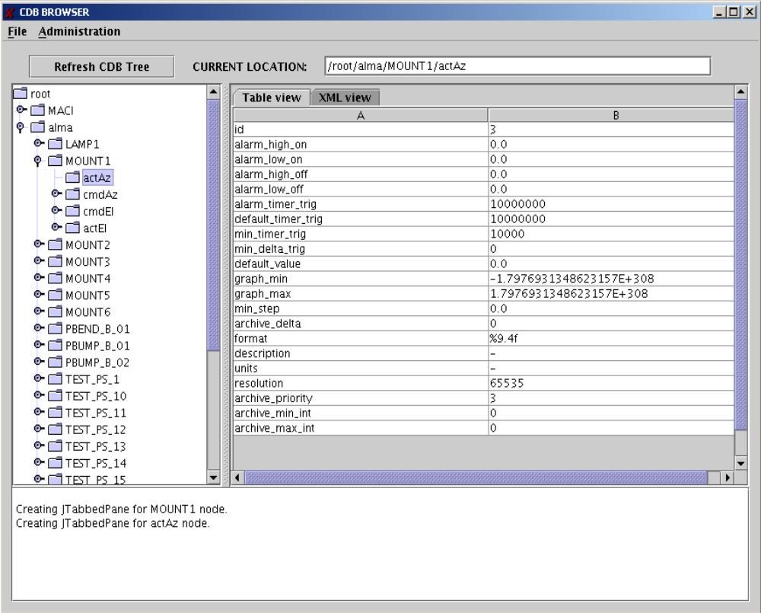
Figure 3- CDB Browser

Logging User Interface
This application is used to display logging system messages.
You can run it with the command:
> jlog
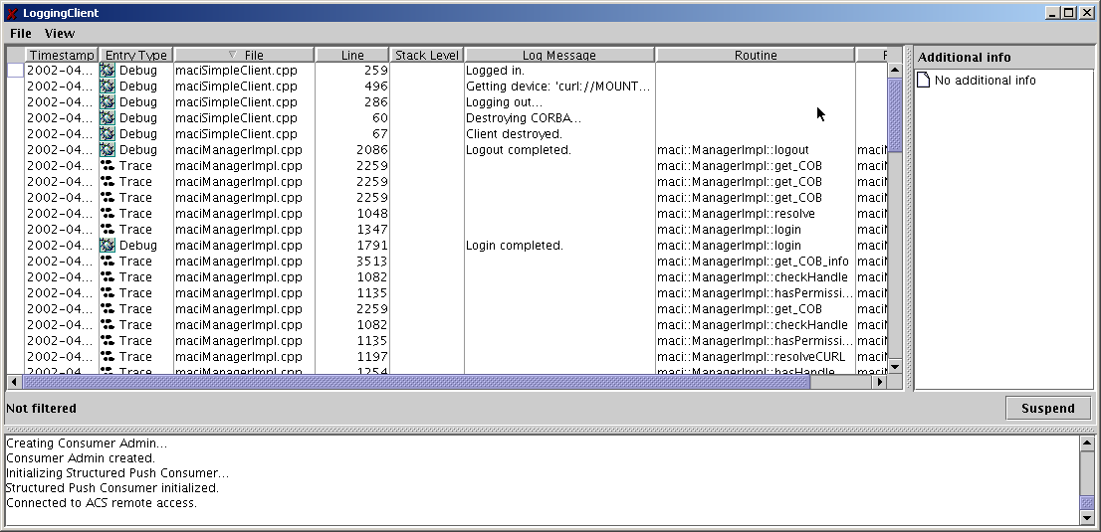
Figure 4- Logging GUI

Object Explorer
This application is used to navigate through the hierarchy of Components in the system. It allows you to call each method, get/set Properties and view Characteristics, install monitors, and draw trend plots.
You can run it with the command:
> objexp

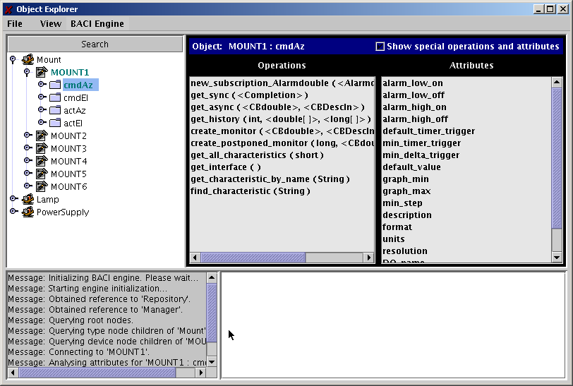
Figure 5- Object Explorer
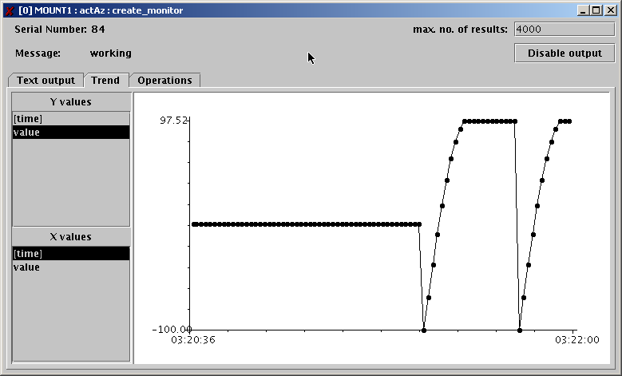
Figure 6- Property Monitor trend plot
You can pass to the objexp command-line all options and Java virtual machine parameters that can be passed to the acsStartJava command.
In particular you can pass the JVM option
-Dobjexp.pool_timeout=<time in ms>

to set DSI pool timeout, that by default is 5000ms.
For example the following command line:
objexp -m corbaloc::te98:3000/Manager -Dobjexp.pool_timeout=60000
will configure the Object Explorer to wait 60 seconds before assuming that a timeout is occurred and to connect to the Manager explicitly specified on the command-line.

  - Event Browser
A browser designed to monitor all events generated by the ACS event channel APIs was introduced with ACS 3.1. A few notes on this:
- The name of the executable which starts the GUI is acseventbrowser.
- This GUI is started automatically by clicking the Event Browser option in the Tools menu of acscommandcenter.
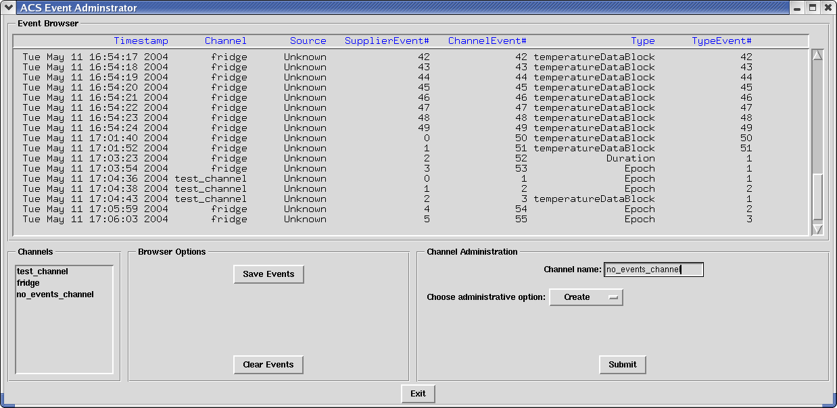
Figure 8 – Event Browser
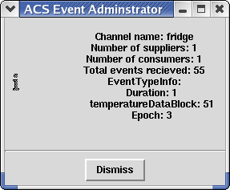
Figure 9 – Panel started by clicking the “fridge” channel in the Channels box.

Structure of the Configuration Database
For more information on the ACS 3.04.02.12.0 Configuration Database syntax, look at the ACS Configuration Database manual[4].
  - Resolving the Configuration Database Reference
ACS applications (like acsStartManager or acsStartContainer) use the following algorithm to resolve the DAL reference:
- Command line option –d or -DALReference
- Environment variable DAL_REFERENCE
- Using generated reference: corbaloc::<hostname>:<dal_port>/CDB
  - Database configuration files
Each Configuration Database is defined by a set of XML ASCII files in the directory:
$ACS_CDB/CDB

A standard configuration database contains three sub-directories:
alma – This directory contains configuration data for Components in the ALMA system, if they actually have configuration stores in the CDB. CharacteristicComponents ALWAYS have configuration data, but simple Components do not require having any data in the CDB..
MACI – This directory contains configuration data for MACI Manager, Containers and the Components’ main configuration file used by ACS Manager to map Component names into their implementation and the Container responsible for them.
schemas – This directory contains schema files used to resolve default values and inheritance in CDB DAO instances. Each DAO instance in the Configuration Database is represented by an XML file and shall be an instance of an XML Schema file in the schemas directory or in the config/CDB/schemas sub-directory of $INTROOT or $ACSROOT. When the cdbjDAL server gets a request for a DAO, the XML parser uses the corresponding XML Schemas to expand the complete structure of the DAO.

  - Manager Configuration Database
    - Manager's own CDB branch
The Configuration Database for the Manager is in the database branch:
/MACI/Managers/Manager
The definition of the configuration parameters for the Manager is in schema file:
$ACSROOT/config/CDB/schemas/Manager.xsd
Important parameters are:
CommandLine: Default command-line added to given command-line
Startup: List of Components to be automatically created on startup

/// Logging configuration data
CacheSize 25 number of logs to be cached before
logging
MinCachePriority 0 minimum log priority
messages with lower priority
are ignored
MaxCachePriority 31 maximum log cache priority
messages with higher priority are not
cached and are logged immediately
    - Component definitions for Manager
For each Component in the system, the Manager must be able to find on request all information needed to return its reference to clients and to start/stop it when commanded.
Therefore, the Configuration Database used by the Manager MUST also contain the file:
/MACI/Components/Components.xml
The definition of the Components configuration file is in the schema file:
$ACSROOT/config/CDB/schemas/Components.xsd
This consists of a table with one record per each known Component, like in the following example:
<_ Name="PBEND_B_01" Code="acsexmplPS"
Type="IDL:ALMA/PS/PowerSupply:1.0"
Container="Container"/>
- Three attributes must be defined for each of these instances:
/// Executable for the Component
/// i.e. Component`s DLL name ('xxx'
/// on Unix becomes 'libxxx.so')
/// for C++ Container Components (or Java class for Java
/// Components)
Code for example "ps"

/// Component`s type name, i.e. its IDL interface
Type for example "IDL:ALMA/PS/PowerSupply:1.0"

/// Name for the Container where the
/// Component shall be activated
Container for example "abm1”

Changing this information allows relocating Components and replace versions without having to stop and recompile the system.
  - Container Configuration Database
    - Container's own CDB branch
The Configuration Database for a C++ Container is in the database branch:
/MACI/Containers/<Container name>
The CDB entry for a C++ Container is optional (defaults are used if not present), while Java Containers currently do not support storing configuration parameters in the CDB. Python Containers have only limited support for Container info at the present.
The definition of the configuration parameters for the C++ Container is in schema file:
$ACSROOT/config/CDB/schemas/Container.xsd
Important parameters are:
CommandLine: Default command-line added to given command-line
ManagerReference Manager reference in the format
corbaloc::<host>:<port>/Manager
Autoload: DLLs to be loaded automatically on Container startup

/// Logging configuration data
CacheSize 25 number of logs to be cached before
logging
MinCachePriority 0 minimum log priority
messages with lower priority
are ignored
MaxCachePriority 31 maximum log cache priority
messages with higher priority are not
cached and are logged immediately
    - Component’s definitions for Manager
Whenever the Manager requests a Container for a Component, it passes to it information about the DLL to be loaded.
  - Characteristic Component Configuration Database
Characteristic Components, i.e. Components implemented according the BACI Design Patterns, keep the configuration for their Properties and Characteristics in the CDB.

Each Characteristic Component looks for its configuration information in the database branch:
/alma/<Component name>
The actual structure of the database depends on the type of Component, but will essentially contain characteristics for each Property as defined in $ACSROOT/config/CDB/schemas/BACI.xsd
  - Configuration Database
After the installation of ACS 3.04.02.12.0, the directory
$ACSDATA/config/defaultCDB:
will contain a sample configuration database.
This is the configuration database that is used by default when ACS is started.
This database declares a number of Component instances that are defined in the ACS example module acsexmpl as well as the Java and Python example modules (jcontexmpl and acspyexmpl).
These Components are provided as examples for the users of ACS and for testing ACS.
It is suggested to make a backup copy of defaultCDB and to modify your own copy. It is also a good practice to create new Configuration Databases for specific applications, assigning them explicit names, like corrCDB, instead of using defaultCDB all the time.
But do NOT forget to export the environment variable ACS_CDB to point to the configuration database instance you want to use.

ACS Environment Variables
The configuration of ACS is determined by a number of environment variables.
Generally, these variables are set to a proper default value by the default login script whose template is available in $ACSROOT/config/.acs/.bash_profile.acs. Each user has to take care of copying this script into his home directory (typically in the .acs directory), eventually adapting it and executing it to prepare the environment.
Some variables have been already described in the previous sections, but we give below a list of the most interesting ones.

Most Important environment variables

ACS_CDB (default: $ACSDATA/config/defaultCDB)
Location of the configuration database files to be used when cdbjDAL is started.
ACSDATA (default: /alma/ACS-<version>/acsdata)
The root directory where all ACS configuration files (including Configuration Database files) are stored.
ACS_LOG_FILE ($ACSDATA/tmp/acs_local_log_, when not set)
Location and root file name for ACS log files. Each process/thread generates a unique file name by appending process name and PID to the root file name. See section 2.5.10.1.
ACS_LOG_STDOUT
Control the amount of information sent to stdout.
By default, only LM_INFO log messages are sent to stdout.
See section 2.5.10.1.
ACS_NAME_SERVICE (default: $MANAGER_COMPUTER_NAME:4000/NameService)
CORBA Initial Reference for the Naming Service.
Usually the reference of the Manage is sufficient for applications, but some special applications, like cdbjDAL need it.
ACSROOT
The place where ACS CMM modules are installed. For ACS 3.04.02.12.0 this is typically:
/alma/ACS-3.04.0/ACSSW
ACS_STARTUP_TIMEOUT_MULTIPLIER
An integer value used to increase the amount of time ACS startup scripts are given to execute. For example, setting this value to “3” would effectively triple the amount of time the acsStart script has to finish before exiting abnormally.
ACS_TMP ($ACSDATA/tmp/, when not set)
The path where all ACS temporary files are written.
This environment variable “cooperates” with the following other variables to allow specifying in a flexible way where ACS temporary files are written:
- ACS_LOG_FILE
- ACS_BACI_RECOVERY_FILE
- ACS_RECOVERY_FILE
The following policy is used to determine where an ACS temporary file is written:
- if none of the above is defined, all files are put in the $ACSDATA/tmp directory
- if ACS_TMP is defined, then temporary files are put in the ACS_TMP directory
- if ACS_LOG_FILE, ACS_BACI_RECOVERY_FILE or ACI_RECOVERY_FILE_NAME is/are defined than file(s) should are created using the env. variable(s) and ACS_TMP is ignored
The utility function getTempFileName() allows applications to generate a temporary filename according to this policy.
ALMASW_RELEASE
The current ACS release. This is ACS-<version>.
This is (together with ALMASW_ROOTDIR) the main variable used to derive all other environment variables; for example, ACSROOT is built as:
$ALMASW_ROOTDIR/$ALMASW_RELEASE/ACSSW
Users can overwrite the default value to switch between different versions of ACS.
ALMASW_ROOTDIR
The root directory for all ALMA ACS software components and all releases.
This is (together with ALMASW_RELEASE) the main variable used to derive all other environment variables.
By default it points to /alma.
INTROOT
The integration area where user software is installed.
Typically each user has their own integration area.
See the ACS Installation Manual[3] for details
MANAGER_REFERENCE
CORBA Reference for the MACI Manager (see section for details)
NAMESERVICE_REFERENCE
CORBA Reference for the Naming Service (see section for details)

Other environment variables set in .bash_profile.acs and used by ACS:
CLASSPATH
form: <JARFILE01>:<JARFILE02>:<JARFILE03>
used by: Java runtime and compile time
Tells Java where to look for Java class files
JAVA_HOME
form: <DIRECTORY>
used by: Java tools
Tells Java/Java tools where to find the Java installation currently being used.
ACE_ROOT
form: <DIRECTORY:$ACE_ROOT_DIR/linux>
used by: ACS environment initialization
This tells where ACE is installed (used by ACE)
ACE_ROOT_DIR
form: <DIRECTORY>
used by: ACS environment initialization
ACS environment variable which tells where the various architecture specific versions of the ACE wrappers can be found
ALMASW_RELEASE
form: <DIRECTORY>
used by: ACS environment initialization
Tells what is the version of the current ACS system
ALMASW_ROOTDIR:
form: <DIRECTORY:/alma>
used by: ACS environment initialization
Tells where the root of all ALMA software is found.
ALMASW_INSTDIR
form: <DIRECTORY:$ALMASW_ROOTDIR/$ALMASW_RELEASE>
used by: ACS environment initialization
Tells where ALMA subsystems are installed.
ANT_HOME
form: <DIRECTORY>
used by: ACS make system
Tells where the ANT make system can be found
OMNI_ROOT
form: <DIRECTORY>
used by: ACS make system
Tells where OmniOrb is installed.
OMNIORB_CONFIG
form: <DIRECTORY:$OMNI_ROOT/config>
used by: OmniOrb
Tells where the configuration files for OmniOrb are found.
IDL_PATH
form: -I<DIRECTORY> -I<DIRECTORY> -I<DIRECTORY>
used by: ACS make system
Where to find IDL files.
JACORB_HOME
form: <DIRECTORY>
used by: ACS make system
Where JacOrb is installed.
PYTHON_ROOT
form: <DIRECTORY>
used by: ACS make system
Where Python is installed
PYTHONPATH
form: <DIRECTORY01>:<DIRECTORY02>:<DIRECTORY03>
used by: Python tools
Where Python source files can be found
GNU_ROOT
form: <DIRECTORY>
used by: <<UNKNOWN>>
Where ACS shipped GNU tools are found.
TCLTK_ROOT
form: <DIRECTORY>
used by: ACS make system
Where ACS shipped TCL/Tk
LD_LIBRARY_PATH
form: <DIRECTORY01>:<DIRECTORY02>:<DIRECTORY03>
used by: dynamic loader, ACS containers
Specifies where share libraries can be found.
PATH
form: <DIRECTORY01>:<DIRECTORY02>:<DIRECTORY03>
used by: Unix shells, ACS make system
Specifies where binaries can be found for shell & makefiles

Environment variables deprecated or not used any more:

CMM_HOST
form: <IPADDRESS:te13.hq.eso.org>
used by: <<UNKNOWN>>
For ESO CMM Configuration Management System. Not used by ALMA
VLTDATA
form: <DIRECTORY:$ACSDATA>
used by: <<UNKNOWN>>
For VLT development environment. Use ACSDATA instead
VLTROOT
form: <DIRECTORY:$ACSROOT>
used by: <<UNKNOWN>>
For VLT development environment. Use ACSROOT instead
RTAPENV
form: <<UNKNOWN>>
used by: <<UNKNOWN>>
For VLT Configuration database. Not used any more

TCP Ports Allocation for ACS
All TAO CORBA Services can locate themselves using TAO Multicast mechanism. This is a very useful feature, but it is not a CORBA standard and it is not usable with multiple services, e.g. more than one Naming Service.
ACS uses a port allocation scheme and API functions are available in C++, Java, Python and Bash shell to retrieve/calculate the port of each ACS service.
See also: http://almasw.hq.eso.org/almasw/bin/view/ACS/AcsPortsAllocation for more details and for a discussions.
In order to allow multiple users to work in completely separate sandboxes on the same machine, we have introduced the concept of “ACS Instance”
The environment variable ACS_INSTANCE can assume the values from 0 (default) to 9.
Based on this environment variable (and/or the –b <ACS_instance #> option for most ACS commands) ports are calculated according to the following formula:
<service port> = 3000 + 100 * ACS_INSTANCE + <offset>
ACS_INSTANCE=0 is treated in a special way for what concerns ports used by Containers: The whole range from 4000 to 4999 is allocated to this purpose. This is done to allow the ACS_INSTANCE=0, to be used in operations and for larger test setups, to handle many more Containers and services than basic developer’s configurations.
Service | offset
Standard Manager | 0
CORBA Services | Range 1 to 10
Naming Service | 1
Notify Service | 2
Logging Service | 3
Interface repository | 4
(Logging) notification service | 5
(BACI monitor archiving notification service | 6
ACS Extended Services | Range 11 to 20
ACS Log Service | 11
Configuration Database | 12
ACS Containers | Range 4000 to 4999 for ACS_INSTANCE==0, 50-98inside range for other values of ACS_INSTANCE (even numbers only)

If the Container port passed to a Container startup command is smaller or equal to 24 it is considered an offset in the range of the instance. If it is greater than 24, the TCP port is used as provided.

