A CS Component Simulator - Design and Usage
Released by: | Signature:
Institute: | Date:

Keywords: DynamicImplementation, ACS, Component, Container
Approved by: | Signature:
Institute: | Date:

Author Signature: | Date:

Design and Usage Document

David Fugate
University of Calgary

Change Record
REVISION | DATE | AUTHOR | SECTIONS/PAGES AFFECTED
REVISION | REMARKS
3.1 | 2003-12-11 | D. Fugate | All
3.1 | Created
3.1 | 2003-12-13 | D. Fugate | All
3.1 | Missing design aspects but complete for the most part.
3.1.1 | 2004-02-06 | G. Chiozzi | All
3.1.1 | Added comments.
3.1.1 | 2004-03-18 | D. Fugate | All
3.1.1 | Updated to reflect Gianluca's comments. Still needs UML diagram fixed.
4.0 | 2004-09-02 | D. Fugate | All
4.0 | Added some preliminary instructions on using the simulator.
4.0 | 2004-11-09 | D. Fugate | All
4.0 | Updated for ACS release
4.0.1 | 2005-02-10 | D. Fugate | CDB
4.0.1 | Added note about CDB usage.
4.0.1 | 2005-03-11 | D. Fugate | CDB
4.0.1 | Added small section about accessing in/inout parameters.

Table of Contents

1 Scope 4
2 Overview 4
2.1 Abbreviations and Glossary 5
2.2 References 6
3 Design 7
3.1 Requirements 7
3.2 Implementation Language 8
Class and Data Descriptions 8
DynamicImplementation 8
Simulator 8
CompSim 8
SimAPI 8
SimGUI 9
__interfaceCharacteristics 9
3.3 UML Diagram 9
3.4 Configuration Database Entries Defining IDL Interfaces 10
3.5 Graphical User Interface 10
4 Usage 11
Getting Started 11
Editing the CDB to Specify Simulated Components 11
Editing the CDB to Specify Default Behavior for a Simulated Component 12
Using the API 13
Using the GUI 14
Special Notes 16
Accessing Method Parameters 16
The in and inout parameters passed to simulated methods are accessible from the CDB, API, and GUI. They can be accessed via the parameters variable (a Python list) which is automatically placed in the proper namespace for the developer to use. 16
The ordering of parameters within this list is identical to that of the IDL->Python mapping. For example, say we are given an IDL method defined like this: 16
In this case, parameters could be equal to [0, 34L] where 0 maps to the x boolean parameter and 34L maps to the y parameter. Under the IDL->Python mapping, z is omitted from the list of parameters. 16
5 Known Problems and Issues 16
6 Appendix 16
HelloWorld IDL Interface 16
HelloDemo IDL Interface 17

Scope
This document describes in detail the design and usage of a CORBA object simulator written in Python.

Overview
Shortly before the release of ACS 3.0, it was decided there was a need for a dynamic component (derived from ACSComponent) capable of implementing its IDL interface at run-time. For those unfamiliar with ACS terminology, ACSComponent is an IDL interface defined in the acscomponent module and it is the base interface for all components within ALMA software. Editor’s note: as of ACS 4.0, the simulator framework also supports components derived from the BACI CharacteristicComponent IDL interface.
A dynamic, “simulated” component becomes especially useful when a developer wants to test Components against an IDL interface that has no concrete implementation yet. This simulator will either generate return values, exceptions, etc. on the fly or accept these parameters from the user in some form or another (i.e., command-line, GUI, configuration database, etc.). Also, the simulator takes advantage of ACS helper classes where applicable (i.e., ComponentLifecycle, ACSComponentImpl, etc.).
For those who only want to learn how to use the ACS simulator framework, you can safely skip ahead to the section on usage.

Abbreviations and Glossary
ACS | ALMA Common Software
acspy | ALMA Common Software Python software module
BACI | Basic Access and Control Interfaces
CDB | ACS Configuration Database
characteristics | The run-time properties of an IDL interface’s implementation. This includes but is not limited to return values, timeouts, and the native code methods should execute.
component | A CORBA object derived from the ACS::ACSComponent IDL interface
container | A CORBA object responsible for the lifecycle of components.
CORBA | Common Object Request Broker Architecture
DynamicImplementation | A dynamic implementation class for IDL interfaces.
IDL | Interface Definition Language
MACI | Management and Control Interface

References
[R01] | ACS Architecture (http://www.eso.org/~gchiozzi/AlmaAcs/OnlineDocs/ACSArchitecture-4.0.pdf)
[R02] | ACS Software Module: “acspy” (ACS/LGPL/CommonSoftware/acspy in the ALMA CVS repository)
[R03] | Python Essential Reference (Beazley)
[R04] | CORBA (http://www.omg.org/technology/documents/formal/corba_iiop.htm)
[R05] | OMG IDL-Python Mapping (http://www.omg.org/technology/documents/formal/python.htm)
[R06] | ALMA Python Coding Standards  (http://www.eso.org/projects/alma/develop/alma-se/reference/CodingStandards.html)
[R07] | A GENERIC SIMULATOR OF CONTROL SYSTEMS FOR APPLICATION  DEVELOPMENT AND TESTING  (http://kgb.ijs.si/KGB/articles/PCaPAC2002-A_Generic_Simulator_of_Control_Systems_for_Application_Development_and_Testing.pdf)
[R08] | BACI Specifications Document  (http://www.eso.org/~gchiozzi/AlmaAcs/OnlineDocs/ACS_Basic_Control_Interface_Specification.pdf)

Design

Requirements
- Must be able to generate complete implementations of all IDL methods and attributes of an interface on the fly.
- Enumerations will be fully supported.
- Regarding exceptions for a given method, end-users should be capable of giving the exception one of three states: ‘ALWAYS’, ‘NEVER’, or ‘RANDOM’. The ‘ALWAYS’ state implies the method will always raise the exception. It should be noted that if a method is capable of throwing multiple exceptions, the infrastructure should prevent end-users from assigning the ‘ALWAYS’ state to more than one exception type. ‘NEVER’ (the default value) means that particular type of exception will never be thrown and ‘RANDOM’ simply implies there’s a 10% chance of the method raising an exception on any given invocation.
- If an interface defines a CORBA object attribute or a method that returns a reference to another CORBA object, the simulator should create the CORBA object.
- A simulated component should behave in the same manner as a real component. That is, simulated components shall be derived from the ComponentLifecyle class and other utility classes where applicable.
- Users will have the option to specify a timeout value for methods. When the method is invoked it will sleep for a period of time defined by the timeout and then return.
- An entire method can be set to a ‘RANDOM’ state meaning that the timeout value is random (but reasonable), all the exceptions the method throws enter the ‘RANDOM’ state, and return values become random too.
- An attribute that is in the ‘RANDOM’ state will return completely random values.
- Read/write attributes should have some form of “memory” to store the value if it is being set. If the attribute is being read and it is not in the ‘RANDOM’ state, the “memory” value will be returned.
- This design recognizes the fact that it may be necessary to simulate the “crashing” of a component.
- A GUI shall be implemented allowing developers to set return values, timeouts, etc. for each attribute and method an IDL interface defines. Furthermore, the GUI will accept as a parameter a Python package and a function name which can substitute for a simulated attribute or method. If the developer does not set these parameters via the GUI, the infrastructure should then search the ACS configuration database and if the values cannot be found there either, they will be generated on the fly.
- The GUI will be a dumb client for all intensive purposes. In other words, the intelligence of the simulation will reside in an API available to developers and the GUI will just make requests of the API. This will be used to facilitate the simulator’s use in modular tests in particular.

Implementation Language
Because the simulator should be able to emulate components where the IDL interfaces are not known ahead of time, a dynamic programming language seems like the logical choice for an implementation. Python is both dynamically scoped and typed, supports dynamic inheritance, and most importantly allows developers to dynamically redefine methods at run-time. ACS already provides a Python container which makes Python the ideal language for the simulator’s implementation.
Class and Data Descriptions
DynamicImplementation
This is a dynamic implementation class which is located in the PortableServer package. Derived classes must override the ‘invoke’ method which is passed: the name of the operation, a variable list of parameters, and the keyword parameter ‘context’ specifying a context object if any. The _get_interface method returning an InterfaceDef reference must also be overridden. More detailed information can be found in section 1.5.2 of the Python Language Mapping v1.2 ([R05]).
For ALMA, this class must be created since it is not provided by our Python ORB vendor.
Simulator
The baseclass for simulated CORBA objects derived from DynamicImplementation. It knows nothing about ACS high-level concepts like ComponentLifecycle and ContainerServices, but takes advantages of ACS helper classes where applicable. This intermediate class’s main purpose is to simulate BACI interfaces.
CompSim
A Simulator subclass which provides a concrete implementation of the ComponentLifecycle class and the ACS::ACSComponent IDL interface. To the Python container, this is just another instance of an ACSComponent. Within the Components entry in the ACS CDB, this class is specified for the ‘Code’ attribute of simulated components (requiring a slight modification to the Python container).
SimAPI
A class which allows developers to modify the characteristics of simulated components via Python modules. In a nutshell, this is an administrative interface into the component simulator.

SimGUI
A class defining a graphical user interface capable of modifying the characteristics of simulated components at run-time. SimGUI depends exclusively on the SimAPI class.
__interfaceCharacteristics
The singleton instance of a dictionary defining the behavior of simulated CORBA objects is rooted in the Simulator module. The keys to this dictionary are the interface repository locations of IDL interfaces (i.e., the ‘Type’ attribute of components in Components.xml). The values of this dictionary are actually more dictionaries defining how IDL operations will be simulated.

UML Diagram

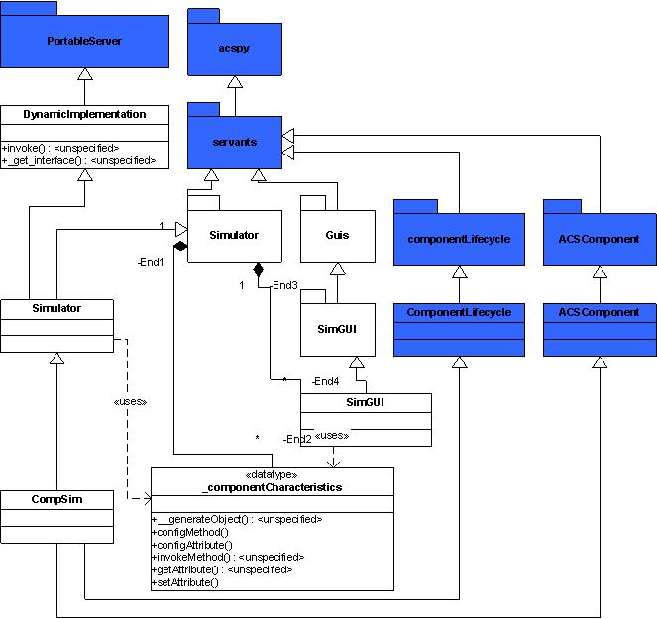

Configuration Database Entries Defining IDL Interfaces
The usefulness of predefining simulated component behavior is acknowledged by this document. For example, perhaps the end-user wants to find out what happens when the return value of some method is fixed, but non-default. Productivity may be hampered because of the time spent changing return value(s) each time the simulated component is activated. For reasons like this, the characteristics of a simulated component should be retrieved from the ACS configuration database if the user does not explicitly set them by some other means. The CDB entries will be placed in $ACS_CDB/alma/simulated/* in a similar fashion to BACI CharacteristicComponents. By doing this, simulated BACI properties will be able to use the real CDB configuration files for the component (if available). The only real difference between the two is that simulated components must validate against the SimulatedComponent.xsd schema defined as follows:
- <xs:schema targetNamespace="urn:schemas-cosylab-com:SimulatedComponent:1.0"
- xmlns:xs="http://www.w3.org/2001/XMLSchema"
- xmlns="urn:schemas-cosylab-com:SimulatedComponent:1.0"
- elementFormDefault="qualified"
- attributeFormDefault="unqualified">
- <xs:complexType name="corbaAttribute">
- <xs:attribute name="Name" type="xs:string" use="required"/>
- <xs:attribute name="Value" type="xs:string" use="optional" default="None"/>
- <xs:attribute name="Timeout" type="xs:int" use="optional" default="1"/>
- </xs:complexType>
- <xs:complexType name="method">
- <xs:attribute name="Name" type="xs:string" use="required"/>
- <xs:attribute name="Value" type="xs:string" use="optional" default="None"/>
- <xs:attribute name="Timeout" type="xs:int" use="optional" default="5"/>
- <xs:attribute name="Random" type="xs:boolean" use="optional" default="false"/>
- </xs:complexType>
- <xs:element name="SimulatedComponent">
- <xs:complexType>
- <xs:sequence>
- <xs:element name="_method" type="method" minOccurs="0" maxOccurs="unbounded"/>
- <xs:element name="_attribute" type="corbaAttribute" minOccurs="0" maxOccurs="unbounded"/>
- </xs:sequence>
- </xs:complexType>
- </xs:element>
- </xs:schema>

Graphical User Interface
No requirements yet.

Usage
Getting Started
Regardless of how you intend on using the simulator, there are a few steps that must be performed. Obviously an IDL file must be created which defines an IDL interface derived from ACS::ACSComponent or ACS::CharacteristicComponent. There are other ACS documents and examples which describe this process in detail so we will assume you have already created an IDL file, compiled it, and installed it into an INTROOT area.
Editing the CDB to Specify Simulated Components
Just like all other components in ALMA software, your simulated component will need at least one entry in the ACS Configuration Database. Specifically, $ACS_CDB/CDB/MACI/Components/Components.xml must be modified to tell the Python container to activate the component using a special Python package developed by ACS. For example, the entry for the “HELLODEMO1” component found in the default ACS CDB installed with ACS would be changed from:
<_ Name="HELLODEMO1"
Code="alma.demo.HelloDemoImpl.HelloDemoHelper"
Type="IDL:alma/demo/HelloDemo:1.0"
Container="frodoContainer"/>
to:
<_ Name="HELLODEMO1"
Code="Acssim.Servants.Simulator"
Type="IDL:alma/demo/HelloDemo:1.0"
Container="somePythonContainer"/>
The Code attribute of the component must appear verbatim as depicted above, but you are completely free to choose a different reasonable name for the Container attribute so long as it is started as a Python container.
Editing the CDB to Specify Default Behavior for a Simulated Component
After completing the previous step, you’ve actually done everything that is required to instantiate and simulate the methods and attributes of your component. That is, the Python package described by the Code attribute for your component in $ACS_CDB/CDB/MACI/Components/Components.xml will use the CORBA Interface Repository to automatically generate random return values on the fly!
In some cases completely random values are desired, but in other cases a developer might want to specify that “abc” method always returns the value “x”. To deal with this, the ACS component simulator framework allows the developer to optionally place an XML file (which conforms to the SimulatedComponent.xsd schema found in $ACSROOT/config/CDB/schemas) with a name identical to that of the component in $ACS_CDB/CDB/alma/simulated/. In this XML the developer can specify the return values or exceptions to be thrown on any given method invocation or attribute access. It’s important to note that the developer can omit method and attribute definitions entirely from this XML without worrying about whether or not they will fail (e.g., the framework will automatically implement them if they’re not found in the XML). The rest of this section is dedicated to an example which depicts how to implement a simple simulated component XML configuration file.
An example simulated component XML configuration file based on the HelloWorld IDL interface found in the acsexmpl CVS module:
- <SimulatedComponent xmlns="urn:schemas-cosylab-com:SimulatedComponent:1.0"
- xmlns:xsi="http://www.w3.org/2001/XMLSchema-instance">
- <_method Name="displayMessage"
- Value="print 'Simulated Hello World!'\nNone"
- Timeout="7"
- Random="false"/>
- <_method Name="badMethod"
- Value="import ACSErrTypeCommonImpl\nraise ACSErrTypeCommonImpl.UnknownExImpl()"/>
- </SimulatedComponent>
This file would be placed in $ACS_CDB/CDB/alma/simulated/HW1/ and named ‘HW1.xml’ for a component named ‘HW1’.
3-6 | Our simulation of the displayMessage method of the HelloWorld IDL interface. Please see the appendix for the complete definition of the HelloWorld IDL interface. Take special note _method elements must be listed before _attribute elements as required by the SimulatedComponent schema.
3 | Name is the only attribute of the _method element that is required. This name must be identical to the name of the method being simulated.
4 | Value is the XML attribute that will be evaluated and returned to clients which invoke displayMessage. In this specific case, a Python print statement is actually executed first and None (the Python return value for an IDL void method) is returned. Take note that the two Python statements within Value are separated by a ‘\n’. Also, it’s useful to know that internally all statements in Value except for the very last one are executed by the Python exec command. The final statement (i.e., None in this case) is evaluated by the Python eval command and returned (unless the string “raise ” is detected within the final statement as we’ll see in the next simulated method implementation).
5 | Timeout defines exactly how long the simulator will wait before determining a return value from the Value attribute. Timeout is in integer seconds format.
6 | Not yet implemented!  In the context of this example, the Random attribute with a value of true makes this simulated method capable of throwing any exception displayMessage is capable of throwing. Due to the fact displayMessage is not defined in IDL to throw exceptions, a true value here implies there is a 10% chance of a generic CORBA exception being thrown on any given invocation.
7-8 | This simulation of the badMethod method does exactly what the real C++ implementation does: it throws an (IDL-defined) exception on every invocation.
7 | See explanation on line 3.
8 | Two things occur here. First, the automatically generated Python exception helper module from the ACS Error System is imported. If you want information on the mapping between ACS Error System Error Definition XML files and the ACS Python Error System, please refer to the ACS Error System tutorial. Second, an IDL exception is raised. It’s absolutely vital to note the only way an instance of an exception defined in the Value attribute can be propagated to CORBA clients is if the last statement of value begins with the string “raise “. If “raise “ is not found, the infrastructure wraps the evaluation of the final statement with a try/catch block.

Notes:
- CORBA attributes that are specified in the CDB and not BACI properties should have _get_ prepended to the Name attribute of the _attribute XML element.
- The Value attribute of BACI properties specified in the CDB should evaluate to a DevIO instance (i.e., an object derived from the DevIO class found in the ACSImpl.DevIO Python package). BACI properties are simulated at the DevIO level.
Using the API
At times it can be quite useful to change the behavior of a simulated method or attribute at run-time. With recent additions to the ACS Python framework this is now possible! A new script, acspyInteractiveContainer, has been added to ACS which starts a Python container in an interactive session. The sole parameter to this script is the name of the container and sample usage could be something similar to: “acspyInteractiveContainer aragornContainer”. This in and of itself is quite useful, but without an API to configure the run-time behavior of simulated components it is somewhat lacking. An API has been created in the form of the Acssim.Servants.Generator Python module. Developers interested in using the API should look at the pydoc for the appropriate methods which are generally in the format setXXX where XXX is some configurable data. Some of the configurable items are:
- A standard timeout for all methods and attributes that are dynamically implemented by the framework
- Not yet implemented. The probability of an exception occurring for methods and attributes that have been set to Random (as defined in the SimulatedComponent schema)
- The maximum sequence size for CORBA sequences
- Associating a new timeout, function to be executed, etc for a particular component’s method or attribute

The following is a sample interactive session in which the behavior of a simulated method has been fine-tuned so to speak:
  - [dfugate@fox dfugate]$acspyInteractiveContainer pyContainer
  - Logging to ACS log server.
  - 2004-09-01T23:26:31.000 pyContainer __init__ - Container pyContainer waiting for requests
  - This container is now running in interactive mode.
  - >>> 2004-09-01T23:26:34.000 pyContainer activate_component - Activated component: HELLODEMO1
  - 2004-09-01T23:26:34.000 pyContainer message - Info message from the manager: Startup statistics: 1 components queued to be activated.
  - 2004-09-01T23:26:34.000 pyContainer message - Info message from the manager: Startup statistics: 1 of 1 components activated.
  - ...
  - >>> HELLODEMO1 - DynamicImplementation.invoke( ('sayHelloWithParameters', 'nada', 0.001) {'context': None} )
  - 2004-09-01T23:27:36.000 _execute - Executing the 'sayHelloWithParameters' method of the 'HELLODEMO1' simulated component on the fly.
  - 2004-09-01T23:27:38.000 _executeList - Failed to evaluate the '('...3930860.0...', -27244156.0, -105184264)' statement!
  - 2004-09-01T23:27:38.000 _execute - sayHelloWithParameters return value looks like:('...3930860.0...', -27244156.0, -105184264) of type:<type 'tuple'>
  - ...
  - >>> def mysayHelloWithParameters():
  - ... print "This is my own simulated method!"
  - ... return ("some string", 3.14, 999L)
  - ...
  - >>> from Acssim.Servants.Generator import setComponentMethod
  - >>> setComponentMethod("HELLODEMO1", "sayHelloWithParameters", mysayHelloWithParameters, timeout=3)
  - ...
  - >>> HELLODEMO1 - DynamicImplementation.invoke( ('sayHelloWithParameters', 'nada', 0.001) {'context': None} )
  - 2004-09-01T23:30:16.000 _execute - Executing the 'sayHelloWithParameters' method of the 'HELLODEMO1' simulated component using the API.
  - This is my own simulated method!
  - …
  - [dfugate@fox dfugate]$

1 | Notice that the acspyInteractiveContainer command is used instead of acsStartContainer.
5-7 | The HELLODEMO1 (simulated) component was activated via objexp. At this point the simulation of any attributes and methods this component has is done completely on the fly because there is no XML file describing this component’s behavior in the CDB and the API hasn’t been used yet.
9-12 | These four lines correspond to objexp being utilized to invoke the sayHelloWithParameters method of HELLODEMO1. The return values are random.
14-19 | Using the provided API, the behavior of the sayHelloWithParameters method of HELLODEMO1 component is modified.
14-16 | The most common way to modify the return values of simulated methods is to define a Python function which returns the values and pass it to the setComponentMethod function of the API. A fundamental understanding of the IDL->Python language mapping is needed to do this and the ACS Python tutorial can be a great help here!
16 | The sayHelloWithParameters method returns a string and contains two inout/out parameters. As a direct result the function we supply to setComponentMethod must return those values in the form of a Python tuple. However, had there only been a single return value it would not have been necessary to place it within a tuple. This is a fundamental rule of the IDL->Python mapping.
19 | The function written on lines 14-16 is associated with the sayHelloWithParameters method of the HELLODEMO1 component. Additionally, there will be a three second delay before control is returned to any clients invoking this component’s method.
21-23 | The sayHelloWithParameters method of HELLODEMO1 is invoked again using objexp. Pay special attention to the different output and the fact that mysayHelloWithParameters is invoked.
24 | Pressing Ctrl-D exits out of the interactive container.

Using the GUI
The first time a simulated component is activated, a graphical user interface is automatically started which allows configuring the run-time behavior of simulated components in the same fashion as the API described previously. Once this GUI has been closed it cannot be restarted without restarting the Python container so be very careful about this.
Figure 1 – the main panel
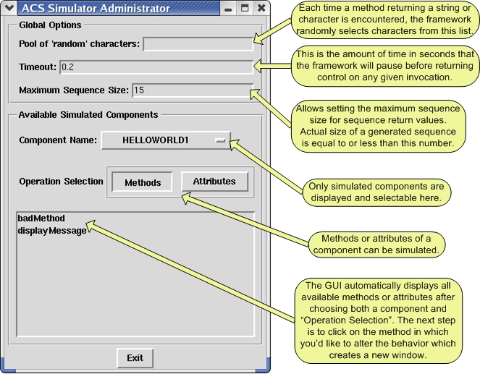

Figure 2 – panel created by clicking on the “displayMessage” text in the main GUI
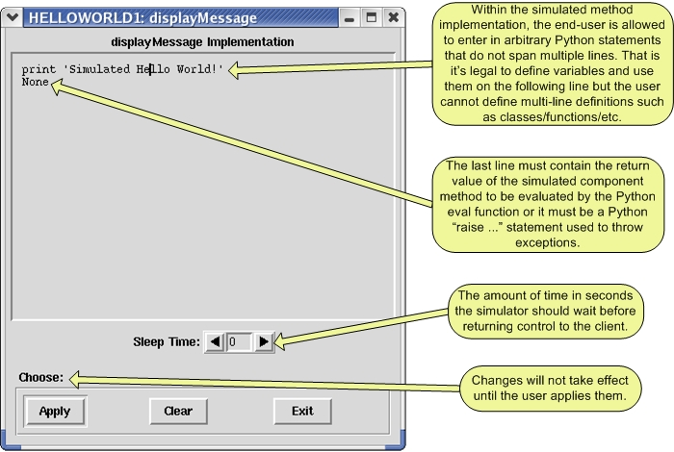

Special Notes
Accessing Method Parameters
The in and inout parameters passed to simulated methods are accessible from the CDB, API, and GUI. They can be accessed via the parameters variable (a Python list) which is automatically placed in the proper namespace for the developer to use.
The ordering of parameters within this list is identical to that of the IDL->Python mapping. For example, say we are given an IDL method defined like this:
string methodA(in boolean x, inout long y, out double z)
In this case, parameters could be equal to [0, 34L] where 0 maps to the x boolean parameter and 34L maps to the y parameter. Under the IDL->Python mapping, z is omitted from the list of parameters.

Known Problems and Issues

Changing the Random attribute of _method elements in the CDB file does not really make exceptions random.
This has not been implemented yet.

Appendix
HelloWorld IDL Interface
#ifndef _HELLO_WORLD_IDL_
#define _HELLO_WORLD_IDL_

#include <acscomponent.idl>
#include <ACSErrTypeCommon.idl>

#pragma prefix "alma"

module acsexmplHelloWorld
{
interface HelloWorld : ACS::ACSComponent
{
void displayMessage();

void badMethod() raises (ACSErrTypeCommon::UnknownEx);
};
};

#endif

HelloDemo IDL Interface
#ifndef _HELLODEMO_IDL_
#define _HELLODEMO_IDL_

#include <acscomponent.idl>

#pragma prefix "alma"

module demo
{
interface HelloDemo : ACS::ACSComponent
{
string sayHello();

string sayHelloWithParameters(in string inString, inout double
inoutDouble, out long outInt);
};
};

#endif

