ACS Java Component Programming Tutorial

Released by: | Signature:
Institute: | Date:

Keywords:
Approved by: | Signature:
Institute: | Date:

Author Signature: | Date:

Programmer’s Manual

Heiko Sommer (hsommer@eso.org)
ESO

Change Record
REVISION | DATE | AUTHOR | SECTIONS/PAGES AFFECTED
REVISION | REMARKS
1.0 | 2003-01-10 | Heiko Sommer | All
1.0 | Created, with suggestions from Joe and Gianluca
1.1 | 2003-02-06 | Heiko Sommer | Almost all
1.1 | Update reflecting new CVS module structure and Makefile syntax; worked in suggestions from Gianluca, David, and Radi; more details added in many places.
1.2 | 2004-02-17 | Heiko Sommer | All
1.2 | Updated instructions, code examples, and references for ACS 3.0; added details on Makefile integration;
1.3 | 2005-06-10 | Heiko Sommer

Table Of Contents

1 Introduction 4
1.1 Purpose and Scope of the Document 4
1.2 Abbreviations 4
1.3 References 4
2 What you need 5
2.1 Getting Eclipse IDE 5
2.2 Getting the source code 5
2.3 Compiling and running the examples 5
2.3.1 Make 5
2.3.2 Run 5
2.3.3 Using an IDE (Debugging!) 7
2.3.4 Windows development with limitations 7
2.3.5 Logging 7
3 Designing the Components 8
4 Creating the HelloDemo Component 10
4.1 IDL 10
4.2 Component Implementation 11
5 Creating the XmlComponent Component 14
5.1 XML entity classes 14
5.1.1 Overview 14
5.1.2 Designing entity schemas 14
5.1.3 Compiling entity schemas 15
5.2 IDL 16
5.2.1 Using XML schema types in IDL – general idea 16
5.2.2 XmlComponent.idl 17
5.2.3 Compiling IDL 18
5.3 Component implementation 19
6 Component Helper Classes 21
7 Configuration Database 23
8 Clients 24
8.1 Generic Client: ObjectExplorer 24
8.2 Client Component 24
8.3 JUnit Test Client 25

Introduction

Purpose and Scope of the Document

The purpose of this document is to give a practical introduction to writing Java components for ALMA software, using the ACS container/component framework. You should have read the section on Technical Architecture in [1] or have learned otherwise about the concepts of container/component and XML binding classes to be used for ALMA software. You should also be familiar with the ALMA build environment (see [8]), even though a few things are explained redundantly in this tutorial.

While describing the steps involved in developing two sample components, I will try to provide information beyond the scope of the demo components in order to help using the framework for concrete ALMA subsystem development. However, this is not a concept or design document for the respective parts of ACS. It should help you to get started nonetheless.

The Java container/component model is fully integrated in ACS. It is meant to be used by ALMA subsystems or the parts of them that don’t have real-time requirements and don’t directly control hardware devices.

Abbreviations

This document no longer maintains a separate section for abbreviations. Please use the ALMA software glossary [13].

References

- ALMA Software Architecture, Section 5 (Technical Architecture) http://almaedm.tuc.nrao.edu/forums/alma/dispatch.cgi/Architecture/docProfile/100018/d20030224132141/No/ALMASoftwareArchitecture_1.0.1.pdf
- ACS Architecture
http://www.eso.org/projects/alma/develop/acs/OnlineDocs/ACSArchitectureNL.pdf
- ACS FAQ
http://almasw.hq.eso.org/almasw/bin/view/ACS/AcsFAQ
- Management and Access Control Interface Specification http://www.eso.org/projects/alma/develop/acs/OnlineDocs/Management_and_Access_Control_Interface_Specification.pdf
- ACS Command Center User Guide
http://www.eso.org/~almamgr/AlmaAcs/OnlineDocs/ACSCommandCenter/Acs_Command_Center_-_User_Guide.html
- ACS Error System
http://www.eso.org/~almamgr/AlmaAcs/OnlineDocs/ACS_Error_System.pdf
- CDB Tutorial
http://www.eso.org/~almamgr/AlmaAcs/OnlineDocs/CDB.pdf
- ALMA Software Development Tools and Integration Procedures
http://www.eso.org/~almamgr/AlmaAcs/OnlineDocs/IntGuidelines.pdf
- OMG IDL to Java Language Mapping
http://cgi.omg.org/cgi-bin/doc?formal/02-08-05
- Eclipse download
www.eclipse.org
- Eclipse background information and configuration for ALMA
http://almasw.hq.eso.org/almasw/bin/view/ACS/FAQJCompEclipse
http://www.eso.org/~hsommer/eclipse20020923.htm
- Castor XML Java binding framework
http://castor.codehaus.org
- ALMA software glossary
http://almaedm.tuc.nrao.edu/forums/alma/dispatch.cgi/Glossary

What you need
Readers should feel very much encouraged to follow at their computers the steps described in the chapters below, switching between this tutorial and the real software.

Getting Eclipse IDE

The Java parts of the ACS framework were developed using the Eclipse IDE. Eclipse is not one of the “official” ALMA standards, but a majority of ALMA developers finds it so helpful that I like to recommend getting it. You can download Eclipse for free from [10]. The latest milestone build is usually fine, but special plugins may require to use a released version.

We have started a description on how to configure Eclipse to work well together with the ALMA build system [11]. It’s expected to grow, feedback is welcome. As background information, notes from a presentation of Eclipse given at ESO are also available on that page.

Getting the source code

The ACS release (currently ACS 4.1.1) contains source code inside the delivered jar files, both for the implementation of the container, compiled IDL files etc, as well as for the examples used in this tutorial.

Automatically generated documentation and the source code for the examples can also be found online at
http://www.eso.org/projects/alma/develop/acs/OnlineDocs/jcontexmpl/doc/html/index.html.

A live web-based CVS view for all relevant ACS modules is at http://websqa.hq.eso.org/bin/viewcvs.cgi/ACS/LGPL/CommonSoftware/.

The modules that play a major role in the Java container/component part of ACS are listed below in compile order, together with the jar files they produce.

jacsutil | Misc. utility classes, test support | jACSUtil.jar
acserr | Exception handling | acserr.jar, acserrj.jar
xmljbind,  Tools/castor | Java binding classes for XML (schema compiler, runtime) based on Castor | xmljbind.jar, castor.jar
comphelpgen | Java code generator for component helper classes, see 6 | comphelpgen.jar
XmlIdl | ACS IDL compiler (produces XML binding class aware component interfaces) | xmlidl.jar
define | IDL and XML schema files that are part of the framework;  Archive IDL | xmlentity.jar, archive_xmlstore_if.jar, systementities.jar
acstestentities | IDL and XML schema files used for demos and testing; forked from ObsPrep | acsTestEntities.jar
acsjlog | Logging | acsjlog.jar
jcont | Java container, component interfaces | jcont.jar
jcontexmpl | Examples used in this tutorial, other examples (e.g. used for testing) | HelloDemo.jar, XmlComponent.jar, BrightLamp.jar, BrightUser.jar, jcontexmpl.jar

Here’s an overview of the directories and files in the module jcontexmpl:

/doc |  | Nothing too exciting since the API documentation is generated by the Makefile and is not supposed to be checked in.
/idl | HelloDemo.idl | definition of the HelloDemo component used in this tutorial
 | XmlComponent.idl | definition of the XmlComponent component used in this tutorial
 | EventComponent.idl  LampAccess.idl  LampCallback.idl | other demo components not considered in this tutorial
 | ErrorSystemComponent.idl  ErrorSystemComponent.xml | definition of errors with certain types and codes, see [6]
/include |  | not used, but required by build system
/lib | jcontexmpl.jar | compilation of /src, produced by running the Makefile in /src
 | HelloDemo.jar | compilation of /idl/HelloDemo.idl
 | XmlComponent.jar | compilation of /idl/XmlComponent.idl
 | other .jar, .so, .a files | output of Java/C++ IDL compilation of the IDL files
/object |  | not used, but required by build system
/src |  | demo components and test clients
/test |  | tests internal to ACS that use the demo components

Compiling and running the examples

To compile and run the software, you need a current installation of ACS. The basic concepts for Java components have not changed since ACS 3.0 though.

Make
The /src and /test directories each contain a Makefile. The command

make clean all

will compile IDL and Java code and pack the results into jar files.

make install

will copy IDL, schema, and jar files to the respective sub-directories of your INTROOT directory so that they are available for other modules.

To learn about using the make system, refer to “man acsMakefile” and “man javaMakefile”.

Run
To run the container, you must first start the ACS services & manager. Either use the graphical ACS Command Center (see [5]), or the command

acsStart

Make sure your ACS_CDB variable points to the CDB installation that you want to use. You find a CDB suitable for the examples under jcontexmpl/test in CVS. You could either use that CDB directly, or merge the entries from Components.xml into your $ACS_CDB/CDB/MACI/Components/Components.xml.

To run the container on the same machine where the Manager runs, use the command

acsStartContainer –java <containername>

For cases where the manager runs on a different machine, please refer to [3] (“FAQGeneralCompContainerOptions”).

To terminate a Java container, you can use the command line

acsStopContainer <containername>

or the brute-force approach with Ctrl-C on the container console; in this case the Manager will attempt to reload components in that container next time the container runs.
The rest of ACS you terminate with

acsStop (or killACS if all else fails).

Using an IDE (Debugging!)
The recommended method is Java remote debugging, which is described in the ACS FAQs [3] under “How do I debug my components?”.

Windows development with limitations
Windows aficionados can run the Java container with its components (or just a client application that accesses components) on a Windows machine that has a network connection to another machine where the rest of ACS is running. Different subversions of JDK 1.4 have worked fine on Windows.

The build process (make) is not available under Windows. Assuming you have ACS installed on a Linux machine, you should keep your source code there, and mount the directories on Windows, e.g. using Samba. The initial compilation must be done on Linux to compile IDL etc. Subsequent plain Java compilations can then be done from Windows.

There is an issue with CR/LF line termination: if you get ASCII sources from CVS on Windows, they come with Windows line breaks; the build process runs on Linux though, and a few tools will fail without telling you why. The Makefile itself and the IDL files are affected. In case of doubt, run dos2unix on them, e.g.

~/CVSPRJ/ACS/jcontexmpl/src 1001 > dos2unix Makefile

Logging
By default, log messages are sent to the local console and to the central ACS logger. There they simply get absorbed in the void if you don’t register for them. For example,

acsStartLoggingClient | tee mylog.xml

will send all logs messages to the file mylog.xml and also to the console where you typed the command.

To adjust the log levels that get through, you may provide your own Java logging properties file. It must be compliant to the JDK 1.4 logging spec. Refer to the FAQ for the details. As a template for the properties file, you could use almalogging.properties from acsjlog/src.

There is also a graphical application “LoggingClient” that you can start with the command

jlog

Designing the Components
During the design of your ALMA subsystem, you should partition your software into one or preferably several components. A component will be the smallest chunk of software that can be deployed separately, e.g. in its own process or even on its own machine. Guidelines are that a component should be small enough to be functionally cohesive (having exactly one functional interface with related methods), but large enough to keep the number of components sufficiently small. Typically, a component will be made up of several Java classes, and a subsystem might consist of a handful of components.
There can be components that will be used by other subsystems, while other components are only used internally by the subsystem. In either case, the functional interface must be specified as CORBA IDL.

The example components that we’ll look at in the tutorial are not jewels of OO design, but they are meant to illustrate the steps involved to get to an implementation. The detailed motivation for all methods used in the interfaces is described in the next section about IDL.

We will work with
- a simple Java component “HelloDemo” that implements the notorious sayHello() method, both plain and with primitive dummy parameters
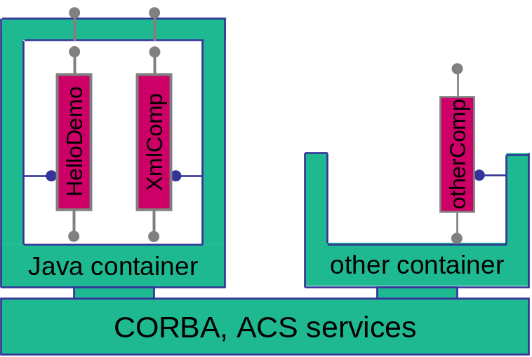
- a fancier “XmlComponent” that demonstrates the handling of XML entity objects with the transparent use of Java binding classes.

The components and their containers can be pictured as follows, with the “antennas” sticking out on top being the functional interfaces.

The two Java components, HelloDemo and XmlComponent, can either run collocated inside one Java container as shown, or run in separate Java containers. The Java container is drawn as a closed box to indicate that it works as a “tight container” (cf. [1]), intercepting all functional calls to any of its components, in addition to starting/stopping the components and providing explicit services to them.

The Java components can talk with, say, a C++ component “otherComp”, which must run inside a C++ container (“other Container”). That container is drawn open to indicate that it is a “porous” kind of container which only takes care of starting/stopping the components, but does not intercept functional calls on the running components.

The ACS containers use CORBA and the ACS services, the ACS Manager, and the Configuration Database. The Manager itself also uses the CDB.

Creating the HelloDemo Component

IDL

A component’s functional interface must be specified as an interface in CORBA’s Interface Definition Language (IDL). An IDL file may contain more than one interface. The Java container framework does not require further restrictions on the usage of the more exotic IDL constructs beyond what ACS already mandates for the definition of C++ components.

Using the ALMA directory structure, you should put IDL files in the <xxxx>/idl directory of your module. Our HelloDemo component is defined in jcontexmpl/idl/HelloDemo.idl.

Let’s look at the listing of HelloDemo.idl with line-by-line explanations.

01 #ifndef _HELLODEMO_IDL_
02 #define _HELLODEMO_IDL_
03 #include <acscomponent.idl>
04 #pragma prefix "alma"
05
06 module demo
07 {
08 // a very simple component
09 interface HelloDemo : ACS::ACSComponent
10 {
11 string sayHello();
12
13 string sayHelloWithParameters(in string inString,
inout double inoutDouble, out long outInt);
14 };
15 };
16 #endif

1, 2, 16 | Standard include guard to avoid multiple inclusions of this IDL file
3 | Mandatory include of acscomponent.idl (see line 9)
4 | Standard CORBA directive that affects generated Java classes. The prefix pragma must come after the include statements (this restriction might be lifted in the future, but for now the TAO IFR would have a problem otherwise.)  It defines the Java package that is prefixed to the package derived from the declared module (“demo”) and interfaces, resulting in classes like “alma.demo.HelloDemo”.  It is an existing ACS practice/restriction to only prefix one package level, e.g. not use “alma.archive” as a prefix. This might be changed in the future when some issues with this have been resolved. The prefix seemed to be transformed differently into Java packages and CORBA repository IDs.
6 | Declaration of the CORBA module “demo”. A module may contain many interfaces.  As a convention, there could be a 1:1 mapping between ALMA subsystems and modules, but this needs further discussions.
9 | Interface declaration for the HelloDemo component. Every ALMA component’s IDL interface must inherit from ACS::ACSComponent. This ensures that all components have a unique instance name and a state visible to other components.
11, 13 | Silly methods using CORBA types string, double, and long

After the IDL file HelloDemo.idl has been written, a couple of Java classes must be generated from it.
The ALMA Makefile will take care of this, given the line (see jcontexmpl/src/Makefile)

IDL_FILES = HelloDemo

The generated Java classes are then automatically compiled and put into /lib/HelloDemo.jar. They belong to the package alma.demo and can be categorized as

Functional interface | HelloDemoOperations.class
Client-side CORBA | _HelloDemoStub.class, HelloDemo.class
Server-side CORBA | HelloDemoPOA.class, HelloDemoPOATie.class
Helper & holder classes | HelloDemoHelper.class, HelloDemoHolder.class

Warning: don’t choose the same name for IDL_FILES as for (one of the values of) JARFILES in your Makefile! Otherwise the jar files produced from the IDL and from your module’s code have the same name and one gets overwritten by the other.

Component Implementation

The implementation of a Java component is a Java class that must implement
- the functional interface (that corresponds to the IDL definition), and the
- alma.acs.component.ComponentLifecycle interface that the container uses to start and stop the component and to provide a callback handle.

The implementation class may inherit from any base class; no such base class is required by the framework though, which saves the single inheritance option offered by Java.

For components that don’t need inheritance for other purposes, there is a generic base class (alma.acs.component .ComponentImplBase) that provides standard implementations of the required methods from ComponentLifecycle and ACSComponent, just to keep the component code simpler.

In real life we would usually first create the component implementation class with just dummy implementations for all mandatory methods, e.g. using code generation features of an IDE like Eclipse, and then move on to the next steps described in sections 6 and below. This document will ignore the iterative process and look at the final implementations right away.

The functional interface for the HelloDemo component is HelloDemoOperations, a Java interface generated by the CORBA IDL compiler.

By convention, we call the implementation class “HelloDemoImpl” and create it in the package “alma.demo.HelloDemoImpl”. It can be found under jcontexmpl/src in CVS.

01 /* legal info cut out
19 */
20 package alma.demo.HelloDemoImpl;
21 import java.util.logging.Logger;
22 import org.omg.CORBA.DoubleHolder;
23 import org.omg.CORBA.IntHolder;
24 import alma.ACS.ComponentStates;
25 import alma.acs.component.ComponentLifecycle;
26 import alma.acs.container.ContainerServices;
27 import alma.demo.HelloDemoOperations;
28
29 /** Javadoc cut out
37 */
38 public class HelloDemoImpl implements ComponentLifecycle, HelloDemoOperations
39 {
40 private ContainerServices m_containerServices;
41 private Logger m_logger;
42
43 /////////////////////////////////////////////////////////////
44 // Implementation of ComponentLifecycle
45 /////////////////////////////////////////////////////////////
46
47 public void initialize(ContainerServices containerServices) {
48 m_containerServices = containerServices;
49 m_logger = m_containerServices.getLogger();
50 m_logger.info("initialize() called...");
51 }
52 public void execute() {
53 m_logger.info("execute() called...");
54 }
55 public void cleanUp() {
56 m_logger.info("cleanUp() called..., nothing to clean up.");
57 }
58 public void aboutToAbort() {
59 cleanUp();
60 m_logger.info("managed to abort...");
61 }
62
63 /////////////////////////////////////////////////////////////
64 // Implementation of ACSComponent
65 /////////////////////////////////////////////////////////////
66
67 public ComponentStates componentState() {
68 return m_containerServices.getComponentStateManager().getCurrentState();
69 }
70 public String name() {
71 return m_containerServices.getComponentInstanceName();
72 }
73
74 /////////////////////////////////////////////////////////////
75 // Implementation of HelloDemoOperations
76 /////////////////////////////////////////////////////////////
77
78 public String sayHello() {
79 m_logger.info("sayHello called...");
80 return "hello";
81 }
82
83 public String sayHelloWithParameters(String inString,
84 DoubleHolder inoutDouble, IntHolder outInt) {
85 m_logger.info("sayHello called with arguments inString=" + inString
86 + "; inoutDouble=" + inoutDouble.value
87 + ". Will return 'hello'...");
88 outInt.value = (int) Math.round(Math.E * 10000000);
89 return "hello";
90 }
91 }

20 | The package declaration in accord with the “subpackage-per-component-implementation” convention
21 | Import for logging (standard JDK logger configured by ACS)
22-23 | Imports for CORBA Holder classes for the OUT parameters in the sayHelloWithParameters method (as defined in [9])
24 | Import of the ComponentStates interface, needed to access (and optionally modify) the component state
25 | Import for the mandatory Lifecycle interface
26 | Import for the ContainerServices interface which the container provides to the component. From this interface, the component gets everything the container can do for it on request (that is, not transparently w/o the component noticing)
27 | Import for the HelloDemoOperations interface, which defines the functional methods that a client of our component would use.
38 | The component implementation class implements the functional and the lifecycle interface; it does not inherit from any base class (if so, there would be even less here to look at…)
40 | Reference to the ContainerServices object that the container will give us (see line 47)
41 | Ref to the logger object which we’ll get from the container (see line 49)
47-51 | The initialize method (from ComponentLifecycle) is called by the container after creating an instance of our component. It provides us with the ContainerServices object. We don’t use it for much besides getting a logger and storing that reference in a separate variable for easy access.  We could do some component initialization, and could throw a ComponentLifecycleException if this something had failed.
52-54 | Implementation of the execute method (from ComponentLifecycle). This method will be called by the container after initialize() has returned. Only few components are foreseen to use both initialize and execute; here we just log a message.  The component will not be available to clients before execute() has returned.
55-57 | Implementation of the cleanUp method (from ComponentLifecycle). This method will be called by the container when the component is getting dismissed by the ACS Manager, but only after the last call to any of the methods from HelloDemoOperations has returned.  This would be the place to free resources (other components etc)
58-61 | Implementation of the aboutToAbort method (from ComponentLifecycle). This method may be called asynchronously when the container or the entire ALMA system must shut down without waiting for proper termination of all components. It is meant as a notification to the component to perform the most urgent actions before being forcefully removed at any time.
67-69 | Implementation of the componentState() method (from ACSComponent).  The component has it’s state managed by the container in a default way (but could also change it itself). Here we simply return the state which the container keeps for us; in real-world components, we could check the state of other components that ours depends upon, and then compute the state.
70-72 | Implementation of the name() method (from ACSComponent). The name is the instance name of our component, e.g. something we can’t know at compile time. We get the name from the container, using the ContainerServices interface.  For static components (instances known at deployment), this name is configured in the configuration database (CDB). For dynamic components, it’s either specified by the component which creates it, or a default name is chosen by the framework.
78-81 | Implementation of the sayHello method which is declared in HelloDemoOperations.  Line 79 shows how to log a simple message.
83-90 | Implementation of the sayHelloWithParameters method: we set the OUT parameter and leave the INOUT parameter untouched.  Note the use of DoubleHolder and IntHolder for outgoing parameters, a concept that is not possible in Java without using these helper classes; they are therefore defined in the CORBA IDL-to-Java mapping spec. [9]

Note that the implementation of the HelloDemo component is done with just one Java class. A real component would rather have one main implementation class that implements the component interfaces and uses other classes to perform the functional tasks.

Creating the XmlComponent Component
Unlike the previous HelloDemo, the component XmlComponent uses entity objects that are transported over the network as serialized XML. We will focus on this feature and not repeat things which have already been demonstrated before.

XML entity classes

Overview
The term “entity” refers to non-primitive, non-binary data with identity such as scheduling blocks, system users, correlator configurations etc., c.f. [1]. These data types are defined in XML schemas. Their instances are XML “documents” that get passed around by value and can be stored in the ALMA Archive.

From the XML schemas, we produce Java classes at build-time, based on the Castor framework [12]. These binding classes represent the hierarchical data structure in memory. They have type-safe methods to navigate the tree and to access data items. The binding classes can be automatically instantiated from XML documents that correspond to the same schema, and can serialize their data into stringified XML.

The idea of “transparent XML entities” is to have the entity objects transported by CORBA as language-neutral XML strings. However, the Java component implementations (both client and server involved in the remote call) don’t have to worry about the serialization and parsing of the XML. The main advantage of this is that the framework ensures type safety, from the IDL/schema definitions, all the way down to the Java implementation classes of a component; it’s not possible to be surprised at runtime that the received XML differs in type or version from what the component expected. To achieve this, the implementation classes use modified component interfaces, in which Java binding classes are substituted for the structs with serialized XML. An example with detailed explanation will be given in 5.3.

A Java component that acts either as a client or as a server with respect to some other component, is completely independent in its decision whether to parse XML entity objects “by hand” or to enjoy transparent support for binding classes. The other component may be written in Java, C++, or whatever other language, and it may or may not use binding classes.
For example, a Java client that exchanges XML entity objects with a C++ server can work with Java binding classes, whereas the C++ server parses the XML using a SAX parser.

Designing entity schemas
We define complex data types in XML schema and use these types in CORBA IDL similar to how CORBA structs would be used.

To keep this tutorial focused on component development, we only touch on the schema development issue. Rather than showing how to develop a new schema, we use the existing schemas from the module acstestentities.

For XML schemas describing ALMA entities, there are the following conventions:
- One schema per entity. This means that the entity “SchedBlock“ must be defined in a different XML schema than the entity “ObsProject”. “Different schema” really means “different schema namespace”; on the file level, one schema can be composed of various files connected through <xsd:include>, as long as these files belong to the same namespace. The reason for using included files would be to make large schemas more readable for the human eye.
- XML namespaces: the typical convention would be to use a namespace that looks like an internet URL (e.g. targetNamespace="http://www.alma.org/xmlschemas/obsprep"). This does not work for ALMA though, since “alma.org” is not ours, and “alma.int” conflicts with the integer type in Java.
Thus in ALMA, the namespace should be “Alma/<subsystem>/<schemaName>” (e.g. “Alma/ObsPrep/SchedBlock”). Our test schemas use the namespace “AlmaTest/schemaName” instead.
- XML schemas consist of “elements” and “types”. Names of schema types must end with a “T”, like in <xsd:complexType name="ObsUnitT">. This avoids problems with generating binding classes (e.g. alma.mypackage.ObsUnitT), and makes it easier to find a name for a wrapper class that adds functionality to such a binding class (e.g. alma.mywrappers.ObsUnit).
- Top-level entities are defined as the root elements in a schema file, like ObsProject or SchedBlock. To allow the system to store administrational data like ID, version etc., the root element must have a child element of type EntityT (defined in the ACS module “define”/idl/CommonEntity.xsd, with the xml namespace “Alma/CommonEntity”).
For example, in the schema file ObsProject.xsd, the schema element ObsProject has a child of type ObsProjectEntityT, which inherits from EntityT.
Perhaps it would have been more intuitive to use an inheritance convention instead of composition (SchedBlock could inherit from EntityT), but since XML schema only allows single inheritance, we don’t want to use it up for the sake of the framework. In the file SchedBlock.xsd we see that in fact our schema element “SchedBlock” inherits from ObsUnitT, which would not have been possible otherwise.
- From one entity object (that is, an XML document) you can reference another entity object through the ID. In the schema, this must be declared uniformly using (a subtype of) EntityRefT, which declared in the schema file CommonEntity.xsd.
For example, a SchedBlock references the ObsProject to which it belongs. The schema element SchedBlock has a child element ObsProjectRef whose type inherits from EntityRefT. Therefore, an XML document for a SchedBlock entity can reference another XML document that is an ObsProject.

Compiling entity schemas
Schema files must be put into the /idl directory of your module, or into the ICD/<yourSubsystem>/ws/idl directory if Like IDL files are meant to be used by other subsystems. Please check with ALMA software engineering.

You must add information to your module’s Makefile so that the XML schemas can be compiled into Java binding classes. Let’s look at how acstestentities/src/Makefile has it:

XSDBIND = acsTestEntities

tells the build process to look for a configuration file ../idl/acsTestEntities.xml which must provide information about the schema files to be compiled (see below). The resulting Java classes will then be packed into ../lib/acsTestEntities.jar.

Schema files can include or import other schema files. In our case, CommonEntity.xsd from the module ACS/define, systementities.jar, is imported. In our Makefile, the line

XSDBIND_INCLUDE = systementities

is required so that the build process can set the include path for the schema compiler.
Here’s a reduced listing of the configuration file /idl/acsTestEntities.xml

<?xml version="1.0" encoding="UTF-8" ?>
<EntitybuilderSettings>
<EntitySchema schemaName="TestObsProject.xsd" xmlNamespace="AlmaTest/ObsProject" />
<EntitySchema schemaName="TestObsProposal.xsd" xmlNamespace="AlmaTest/ObsProposal" />
<EntitySchema schemaName="TestSchedBlock.xsd" xmlNamespace="AlmaTest/SchedBlock" />
<XmlNamespace2JPackage xmlNamespace="AlmaTest/ObsProject" jPackage="alma.xmljbind.test.obsproject" />
<XmlNamespace2JPackage xmlNamespace="AlmaTest/ObsProposal" jPackage="alma.xmljbind.test.obsproposal" />
<XmlNamespace2JPackage xmlNamespace="AlmaTest/SchedBlock" jPackage="alma.xmljbind.test.schedblock" />
</EntitybuilderSettings>

We see that schema files are listed together with their xml namespaces (<EntitySchema>). Then the namespaces are mapped to Java packages (<XmlNamespace2JPackage>). Files and packages are separated here because several schema files can use the same xml namespace, but the Java package of the resulting classes must depend on the namespace, not the schema file.

Note that the compilation of xml schemas is specified differently in the Makefile, compared with the compilation of IDL files. IDL files are listed individually and are compiled into one jar file each, whereas schema files are only referenced indirectly through their XML configuration file, and are compiled into only one jar file per module.

The diagram below illustrates the relationships among the xml schema files, IDL files, and Makefiles from our module “acsjexmpl” and the modules “define” and “acstestentities” from where resources are used by the example module.

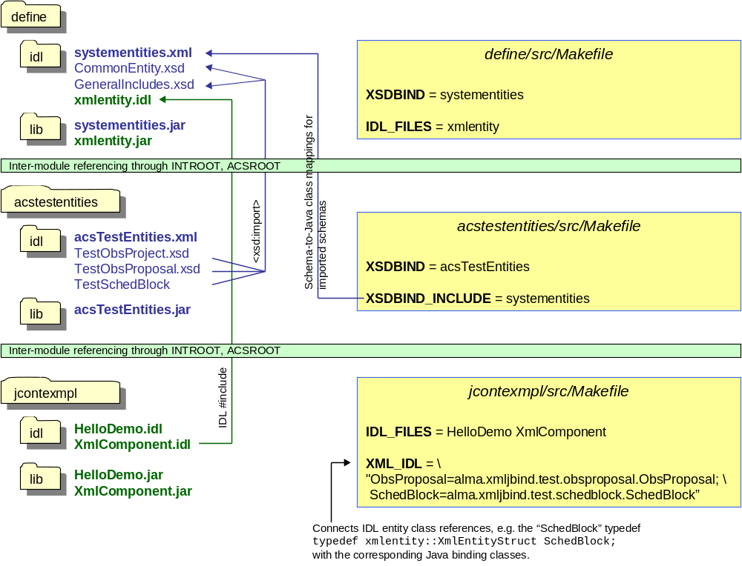

IDL

Using XML schema types in IDL – general idea
The diagram below shows how to use the XML schema definition of a SchedBlock in the IDL definition of a component interface.
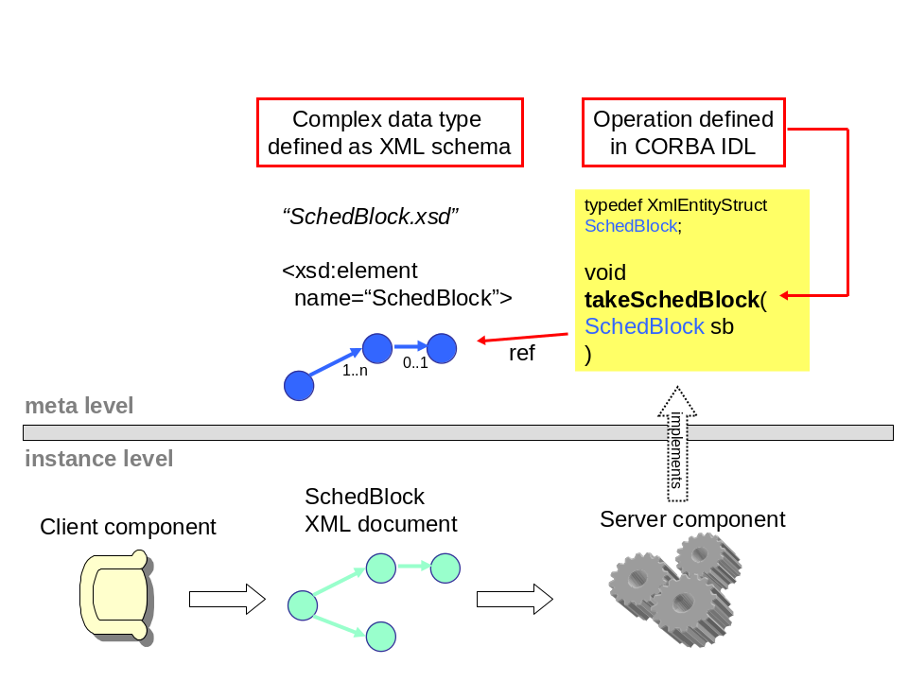

XmlComponent.idl

Here’s a thinned-out listing. Since lines are missing, we use letter tags instead of line numbers.

A #include <xmlentity.idl>
#include <acscomponent.idl>
B #pragma prefix "alma"

C module demo
{
D typedef xmlentity::XmlEntityStruct ObsProposal;
typedef xmlentity::XmlEntityStruct SchedBlock;
typedef sequence <SchedBlock> SchedBlockSeq;

E exception XmlComponentException {};

F struct ObsProjectTree
{
ObsProposal prop;
SchedBlockSeq schedBlocks;
};

G interface XmlComponent : ACS::ACSComponent
{
H long dumbMethod(in string somevalue);
I ObsProposal createObsProposal();
J SchedBlockSeq getAllSchedBlocks();
K void xmlInOutMethod(in ObsProposal opsPropIn,
out SchedBlock schedBlockOut);
L ObsProjectTree getEntireTreeInAStruct();
M void exceptionMethod() raises (XmlComponentException);
};
};

A | xmlentity.idl comes from define/idl and declares the CORBA struct XmlEntityStruct which is used to transport serialized XML together with some meta data. It must be included whenever xml entity objects are used (see I-K). The developer does usually not have to know the details of that struct.
B | The prefix pragma must come after the include statements; this restriction might be lifted in the future, but for now the TAO IFR would have a problem otherwise.
C | We use the same module as for the HelloDemo component
D | Typedefs for xml entity classes. The interface methods that use entity classes as parameters or return types (see H-K) must use these named typedefs like ‘ObsProposal’ instead of ‘XmlEntityStruct’. This not only makes the interface more readable, but is also required for the automatic use of Java binding classes.  Notice that the defined names are used to match the XML entity (IDL struct) with its corresponding binding class. For instance, “ObsProposal” will be matched to the Java class alma.xmljbind.test.obsproposal.ObsProposal.
E | Declaration of an exception. (How to use the ACS Error System [6] instead of plain CORBA exceptions may be demonstrated in a future version of this document.)
F | A struct that contains XML entities.
G | Interface declaration for the XmlComponent
H | Just to have something dumb in here
I | Method that returns an xml entity object (as a struct that contains the xml data as a string if the component is accessed as a plain CORBA object, see below.)
J | Demonstrates the use of a sequence (~array) of xml entity objects
K | Demonstrates the use of xml entity objects as an OUT parameter
L | Uses the ObsProjectTree struct, with entities inside
M | Uses an exception (again, later the mechanism described in [6] will be used.)

Compiling IDL
We have to add the new IDL file to jcontexmpl/src/Makefile:

IDL_FILES = HelloDemo XmlComponent

In addition to running this file through the standard CORBA IDL compiler, it is also fed into the “ACS IDL compiler”. This tool gets started by the build process, so you never have to see it; the interested reader can find it in the CVS module ACS/…/XmlIdl. The ACS IDL compiler creates additional Java classes which the CORBA IDL compiler would not create. They are used for working with Java XML binding classes instead of plain XML strings, see 5.1.1.

In the Makefile, the line

XML_IDL = "ObsProposal=alma.xmljbind.test.obsproposal.ObsProposal; \
SchedBlock=alma.xmljbind.test.schedblock.SchedBlock"

provides the mapping from IDL typedefs (see lines 6-8) to Java binding classes (conceptually: to the schema that defines the entities).

The Java files that are produced from XmlComponent.idl are

Functional interfaces | XmlComponentOperations.class, XmlComponentJ.class
Client-side CORBA | _XmlComponentStub.class, XmlComponent.class
Server-side CORBA | XmlComponentPOA.class, XmlComponentPOATie.class
Helper & holder classes | ObsProposalHelper.class, ObsProposalHolder.class, SchedBlockHelper.class, SchedBlockHolder.class, SchedBlockSeqHelper.class, SchedBlockSeqHolder.class, SchedBlockSeqJHolder.class, XmlComponentHelper.class, XmlComponentHolder.class

The classes shown in normal print are mandated by CORBA standards and generated by the CORBA IDL compiler, while the italicized classes are required by the ACS framework and are generated by the ACS IDL compiler.

Component implementation

In section 5.2, we saw the IDL file with the typedefs for the entity classes, and their use in the methods of the XmlComponent interface.

The following two functional interfaces have been generated for XmlComponent. The component implementation must implement one of them:
- XmlComponentOperations uses serialized XML; if the component implemented this interface, it would have to parse and serialize the xml entity objects “manually”.
- XmlComponentJ uses Java binding classes; the container will offer transparent parsing and serialization of XML.

We will choose the convenience and type-safety offered when implementing XmlComponentJ. The interface generated by the ACS IDL compiler is listed below (Javadoc lines omitted).

01 package alma.demo;
02
03 /**
04 * XML binding class aware ACS component interface XmlComponentJ */
05 public interface XmlComponentJ extends alma.ACS.ACSComponentOperations
06 {
10 public int dumbMethod(String somevalue);
11
15 public alma.xmljbind.test.obsproposal.ObsProposal createObsProposal();
16
25 public alma.xmljbind.test.schedblock.SchedBlock[] getAllSchedBlocks();
26
30 public void addNewSchedBlocks(
alma.xmljbind.test.schedblock.SchedBlock[] newSchedBlocks);
31
35 public void xmlInOutMethod(
alma.xmljbind.test.obsproposal.ObsProposal opsPropIn,
alma.demo.SchedBlockHolder schedBlockOut);
36
40 public alma.demo.ObsProjectTreeJ getEntireTreeInAStruct();
41
50 public void exceptionMethod()
51 throws alma.demo.XmlComponentException;
53 }

Comparing this with the IDL definition, we see that binding classes like alma.xmljbind.test.schedblock.SchedBlock are used whenever the IDL contained a typedef’d entity struct. In addition to this direct substitution, the ACS IDL compiler created the class ObsProjectTreeJ which contains binding classes, thus substituting the IDL struct ObsProjectTree as the return type of the method getEntireTreeInAStruct();

Let’s look at the implementation of the method createObsProposal().

121 public ObsProposal createObsProposal()
122 {
123 ObsProposal obsProp = new ObsProposal();
124
125 try
126 {
127 ObsProposalEntityT entity = new ObsProposalEntityT();
128 m_containerServices.assignUniqueEntityId(entity);
129 obsProp.setObsProposalEntity(entity);
130
131 obsProp.setPerformanceGoals(
"peak performance enduring a 24-7-365 schedule.");
132 }
133 catch (ContainerException e)
134 {
135 m_logger.log(Level.SEVERE, "failed to create ObsProposal. ", e);
136 }
137
138 return obsProp;
139 }

We see that the Java class ObsProposal has type-safe methods like “setPerformanceGoals” or “setObsProposalEntity”.
The latter takes an object of type ObsProposalEntityT, also generated by the binding framework. It is used to store administrational information about the ObsProposal object, most important the object ID.

For a new entity object, a valid and unique object ID can be obtained conveniently through a call to ContainerServices#assignUniqueEntityId, for which the container collaborates with the archive. If the archive is not present, it defaults to using random numbers which should be almost always unique (2^64).

Our method implementation simply returns the top-level Java object for the ObsProposal. The container framework will then automatically serialize it to XML, embed the string in the XmlEntity CORBA struct, and send it to the client using CORBA. If the client is another Java component, its container will automatically create an ObsProposal class and fill it with the data from the serialized XML.

To keep the size of this tutorial small, the implementations of the other methods are not listed here. They are meant to serve as more detailed examples, for which the source code of the module jcontexmpl should be retrieved anyway.
Alternatively, the code listing can be found online at the ACS documentation site:
http://www.eso.org/projects/alma/develop/acs/OnlineDocs/jcontexmpl/doc/html/XmlComponentImpl_8java-source.html

To see how the code would look like if the component would implement XmlComponentOperations, take a look at the inner class XmlComponentHelper::IFTranslator.

Component Helper Classes
For each component class, a corresponding helper class is needed. In most cases this helper class will be used only by the framework, which means that the component developer will not have to look at it much.

The framework uses the helper class to
- instantiate the component implementation class
- get information about the component’s interface(s)
- get the CORBA POA Tie skeleton class for the component

A template for the helper class gets generated automatically by the build system if the Makefile contains the line

COMPONENT_HELPERS=on

The template has a file ending .java.tpl to ensure that no edited .java helper class gets overwritten. It is meant as a convenience for the component developer who will normally just have to remove the .tpl ending and then treat that Java file like his/her own, which requires checking it into CVS.

For our HelloDemo component, the helper class does not need to be changed (some Javadoc lines stripped from the listing):

23 package alma.demo.HelloDemoImpl;
24
25 import java.util.logging.Logger;
26
27 import alma.acs.component.ComponentLifecycle;
28 import alma.acs.container.ComponentHelper;
29 import alma.demo.HelloDemoOperations;
30 import alma.demo.HelloDemoPOATie;
31 import alma.demo.HelloDemoImpl.HelloDemoImpl;
32
33 /**
38 * To create an entry for your component in the Configuration Database,
39 * copy the line below into a new entry in the file $ACS_CDB/MACI/Components/Components.xml
40 * and modify the instance name of the component and the container:
42 * Name="HELLODEMO1" Code="alma.demo.HelloDemoImpl.HelloDemoHelper" Type="IDL:alma/demo/HelloDemo:1.0" Container="frodoContainer"
45 */
46 public class HelloDemoHelper extends ComponentHelper
47 {
52 public HelloDemoHelper(Logger containerLogger)
53 {
54 super(containerLogger);
55 }
56
60 protected ComponentLifecycle _createComponentImpl()
61 {
62 return new HelloDemoImpl();
63 }
64
68 protected Class _getPOATieClass()
69 {
70 return HelloDemoPOATie.class;
71 }
72
76 protected Class _getOperationsInterface()
77 {
78 return HelloDemoOperations.class;
79 }
80
81 }

Only in special situations, when a Java component chooses to sometimes use Java binding classes, but other times send or receive serialized XML instead, then the helper class must be modified. This goes beyond the scope of this tutorial and will be described in a more specialized document.
An example for this can be found in alma.demo.XmlComponentImpl.XmlComponentHelper from jcontexmpl/src/.

Configuration Database
The ACS configuration database contains information about which components are deployed on the different machines. It assists the ACS Manager to locate components at runtime. All the runtime action is hidden from the programmer by the container.

There are two different types of components:
- static components whose instances are fixed at deployment time. These typically represent (abstracted) hardware devices, or service components for which we choose a fixed number of instances. One component can be deployed many times under different names, like “Pipeline1”, ”Pipeline2”.
- dynamic components whose type (and optionally container location) is fixed at deployment time, whereas the number and names of instances is determined only at runtime. For more details on this, refer to [3], topic “FAQGeneralCompDynamic”.

Let’s make HelloDemo a static component. We create a new line in the file CDB/MACI/Components/ Components.xml with
- The instance name (“Name”), which has the format of an ACS CURL, and is used by a client to get access to the component. We call it HELLODEMO1.
- The component helper class (“Code”, see section 6)
- The CORBA interface repository ID of the component (“Type” – remember that to CORBA a component is just a servant).
- The name of the Java container that will be asked by the ACS Manager at runtime to instantiate our components – called “frodoContainer” in the examples.
Note that the generated component helper class contains these values in a comment (code listing above, line 42). This facilitates adding the CDB entry using copy and paste.

The CDB file Components.xml then looks similar to

<?xml version="1.0" encoding="utf-8"?>
<Components xmlns="urn:schemas-cosylab-com:Components:1.0"
xmlns:cdb="urn:schemas-cosylab-com:CDB:1.0"
xmlns:baci="urn:schemas-cosylab-com:BACI:1.0"
xmlns:xsi="http://www.w3.org/2001/XMLSchema-instance">

<_ Name="TEST_PS_1" Code="acsexmplPowerSupplyImpl"
Type="IDL:alma/PS/PowerSupply:1.0" Container="bilboContainer"/>
<_ Name="HELLODEMO1" Code="alma.demo.HelloDemoImpl.HelloDemoHelper"
Type="IDL:alma/demo/HelloDemo:1.0" Container="frodoContainer" />
<_ Name="XMLCOMP1" Code="alma.demo.XmlComponentImpl.XmlComponentHelper"
Type="IDL:alma/demo/XmlComponent:1.0" Container="frodoContainer" />
<_ Name="LAMP1" Code="acsexmplLamp" Type="IDL:ALMA/PS/Lamp:1.0" Container="bilboContainer"/>
<_ Name="OPERATIONAL_ARCHIVE" Code="alma.archive.components.OperationalHelper"
Type="IDL:alma/xmlstore/Operational:1.0" Container="frodoContainer" />

</Components>

ACS ships with a default CDB that contains the entries for the demo components.
You’ll have to add entries for your own components, or create a new CDB structure and reset the ACS_CDB environment variable.

Clients
A component can have different kinds of clients which we’ll discuss separately:

Generic Client: ObjectExplorer

We can use the ACS tool ObjectExplorer as a generic client for all components. Run it with

objexp

and you should find your Java components (e.g. XmlComponent) and their instances (e.g. XMLCOMP1) listed on the dialog, together with C++ components (e.g. Lamp).

At first, you see only a visualization of the information in the CDB, as opposed to actually loaded components. When you click on a component instance, the Manager will tell the Container to activate the component with the given instance name.

The screenshot shows the output after XMLCOMP1 has been loaded and the method getBestSchedBlock has been called (with View → Expand result data checked in ObjectExplorer.)

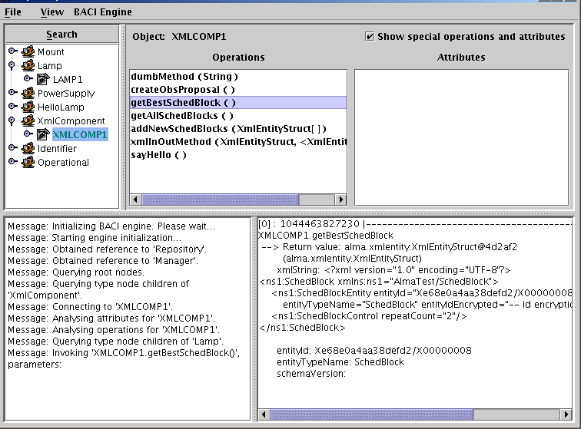

Client Component

We’ve seen the example of a Java component accessing a C++ Component in 4.2, and a Java component accessing another Java component without transparent XML binding support referenced in 5.1.

To use support for xml binding classes on the client side of a call, we first obtain the other component (here: XMLCOMP1)

XmlComponent xmlComp = alma.demo.XmlComponentHelper.narrow(
getComponent("XMLCOMP1"));

and then ask the container to wrap it with the more convenient interface that uses XML binding classes, provided in the ContainerServices interface

XmlComponentJ xmlCompJ =
(XmlComponentJ) m_containerServices.createXmlBindingWrapper(
XmlComponentJ.class,
xmlComp,
XmlComponentOperations.class);

Now we can keep working with xmlCompJ, and the framework will delegate all calls to xmlComp, translating between XML binding classes and serialized XML presentation in between.

JUnit Test Client

To facilitate the writing of JUnit test clients, ACS (module jcont) offers the class
alma.acs.component.client.ComponentClientTestCase
which is a subclass of JUnit’s TestCase that does the talking with ACS Manager. It provides most of the functionality that ContainerServices provides for components.

A JUnit test that gets a reference to the XmlComponent component and runs some tests on it is
jcontexmpl/src/alma.demo.client.XmlComponentClient

020 package alma.demo.client;
022 import alma.acs.component.client.ComponentClientTestCase;
023 import alma.demo.SchedBlockHolder;
024 import alma.demo.XmlComponent;
025 import alma.demo.XmlComponentException;
026 import alma.demo.XmlComponentJ;
027 import alma.demo.XmlComponentOperations;
028 import alma.entities.commonentity.EntityT;
029 import alma.xmljbind.test.obsproposal.ObsProposal;
030 import alma.xmljbind.test.schedblock.SchedBlock;
031
039 public class XmlComponentClient extends ComponentClientTestCase
040 {
042 private XmlComponentJ m_xmlCompJ;
043
049 public XmlComponentClient() throws Exception {
050 super("XmlComponentClient");
051 }
052
053 protected void setUp() throws Exception {
054 super.setUp();
055
056 org.omg.CORBA.Object compObj = getContainerServices().getComponent(
057 "XMLCOMP1");
058 assertNotNull(compObj);
059 XmlComponent xmlComp = alma.demo.XmlComponentHelper.narrow(compObj);
060
061 m_xmlCompJ = (XmlComponentJ) getContainerServices()
062 .getTransparentXmlComponent(XmlComponentJ.class, xmlComp,
063 XmlComponentOperations.class);
064
065 assertNotNull(m_xmlCompJ);
066 }
067
071 public void testSayHelloUsingHelloDemoComponent() {
072 String reply = m_xmlCompJ.sayHello();
073 assertNotNull(reply);
074 System.out.println("received reply " + reply);
075 assertEquals("reply must be 'hello'", "hello", reply);
076 }
077
081 public void testCreateObsProposal() {
082 ObsProposal obsProp = m_xmlCompJ.createObsProposal();
083 assertNotNull(obsProp);
084
085 EntityT ent = obsProp.getObsProposalEntity();
086 assertNotNull(ent);
087
088 String id = ent.getEntityId();
089 assertNotNull(id);
090
091 System.out.println("received ObsProposal with id " + id);
092 }
093
094 public void testXmlInOutMethod() {
095 ObsProposal obsProp = m_xmlCompJ.createObsProposal();
096 assertNotNull(obsProp);
097 SchedBlockHolder sbh = new SchedBlockHolder();
098
099 m_xmlCompJ.xmlInOutMethod(obsProp, sbh);
100
101 SchedBlock schedBlock = sbh.value;
102 assertNotNull(schedBlock);
103
104 EntityT ent = schedBlock.getSchedBlockEntity();
105 assertNotNull(ent);
106 String id = ent.getEntityId();
107 assertNotNull(id);
108
109 System.out.println("received out-param SchedBlock with id " + id);
110 }
111
117 public void testException() throws Exception {
118 boolean gotException = false;
119
120 try {
121 m_xmlCompJ.exceptionMethod();
122 }
123 catch (XmlComponentException e) {
124 gotException = true;
125 System.out.println("received XmlComponentException as intended.");
126 }
127
128 assertTrue("must receive XmlComponentException", gotException);
129 }
130 }
The constructor must call the constructor of the base class (c.f. line 50) with a name to be used for this client (here: “XmlComponentClient”). If you override the setup() method, it’s necessary there to call super.setUp() first (see line 54).

JUnit will call all methods that start with “test” in their name, such as testException().

In the Eclipse Java Perspective, you can run such a class with JUnit. Open the class in the editor, then choose
Menu Run → Run As → JUnit Test. It will display the results.

The ACS FAQ will describe the setup in more detail.
The “subsystem master component” concept may be included in this tutorial in the future
Currently there is a problem with IDL attributes which will be fixed later.
At least for what we care about here; primarily the prefix controls the CORBA repository ID.
This is possible because for Java components the framework uses the CORBA tie delegation model; C++ components can use multiple inheritance and extend the CORBA skeleton directly, thus saving one runtime delegation step.
If this other component is written in Java, the developer has a real choice on this; for C++ at least at the moment there is no support for XML binding classes, so the C++ XML parser (expat) that comes with ACS should be used.
The term “Helper” is a bit unfortunate since CORBA has its own concept of helper classes, which is unrelated to the component helper. We are still open to suggestions for a better name.

