Administrator Client for MACI
Released by: | Signature:
Institute: | Date:

Keywords:
Approved by: | Signature:
Institute: | Date:

Author Signature: | Date:

User’s manual

Janez Dovč
Josef Stefan Institute

Change Record
REVISION | DATE | AUTHOR | SECTIONS/PAGES AFFECTED
REVISION | REMARKS
0.1 | 2001-07-11 | Janez Dovč | All
0.1 | Document created.
1.1 | 2002-02-14 | Janez Dovč | 4
1.1 | New features documented.
1.2. | 2003-11-11 | Matej Šekoranja | All.
1.2. | Ported to ACS 3.0 MACI IDL.

Table of contents
1 Table of contents 3
2 Introduction 4
3 Administrator Client Functionality 4
4 Administrator Client Design 5
4.1 Administrator Client GUI 5
4.1.1 A Menu bar 6
4.1.2 Tree panel with Tree, Start Search and Manager Shutdown button 6
4.1.3 Tabbed pane 6
4.1.4 Status panel 8
4.1.5 Message text area 9
4.1.6 Error and message dialog 9

Introduction
This document describes the Administrator client (AC) for Management and Access Control Interface (MACI). MACI is a CORBA IDL interface specifying how clients can access and query data about the servant objects activated on servers and distributed on the network. Administrator client for MACI is a standalone Java program that uses the MACI IDL to:
- Display the information about CORBA objects on the local network. This includes MACI defined objects, such as Containers and Managers as well as BACI defined objects, such as components. Both currently active components and potentially active components (i.e. components that the Manager is able to bring online on request) are displayed.
- Interact with the MACI Manager through IDL Administrator interface, by receiving notifications about other clients and containers in the system from the Manager.
Administrator client for MACI will be written as standalone application, without needing Abeans libraries to run.
Administrator client is separate from ObjectExplorer. This reflects the strong decoupling between MACI and BACI: AC is a MACI client and ObjectExplorer a BACI client only. Moreover, the first needs only normal privileges to run, while the second needs administrator privileges.

Administrator Client Functionality
On startup, AC:
- Examine “ACS.manager” Java system property to determine the corbaloc (i.e. “corbaloc::<host>:<port>/Manager”).
- Login as an Administrator using Manager::login method. Client::authenticate will return an “S” string to Manager requiring identification.
- Query the Manager for:
- Component information, using Manager::get_component_info method.
- Client information, using Manager::get_client_info method.
- Container information, using Manager::get_container_info method.
- Display GUI and fill it with above information. Update the information with data received through Administrator IDL interface.
- Allow user to view details about any of the above objects, send Client::disconnect or Manager::logout for any client, shutdown the Container.

Administrator Client Design
AC is a two-tiered application. The first layer consists of an invisible engine bean, which does the actual CORBA communication and uses the Java Beans compliant mechanisms (properties and events) to communicate with the GUI. Both beans are connected only through visual composition, reducing the dependencies.

Administrator Client GUI

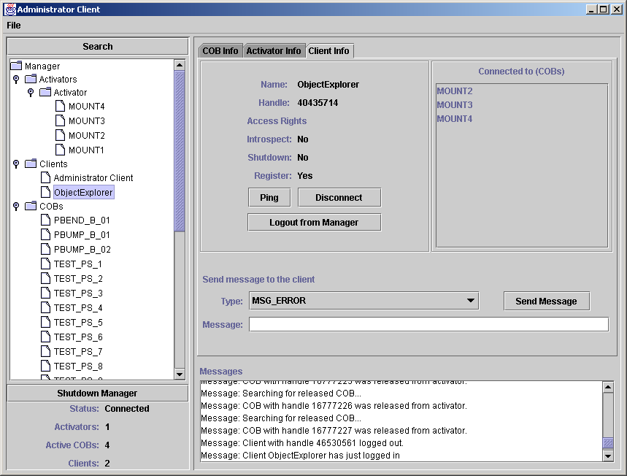
AC features the following basic GUI elements:
- A menu bar
- Tree panel with Tree, Start Search and Shutdown Manager button
- Tabbed pane containing ComponentInfo panel, ContainerInfo panel and ClientInfo Panel
- Status panel
- Message text area
- Error and message dialog

A Menu bar
The menu bar contains items to set the “Manager Location” (i.e. “corbaloc::<host>:<port>/Manager”) and “Connect/Disconnect” item used for connect/disconnect to/from manager.

Tree panel with Tree, Start Search and Manager Shutdown button
When the AC has queried all data from the Manager, the tree contains a root node named Manager, which contains three nodes called “Containers”,”Clients” and “Components”. Each of these sub-nodes contains names of the appropriate classes of CORBA Objects. Therefore node “Components” contains all potentially accessible “Components”, regardless of whether they are activated or not. On the other hand, each “Container” contains component names of the components that it has activated and exported. Client node contains all clients that are currently logged to Manager. The Tree refreshes itself thru callbacks from the Manger. Use “Start search” to make a new query for all objects and refresh the tree.
Manager Shutdown calls shutdown() method on Manager object.

Tabbed pane
The tabbed pane on the right contains tabs “Component”, “Container” and “Client”. Depending on the class of the item selected in the tree, the correct tab will be in focus and vice versa.

ComponentInfo panel

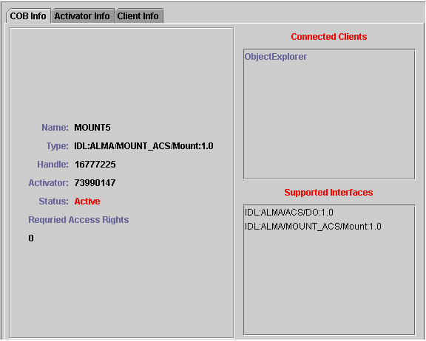
Panel displays following items:
- Component name, type, handle, handle of container which hosts the component, status of the component, required access rights to access the component (via Manager’s get_component)
- A list of clients, requested the component. Selected client will be focused in the tree. If list is empty and status is active, Manager requested and registered component at start up.
- A list of all interfaces supported by the component. The interface names are in the CORBA repository_id format, and are prefixed with “IDL”. The first interface in the list is the default interface.

ContainerInfo panel

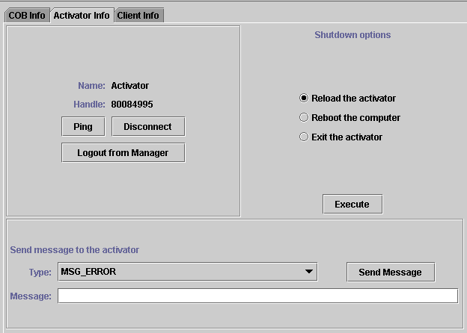
The ContainerInfo panel consist of:
- Container name and handle
- Shutdown panel with shutdown options and execute button
- Client functions - ping(), disconnect(), logout() - while Container object extends Client object. Ping and Disconnect methods are called on client, logout is called on Manager.
- Message panel, applicable to send “MSG_ERROR” or “MSG_INFORMATION” to the Container

ClientInfo panel

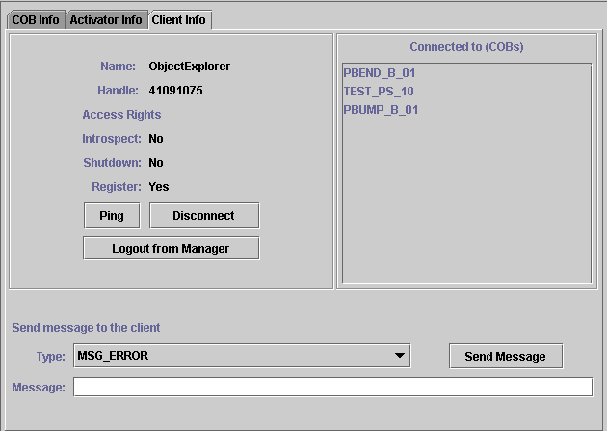
ClientInfo panel displays:
- Client name and handle
- Access rights of the client
  - Client must have the INTROSPECT_MANAGER access right to be able to gain access to Manager’s internal state. This access is usually given to administrator clients.
  - Client must have SHUTDOWN_SYSTEM access right to be able to call Manager’s shutdown method, thus shutting down the entire control system.
  - Client must have the REGISTER_COMPONENT access right to be able to call Manager’s register_component and unregister_component methods.
- Client functions - ping(), disconnect(), logout(). Ping and Disconnect methods are called on client, logout is called on Manager and directly logouts client from Manager.
- A list of components to which the client has requested and successfully obtained a reference from the Manager.
- Similar to ContainerInfo panel a message panel, applicable to send “MSG_ERROR” or “MSG_INFORMATION” to the Client

Status panel
Status panel expose the status of the AC (Not connected, Connecting.., Connected) and number of active containers, clients and active components.

Message text area
Message text area displays messages reported by the GUI or AC engine and messages, sent by Manager or other Clients. When an error occurs, a message is also printed here.

Error and message dialog

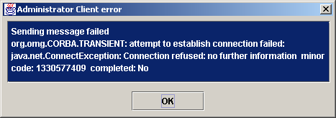
Error dialog appears when an exception is caught either by the GUI or engine. It displays the error message and exception type. User can select the message in the text area and copy it to clipboard. Exception stack trace is printed to console. To close the error dialog, click the OK button. The same dialog also appears, when message is received with
Error dialog is modal, so it stops the current thread, preventing multiple dialogs to appear at a time.

