Alarm Table
Released by: | Signature:
Institute: | Date:

Keywords: CSL-DOC-02-06
Approved by: | Signature:
Institute: | Date:

Author Signature: | Date:

Software Manual

Matej Sekoranja (matej.sekoranja@ijs.si)
KGB Team, Jozef Stefan Institute

Change Record
REVISION | DATE | AUTHOR | SECTIONS/PAGES AFFECTED
REVISION | REMARKS
1.0 | 2000-05-13 | Matej Sekoranja | All
1.0 | Created
1.1 | 2001-09-20 | Nika Oman | All
1.1 | Appearance change
1.2 | 2002-04-10 | Grega Milcinski | 2.1
1.2 | Corrected screenshot description, changed to ALMA template

Table Of Contents
1 Introduction 4
2 User Interface 4
2.1 Startup window 4
2.2 AlarmTable window 5
2.3 Connection status window 6

Introduction
The aim of AlarmTable is to monitor alarms reported by devices. Devices and alarms can easily be filtered out.
In addition, not to use 100% CPU for alarms which are reported more than once per second, AlarmTable automatically filters them out and informs user via Status-report area in AlarmTable window.

User Interface
When AlarmTable is started (abeansStart si.ijs.anka.AlarmTable), a Startup window appears. In the Startup window, you can choose which devices to connect to on Startup.

Startup window
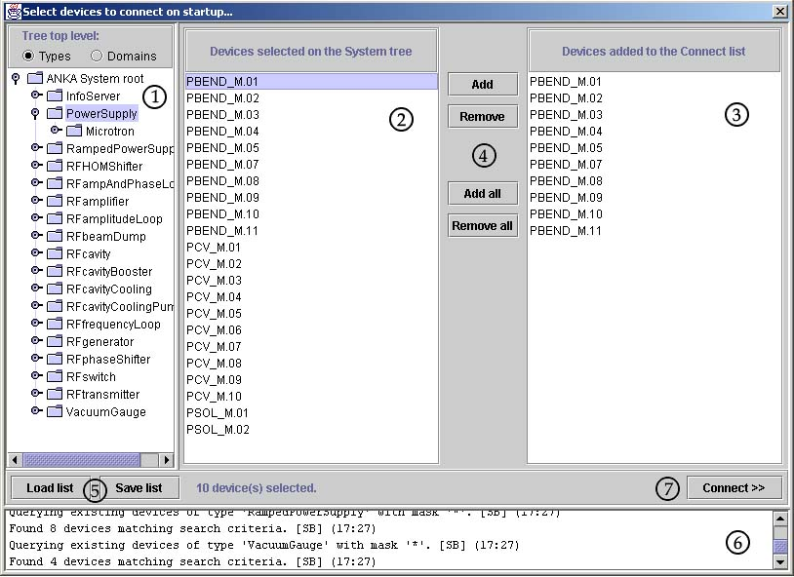
- System tree
It represents the actual state of the system (devices that are reachable from the client at the moment). It has two hierarchical modes of displaying devices. The first displays types of the devices on the highest hierarchical level and domains on one level lower and the second mode is vice versa, so domains are displayed a level higher than types. Switching between these two modes can be done using two radio buttons above the tree. Devices selected on the system tree are immediately shown on Devices selected on the System tree list.
- Devices selected on the System tree list
The list contains devices selected in the System tree. These devices can be added to the Devices added to the Connected list by clicking the "Add" button.
- Devices added to the Connected list
The list contains devices to be connected to. These devices can be removed from the list by clicking the "Remove" button.
- Buttons to add/remove devices to/from Connection list
- Load list and Save list buttons
Save list saves devices from the Connection list into the specified file. This list of devices can be later loaded to the Connection list from the file by using Load list.
- Status area
Provides additional information to the user.
- Connect – starts Alarm Table, monitoring selected devices

AlarmTable window
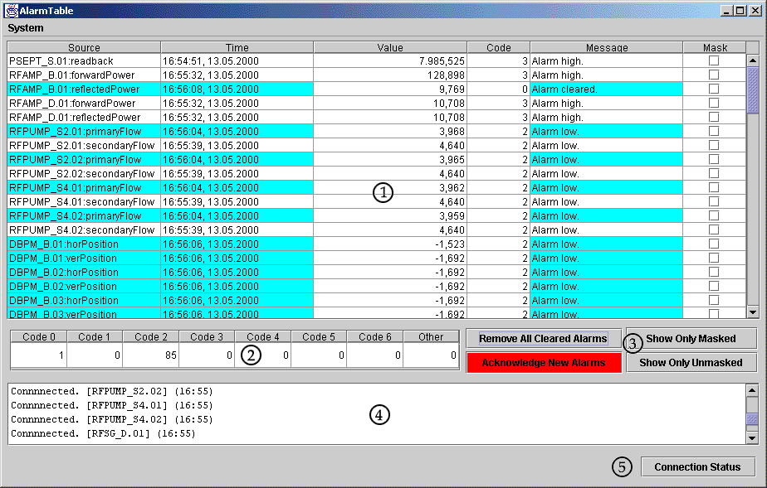
- Table of all caught alarms
- Unacknowledged alarms counter table
Counts unacknowledged alarms (unacknowledged alarms are marked with gray color) and groups them by their code.
- Action Buttons
Remove All Cleared Alarms button - removes all cleared alarms
Acknowledge New Alarms button - acknowledges all new (unacknowledged alarms - marked with gray color)
When there are no unacknowledged alarms this button is disabled and it becomes red , if there are any.
Show Only Masked button - hides all unmasked alarms (all hidden alarms are automatically acknowledged)
Show Only Unmasked button - hides all masked alarms (all hidden alarms are automatically acknowledged)
When a new alarm arrives or its state changes it automatically becomes visible.
A masked alarm is an alarm whose Mask column is .

- Status-report area
Messages like 'Connected.', 'Disconnected.', 'Connection Failed!' are reported in this area. Brings up the Connection status window.

Connection status window
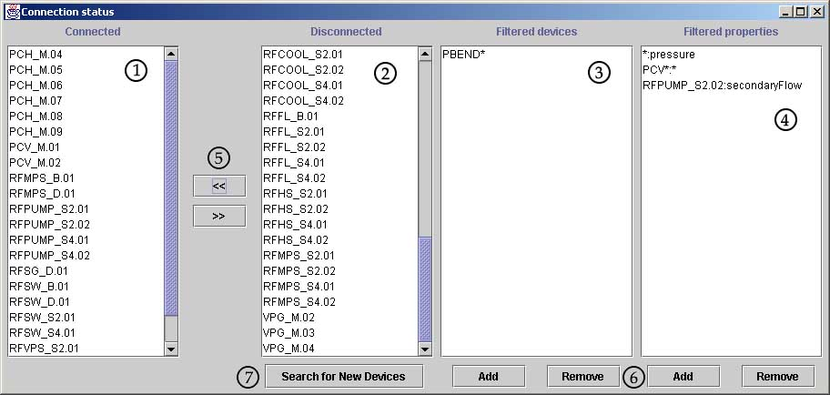
- List of connected devices
- List of disconnected devices
- List of device filters (filtered devices are disconnected)
- List of property filters (filtered properties are not monitored)
- Use '<<' and '>>' button to connect/disconnect to/from devices.
- Use 'Add' and 'Remove' buttons to add/remove filters.
- Searches for new devices, if any are found they are added to the list (button is disabled during search procedure)
All lists are sorted.
- Filter syntax (see filter lists for samples)
You can use wildcards (?, *) for filters: '?' replaces any character and '*' replaces one or more characters.
Property filters have one special character ':' - it separates device name from property name.

