## For Loop

A "For" Loop is used to repeat a specific block of code (statements) a known number of times. The for-loop statement is a very specialized while loop, which increases the readability of a program. Here is the syntax of the of for loop.

for ( initialize counter ; test counter ; increment counter)

{

execute the statement(s);

}

* initialize counter : Initialize the loop counter value.
* test counter : Verify the loop counter whether the condition is true.
* increment counter : Increasing the loop counter value.
* execute the statement : Execute C statements.

Note : The for-loop must have two semi-colons between the opening and closing parenthesis.

The following picture has clearly described the for loop syntax.

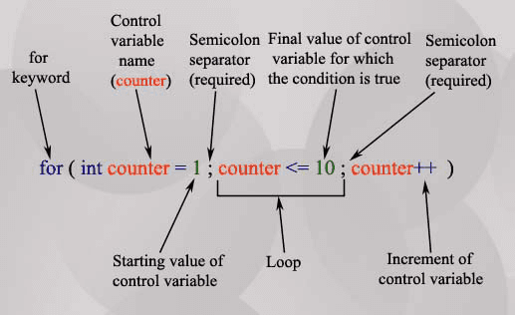

## Why For Loops?

1. " For" loops execute blocks of code over and over again.

2. It is clear to a developer exactly how many times the loop will execute before the loop starts.

3. You need to use a customized loop in addition to **void loop()** which is a part of the basic program structure.

## For loop repetition statement

Here are some examples of for loop repetition statements.

The following code prints the numbers from 1 to 100 in increments of 1.

for ( int x = 1; x <= 100 ; x++ ) {

Serial.print(x);

}

Output: 1 2 3 4 5 6 7 ... 100

The following code prints the numbers from 100 to 1 in increments of -1.

for(int x = 100 ; x >= 1; x--) {

Serial.print(x);

}

Output: 100 99 98 97 96 ... 1

The following code prints the numbers from 8 to 88 in steps of 8

for(int x = 8; x <= 88 ; x += 8) {

Serial.print(x);

}

Output: 8 16 24 32 40 48 ... 88

The following code prints : 2, 7, 12, 17, 22, 27

for(int x = 2; x <= 30 ; x += 5) {

Serial.print(x);

}

The following code prints: 66, 60, 54, 48, 42, 36, 30, 24, 18, 12, 6, 0

for(int x = 66 ; x >= 0; x -= 6 ) {

Serial.print(x);

}

## For loop Examples

**Example - 1:**

The following program calculates the sum of 1+2+3+...+50. The sum is stated in sum = sum + x, where i takes values from 1 to 50.

int sum=0;

for(int x=1;x<=50;x++) // x takes values in {1,2,3,...,50} {

sum = sum + x;

}

Serial.print(sum);

}

Output:

1275

**Example - 2:**

The following program will set pins 2,3,4,5, and 6 to INPUT.

void setup(){

for(int i=2;i<=6;i++) // i take values in {2,3,4,5,6} {

setMode(i,INPUT);

}

}

void loop(){

}

**Example - 3:**

The following program will set pins 1,2,3,4,5, and 6 to OUTPUT and send LOW to all of them.

void setup(){

for(int i=1;i<=6;i++) // i take values in {1,2,3,4,5,6} {

setMode(i,OUTPUT);

}

}

void loop(){

for(int i=1;i<=6;i++) // i take values in {1,2,3,4,5,6} {

digitalWrite(i,LOW);

}

}

## Exercises

What will be printed? Assume that the code in the **void setup()** section, and **Serial.begin(9600);** is written before the code snippets.

1. for (int i=0; i <= 5; i++){

Serial.print(i);

}

2. for (int i=0; i <= 4; i++) {

Serial.println(i);

}

3. for (int i=0; i >= 7; i++){

Serial.print(i);

}

4. for (int i=10; i <= 80; i=i+10){

Serial.print(i);

}

5. int prod=0;

for (int i=1; i <= 5; i++){

prod=prod*i;

Serial.print(i);

}

6. int prod=1;

for (int i=1; i <= 5; i++){

prod=prod*i;

Serial.print(i);

}

7. int prod=1;

for (int i=1; i <= 5; i++){

prod=prod*i;

}

Serial.print(i);