**If Statements**

if (*logical test*) {

*what to do if true*

} else {

*what to do if false*

}

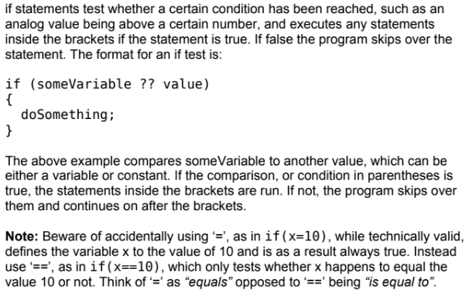

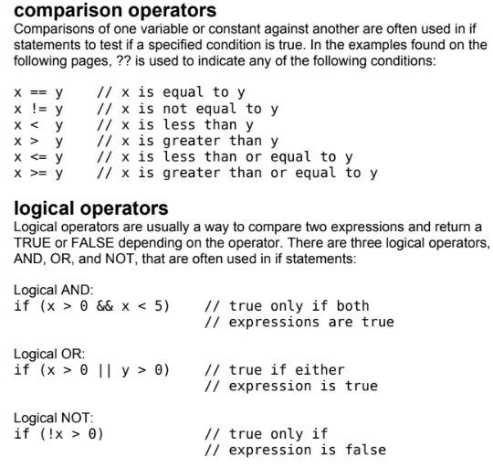

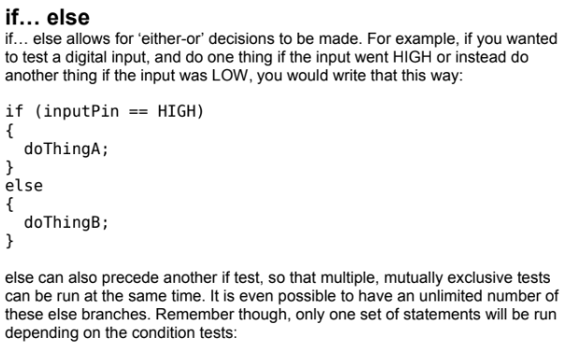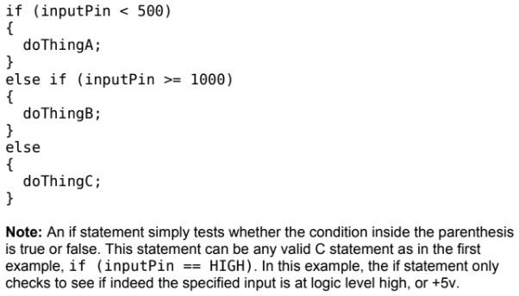

**Example 1:**

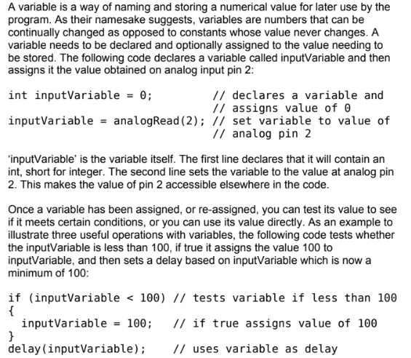

**Example 2:**

int value=33;

**if**( value <50){

Serial.print("The value is less than 50");

}

**else if** (value ==50){

Serial.print("The value is equal to 50");

}

**else**{

Serial.print("The value is greater than 50");

}