**Lab #5 (10%)**

**Practice Penetration Testing**

For this lab, please read Chapter 6 - So You Want to Be a Pen Tester? from Gray Hat Hacking: The Ethical Hacker’s Handbook, 5th edition.

For this Lab, you will be downloading a virtual machine from [www.vulnhub.com](http://www.vulnhub.com) and testing your penetration testing skills. This website contains virtual machines you can practice your pentesting skills. For this lab we will be using “Basic Pentesting 1”. You can download the image from here:

<https://www.vulnhub.com/entry/basic-pentesting-1,216/>

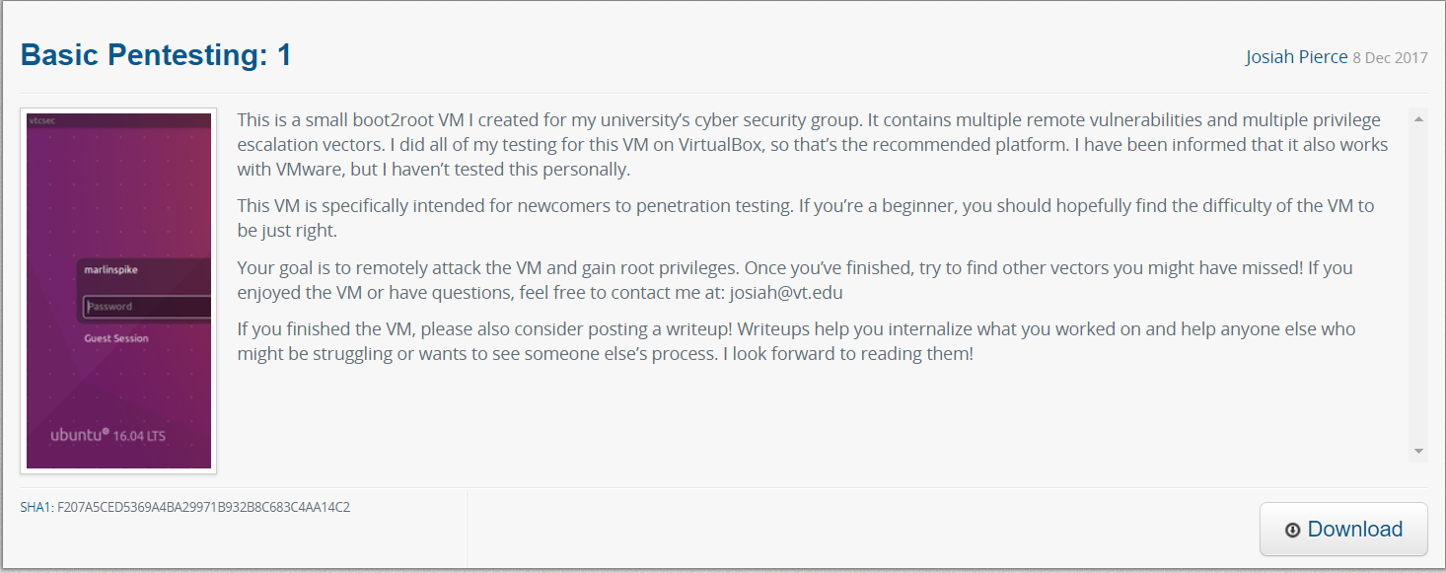

Download the virtual machine image and open it in your virtual machine software.

Using Kali Linux and the skills you’ve learned, conduct a penetration test against the virtual machine image.

As you conduct the test, take screenshots along the way and make note of the commands and tools you used. You will need to consolidate all of this evidence to obtain full marks.

In a real ethical hacking engagement, a proper report would be created to provide to the customer. This is why documenting is so important while you’re testing.

Hint 1 – Ensure the network interface for this VM is the same as your Kali VM or they will not be able to communicate with each other

Hint 2 – Though you can log onto the console of the target VM, this is not considered a successful attack. All attacks should originate from your Kali Linux VM.

Rubric

|  |  |
| --- | --- |
| Screenshots required: | Mark |
| Steps of the ethical hack | 5 |
| Tools and command usage | 10 |
| How far you were able to get into the system. | 10 |
| Admin level access | 5 |
| Formatting: (specify file format) |  |
| Total: | 30 |