**TEJ3M ( lab assessment) /15 marks**  Name:

1.Why are logic gate ICs powered on the breadboard through a resistor? Calculate current in the following circuit? ( 3 marks)

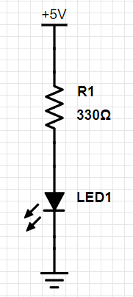

2. In the following touch current circuit, discuss the function of the transistor in the circuit? (2 marks)

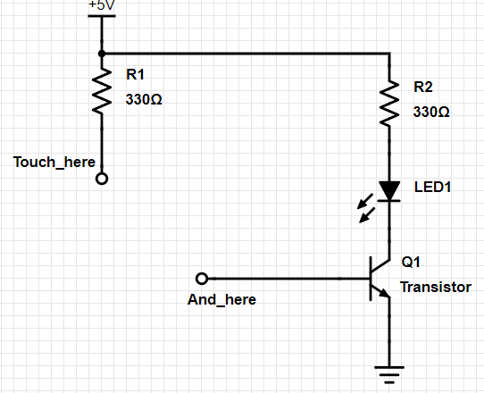

2. Using the following schematic diagram, answer the following.( 5 marks)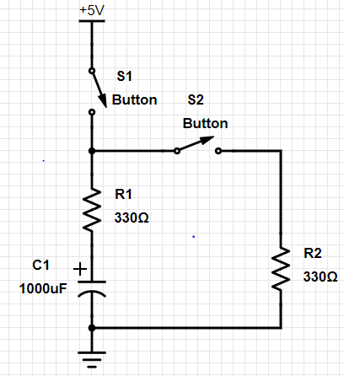

1.What happens when switch S1 is closed and S2 is open?( 1 mark)

2. After some time, S1 is open and S2 is closed. Determine the current in this circuit assuming the internal resistance of the capacitor is zero.( 2 marks)

3. What is the function of the capacitor in the circuit?( 1 mark)

4. NAND gate is called a universal gate. Use a NAND gate to create the EX-NOR. Draw a schematic diagram to support your answer. ( 3 marks)

5..Use the following truth table and use k-maps to minimize the boolean expression for output Sum of a 4 bit adder circuit using the inputs A,B,C.. Draw a schematic diagram of the circuit using logic gates. (2 +2 +3 marks)