queXS reports

Sample Report/ Quota Screen Snapshot
The Sample Report/Quota Screen Snapshot is available in the queXS administration menu under "quota report"
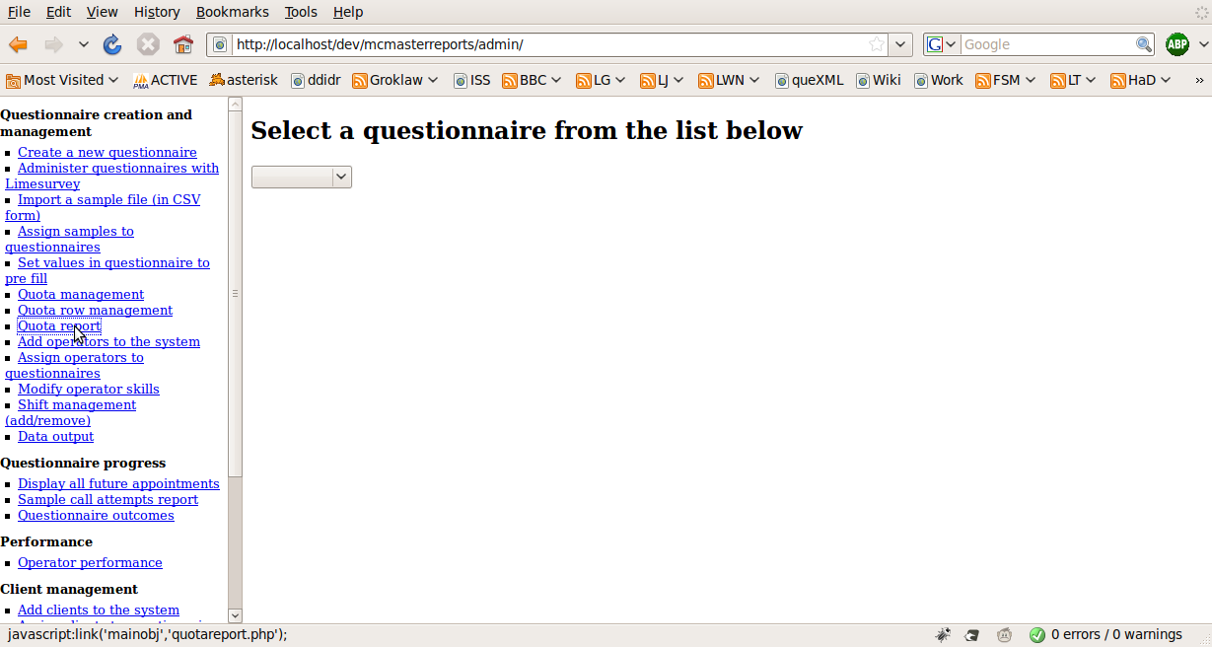
Select a questionnaire, then the sample file to display the report.
An example report is displayed below:
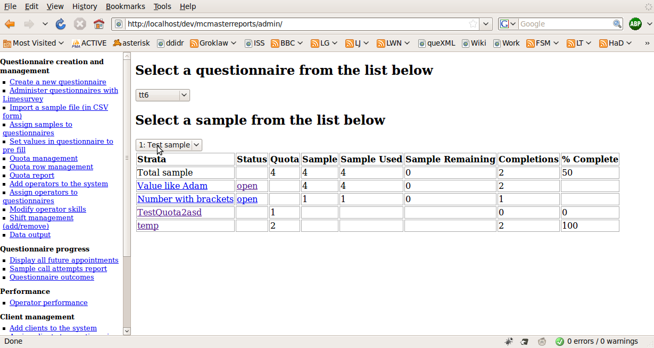
The report contains the following columns:
- Strata
  - The strata is a "piece" of a sample.
  - The first strata displayed in the report is always the entire sample (Total sample)
  - Next, "quota row" strata are displayed (strata defined under "quota row management" in the administrative menu)
  - Next, "replicate" strata are displayed (strata defined under "quota row management" in the administrative menu, that do not automatically exclude sample records based on completed questionnaires)
  - Finally, "questionnaire" strata are displayed (strata defined inside limesurvey which are based on collected data (eg: Gender))
- Status
  - The status of a particular strata row is either "open" or "closed"
  - "open" strata are sample records, or questionnaires available to interviewers.
  - "closed" strata records are not available to call or continue in a questionnaire
  - If a strata is not complete (reached the number of completions required to close it automatically) then by clicking on this status link, it is possible to manually open and close a strata
    - Note: if you manually close a strata, it will not automatically open again
- Quota
  - This is the number of completions defined by the operator for the system to automatically allow to complete
  - Once this number of completions is reached, the system will automatically set the Status of the strata to "closed"
- Sample
  - This is the number of sample records which match the quota criteria
- Sample used
  - The number of sample records which match the quota criteria, and that have been assigned to a case
- Sample remaining
  - The number of sample records which match the quota criteria, and have not been assigned to a case
- Completions
  - The number of sample records which match the quota criteria, that have been completed
- % Complete
  - The percentage complete of the quota: (completions/quota) * 100

Productivity report
The productivity report is available under "Operator performance" in the queXS Administrative menu
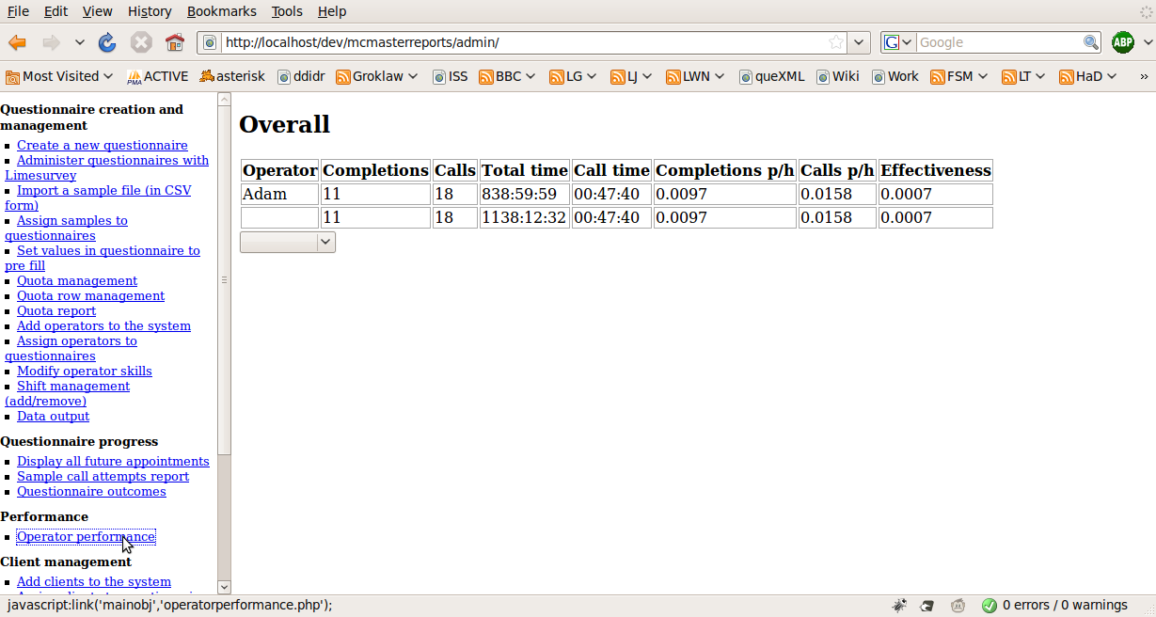
This report can be broken down by project (questionnaire) and shift
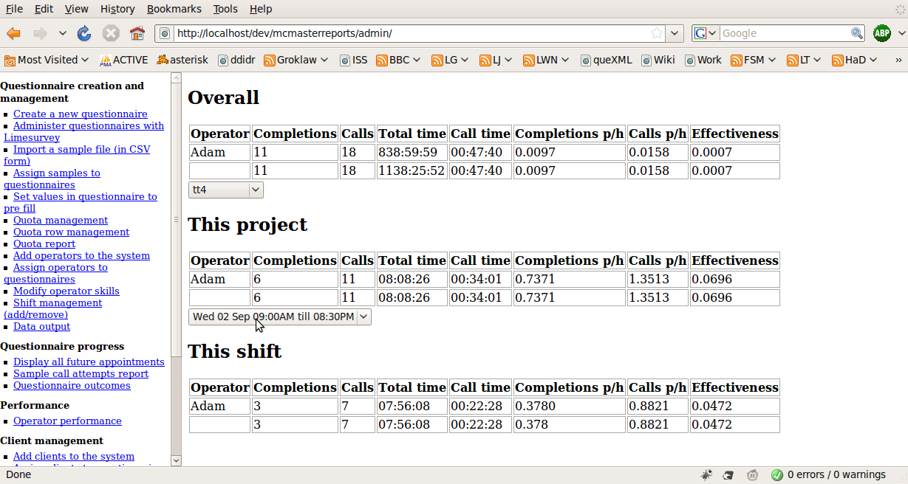
The productivity report contains the following columns:
- Operator
  - The operator (interviewer)
- Completions
  - The number of completions
- Calls
  - The total number of calls made
- Total time
  - The entire time assigned to a case (total working time)
- Call time
  - The amount of time on an active call
- Completions p/h
  - The number of completions per hour of total working time
- Calls p/h
  - The number of calls made per hour of total working time
- Effectiveness
  - The proportion of time spent on calls versus total working time

Disposition report
The disposition report is available under the queXS administration screen under "Questionnaire outcomes"
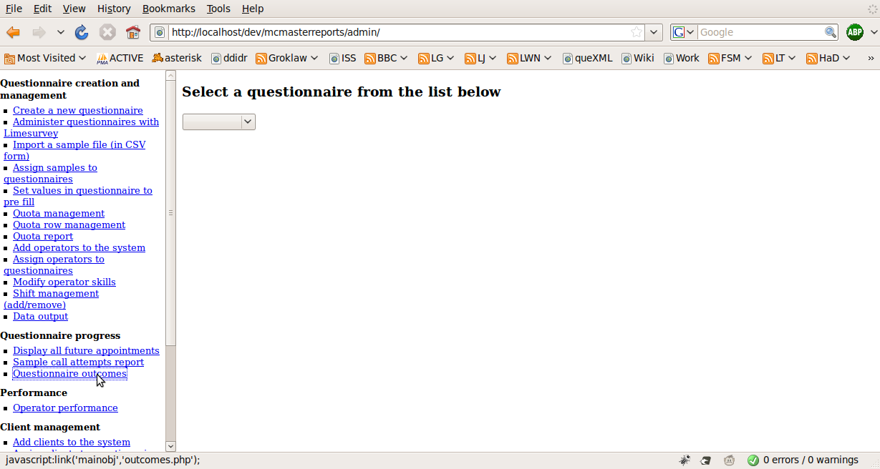
Selecting a questionnaire will list the disposition report
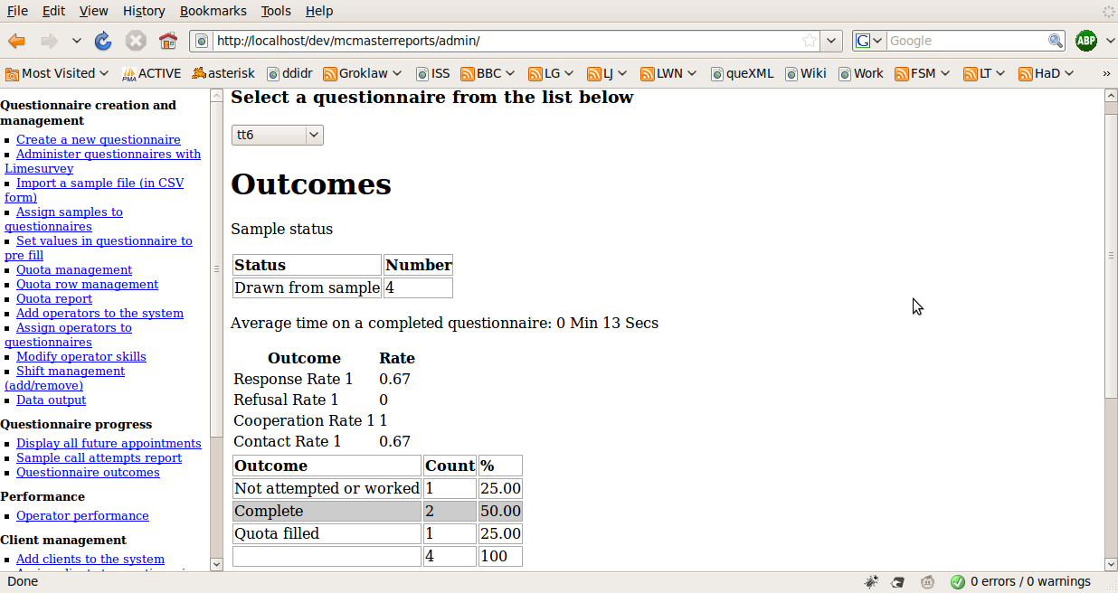
The report can be further broken down by operator or sample, then by shift
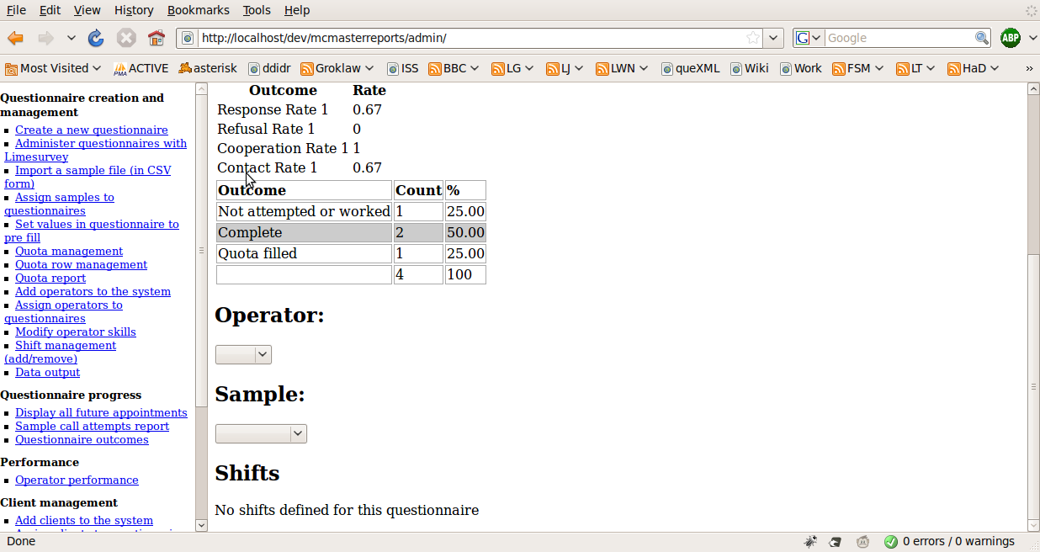
The disposition report displays:
- Sample status
  - The number of records drawn from the sample (assigned to a case)
  - The number of records that remain in the sample
- Average time on a completed questionnaire
- AAPOR Outcome codes
  - These are calculated using AAPOR Standard definitions (see the report here)
- Outcome codes
  - These codes are based on the AAPOR Standard definitions: Final Disposition Codes for RDD Telephone Surveys (See page 46 of the AAPOR Standard definitions report)
  - The last row in this table is a total

Sample call attempts report
This report is available under "sample call attempts report" in the queXS administrative menu
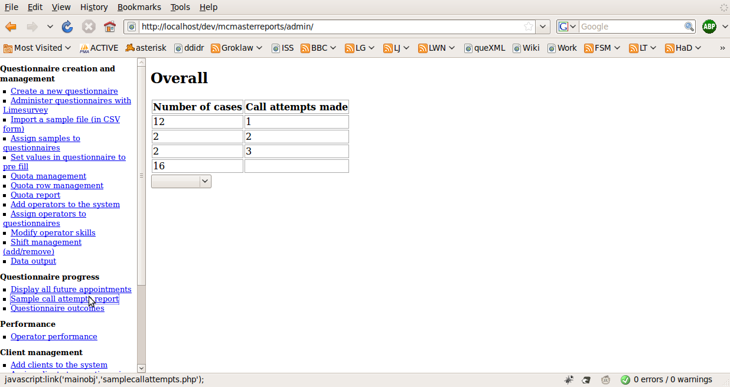
This report can be broken down by project (questionnaire), sample and then quota
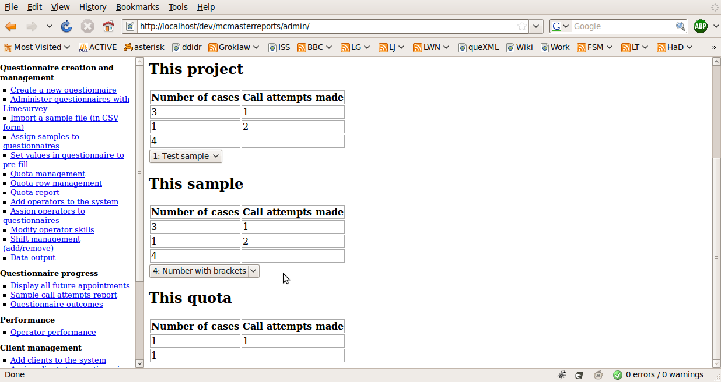
This report contains the number of call attempts made, and the number of cases that fall into that category.
For example, the first row contains how many cases have had 1 call attempt made, the second row contains the number of cases where 2 calls attempts were made, and so on.
The last row always contains the total number of cases in that category (eg that sample, or that quota)

queXS quota's and their relation to reports
There are 4 types of quota's in queXS - although only 3 of them apply to these reports. The type of quota to ignore is listed under "Quota Management" in the queXS administration screen. This quota is ignored as it excludes an entire sample file - this is not appropriate given the specifications for these modifications.
Therefore the 3 quota types that relate to the reports above are:
- Monitor outcomes of questions in completed questionnaires, and exclude selected sample records when completion limit is reached (Standard Quota Row)
- Exclude selected sample records (Replicate)
- Monitor outcomes of questions in completed questionnaires, and abort interview when completion limit is reached (Questionnaire)

1 - Standard Quota Row
This quota is used to exclude records from the sample (eg a province) based on data collected in the questionnaire (eg What province do you live in?). This quota is used where there is information in the sample to allow certain records to be excluded.
To create a quota row, click on "Quota row management" in the administration screen
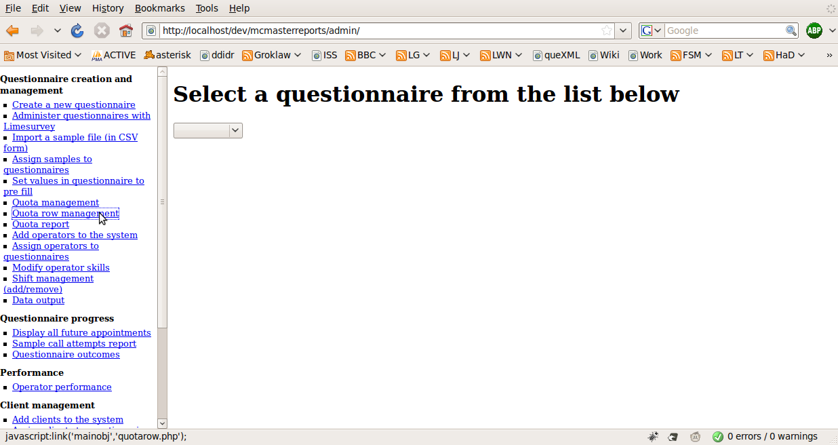
Then select the question in the questionnaire that the quota applies to
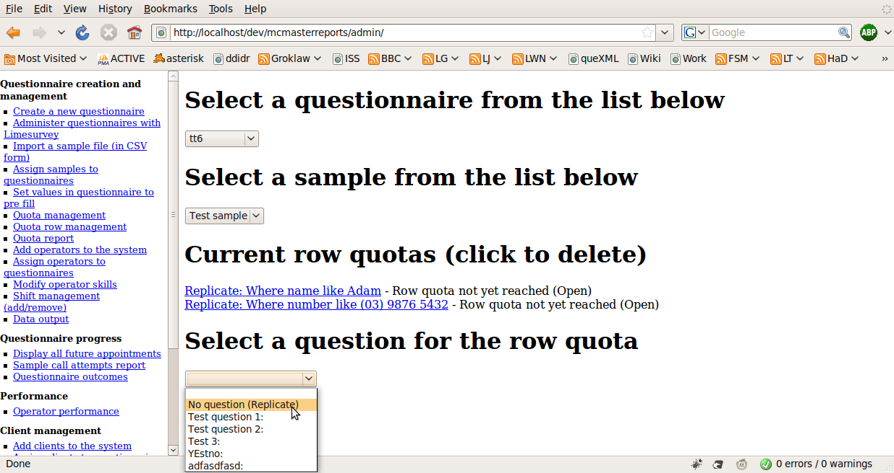
Then supply the parameters
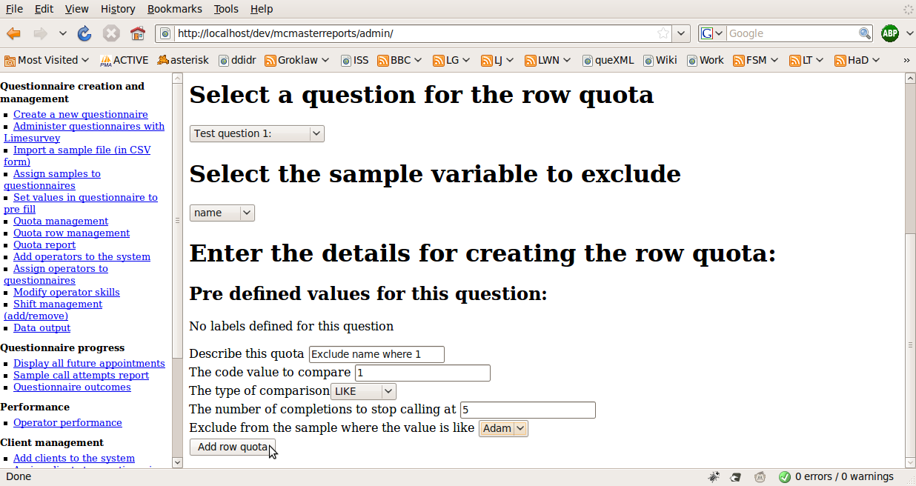
- Description
- Code value to compare to
  - The value to compare against the data collected in the questionnaire
- Type of comparison
  - The comparison operator
- Number of completions
  - This is the quota size
- Exclude from sample where the value is like
  - The value to compare against in the sample file to exclude matching rows

2 - Replicate
This quota is used to manually exclude records from the sample. The administrator will use the open and close links in the quota report screen to exclude or allow sample records.
To create a replicate, click on "Quota row management" in the administration screen
Then select "No question (Replicate)"
Then supply the parameters
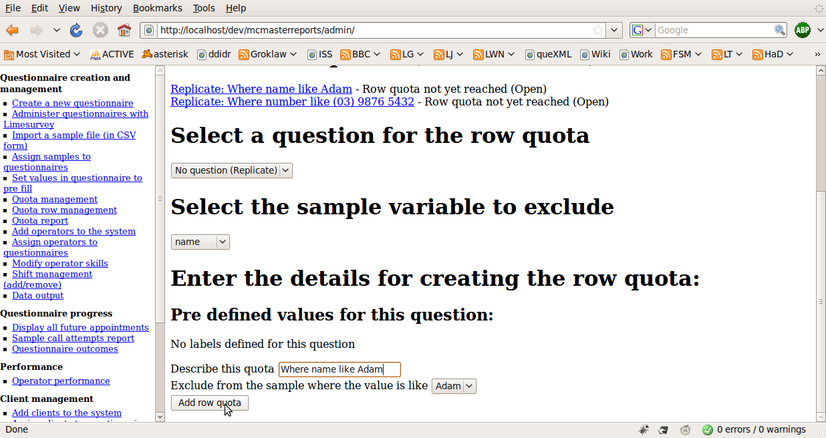
- Description
- Exclude from the sample where the value is like
  - The value to compare against in the sample file to exclude matching rows

3 - Questionnaire
This quota will abort an interview based on data collected in the questionnaire (sometimes referred to as a screener question). An example would be a quota on gender. A message will be displayed to the interviewer to read to the respondent, and the outcome for the case will be set to: "Quota filled".
To add a questionnaire quota, we use limesurvey. Firstly, select "Administer questionnaires with limesurvey"
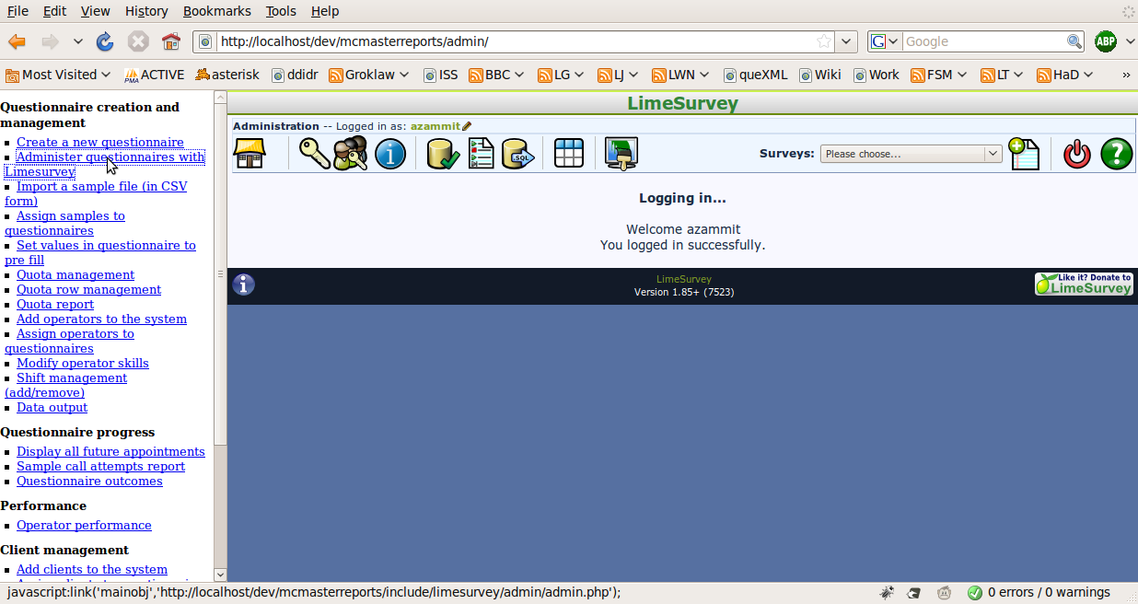
Choose the questionnaire, then select "Set survey quotas" (A pie icon)
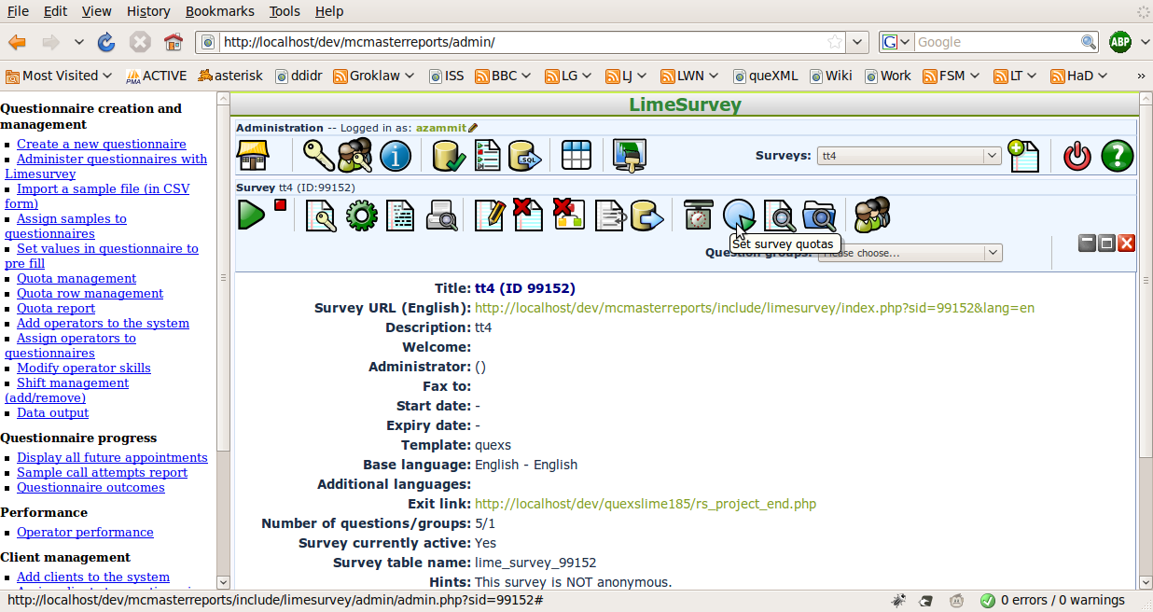
Then choose "add new quota"
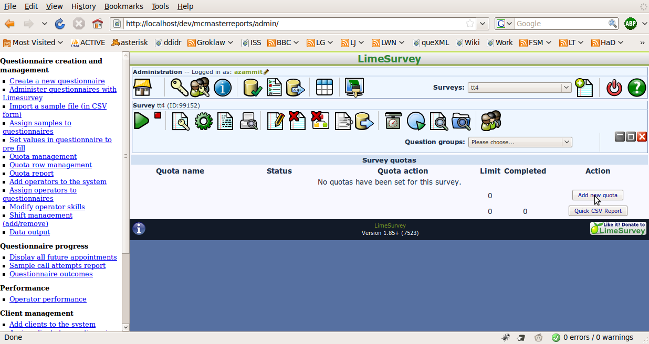
Enter the description for the quota, the number of completions, and a message to display to the interviewer when the quota is full, then click on "add quota"
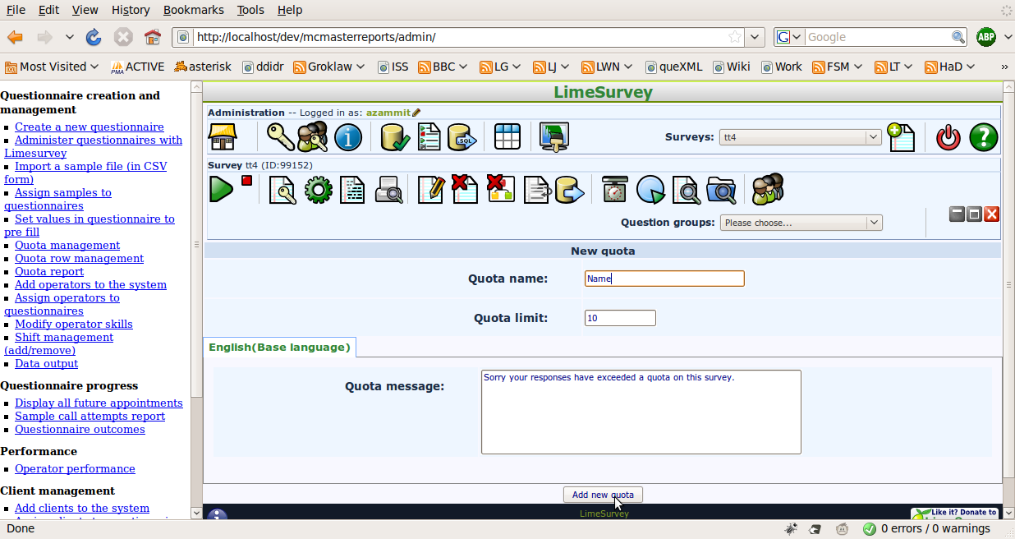
Now you must add "answers" to the quota to define which questions apply to the quota. Click on "add answer"
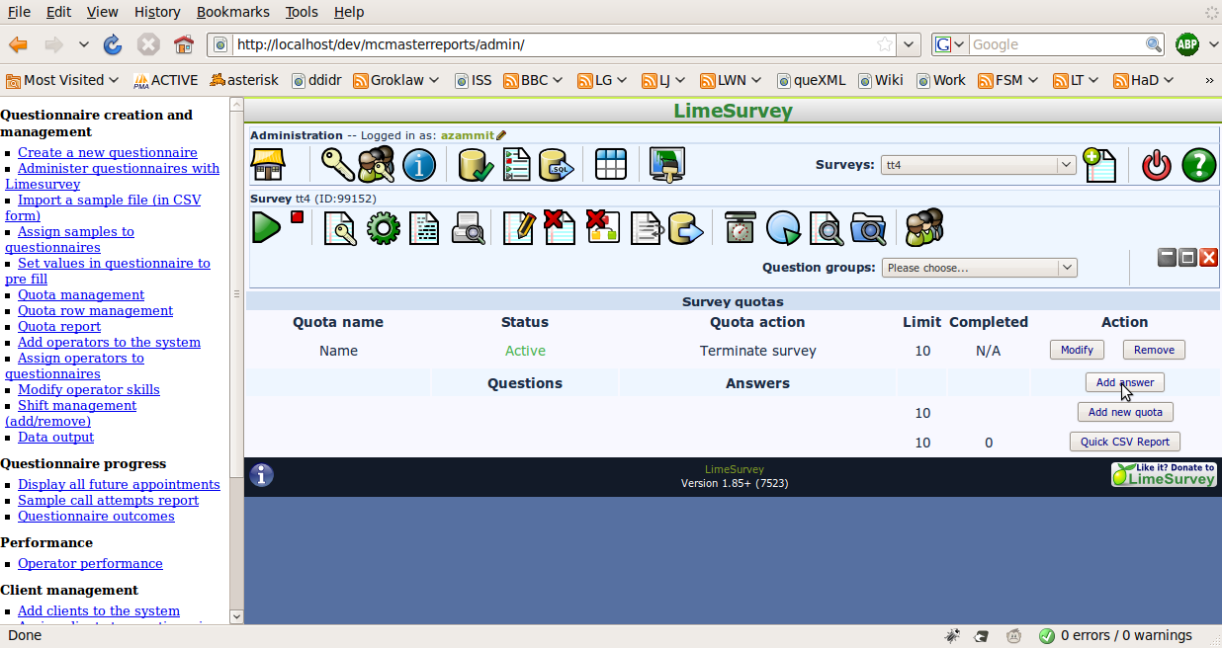
Select the question that will apply to the quota (Not all question type are available, see the limesurvey documentation for further information) and click next
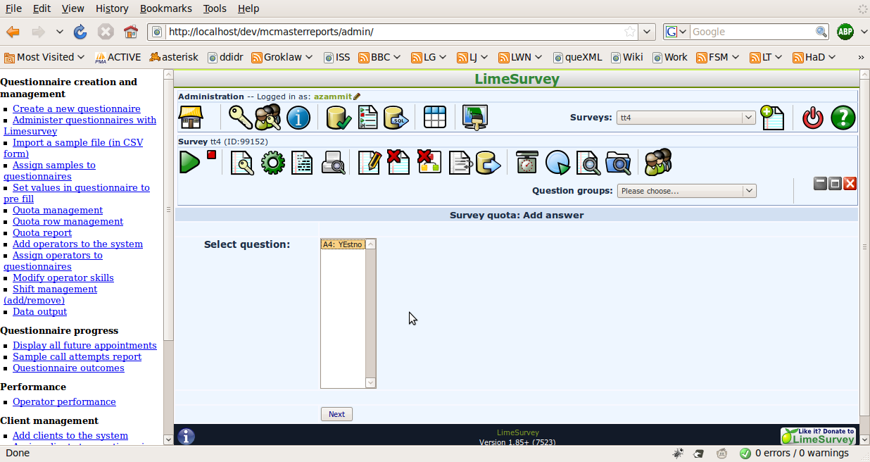
Then select the response that will apply, and click next to complete creating the questionnaire quota
