**NHDPlus High Resolution Navigation**

**Workshop Hands-on Exercise**

**\*\*\*Adapted for ArcGIS Pro 2.6.3\*\*\***

# Getting Started

1. On your C: or D: Drive create a file pathway that contains a folder called

NHDPlusHR_Workshop_1209

1. Obtain the 1209 GDB file from the National Map website:

<https://viewer.nationalmap.gov/basic/#productSearch>

* 1. Click on the **Advanced Search dropdown** and enter 1209
  2. Check the box: Hydrography (NHDPlus HR, NHD, WBD)
  3. Select: **NHDPlus High Resolution (NHDPlus HR)**
  4. Click the “Search Products” button above.
  5. Click on “Download Link (ZIP)”
  6. 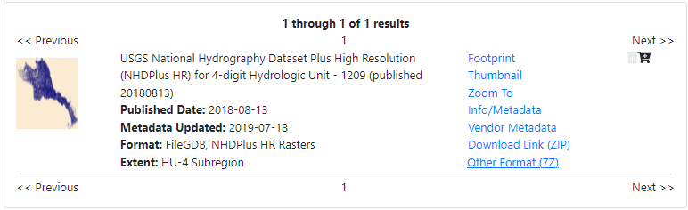Should download as NHDPLUS_H_1209_HU4_GDB.zip

1. Open a new ArcGIS Pro Session and connect to the folder created earlier

(NHDPlusHR_Workshop_1209)

* 1. Within NHDPlusHR_Workshop_1209, create a new File Geodatabase (GDB) called Results.gdb

1. Secondary Data Location: [TNM on AWS](https://prd-tnm.s3.amazonaws.com/StagedProducts/Hydrography/NHDPlusHR/Beta/GDB/NHDPLUS_H_1209_HU4_GDB.zip)

# Navigating with Network Attributes

1. Navigating *Upstream Mainstem* is relatively easy. [Lake Link](https://austin.curbed.com/2019/7/10/20689146/austin-parks-development-lake-walter-e-long)
   1. Open both the NHDFlowline layer and NHDPlusFlowlineVAA table located in the NHDPLUS_H_1209_HU4_GDB.gdb
   2. Join the Tables based on NHDPlusID and do NOT Keep all Records
      * 1. Right click on NHDFlowline layer in the table of contents
        2. Joins and Layers > Add Join
        3. Input Table = NHDFlowline. Join Table = NHDPlusFlowlineVAA. Join Field = NHDPlusID
        4. Uncheck “Keep all records”, as some disconnected features do not get an NHDPlusID, which is what we are basing the join on.
   3. Export Joined table to a new layer called NHDFlowline_VAA and save to Results.gdb

* + 1. Open the NHDFlowline_VAA attribute table and inspect that the VAAs are now included along with the NHDFlowline attributes (LevelPathI, Hydroseq, DnLevelPat, DnMinorHyd, ect.).

* + 1. Then select the LevelPathID of the Decker Creek

(LevelPathI= 30000300019207). This will select 24 flowlines that share this level path, before the stream converges with Gilleland Creek. This is an **Upstream Mainstem Navigation**.

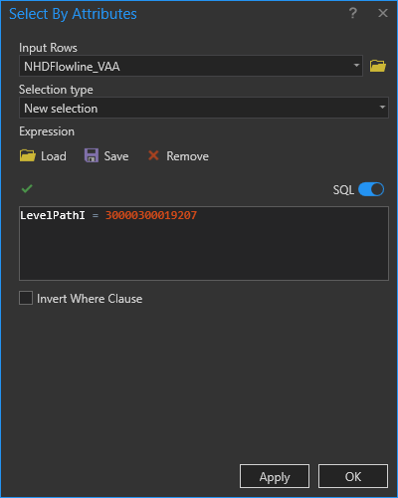

1. To navigate *Upstream with Tributaries* from the bottom of a level path is more complex and requires an iterative process.

* 1. Starting with the Mainstem navigation from above, Export the selected

NHDFlowline_VAA (For the Decker Creek, LevelPathI = 30000300019207) to

\NHDPlusHR_Workshop_1209\Results.gdb\NavResults1

* 1. This iterative process involves performing a **Select By Attributes** query on the Joined NHDFlowline layer. Enter the following text in the **Select By Attributes** dialog:
  2. DnLevelPat in (SELECT LevelPathI FROM NavResults1) OR DnMinorHyd in (SELECT HydroSeq FROM NavResults1)

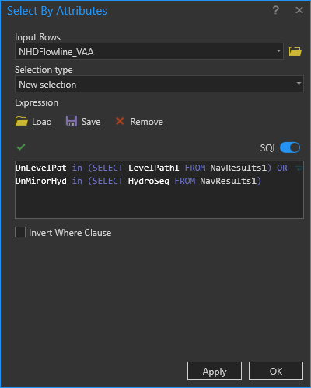

***This selection statement above involves a SQL sub-query, which only works on geodatabase feature classes. This code will*not* work on shapefiles.***

***The query is looking for any records from NHDFlowline_VAA whose “DnLevelPat” value is also located in the “LevelPathI” field in the NavResults feature class, OR any records from NHDFlowline_VAA whose “DnMinorHyd” value is also located in the “Hydroseq” field from NavResults1.***

***Basically, since NavResults1 is the mainstem of Decker Creek, this Select By Attributes query is looking for any tributaries in NHDFlowline that flow into that mainstem.***

1. Compare the number of selected records in NHDFlowline_VAA to the number of records in NavResults<m>. *Note: the first time through this procedure substitute 1 for <m>, then next time through this procedure substitute 2 for <m>, then 3 and so on.*

* 1. If the number of selected records in NHDFlowline_VAA is less than or equal to the number of records in NavResults<m>, then the process ends because all of the waters have been found that flow into flowlines that have already been navigated.

* 1. If the number of selected records in NHDFlowline_VAA is greater than the number of records in NavResults<m>, then the Upstream with Tributaries navigation is still finding new waters that into flowlines that have already been navigated.

* 1. Each time this selection query is run, Export the selected NHDFlowline records to a new geospatial feature class called:

\NHDPlusHR_Workshop_1209\Results.gdb\NavResults<m+1>

* 1. The file name should be NavResults2 the first time through this step, then NavResults3 next time, etc.

* 1. When prompted, add NavResults<m+1> to the map.

1. Increment the value of m by 1, substitute m’s new value for <m> in the query below. Cut and paste the query into a new **Select by Attributes** from NHDFlowline_VAA.

* 1. DnLevelPat in (SELECT LevelPathI FROM NavResults<m>) OR DnMinorHyd in (SELECT HydroSeq FROM NavResults<m>)

* 1. The query is looking for any records from NHDFlowline_VAA whose “DnLevelPat” value is also located in the “LevelPathI” field in the NavResults<m> feature class, OR any records from NHDFlowline_VAA whose “DnMinorHyd” value is also located in the “Hydroseq” field from NavResults<m>.

* 1. Basically, each time the Select By Attributes is performed, another level of tributaries is added to the select. We started with main stem of Decker Creek, then added the tributaries that flow into it and eventually all of the upstream features.

* 1. After the query is executed, go to Step c and repeat steps c and d.

1. The final result of this *Upstream with Tributaries* navigation looks like this:

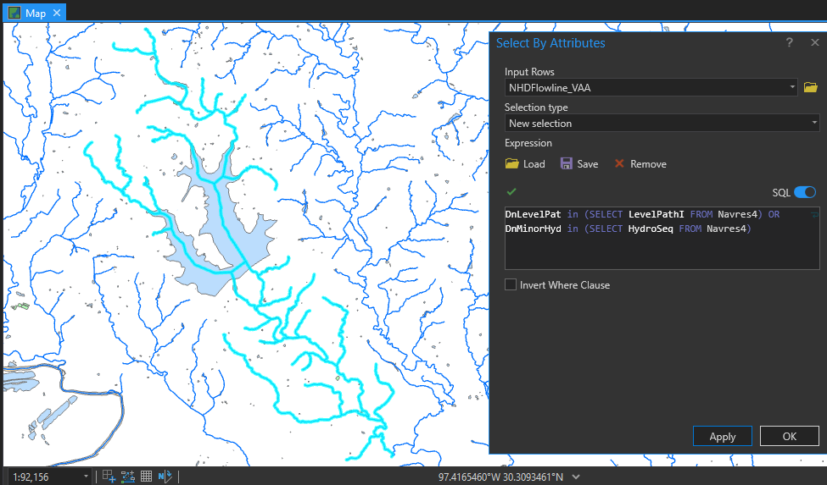

Optional: Rename Map *Upstream Navigation*

There is an NHDPlus desktop tool that performs all of these VAA navigations from an ArcMap toolbar. This navigation performs point-to-point navigations and has many options. The tool is callable from Python. The High Resolution NHDPlus VAA Navigator is available on the NHDPlus HR website.

# Find all the tributaries in the Colorado River

1. In the Catalog sidebar create a new map and name it *Find Tributaries* and add the layer NHDFlowline_VAA from the previous section.
2. Select any feature in the middle to northern section of the HUC 4. Copy this features TerminalPathIdentifier = 30000300000580
3. Clear this selection. Create a new section by attributes from the NHDFlowline_VAA feature class where HydroSeq = 30000300000580 . This is the terminal path from the random upstream feature. The terminal path is the same as the hydro sequence of the most downstream feaure in the network.
4. Zoom to this selected feature.

1. Use the **Identify** tool to display the NHDFlowline_VAA attributes for the most downstream flowline. Note that the LevelPathIdentifier is 30000300000580. This is a unique ID that defines the main path from the mouth of the Colorado River to the main headwater flowline.

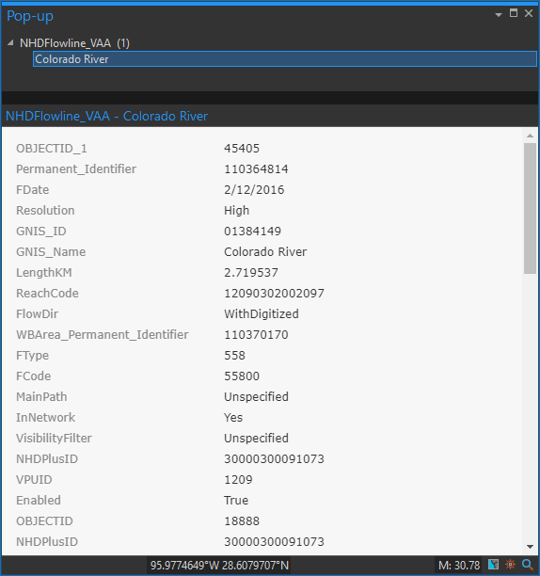

1. To see the entire water course, from the mouth of the Colorado River to the main headwater, do a selection on LevelPathI = 30000300000580 and zoom to selected.

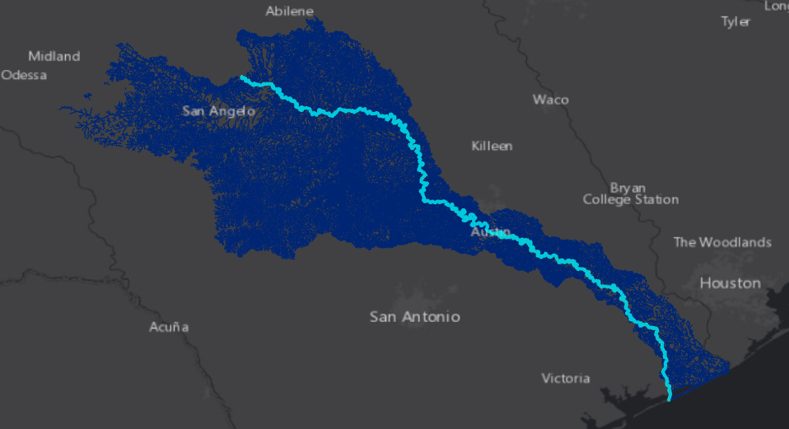

1. Find the tributaries to the Colorado River: Open the NHDFlowline_VAA attribute table and display the selected records from Part e. above. Sort ascending on Hydrologic Sequence (Hydroseq). Record the minimum and maximum Hydrologic Sequence of the Colorado- 30000300000580 and 30000300105372.

1. To find the tributaries, perform a selection as follows:
   * 1. To find every tributary

DnLevelPat = 30000300000580 And DnHydroSeq >= 30000300000580 And DnLevelPat = 30000300000580 And DnHydroSeq <= 30000300105372 And GNIS_ID NOT IN ('01384149')

ii To find only named tributaries

DnLevelPat = 30000300000580 And DnHydroSeq >= 30000300000580 And DnLevelPat = 30000300000580 And DnHydroSeq <= 30000300105372 And GNIS_ID <> ('01384149')

1. In English, this statement says, select any NHDFlowline features whose immediate downstream flowline is the Colorado River and whose downstream hydroseq is greater than or equal to the minimum hydroseq on the Colorado and whose downstream hydroseq is less than or equal to the maximum hydroseq on the Colorado and which is not the Colorado River itself.

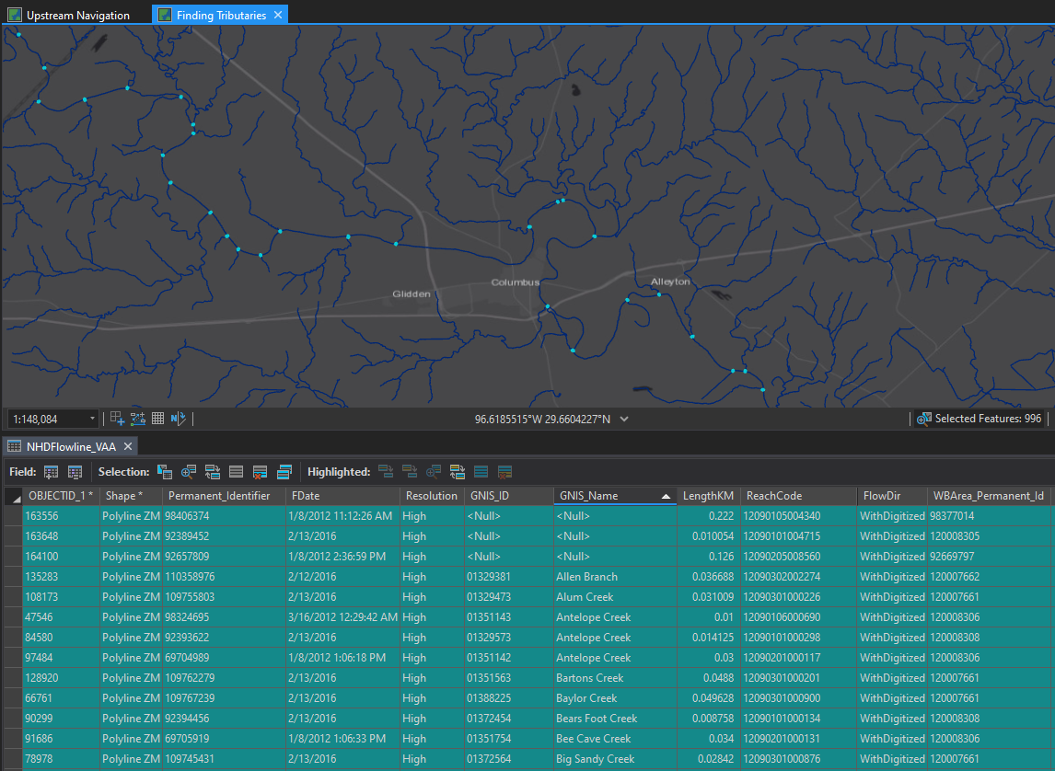

1. And we find that there are 158 (Named) tributaries to the Colorado River in High Resolution NHDPlus, and 995 total tributaries.

**How Many Lakes are along the Colorado River?**

Let’s find out.

* 1. Create a new map named *Find Lakes* and add NHDFlowline_VAA and NHDWatebody layers to the map
  2. Find the Colorado River by opening the NHDFlowline_VAA attribute table and select:

LevelPathI = 30000300000580. Zoom to selected.

* 1. Sort these selected records by PathLength ascending and zoom to the PathLength =0 feature. This is the mouth of the Colorado River again, but we are able to navigate to a specific part of the path using this attribute. Path Length tells us how far it is from the bottom of a feature to the end of the network. Reciprocally then we can sort PathLength descending and zoom to the highest value feature. This is where the Colorado River flows into 1209. Another VAA, VPUIn, also notes documents this.

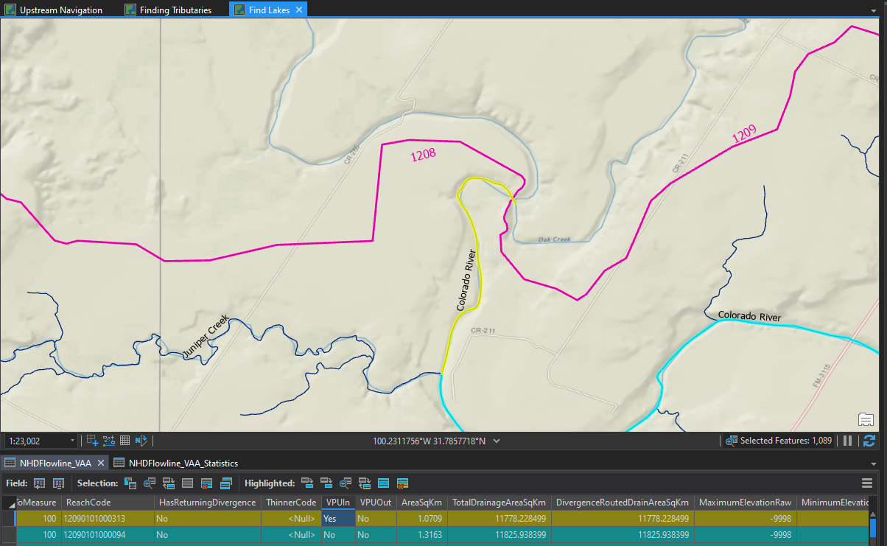

* 1. To find the lakes on the Colorado River, start with **joining** NHDFlowline_VAA with NHDWaterbody based on the following: *uncheck Keep All Target Features*

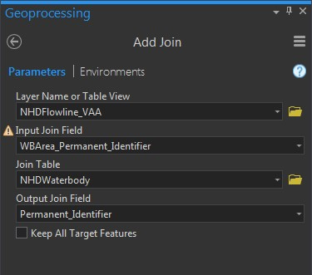

Export the joined layer to the Result.gdb folder and name it NHDFlowline_VAA_Waterbodies. ***Remove join from NHDFlowline_VAA***

* 1. Make a selection from NHDFlowline_VAA_Waterbody using:

GNIS_ID = '01384149' And LevelPathI = 30000300000580 And FType_1 = 390

Which is the GNIS_ID and LevelPath of the Colorado River and FType of 390 (Lake/Pond) for the Waterbody.

* 1. There are 355 NHDFlowlines inside lake features along the Colorado.

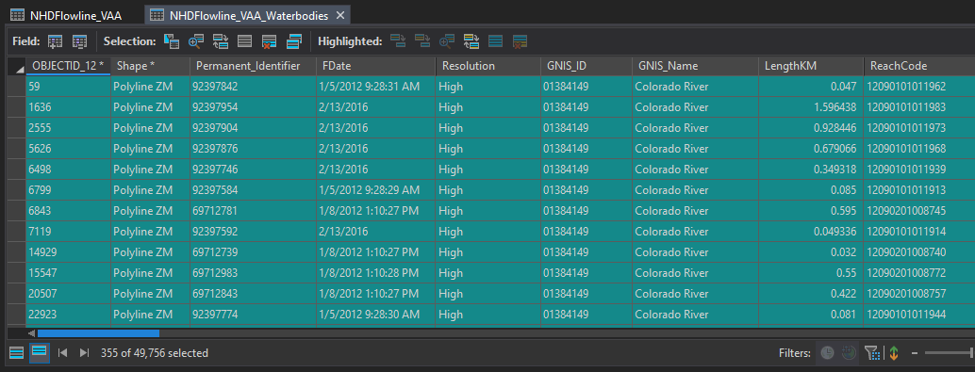

1. Determine the lake outlets.
   1. Right click on the NHDFlowline_VAA_Waterbodies table on the WBArea_Permanent_Identifier column.
   2. **Summarize** computing minimum Hydroseq, minimum Pathlength, and WBArea_Perminant_Identifier as the Case field creating a table… \NHDPlusHR_Workshop_1209\Results.gdb\**LakeOutlets**.

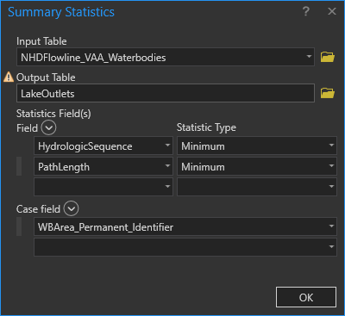

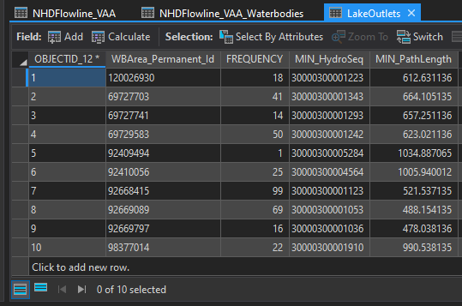

1. There are ten lakes on the Calorado River. Each lake’s outlet is the NHDFlowline that has the Hydroseq value in the Minimum_Hydroseq column.

1. Open LakeOutlets table. From **Table Options, Joins and Relates** -> **Relate,** relate LakeOutlets. Min_HydroSeq to NHDFlowline_VAA HydrologicSequence. Assign a name to the Relate if you wish and run the relate.
2. Select all LakeOutlet records from their table.
3. From the Data ribbon, select Related Data, and then select the relate we just performed.

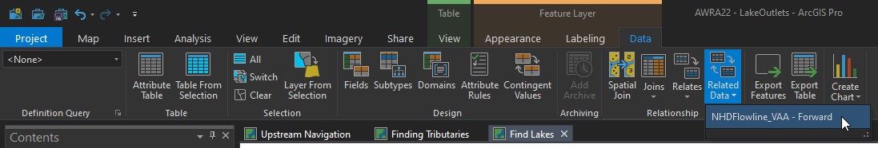

1. Select an NHDFlowline and **Zoom to Highlighted.** Perform an **Identify** on the lake. This is the outlet of the lake.

