RPG Nexus Site Plan

Atticus Carter

WDD 130

Pitch

RPG Nexus is a neon-lit hub dedicated entirely to Destiny 2 builds. We break down the strongest loadouts, meta weapons, subclass synergies, and mission-ready setups for every activity — from Strikes to Grandmasters. Explore expert guides, discover community-created builds, and fine-tune your Guardian in a glowing futuristic space made for theory crafters and hardcore Destiny players.

Overview

Purpose:

Gives sources to build guide websites for Destiny 2

Audience:

Returning players or hardcore players

Branding

Website Logo
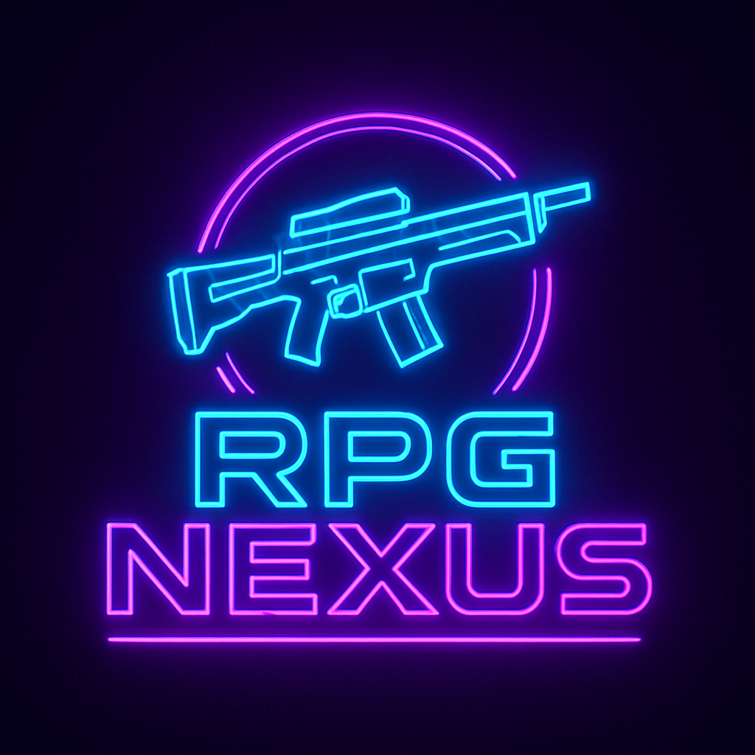

Style Guide

Color Palette
Primary | Secondary | Accent 1 | Accent 2
#00E8FF | #FF3CFF | #0A0014 | #1A0B2E

Typography

Heading Font: [‘Orbitron’, sans-serif]

Paragraph Font: [‘Inter’, sans-serif]

Navigation
Home Builds Guides

Content

Home
The home will have a section to where the user can click on it and there will be a questionnaire to help them find the build they would like.

Builds

There will be 6 images displayed showing examples of builds with the titles of the builds under it

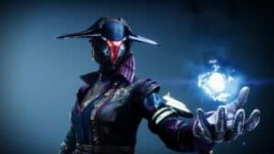

Sparkle Fingers

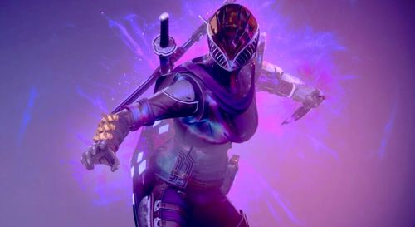

Invis Hunter



Gunslinger Hunter

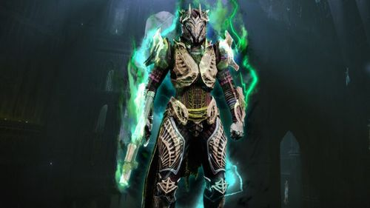

Invincible Titan

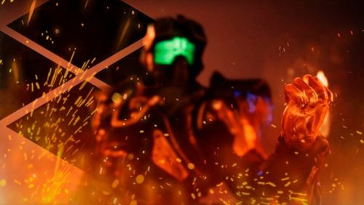

Bonk

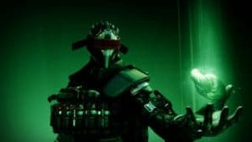

Strand Worlock

Guides
There will be a title of the guide you will click on to send you to a YouTube video and a description of the guide

https://www.youtube.com/watch?v=xKH_-KvbaD0

Trials Tips

https://www.youtube.com/watch?v=d3wrBTUx2oI

Solo GM

https://www.youtube.com/watch?v=f1ZvTbi4mUg
D2 Guide

Wireframes

Home Page Wireframe

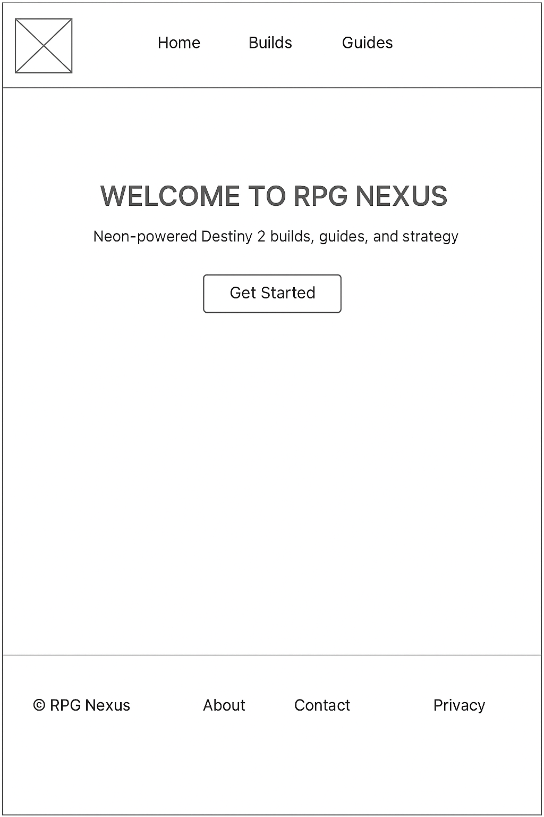

Builds Wireframe

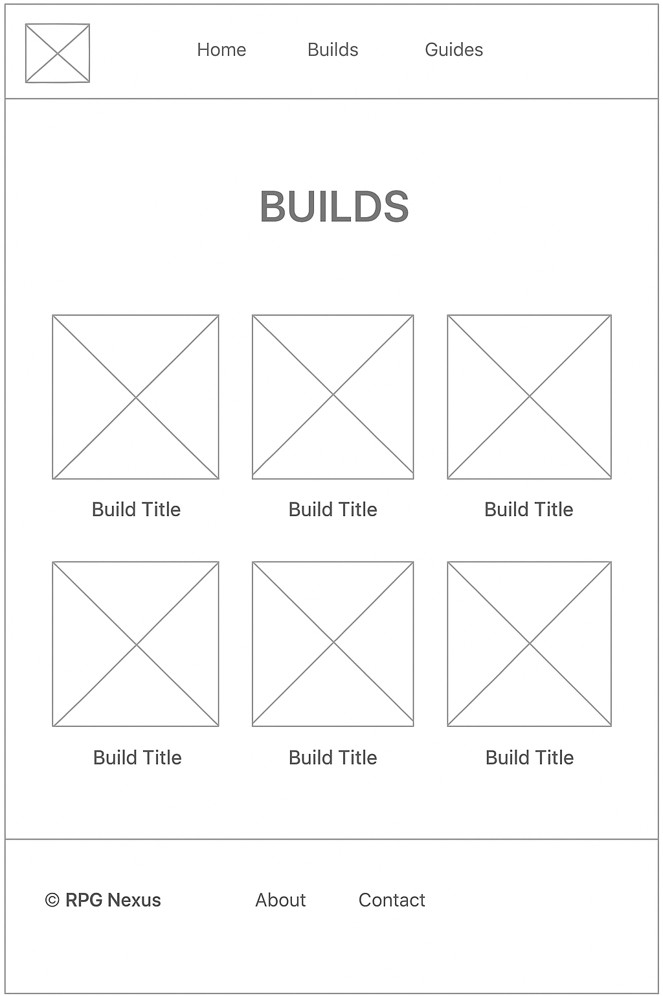

Page 2 Wireframe
