数据库字典

单元房表：

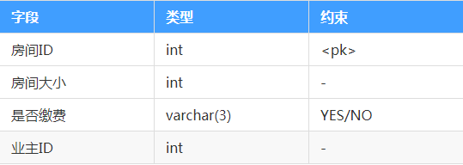

业主表：

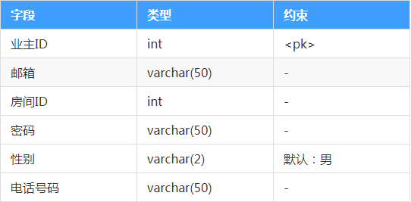

管理员表：

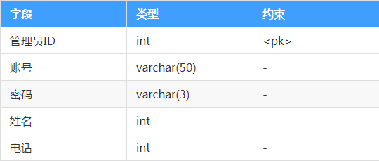

投诉表：

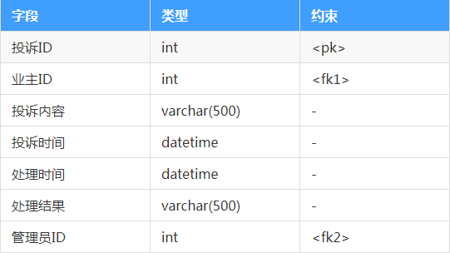

建议表：

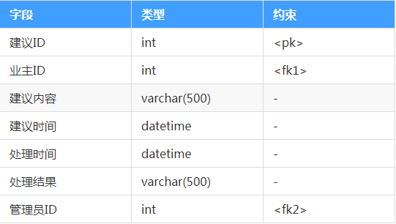

公告表：

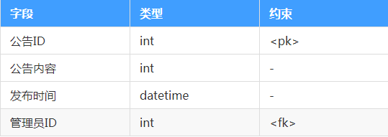

报修表：

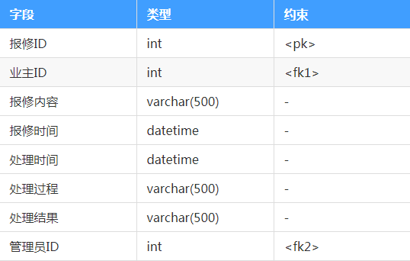

缴费表：

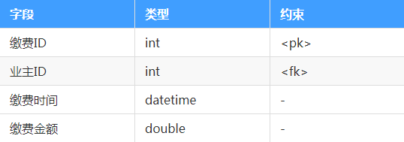

聊天表：

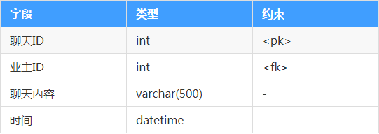

活动表：

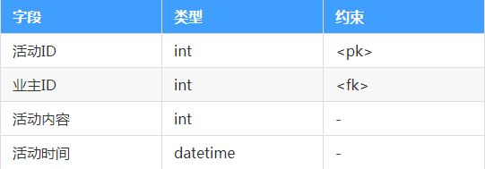

参与表：

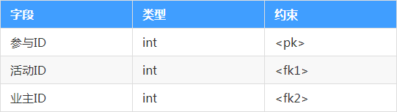

活动审核表：

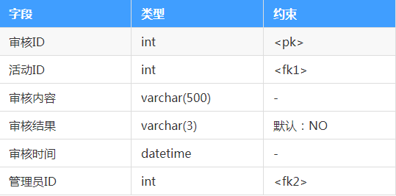

表的设计

|  |  |
| --- | --- |
| Name | Code |
| 房间ID | room_id |
| 房间大小 | room_size |
| 是否缴费 | room_pay |
| 业主ID | owners_id |
| 邮箱 | owners_email |
| 密码 | owners_password |
| 姓名 | owners_name |
| 性别 | owners_sex |
| 电话号码 | owners_phone |
| 管理员ID | admin_id |
| 账号 | admin_account |
| 密码 | admin_password |
| 姓名 | admin_name |
| 电话 | admin_phone |
| 投诉ID | complain_id |
| 投诉内容 | complain_content |
| 投诉时间 | complain_time |
| 处理时间 | complain_handle_time |
| 处理结果 | complain_handle_result |
| 建议ID | suggest_id |
| 建议内容 | suggest_content |
| 建议时间 | suggest_time |
| 处理时间 | suggest_handle_time |
| 处理结果 | suggest_handle_result |
| 公告ID | notice_id |
| 公告内容 | notice_content |
| 公告发布时间 | notice_time |
| 报修ID | upkeep_id |
| 报修内容 | upkeep_content |
| 报修时间 | upkeep_time |
| 处理时间 | upkeep_handle_time |
| 处理过程 | upkeep_process |
| 处理结果 | upkeep_result |
| 缴费ID | pay_id |
| 缴费时间 | pay_time |
| 缴费金额 | pay_price |
| 聊天ID | chat_id |
| 聊天内容 | chat_content |
| 时间 | chat_time |
| 活动ID | activity_id |
| 活动内容 | activity_content |
| 活动时间 | activity_time |
| 活动发起人 | owners_id |
| 参与ID | joins_id |
| 审核ID | verify_id |
| 审核内容 | verify_content |
| 审核结果 | verify_result |
| 审核时间 | verify_time |
| 审核人 | admin_id |

数据库各表中的字段

1、**单元房表**：

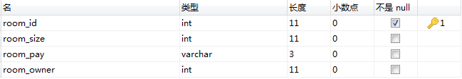

2、**业主表**：

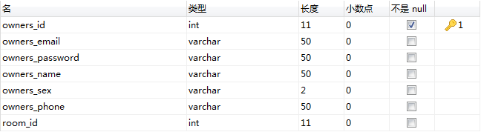

3、**管理员表**：

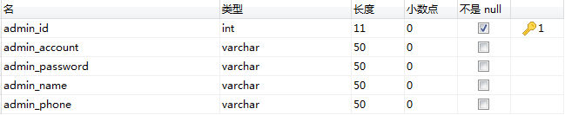

4、**投诉表**：

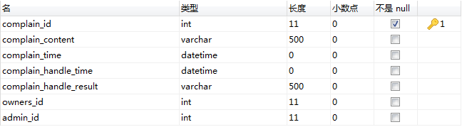

5、**建议表**：

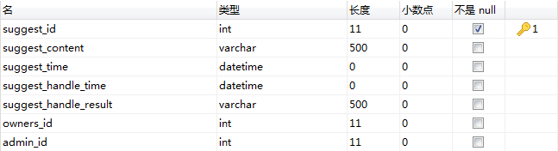

6、**公告表**：

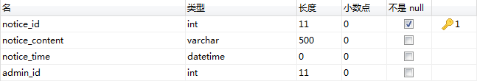

7、**报修表**：

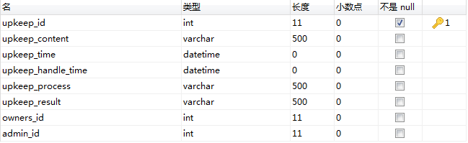

8、**缴费表**：

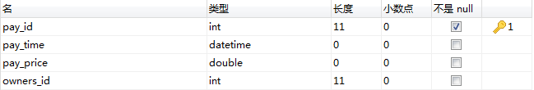

9、**聊天表**：

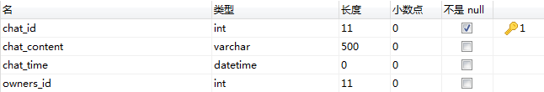

10、**活动表**：

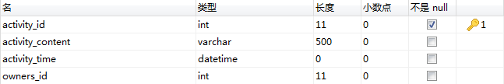

11、**参与表**：（用来连接活动表和用户表，参加人员）

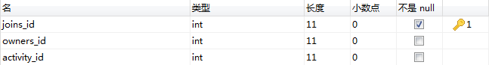

1. **活动审核表**：

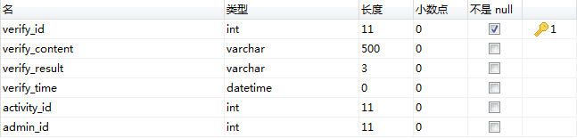

表之间的关系

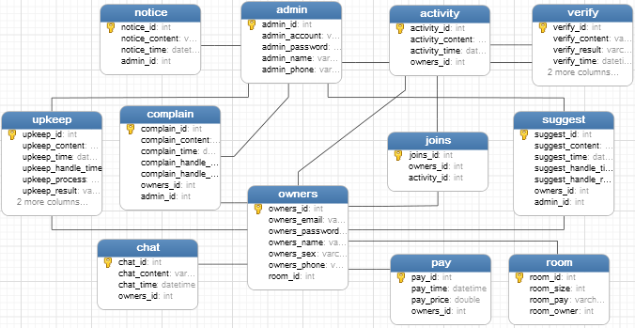

建表的SQL语句

CREATE TABLE room (

room_id INT PRIMARY KEY NOT NULL auto_increment,

room_size INT,

room_pay VARCHAR (3),

room_owner INT

);

CREATE TABLE owners (

owners_id INT PRIMARY KEY NOT NULL auto_increment,

owners_email VARCHAR (50),

owners_password VARCHAR (50),

owners_name VARCHAR (50),

owners_sex VARCHAR (2) DEFAULT '男',

owners_phone VARCHAR (50),

room_id INT,

FOREIGN KEY (room_id) REFERENCES room (room_id)

);

CREATE TABLE admin (

admin_id INT PRIMARY KEY NOT NULL auto_increment,

admin_account VARCHAR (50),

admin_password VARCHAR (50),

admin_name VARCHAR (50),

admin_phone VARCHAR (50)

);

CREATE TABLE complain (

complain_id INT PRIMARY KEY NOT NULL auto_increment,

complain_content VARCHAR (500),

complain_time datetime,

complain_handle_time datetime,

complain_handle_result VARCHAR (500),

owners_id INT,

admin_id INT,

FOREIGN KEY (owners_id) REFERENCES owners (owners_id),

FOREIGN KEY (admin_id) REFERENCES admin (admin_id)

);

CREATE TABLE suggest (

suggest_id INT PRIMARY KEY NOT NULL auto_increment,

suggest_content VARCHAR (500),

suggest_time datetime,

suggest_handle_time datetime,

suggest_handle_result VARCHAR (500),

owners_id INT,

admin_id INT,

FOREIGN KEY (owners_id) REFERENCES owners (owners_id),

FOREIGN KEY (admin_id) REFERENCES admin (admin_id)

);

CREATE TABLE notice (

notice_id INT PRIMARY KEY NOT NULL auto_increment,

notice_content VARCHAR (500),

notice_time datetime,

admin_id INT,

FOREIGN KEY (admin_id) REFERENCES admin (admin_id)

);

CREATE TABLE upkeep (

upkeep_id INT PRIMARY KEY NOT NULL auto_increment,

upkeep_content VARCHAR (500),

upkeep_time datetime,

upkeep_handle_time datetime,

upkeep_process VARCHAR (500),

upkeep_result VARCHAR (500),

owners_id INT,

admin_id INT,

FOREIGN KEY (owners_id) REFERENCES owners (owners_id),

FOREIGN KEY (admin_id) REFERENCES admin (admin_id)

);

CREATE TABLE pay (

pay_id INT PRIMARY KEY NOT NULL auto_increment,

pay_time datetime,

pay_price DOUBLE,

owners_id INT,

FOREIGN KEY (owners_id) REFERENCES owners (owners_id)

);

CREATE TABLE chat (

chat_id INT PRIMARY KEY NOT NULL auto_increment,

chat_content VARCHAR (500),

chat_time datetime,

owners_id INT,

FOREIGN KEY (owners_id) REFERENCES owners (owners_id)

);

CREATE TABLE activity (

activity_id INT PRIMARY KEY NOT NULL auto_increment,

activity_content VARCHAR (500),

activity_time datetime,

owners_id INT,

FOREIGN KEY (owners_id) REFERENCES owners (owners_id)

);

CREATE TABLE joins (

joins_id INT PRIMARY KEY NOT NULL auto_increment,

owners_id INT,

activity_id INT,

FOREIGN KEY (owners_id) REFERENCES owners (owners_id),

FOREIGN KEY (activity_id) REFERENCES activity (activity_id)

);

CREATE TABLE verify (

verify_id INT PRIMARY KEY NOT NULL auto_increment,

verify_content VARCHAR (500),

verify_result VARCHAR (3) DEFAULT 'NO',

verify_time datetime,

activity_id INT,

admin_id INT,

FOREIGN KEY (activity_id) REFERENCES activity (activity_id),

FOREIGN KEY (admin_id) REFERENCES admin (admin_id)

);

E-R图

前台：

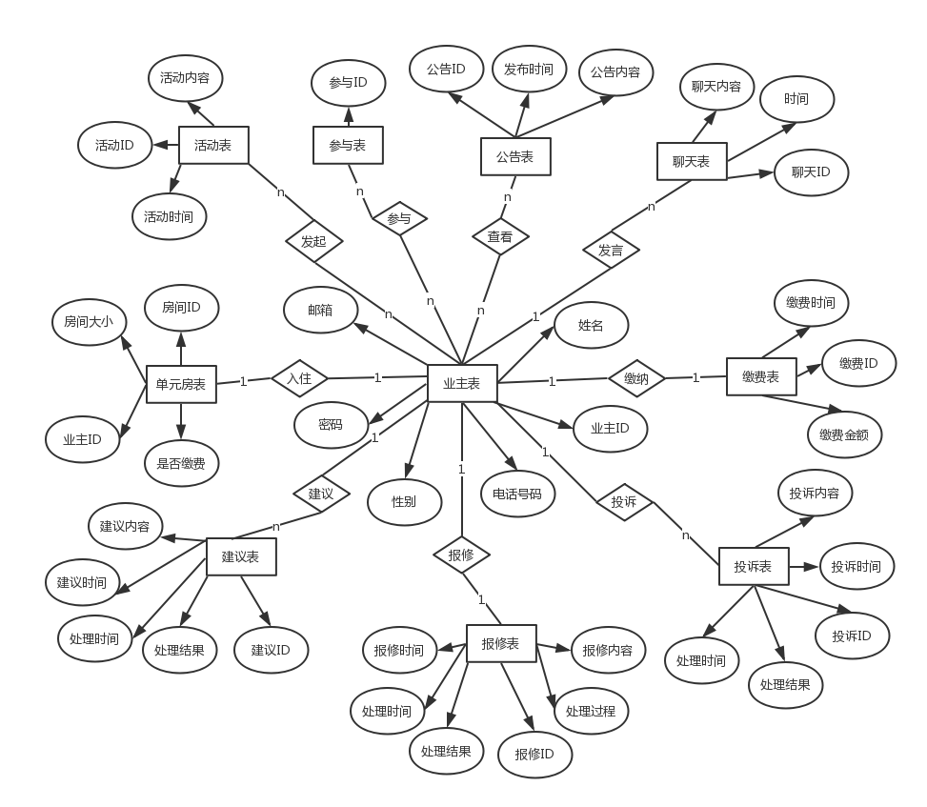

后台：

