Abstract

If you are an enterprise who builds an application that processes credit card data, you need to conform to PCI DSS (Payment Card Industry Data Security Standard). Adherence to the standard means that you need to meet control objectives for your network, protect cardholder data, implement strong access controls, manage operations and more. To help customers to quickly standup infrastructure that conform to PCI DSS, we are releasing an Azure Quickstart sample. The template describes a stack that deploys a multi-tiered azure PaaS web application stack. It makes use of many nested templates, and can be customized as desired.

Azure PaaS PCI Solution Deployment Guide

A Reference Architecture

# High level summary

# Pre-deployment Steps

## Manual creation of Azure AutomationAccount

Create an Automation account with **RunAs Service principal**. Unfortunately, ARM templates don't allow for creating AD service principals yet, so this step is currently a manual one.

* Refer the blog https://azure.microsoft.com/en-us/documentation/articles/automationsecconfigure-azure-runas-account/ for the steps.
* Creation of ServicePrincipal has a propensity to fail randomly. A basic verification whether it was successfully created is **mandatory**

Note the name of the automation account. You will be using that as a parameter to the ARM template

# Deployment steps

Timeline

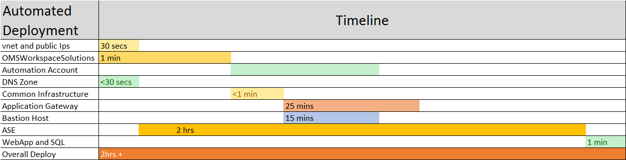

# Post Deployment Steps

## Update 1&1 DNS setting with Application Gateway IP

Modify the DNS settings under the Target settings

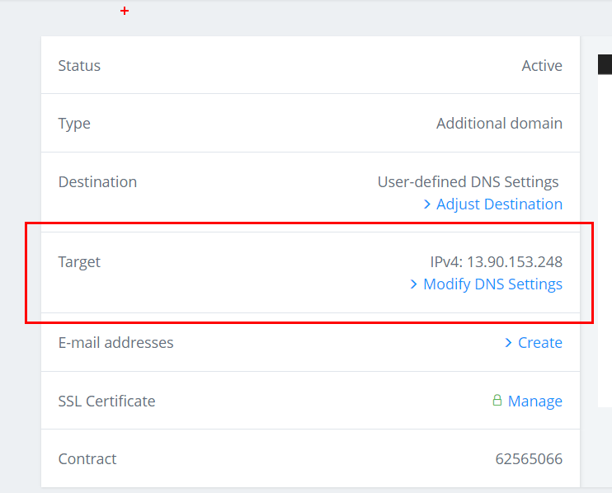

Note the public IP address of App gateway

You can find the gateway IP address in the output of the deployment

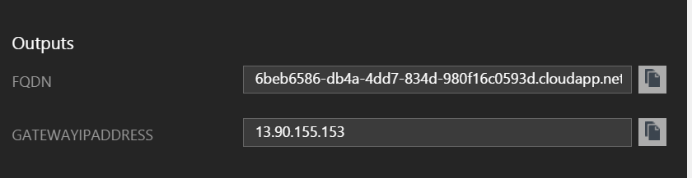

Or go to the Application gateway object (appGateway-WAF) and checkout the IPaddress

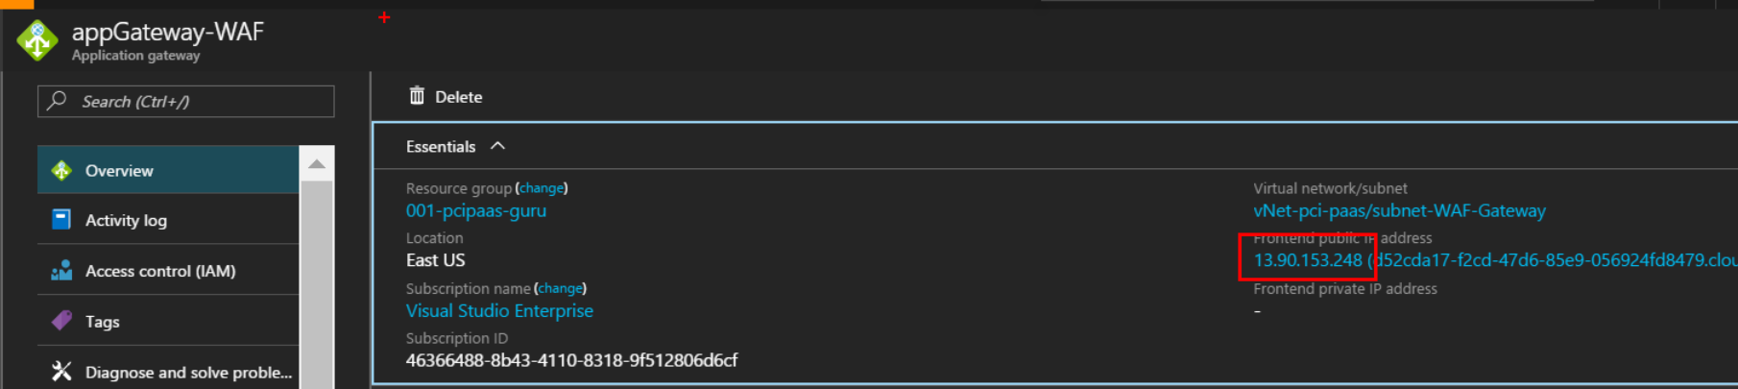

Update the A record IP address to be the App Gateway address

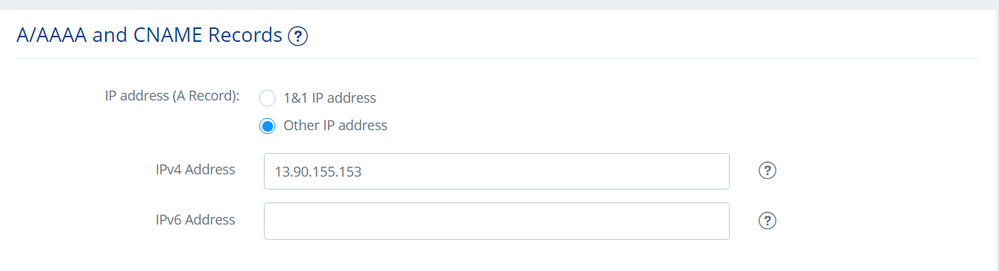

Verification

Site is working with <https://www.azurepcisamples.com>

