

Relational Database Features

By Adam Chu



Contents

No table of contents entries found.

# What is a Database?

A database is used usually by businesses to collate and organize their information, these come usually in two designs; Flat-File & Relational Databases.

A database can be accessed in a variety of ways these help the creator / employee gather, sort & filter information. These are Tables & Forms (For Gathering), Filtering records via (A→Z, Z→A) & Queries to select which entities are shown.

# Flat-File Databases

A flat file database is where all the information is on one table, this has some flaws with it these are Data inconsistency & the larger file size because of the data being repeated.

This is a Flat-File Database hypothesis based on subjects taught at the college under the IT bracket. This also does a good job showing the problems with the flat file database, these are Data Inconsistency, because the initials have to be repeated for every single record it can lead to typing errors and this also shown in the extension number.

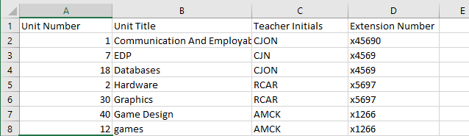

It also has a problem with Data redundancy, as the teacher’s names and extension numbers have been repeated multiple times whereas it would be more efficient to have linked tables one for the teacher’s credentials and one for the units. This is smaller in file size and easier to understand as well as the data is separated.

## Relational Databases

A relational database is where the uses IDs to link a primary to a foreign key, these are unique identifiers which in this example are numbers. This takes the teachers name & extension numbers and gives it a number referencing them and cross referencing them to another table with the rest of the information. This means the data with the teachers is only inputted once, which leads to less data inconsistency.

Fields (With) Headings

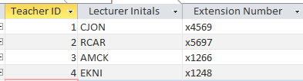

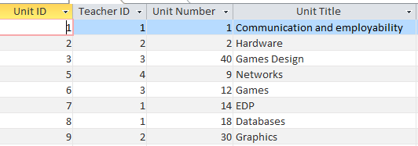Records

# How is information represented using entities

## What is an entity?

An entity is a group related to a business these could be Students, Teachers, Courses. Each singular group is called an entity.

In access an entity is shown as a table which has a title in the form of an ID with either an AutoNumber or a Number or a text for a data type.

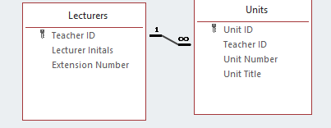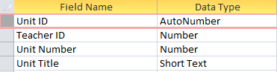

AutoNumbers is a data type which every time a new record is created that it adds a value to a hidden variable. But if you delete a record the number assigned does not reduce in value after deleting a record. The Primary Keys in my example use auto numbers.

Short Text is similar to a string that allows the user to enter some characters you can use a input mask to set sizing and you could use format to choose CASE (> for UPPER, < for LOWER). And an input Mask allows you to select the amount of characters. For example:

|  |  |
| --- | --- |
| 9 | Must Input a number |
| 0 | Can Input a number |
| L | Can input a Letter |

Numbers can also input masks shown above.

## Keys

These are used to show which entity is the information coming from or related to, there are 3 kinds of keys

Primary Keys which are the custom labels for each single entity on the relationship image above it shows Teacher ID under the Lecturers table & Unit ID under the Units table. These are shown as golden keys or black keys depending on the version of access (the location is the same).

* 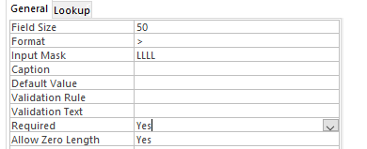Required forces the user to input these fields
* The Format Forces the upper CASE using >
* Input mask means only 4 letters and no numbers are allowed to be used

# Benefits of Using Access & Relational Databases

Through the process of Normalization, which is where the user will separate the parts of a flat file database to create smaller linked tables within a relational database. This is important as it causes the data to become smaller on the server, (this gives you faster access) it also reduces the amount of errors due to data inconsistency. Its more efficient to maintain and add to as you can use forms to make data entry less ambiguous.

This last point is also true when you have to create reports as they can be colour coded for example if it was a teachers for a school they could set the report to colour code it for the amounts of units they are teaching and colour coding it Max to Min (Green to Red).

You can use query using a part of Access which allows the user to select parts of a database to hide & sort.

You have the option of sorting by field, this allows you to disable the field from view. Sort from A to Z, Sort by Ascending Numbers & Declare which number is shown. Even if you deselect a series of records & periods their adjustment still affects the other cells.

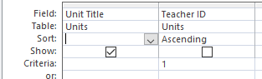

So for this example I have unshown the column which has Teacher ID as this is labelled as the Units Christine Teaches. But I have kept the criteria as ==1 meaning only her Units appear.

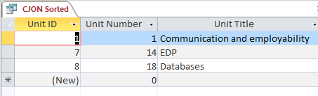

This is the same query outputted as a report to make it easier to understand and show in a meeting as it has been tidied up and accepts House Fonts & Styling (Colour Schemes and Logos).

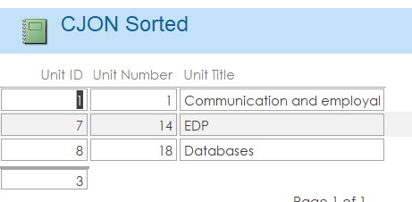

# Relationships

## 1 to 1

The 1 to 1 has the same Primary Key between 2 tables. This allows the user to separate the information that could go inside the first table. But there reasons for doing this mainly data security, because in Access you can set up levels of access which allows certain tables & forms to be blocked off to different users.

As you can see below you can see the keys that there is not shown a 1 or $∞$ because its implied that it is a 1 to 1 relationship.

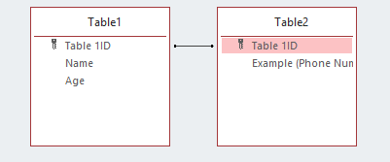

## 1 to Many

A one to many has the Primary Key of one table joined to a clone of it inside of a different entity, BUT this key is separate to the second tables Primary Key. This is called the Foreign Key, what this means is that the user will have one Teacher ID which links to many other fields.

## Many to Many

Access doesn’t natively support Many to Many relationships so the way we get around this, is by having 2 sets of 1 to Many relationships linked together so that the two tables have a transition table with both unique ID’s and the relevant fields.

# Referential Integrity and Cascades

## What is Referential Integrity and how to Enforce It?

Referential Integrity is where the database has set a clear rule on it:

To Add a new Record in the $∞$ Table of your 1 to $∞$ you must have a ‘parent’ record. If this occurs when Integrity is selected you will get an error message and not be able to complete your change. What you have to do is to create or delete the records that should have been their first.

You get the option to enforce this & Cascade Updating when you make a relationship.

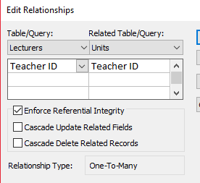

If you do not enforce referential integrity you can end up with orphaned records which occur when the user has not entered the information which joins a Primary Key to a Foreign Key/Primary Key/ Composite Key correctly. These will only occur if you haven’t enabled enforcing as the moment you enter an orphaned record it gives an error.

`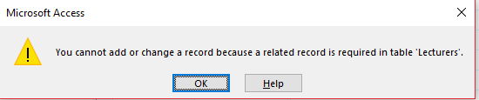

## Cascading Updates

This is where the database automatically reacts to changes you make in a related table that prevent orphaned records.

Cascade Update means that anytime that you would create a record inside a database which is missing its ID from the other table it will create a record in the other table with the same name as your new one. This stops it from becoming an orphan record. This is harder to mess up a database with as your data isn’t being deleted without manual control.

Cascade Delete is where the database deletes any orphaned records that you create this is useful if you want it to delete any related information about deleted records. But this could also lead to data being deleted by accident or mismanagement.

# Distinction

I have accessed the student information database and tried to create the relationship between ‘Course’ and the ‘Enrol’ tables and this error occurs.

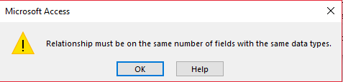

What this states is that the datatypes have to be the same before a relationship can be established because the CODE (PRIMARY KEY) but because they are two different data types of text. I changed the long text entry to short text with design view.

The other problem stopping there being a relationship between the Course and Enrol is the name of CODE is different between the two. With the Code for AON2 having both AON2 & AON2. Using Find and Replace I have changed the AON2 to AON2 over the whole document. This allowed me to make the relationship.

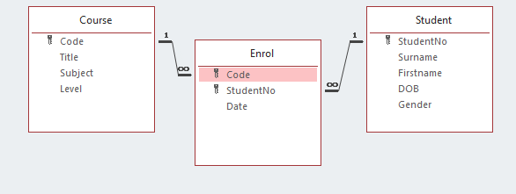

The relationship between Student and Enrol just needed the Primary Key’s adjusted from being a Number in the student table and a Long text In the Enrol Table what I had to do was to change them to being both Numbers.

I feel like a design flaw would be not using: input masks, required, data validation (rule) & Cascade Update or Delete. What these would do is help to stop data inconsistency caused by poor data entry.

In my opinion to improve this database I would use Cascade Update to make sure there cannot be orphaned records where the ID’s get copied over properly not just being manually copied over. I would also put in some forms as they make data entry so much easier than a table.

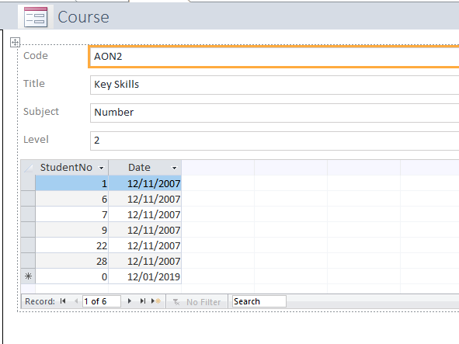

Also using dropdowns for the fields with set answers like Gender could have M, F, Other & Prefer not to say instead of just leaving gaps where it is not appropriate. Otherwise the data is incomplete and could lead to problems creating or enforcing relationships & surveys. For example you were doing a survey and needed to know the ratio between girls and boys doing a course. And you use a survey or query with gaps in this table it makes the data less valuable.

