**Java Academy 2016 - How to commit academy exercises solutions**

1. - Read and follow instructions to install GIT here <https://git-scm.com/book/en/v2/Getting-Started-Installing-Git>. If you would like to know a little bit of GIT background you can start here <https://git-scm.com/book/en/v2/Getting-Started-About-Version-Control>. If already have GIT installed skip this step.

2. - Create a GitHub account at <https://github.com/> and log in.

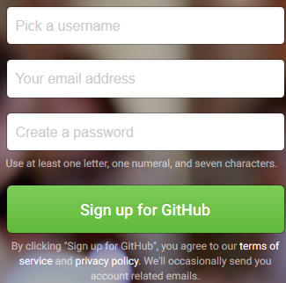

3. - Go to <https://github.com/mdc-java/java-academy-2016> and click on fork button.



This will create a repository copy in your profile. Year in name is being summed up automatically so please ignore it.



4. - Click on “Clone or download” and copy HTTPS url to clone repository locally. If you already know how to configure SSH keys select “Use SSH” and copy SSH URL.

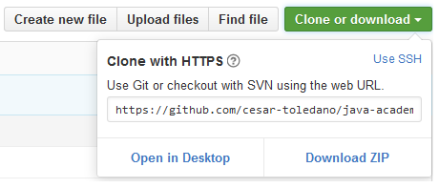

5. - Open a GIT bash prompt. This can be accomplished with a right mouse click on any directory.

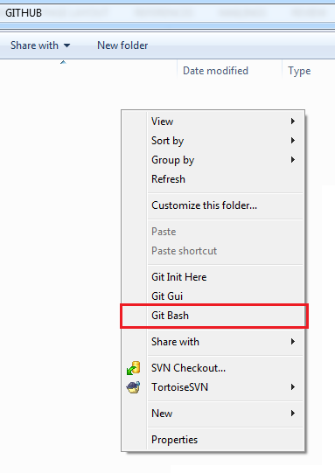

6. – Clone repository by using “git clone” command and copied URL



You’ll get this directory structure

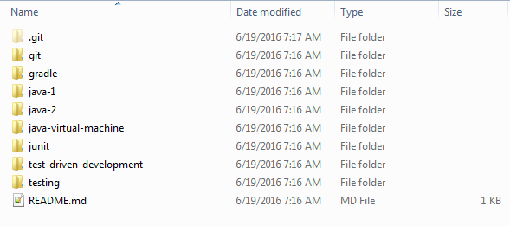

7. – Create a directory with your name and add your exercises solutions there.

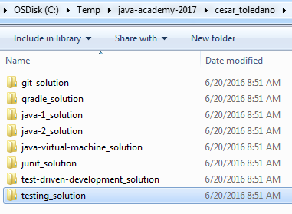

8. – Open a new GIT bash prompt and type the next commands (press enter after each)

* “git add --a” so files can be marked as added
* “git commit –m “my solutions”” to commit your changes
* “git push origin master” to push your changes into GitHub, this will require you to provide GitHub username and password

You should now see something like this in your cloned repository in GitHub

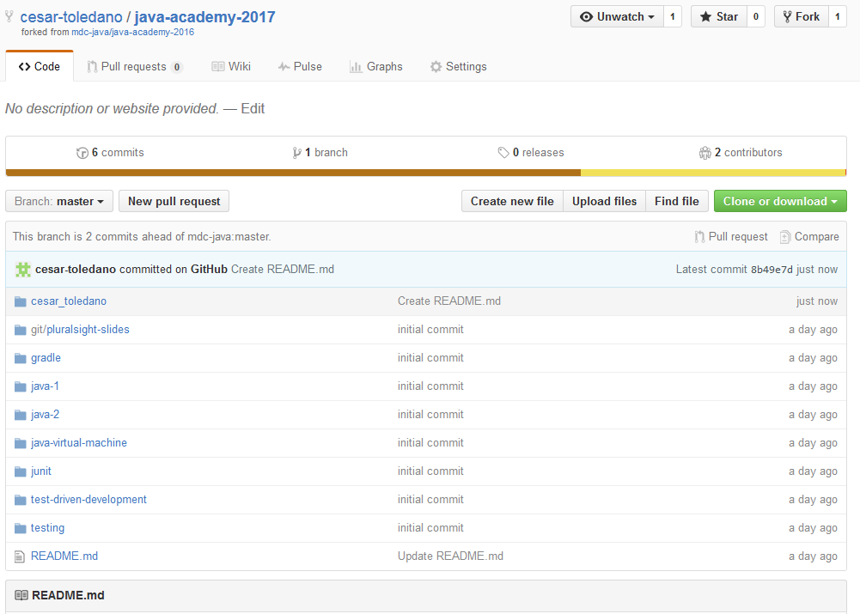

9. – Create a pull request to original repository by clicking on “New pull request” in GitHub. Wizard will require you to confirm and provide any comment you might have.

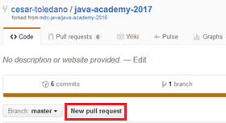

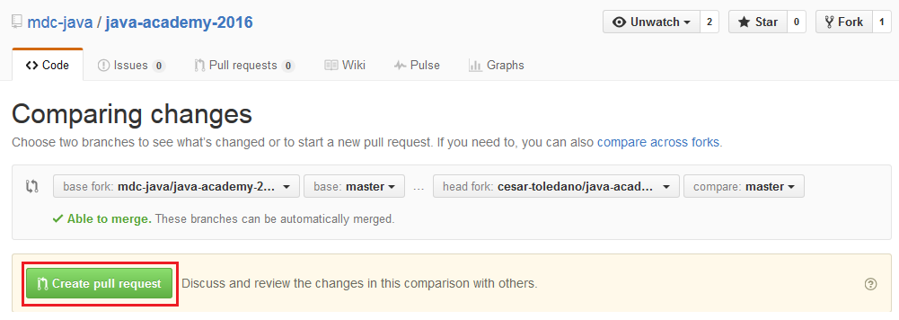

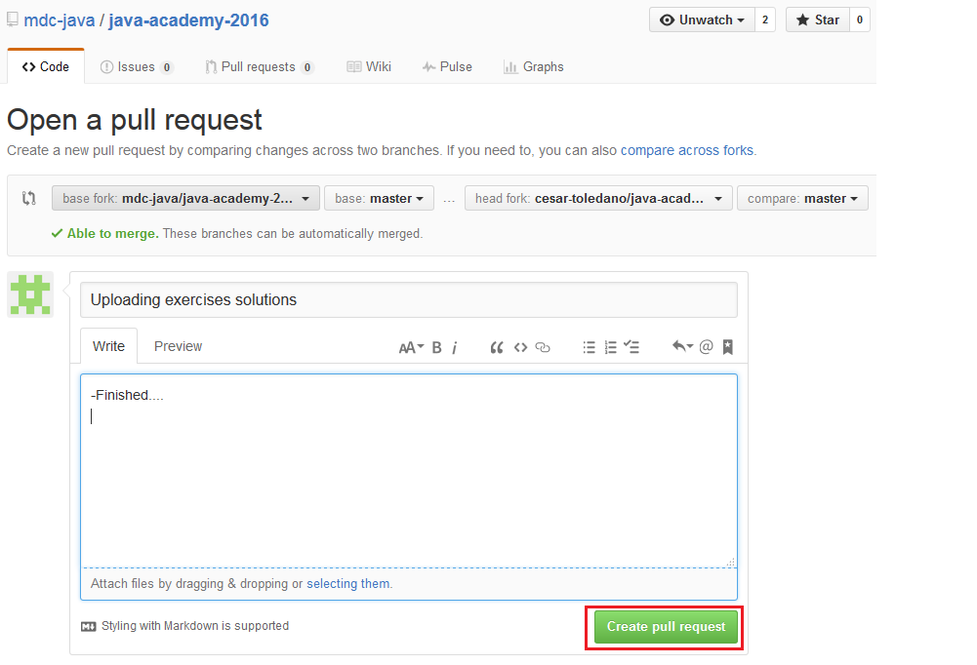

We should see a new pull request summed up in original repository

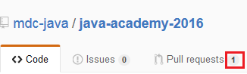

Faculty team will accept you pull request and review your exercises