Project Report for EE 262:

Image Processing and Reconstruction

HMM-BASED

PATTERN DETECTION

Morteza Shahram

Supervision: Prof. Peyman Milanfar

Winter 2002

HMM-BASED PATTERN DETECTION

ABSTRACT

Mathematical basis of Hidden Markov Modeling (HMM) are presented. For the proposed application that is 2-Dimensional pattern classification, a set of ergodic continuous observation HMMs were constructed, each of them corresponding to one pattern. To classify the patterns, particular combinations of 2-D DCT coefficients have been employed for feature vectors. Forward-backward algorithm and Vitterbi formulation are explained for evaluation of models. Initial parameters were estimated via a K-means clustering algorithm and then reestimated by EM (Expectation Modification) algorithm from a multi-observation training set. To see how well this modeling can help us to successfully detect the patterns, Learning Vector Quantization and Template Matching were implemented and compared. The results show that this approach does not seem hopeful for this application.

I. INTRODUCTION [1]

Signal modeling not only provide the basis for a helpful description of sources that produce the signals and therefore enable us to simulate the source, but also they often work well in practice. This possibility enable us significant practical system for signal analysis and processing. One broad category of signal models is the set of statistical models I which one tries to characterize only the statistical properties of signal. The necessary assumption here is that the model can be characterized as a parametric stochastic process and those parameters can be precisely estimated. Examples of such models include Markov chain and hidden Markov process that in viewpoint of information theory is interpreted as a Markov chain viewed through a memoryless noisy channel.
Markov models are very rich statistical models that are widely used in signal and image classification. Specially, The theory of hidden Markov models (HMM) was developed by Baum in 1970 and was started to implement for speech processing by Baker. Since they have been very successful in automatic recognition of speech, this model has earned increasingly popularity in the last several years.
There have been other fields of interest that HMM are utilized for computational biology, biomedical signal interpretation and also for image classification, segmentation and denoising. For example in papers [ , ], HMM structure was applied for image segmentation that used 2-Dimensioanl structure. This structure actually covers concept of second order Markovian process.
In this paper, it is tried to implement HMM for a particular application of 2-dimensional pattern detection. These patterns are acquired through a imaging system with circular aperture where image of a point is spread by a point spread function. Problem of interest here is the ability to detect three patterns generated by two points, one point as well as no point, respectively. Obviously, this problem should be considered with presence of the noise in all cases.
Organization of this report is as follows: in Part II, the theory of hidden Markov models will be provided and in the next section, proposed application will be introduced and then results will be presented. To compare the results with other basic classification, learning vector quantization and template matching approaches were simulated and the results are included.

II. HIDDEN MARKOV MODELS

- Markov Chains and Extension to Hidden Models [1,2,3]:

A stochastic process is an indexed sequence of random variables. In general, there can be an arbitrary dependence among the random variables. This process is characterized by the joint probability mass function. Now, consider a process that can be described at any time as being in one of a set of N distinct states as illustrated in figure 1 (N=3). At any index of time, system undergoes a change of state (possibly back to the same state) according to a set of probabilities.

S₁
S₂
S₃

a₃₁

Figure 1: A Markov chain with 3 states

A full probabilistic description of the above system requires specification of current state and all previous states. For the special case of first order Markov process this probabilistic description is truncated to just the current and previous state.
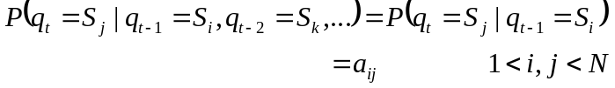
(1)

Where q_{t} is actual state at time t and a_{ij} is the transition probability between state i and j. State transition coefficients have the property
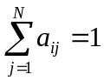
(2)

The above stochastic process could be called an observable Markov model since the output of process is the set of states at each instant of time, where each state corresponds to a physical event. This model is too restrictive to be applicable to many problems of interest. We can extend the concept of Markov models to include the case where observation is a probabilistic function of the states. Underlying a HMM is a basic Markov process that is not observable but can be observed through another set of stochastic sources that produce observation. In fact HMM is a conditionally independent process or in viewpoint of information theory is a Markov chain view through a memoryless noisy channel. States corresponds to clusters of information in “context” that have similar probability distributions of observation.

- Elements of Hidden Markov Models[1]

In order to characterize an HMM completely, following elements are needed.

  - The number of states of the model, N
  - The number of distinct obseravtion symbols per state, M
  - The state transition probability distribution A={a_{ij}}
(3)
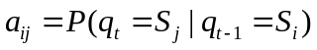

  - The observation symbol probability distribution ins state j;
(4)
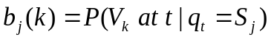

  - the initial state distribution
(5)
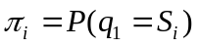

The model parametres notation: 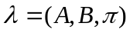
Actaullay these parameters are refered to the case when the observation were characterized as discrete symbols chosen from a finite alphabet and therefore dicstere probability density could be used. But in practice we mostly deal with contiuous observation signals like as speech, biological signals and image.hence we have to use HMM with continuous observation density. The most general representation of the PDF is a finite mixture of normal distributions with different means and variances for each state.

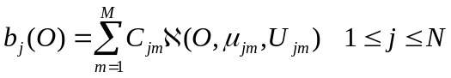
(6)

where C_{jm} is mixture coefficient for the m’th mixture in state j and ℵ is Guassian with mean μ_{jm} and covariance matrix U_{jm} for the m’th mixture component in state j. In following parts formulation for continuous observation will be presented, too.

- Three Fundamental Problems for HMM[1]

There are three problems of interest that must be solved for the model:

Problem 1:Evaluation
Given the observation sequence O=O₁ O₂ …O_{T} and a model λ, compute P(O| λ), the probability of the observation sequence, given the model. This problem is evaluation or scoring problem. If we consider the case in which we are trying to choose among several models, this solution give us the model which best matches the observation.

Problem 2: Optimization (Decoding)
Given the observation sequences and the model, find the optimal corresponding state sequence. This is the one that tries to uncover the hidden part of the model. There is no exact and unique solution for this problem, but in practice, an optimality criterion is considered to solve the problem. There are several optimality criteria that can be applied.

Problem 3: Training
Estimating model parameters. Some observations sequences used to adjust the model parameters.

Evaluation Problem[1]

The most straightforward way to find the probability of observation given the model, is enumerating every possible state sequence of number of observations T. The probability of the observation sequence for the sate sequence of Q=q₁ q₂ …q_{T} is
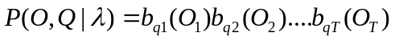
(6)

and the probability of such a state sequence can be written
(7)
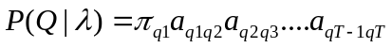

So, the probability of observation given the model will be
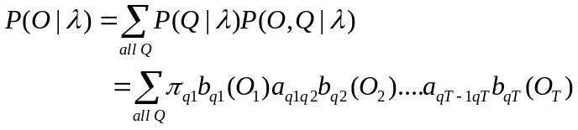
(8)

direct calculation of this equation will involve on he order of 2TN^{T} calculations that is absolutely impossible for practical applications. Fortunately an efficient procedure exists and is called forward-backward procedure.

Forward-Backward Algorithm[1]

Consider forward variable α_{t}(i) defined as
(9)
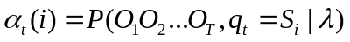

Here is the procedure to compute this variable inductively:
- Initialization
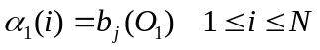
(10)
- Induction
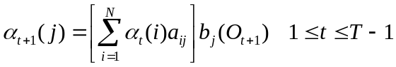
(11)
- Termination
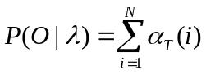
(12)

We see that it requires on the order of N²T calculations.
In similar manner, we can define backward variable as follows:

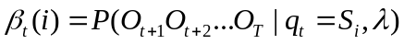
(13)

Again, we can solve for this variable inductively,
- Initialization
(14)
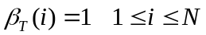
- Induction
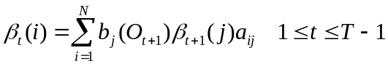
(15)

Backward procedure will be used in the solution to problem 3and it is not required for the solution of problem 1.

Optimization (Decoding) problem [1]

There are several possible was of solving problem 2, the optimal state sequence associated with given observation. For example one optimality criterion is to choose the states which are individually most likely. To implement this, define a new variable:

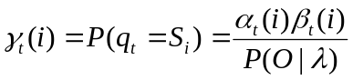
(16)

using this variable, we can solve for individually most likely state at time t:
(17)
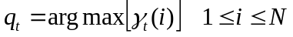

but this solution is not perfect solution in case of there be some null transition between the states and this solution determines the most likely state without regard to the probability of occurrence of sequences of states.
So, we need to modify the optimality criterion. Following algorithm find the single best state sequence for the given observation sequence and the model.

Viterrbi Algorithm[1]

The best score along the a single path at time t, which accounts for the first t observations and ends in state S_{i} can be expressed as follows:
(18)

The complete procedure for finding the best state sequences follows: (ψ is the variable that track the of the argument which maximized)

Initialization:
(19)
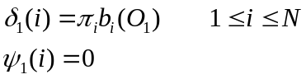

Recursion
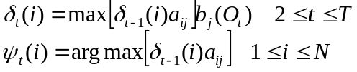
(20,21)

Termination
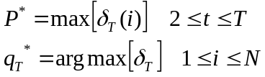
(22,23)

Path backtracking
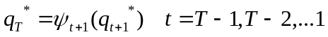
(24)

Training problem[1]

There is no known analytical approach to solve the model parameters that maximizes probability of observation given that model. Here one of the most famous algorithms named the expectation-modification algorithm is described.
For this algorithm, again, a new variable is defined:
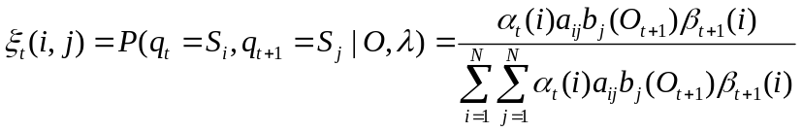
(25)

The reestimation procedure here is as follows:
(26)
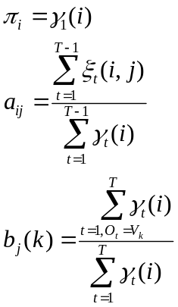
(27)
(28)

This procedure will be repeated until convergence of model parameters. This formulation is for single discrete observation sequence. As it was explained before we have continuous observation in most of the real-world applications. In addition to this matter, for appropriate training of the model, we need to feed multi-observation sequences to the reestimation procedure. The modification for the reestimation procedure is straightforward: suppose we have the set of K observation of sequences. Therefore we need to maximize the product of each probability of individual observation given the model instead of the one we saw before.

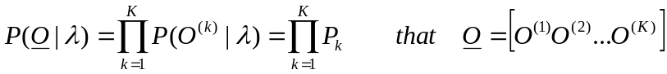
(29)

All of the parameters used for intermediate computation including forward variable and backward variables will be computed individually for each observation; 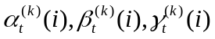.
The final reestimation formulation for ergodic, continuous observation HMM with multi-observation training can be shown this way. The term “ergodic” here refers to this fact that every state the model could be reached in a single step from every other state (fully connected HMM).
This formulation is supposed for mixture of Gaussian distribution as PDF of observations.

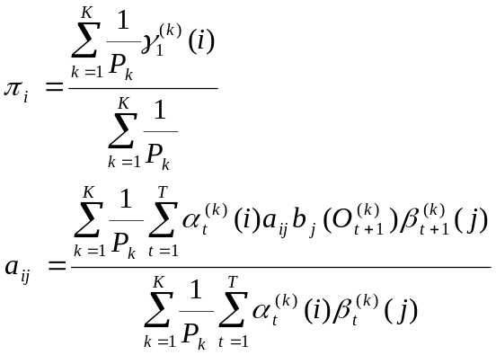
(29)
(30)
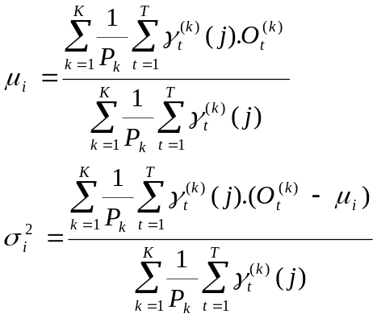
(31)
(32)

In this process Forward and backward variables consist of a large number of terms of a and b that are generally significantly less than 1. it can be seen as t get big, each term will exceed precision range of any machine even in double precision. Hence the only reasonable way of those computations is incorporating a scaling procedure. A detailed description of scaling can be found in [].

III. APPLICATION

In this paper, it is tried to implement HMM for a particular application of 2-dimensional pattern detection. These patterns are acquired through an imaging system with circular aperture where image of a point is spread by a point-spread function. Problem of interest here is the ability to detect three patterns generated by two points, one point as well as no point, respectively. Obviously, this problem should be considered with presence of the noise in all cases. Suppose the point spread function has the form of first order Bessel function divided by radius. This is kind of 2-D version of sinc function in 1-D case[4].

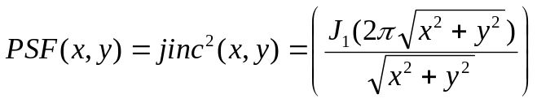
(33)

So, measured patterns are in the forms of:

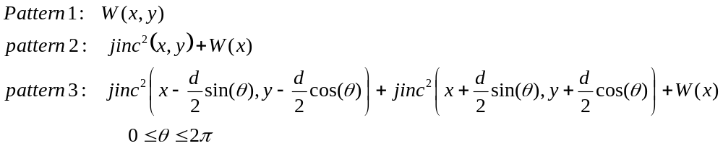
(34)
where W(x) is supposed to be white Guassian noise. In figure 2, some sample of these images are shown. The first and second line of figures are the images with SNR=-10 and 5, respectively. The left, center, and right images are samples of pattern 3, 2 and 1. (d=2)

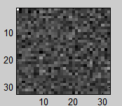
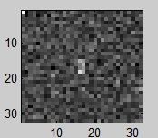
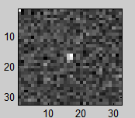
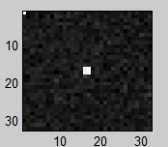
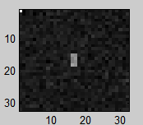
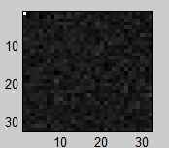

Figure 2: samples of patterns measured from
two objects, one object and noise (from left to right)

Feature vector
The images that used for application are 16*a6 pixels and DCT coefficient or averages of absolute value over some of them used as feature as figure (3). This way we have a feature vector with 13 elements for 16*16 image.

Average of absolute values of the coefficients

Figure 3: Feature vector built from DCT coefficients

Initial Estimation of HMM parameters

Basically there is no straightforward answer to above question. Choosing either random or uniform variable for transition matrix may reach the process to convergence in global minima. But for parameters of observation distribution are really necessary. Random quantities in this case will hardly converge. For this purpose, K-means clustering algorithm was used to extract clusters of information from the observation. Detailed description of this algorithm can be found in related textbooks [5]. Results show that this algorithm gives really reasonable estimation of parameters.

IV. RESULTS

To see how well this modeling can help us to successfully detect the patterns, Learning Vector Quantization and Template Matching were implemented and compared. Reader can refer to major textbooks to find more about learning vector quantization [6]. Basic idea in vector quantization is constructing some reference vector for each class (pattern, here DCT coefficients). There is a learning stage for tuning values of this references. In addition of computing these vectors (centroids), variance of each entry of them are estimated, too. This estimation allows us to utilize following distance measure that gives us more precise answer in sense of some statistical criterions. The distance measure between observation O and k’th centroid C_{k} with variance of 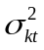 for every elements of it will be:

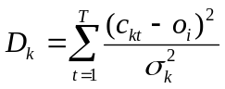
(35)

Training set of both HMM and LVQ were same And there have been created 5 representative (centroid) for each pattern for LVQ stage.
The results is shown in figures (4). In right side of figure 4, we see the detection error rate vs. SNR for three different values of “d”. The results for d=1 and d=2 are very close to each other that it could be predicted.
In left side, results for mentioned methods are depicted and states unsuccessful behavior of HMM for this specific problem. LVQ has worked much better than HMM.
It will be fine to investigate the reason of high error rate of detection for hidden Markov modeling. Possible reasons can be mentioned as insufficient training, convergence to local minima, inappropriate feature vector used in this problem or even intrinsic limitation of HMM for this problem.

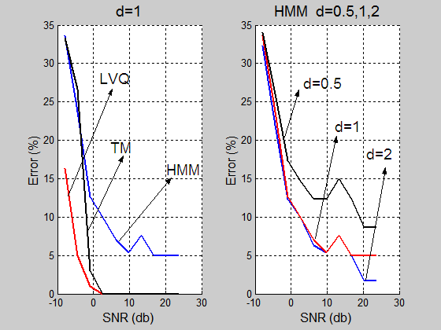

figure 4: detection error for HMM, LVQ and template matching (right)
HMM result for three different values of d

REFERENCES

[1] L.R. Rabiner “ A Tutorial on Hidden Markov Models and Selected applications in speech recognition” Proceeding of the IEEE, Vol. 77, No 2, Feb 1989

[2] Thomas Cover and joe Thomas “Elements of Information Theory” ?

[3] J. Li, A. Najmi and R. Gray “Image Classification by a Two-Dimensional Hidden Markov Model” IEEE Transaction on Image Processing Vol 48, No 2, Feb 2000

[4] Goodman “Fourier Optics?” ? McGarw Hill

[5] Gonzales and Witz “Pattern Recognition” Prentice Hall International ?

[6] Gray and Gersho “Signal Compression and Vector Quantization”, Kluwer Academic Publication ?

