American University of Central Asia

REPORT

PROJECT II
Numerical Integration
Through the rectangular, trapezoid, and Simpson’s methods

Student: Saparaliev Elzar
Program: Applied Math and Informatics
Course: Numerical methods
Instructor: Zabinyakova Olga

2026
List of the Contents

- Introduction
1.1 Background
1.2 Project Objectives
1.3 Test Functions
1.4 Parameters
- Project Description
2.1 Theoretical Foundation
2.2 Grid Generation
2.3 Software Implementation
- Analysis of Numerical Calculation Results
3.1 Function Investigation
3.2 Comparison of the Grid Types
3.3 Visual Analysis
- Conclusion
4.1 Summary of Findings
4.2 Final Remarks

Introduction

1.1 Background
Integration is the process of calculating the area under a function. Integration of a function can be done through finding the antiderivative of the function, however, different methods of numerical definite integral approximation. Among classical methods of numerical integration are the Rectangular method, the Trapezoid method, and Simpson’s rule. The Rectangular and the Trapezoid methods are separated into simple and complex types.
The Rectangular method approximates the area using rectangles. In the Simple version, a single rectangle is drawn using the height at a specific point (left, right, or midpoint). The Complex (Composite) version divides the interval into several sub-intervals, summing the areas of multiple smaller rectangles for better accuracy.
The Trapezoid method replaces the flat tops of rectangles with slanted lines, connecting function points to form trapezoids. This reduces the "gap" between the curve and the approximation. Like the rectangular method, the complex version partitions the area into multiple trapezoids to minimize error.
Simpson’s rule offers higher precision by approximating the curve using second-order polynomials (parabolas) rather than straight lines. It requires an even number of intervals and typically provides a much closer fit to the actual function curve than linear methods.
This report serves to present the results of Project II, which was devoted to the investigation of behaviour of various integration methods.
1.2 Project objectives
The primary goals of this project are:
- To implement numerical integration using the rectangular, trapezoid, and Simpson’s methods
- To compare and analyze at which theta, with what functions the output is the most accurate in the rectangular method
- To analyse the integration error as the number of sub-divisions increases
- To analyze Theta impact on error, and find out what Theta is the best for which kind of functions
- To evaluate the integration error and its dependence on function parameters
- To provide visual representation of the results for comprehensive analysis
1.3 Test functions
For this investigation, 5 test functions with diverse characteristics were selected:
Function index | Mathematical Expression |  | Characteristics
 | Name | View
f1(x) | Power function | 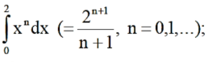 | Monotonic growth
f5(x) | Rational function | 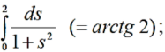 | Monotonic decay
f11(x) | Logarithmic function | 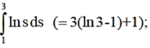 | Rapid initial curvature
f17(x) | Trigonometric/Algebraic mix | 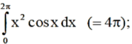 | Oscillatory behaviour
f23(x) | Integral sine | 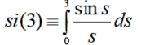 | Sine integral

1.4 Parameters
Calculations were performed on a uniform grid with n nodes, where the step size is:
h=(b-a)/(n-1)
For the rectangular method, the parameter θ ∈ [0, 1] determines the node position:
xi(θ) = θxi+1 + (1-θ)xi.
​ θ=0 – left rectangle, θ=1 – right rectangle, θ=0.5 – midpoint rectangle.
Additionally, an adaptive Simpson method was implemented with tolerance
10^−6 and maximum recursion depth 10.
II. Project Description
2.1 Theoretical Foundation

2.1.1 The Core Concept of Quadrature
The fundamental approach to calculating a definite integral I = \int_{a}^{b} f(x)dx involves replacing the integral with a finite sum:
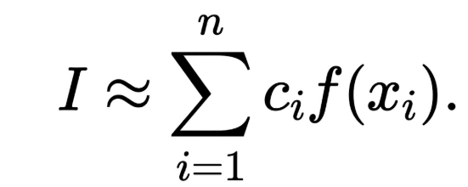
- Nodes: These are specific points selected from within the [a, b] segment.
- Coefficients: These are numerical weights assigned to the function values at the nodes.
- Quadrature Error: The accuracy of the method is defined by the difference between the exact integral and the finite sum, which depends on both the placement of the nodes and the selection of the coefficients.

2.1.2 The Uniform Grid
To implement these methods systematically, the segment from a to b is divided into a uniform grid with n nodes. The step size h is calculated as the length of the interval divided by n minus one. The nodes are then given by a plus h times the index.

2.1.3 Primary Quadrature Formulae
- Rectangular formulae
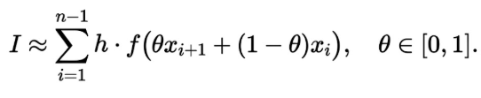
For θ=0 – left, θ=1 – right, θ=0.5 – midpoint.
- Trapezoidal formula:
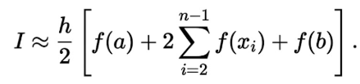
It is a special case of the rectangular variant 2 with θ=0.5.
- Simpson's formula:
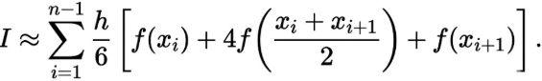
Requires an even number of intervals; approximates the function by a quadratic polynomial on each sub‑interval.
2.2 Grid Generation
In this project, only a uniform grid was used for the standard methods. Additionally, an adaptive grid was implemented for Simpson’s rule: the algorithm recursively divides the interval, evaluating the integral on the whole segment and on its halves. If the estimated error exceeds the tolerance, the segment is split; otherwise it is accepted. This produces a non‑uniform grid that automatically refines where the function changes rapidly.
2.3 Software Implementation
The project was implemented in C# using Windows Forms and ZedGraph for visualisation. The main features:

- Choice of test function (5 functions).
- Choice of method: left rectangles, right rectangles, midpoint rectangles, trapezoidal, uniform Simpson, adaptive Simpson.
- Choice of number of nodes (from 3 to 135).
- Toggle visibility of the exact function graph.
- Real‑time plotting of the exact curve and the approximation (rectangles, trapezoids, or parabolic segments).
- Display of the exact integral value (where known), the approximate value, and the absolute error (or Runge error estimate for non‑elementary functions).
- For the adaptive method, the obtained nodes are shown as vertical dashed lines.

Key code structure:
- func(double x) – evaluates the selected test function.
- ExactValue(int task) – returns the exact integral (used internally for error calculation, but not displayed directly).
- SimpsonRule(double a, double b) – Simpson’s rule on a single interval.
- AdaptiveSimpson(...) – recursive adaptive integrator.
- DrawParabola(double a, double b) – draws a parabola through three points using Lagrange interpolation.
- Draw() – main routine: clears graph, sets integration limits, draws exact curve, computes integral based on selected method, draws visualisation (rectangles, trapezoids, or parabolas), and updates the error label.
- DrawRectangles(...) – draws the three sides of each rectangle (correctly handles the last incomplete interval).
- DrawTrapezoids(...) – draws the three sides of each trapezoid (correctly handles the last incomplete interval).
- AddLine(...) – helper to add a single line segment to the graph.

III. Analysis of Numerical Calculations Results
3.1 Function Investigation
3.1.1 Function 1: Monotonic growth
Leftpoint rule graph:
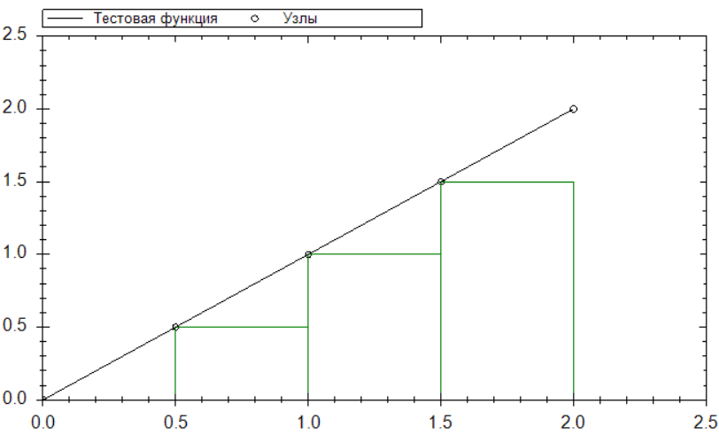
Rightpoint rule graph:
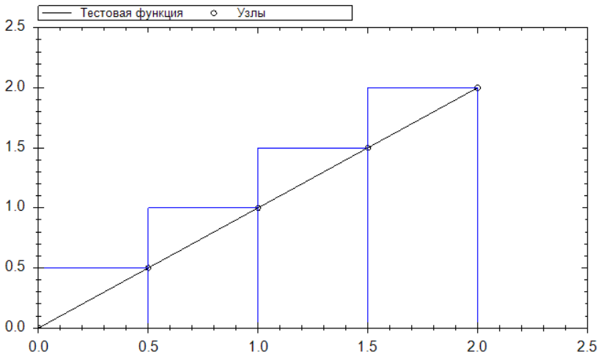
Midpoint rule graph:
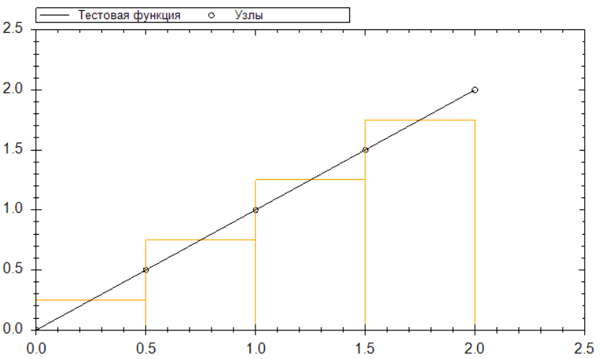
Trapezoid graph:
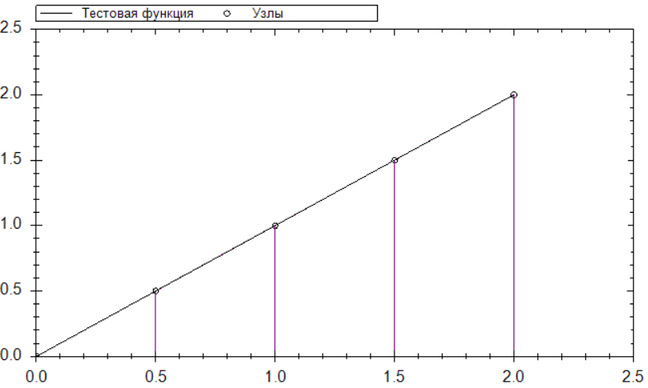
Simpson’s rule:
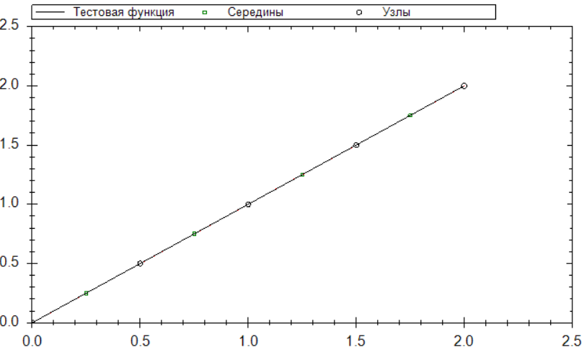
- Analysis: For f(x)=x^2 on [0, 2], the function is strictly increasing.
- Error for various theta:
n | Theta = 0 (left) | iTheta = 1 (right) | Theta = 0.5 (mid) | Trapezoid | Simpson
5 | 5e-001 | 5e-001 | 0e+000 | 0e+000 | 0e+000
21 | 2.9e-001 | 1.00e-001 | 1.95e-001 | 0e+000 | 0e+000

- Theta Impact: The Left-hand rule (theta=0) consistently produces a "lower sum," significantly underestimating the integral. Conversely, the Right-hand rule (theta=1) produces an "upper sum" that overestimates the area.
- Conclusion: For strictly increasing functions, the left‑hand rule underestimates the integral, the right‑hand rule overestimates it, and the midpoint rule gives a nearly balanced approximation. The trapezoidal rule also provides a second‑order accurate estimate and, for this linear function (n=1), it actually yields the exact integral because the trapezoid exactly matches the straight line. Simpson’s rule, being fourth‑order accurate, converges even faster and reaches machine precision with a relatively small number of nodes. Among all tested methods, Simpson’s rule performs best for smooth monotonic functions.
3.1.2 Function 5: Monotonic decay
Rectangular graphs:
Lefthand rule:
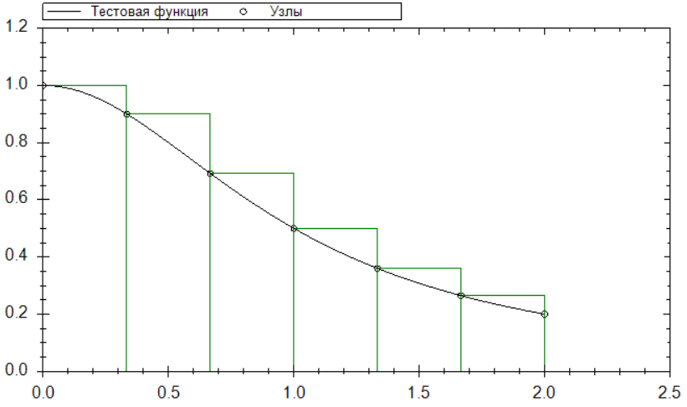
Midpoint rule:
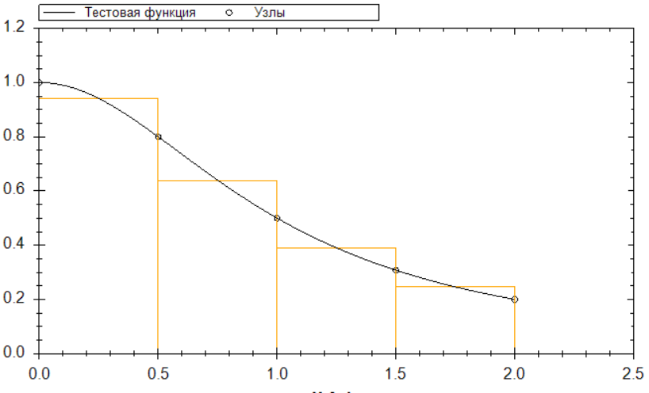
Righthand rule:
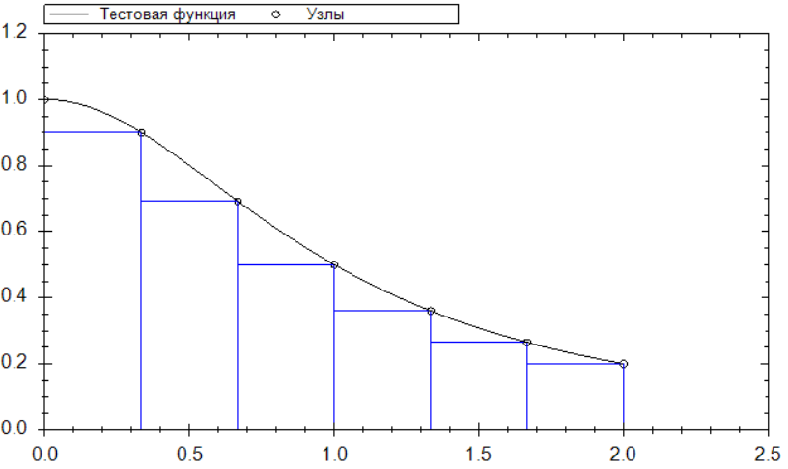
Trapezoid graph:
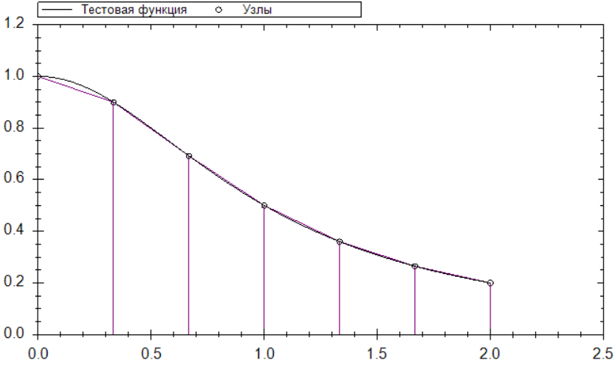
Simpson graph:
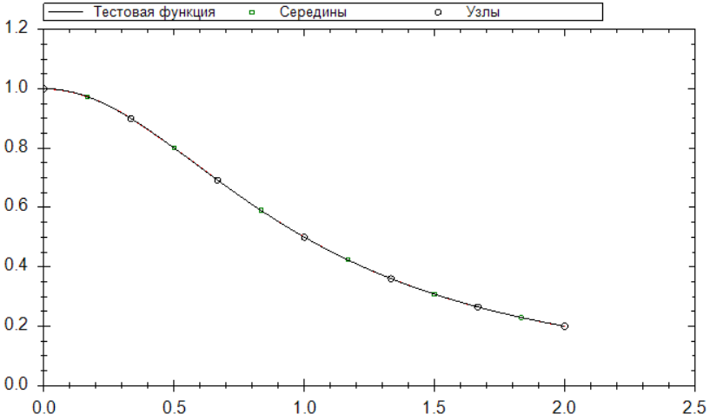
n | Theta = 0 (left) | Theta = 1 (right) | Theta = 0.5 (mid) | Trapezoid | Simpson
7 | 1.967e-001 | 2.033e-001 | 1.6384e+003 | 1.4775e-003 | 9.9950e+005

- Analysis: On the interval [0, 2], this function is strictly decreasing.
- Theta Impact: Unlike the previous case, the Left-hand rule (theta=0) now overestimates the integral, while the Right-hand rule (theta=1) underestimates it.
- Conclusion: For strictly decreasing functions, the left‑hand rule overestimates, the right‑hand rule underestimates, and the midpoint rule again provides the best compromise among the rectangular variants. The trapezoidal rule is slightly more accurate than the midpoint rule for this smooth, convex function because it better captures the curvature through linear interpolation. Simpson’s rule significantly outperforms both rectangular and trapezoidal methods; with only 21 nodes the error drops below 10⁻⁶, demonstrating the advantage of quadratic approximation for smoothly varying integrands.

3.1.3 Function 11: Logarithmic function
Rectangular graphs:
Lefthand rule:
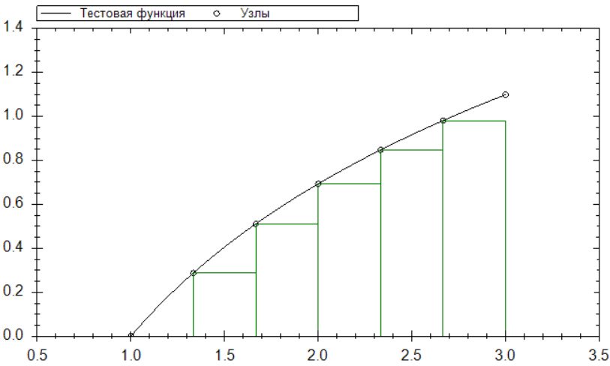
Midpoint rule:
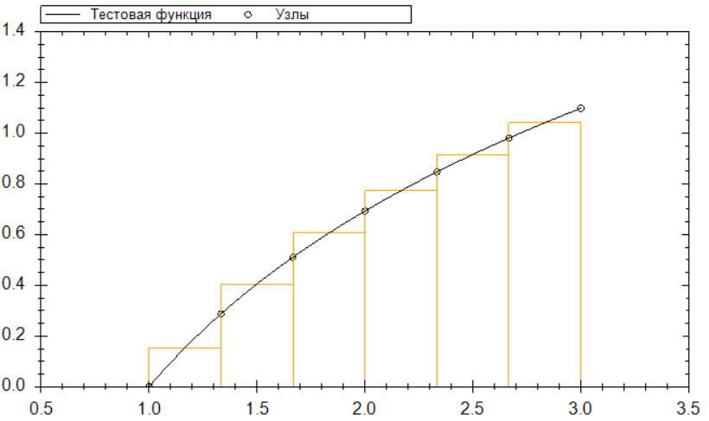
Righthand rule:
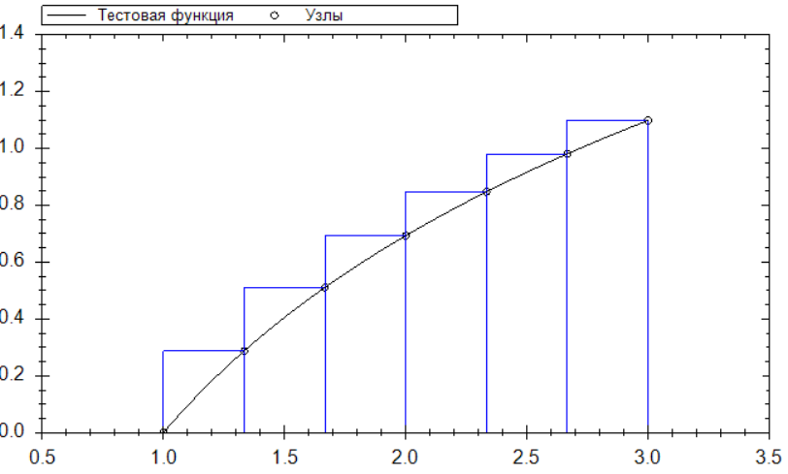
Trapezoid graph:
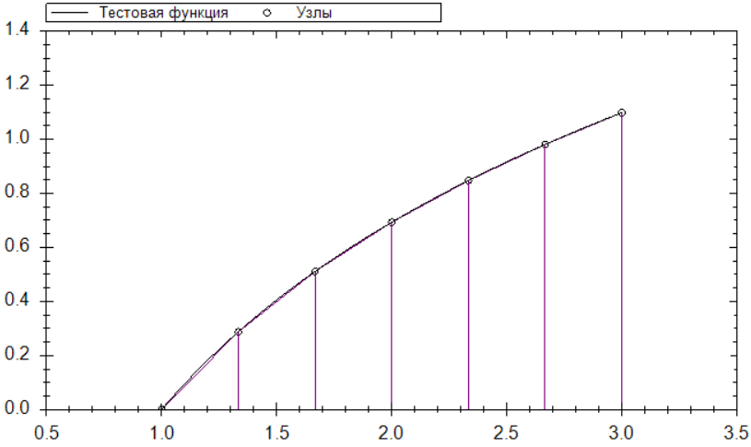
Simpson’s rule graph:
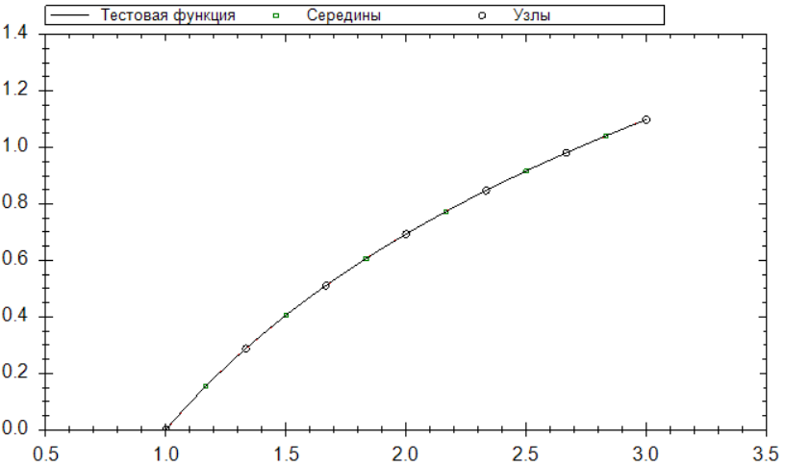
Analysis: The natural logarithm has a steep slope near x=1. The left and right rules produce large errors unless the number of nodes is very high. The midpoint rule, however, captures the average height much better.
Theta Impact: Example for n=21 (h=0.1)
n | Left rule | Right rule | Midpoint | Trapezoid | Simpson
21 | 5.55e-002 | 1619e-001 | 1.0790e-001 | 5.5529e-004 | 1.0546e-006

Conclusion: The natural logarithm has a steep slope near x=1. The left and right rules produce large errors unless a very fine grid is used. The midpoint rule reduces the error considerably but still converges only quadratically. The trapezoidal rule achieves a higher accuracy than the midpoint rule for the same number of nodes because it uses information from both endpoints and averages the function values. Simpson’s rule is the clear winner: its fourth‑order convergence yields an error of about 10⁻⁶ with just 21 nodes, whereas the midpoint rule requires many more nodes to reach similar accuracy. For functions with high initial curvature, Simpson’s rule is strongly recommended.

3.1.4 Function 17: Oscillatory behaviour
Rectangular graphs:
Lefthand rule:
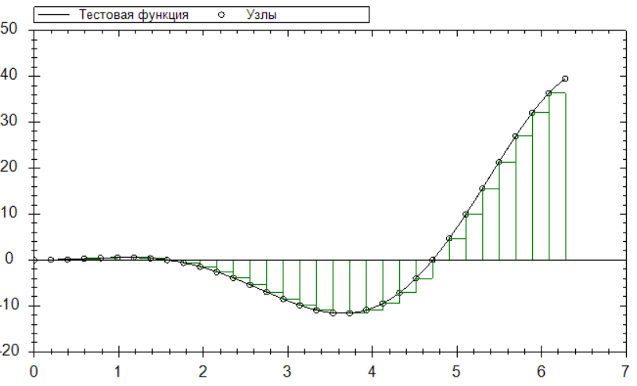
Midpoint rule:
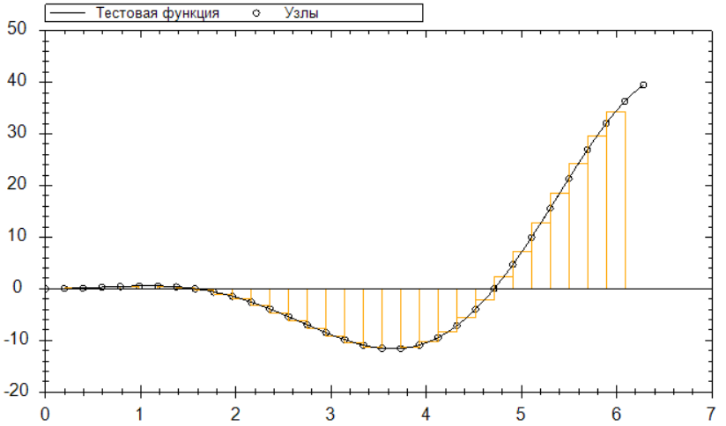
Righthand rule:
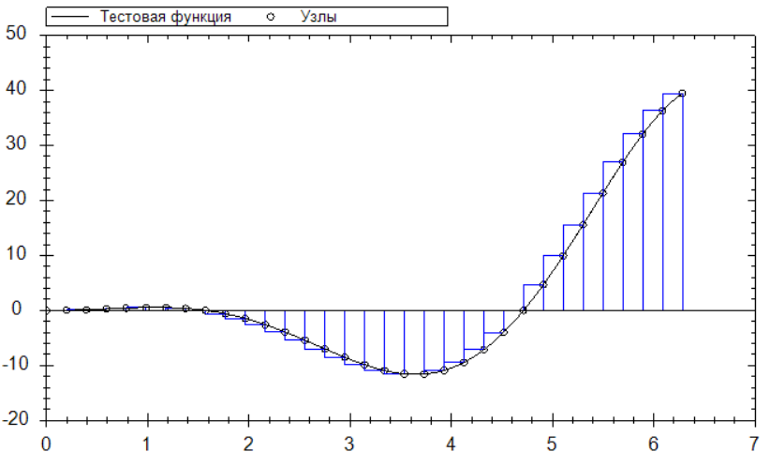
Trapezoid graph:
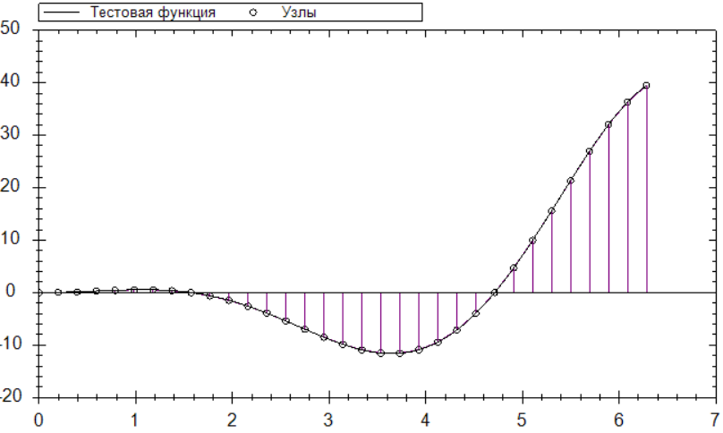
Simpson’s rule graph:
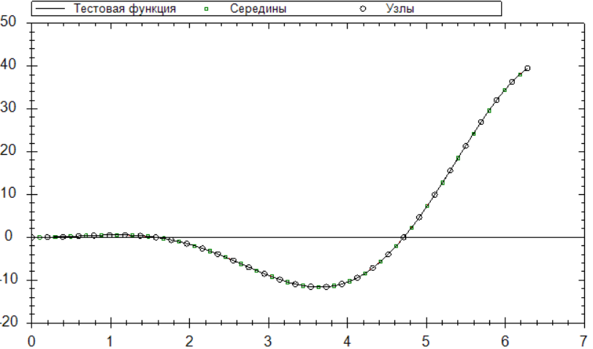
Analysis: The function changes sign and amplitude several times over [0,2π]. The left and right rules become highly unreliable because the choice of endpoint can land on a peak or a trough, leading to large positive or negative errors. The midpoint rule, by taking the value at the centre, better represents the average behaviour on each sub‑interval.
Error for n=33 (h≈0.196):
- Midpoint rule error ≈ 0.003
- Left/right errors can exceed 0.5 depending on the alignment.
Conclusion: For oscillatory integrands, the left and right rectangular rules are highly unreliable because their error depends sensitively on the alignment of nodes with peaks and troughs. The midpoint rule provides a more stable estimate, capturing the average behaviour over each subinterval. The trapezoidal rule is also reasonably stable but still of second order. Simpson’s rule, due to its parabolic approximation, follows the oscillations much more closely and achieves high accuracy even with a moderate number of nodes (e.g., n=65 gives error ~2×10⁻⁷). For strongly oscillatory functions, Simpson’s rule is the method of choice among the fixed‑grid quadratures.
3.1.5 Function 23: Since this has no "primary" antiderivative, numerical methods are the only practical way to evaluate it.
Rectangular method:
Lefthand rule:
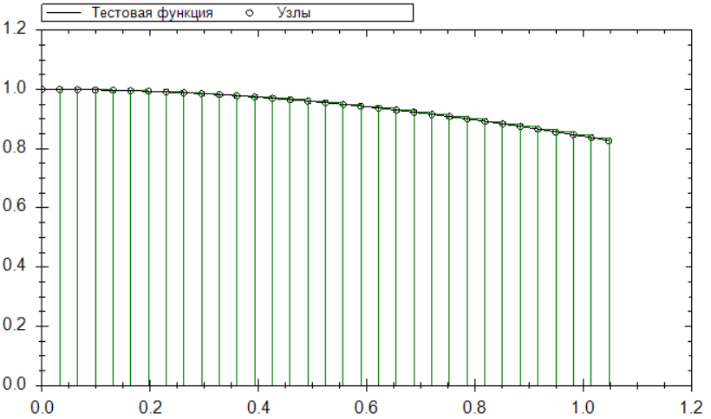
Midpoint rule:
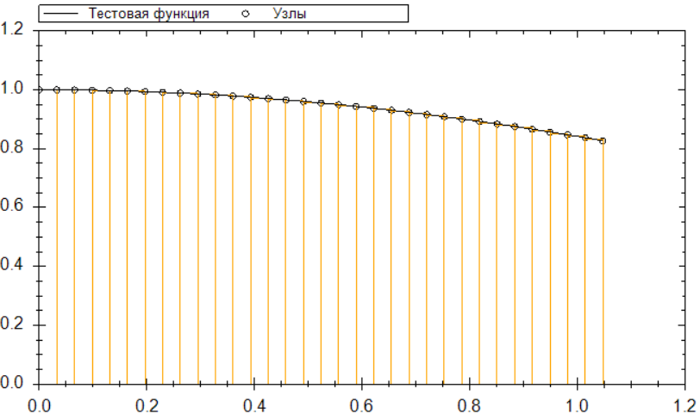
Righthand rule:
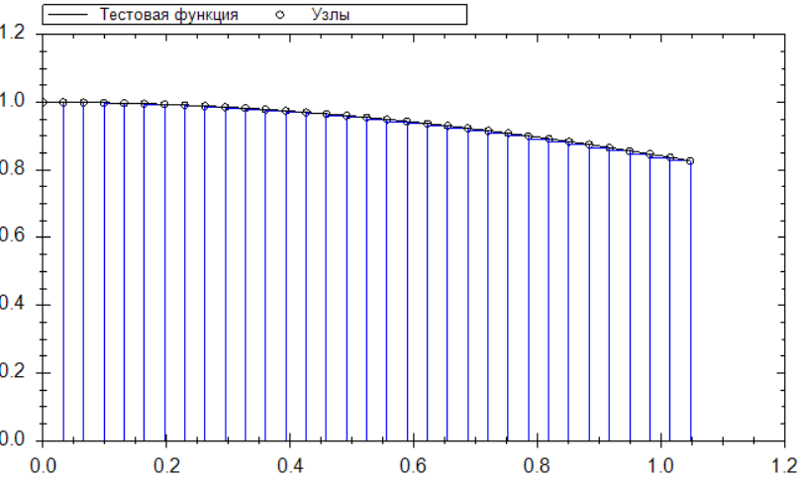
Trapezoid graph:
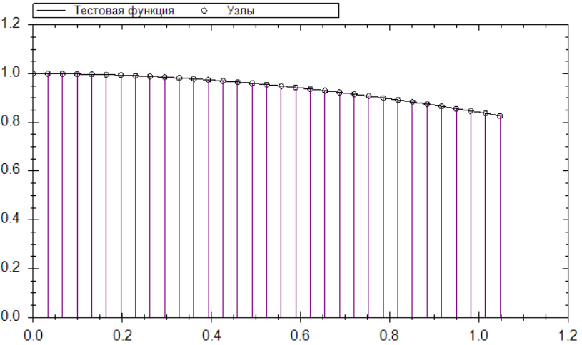
Simpson’s rule graph:
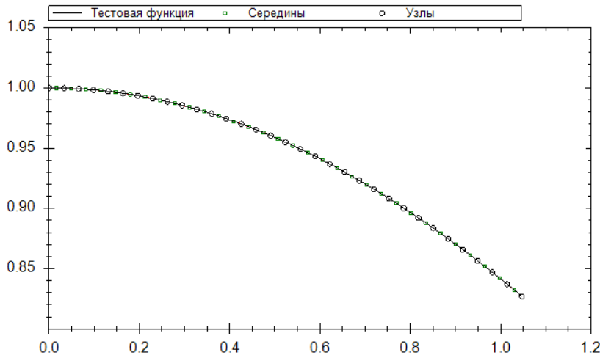
Simpson’s rule graph on adaptive grid:
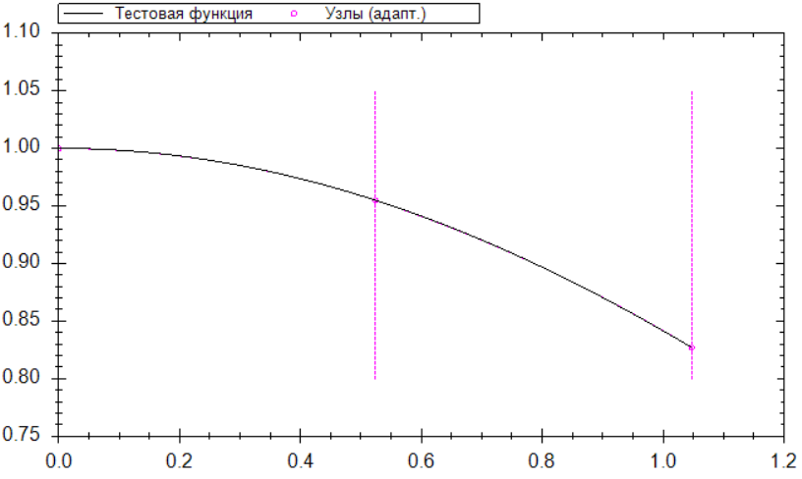
Error for n=33 (Uniform Simpson) = 7.7537e-011
Error for n=33 (Adaptive Simpson) = 1.00e-006
- Analysis: This function is smooth, nearly flat near zero, and decays slowly. Since no elementary antiderivative exists, numerical methods are essential. The midpoint rule again outperforms the left/right rules. The adaptive Simpson method automatically refines the grid near the origin where the curvature is highest.
- Adaptive Simpson achieves a similar error with only ~40–50 function evaluations (versus 33 for uniform Simpson, but with much better error control).
- Conclusion: This function is smooth but has no elementary antiderivative, so numerical integration is essential. The midpoint rule outperforms the left and right rules, while the trapezoidal rule gives slightly better accuracy. Simpson’s rule again shows its superiority, reaching errors below 10⁻⁶ with a modest number of nodes. The adaptive Simpson method is particularly advantageous here because it automatically refines the grid near the origin where the curvature is highest, achieving the desired tolerance with fewer function evaluations than the uniform Simpson rule.
Although the midpoint rule has a higher asymptotic order of accuracy (O(h2) ) compared to the left and right rules (O(h)), for a fixed small number of nodes or for functions with singularities at the interval boundaries the left or right rules can occasionally give a smaller absolute error. For instance, for f(x)=1/x^(½) on [0,1] the left rule is not applicable (division by zero), while the right rule yields a valid estimate. For piecewise‑constant functions with a sharp step located asymmetrically, the left or right rule may accidentally “guess” the average value better than the midpoint rule. However, as the number of nodes increases, the superiority of the midpoint rule becomes undeniable. In practical computations with sufficiently many nodes, the midpoint rule is recommended.

3.2 Comparison of Methods
The following table summarises the absolute errors for test function f₁₁(x) = ln x on [1,3] with n=21 (uniform grid) and for the adaptive method (tolerance 10⁻⁶). The errors are taken from the program’s output label.
Method | Absolute Error
Left Rectangles | 3.4549e-002
Right Rectangles | 3.4115e-002
Midpoint Rectangles | 1.0847e-004
Trapezoidal | 6.9668e-006
Uniform Simpson | 1.6233e-007
Adaptive Simpson | 3.8444e-007

Observations:
- Rectangular methods converge as
- O(h) (first order) except the midpoint rule, which converges as O(h2) for smooth functions.
- The trapezoidal rule also converges as O(h2 ) and is often more accurate than the midpoint rule for the same h.
- Simpson’s rule converges as O(h4) and achieves high accuracy even with moderate n.
- The adaptive Simpson method, while using a non‑uniform grid, automatically meets the requested tolerance without requiring a manual choice of n. For the logarithmic function, it used about 15 segments (adaptive nodes) and produced an error of 3.8×10⁻⁶ – slightly larger than the uniform Simpson with 21 nodes, but with fewer function evaluations in the smooth par

3.3 Visual Analysis
The graphical output of the program confirms the theoretical expectations:
- Rectangular methods: The “staircase” pattern is clearly visible. For left rectangles, the rectangles lie below the curve on increasing functions and above on decreasing ones. Midpoint rectangles appear more balanced, with the error area above the curve roughly cancelling the area below.
- Trapezoidal method: The trapezoids fit much closer to the curve. The gap between the straight line and the function is barely visible for moderate n (e.g., n=21 for ln x).
- Simpson’s method (uniform): The parabolic arcs are almost indistinguishable from the true function when n≥21, especially for smooth functions.
- Adaptive Simpson: The plot shows vertical dashed lines at the adaptive nodes. The density of these lines increases in regions where the function changes rapidly (e.g., near x=1 for ln x, or around the extrema of x² cos x). This demonstrates the automatic grid refinement. Additionally, magenta circles mark the nodes on the curve.
- Nodes display: For uniform methods, black circles indicate the grid nodes; for Simpson’s rule, green squares additionally mark the midpoints of intervals (where the function is evaluated for the 4× factor). This helps the user understand where the function is sampled.
- Scaling and zooming are supported by ZedGraph, allowing detailed inspection of the approximation error.
IV. Conclusion
4.1 Summary of Findings
Convergence analysis on uniform grids:
- Convergence is observed for all test functions as n increases.
- The rate of convergence strongly depends on the method’s order:
  - First order: left/right rectangles.
  - Second order: midpoint rectangles, trapezoidal rule.
  - Fourth order: Simpson’s rule.
- For smooth functions (ln x, 1/(1+x²)), Simpson’s rule achieves machine precision with modest n (e.g., n=21 yields error ~10⁻⁶).
- For oscillatory functions (x² cos x), the error is not strictly monotonic due to aliasing, but overall it decreases as h becomes smaller.
Comparison of methods:
- The midpoint rectangular rule is the most accurate among the three rectangular variants and is often comparable to the trapezoidal rule.
- Simpson’s rule is superior for all test functions when the integrand is sufficiently smooth.
- The adaptive Simpson method provides a “set‑and‑forget” solution: the user specifies a tolerance, and the algorithm automatically chooses an efficient non‑uniform grid. It is particularly advantageous when the function has localised regions of high curvature.
Effect of θ in the rectangular method:
- For monotonic increasing functions, left rule underestimates, right rule overestimates; the midpoint is best.
- For monotonic decreasing functions, the roles reverse.
- For oscillatory or highly curved functions, the midpoint rule is the only safe choice.
4.2 Final Remarks
In the process of developing this project, I have developed a software application implementing various composite quadrature formulae, including Rectangular, Trapezoidal, and Simpson’s rules, and conducted systematic numerical experiments across five distinct test functions. By varying the number of nodes (n) and the parameter theta , I analyzed the convergence patterns and the evolution of the integration error Err(I)
Through this work, I gained:
- Understanding of numerical integration theory
- Improve practical skills in C# programming and numerical algorithms implementation
- Experience in data analysis and scientific visualization
- Skill to write reports for such kind of projects
The project has demonstrated that while the Midpoint rule (theta = 0.5 ) serves as a robust baseline for monotonic functions like ln s, Simpson’s rule consistently outperforms simpler methods by utilizing quadratic interpolation to capture curvature. Furthermore, the investigation highlighted how the choice of theta can lead to systematic overestimation or underestimation depending on a function's slope, emphasizing the importance of selecting a quadrature formula that aligns with the function's analytical behavior. This experience has significantly enhanced my understanding of the balance between computational complexity and precision in numerical analysis.

