American University of Central Asia

REPORT

PROJECT III
Numerical solution of initial-value problems
for Ordinary Differential Equations and systems of the first order

Student: Saparaliev Elzar
Program: Applied Math and Informatics
Course: Numerical methods
Instructor: Zabinyakova Olga

2026
List of the Contents

- Introduction
1.1 Background
1.2 Project Objectives
1.3 Test Functions
1.4 Parameters
- Project Description
2.1 Theoretical Foundation
2.2 Software Implementation
- Analysis of Numerical Calculation Results
3.1 Function Investigation
3.2 Comparison of the Grid Types
3.3 Visual Analysis
- Conclusion
4.1 Summary of Findings
4.2 Final Remarks

Introduction

1.1 Background
Many physical, biological, and engineering phenomena are described by ordinary differential equations (ODEs). The Cauchy problem (initial value problem) for a first‑order ODE,
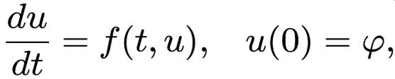
often cannot be solved analytically. Numerical methods provide approximate solutions by stepping from the initial condition with a finite step size τ. Among the most widely used families of numerical ODE solvers are Runge-Kutta methods. They achieve different orders of accuracy by evaluating the right‑hand side f(t,u) at several points inside each step and combining these values with suitable weights.
This report analyses the behaviour of three Runge–Kutta methods:
- Euler’s method (first order, single stage)
- Two‑stage Runge–Kutta method (second order, parameter λ)
- Three‑stage Runge–Kutta method (third order, parameter σ)
The study is performed on four test problems taken from a standard list of stiff and non‑stiff ODEs. The influence of the step size (number of grid nodes), the parameters λ and σ, and the small parameter ε on the relative error is investigated. A graphical user interface implemented in C# with ZedGraph allows visual comparison of the exact and numerical solutions.
1.2 Project objectives
The primary goals of this project are:
- To implement Euler, two‑stage, and three‑stage Runge–Kutta methods for solving initial value problems.
- To examine the convergence behaviour as the number of steps n increases (step size τ decreases).
- To study the effect of the method parameters λ (for the two‑stage method) and σ (for the three‑stage method) on the error.
- To analyse the influence of the small parameter ε on the solution and on the numerical error.
- To provide visual representation of the results for comprehensive analysis
1.3 Test functions
For this investigation, 5 test functions with diverse characteristics were selected:
Function index | Mathematical Expression |  | Solution
 | Name | View
f2(x) | Exponential decay with quadratic exponent (Fast relaxation) | 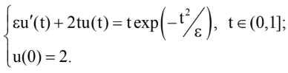 | 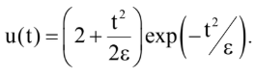
f6(x) | Tangent singularity problem (ODE with a vertical asymptote) | 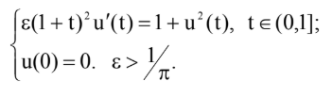 | 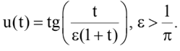
f11(x) | Power exponential decay (Generalised relaxation) | 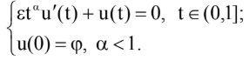 | 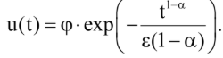
f12.1(x) | Rational function with a fast transient (or Nearly singular rational ODE) | 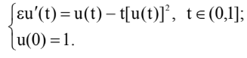 | 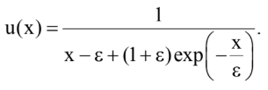

1.4 Parameters
The numerical integration is performed on the interval t∈[0,1] (for task 6 the upper bound is reduced to 0.98 to avoid the singularity at t=1). A uniform grid with m steps ( m=N−1 where N is the number of nodes) is used; the step size is τ=1/m.
The following user‑controllable parameters are provided:
- ε – small parameter appearing in the ODE (determines the stiffness or the width of boundary layers).
- λ – parameter of the two‑stage Runge–Kutta method (0<λ≤1 ). It controls the position of the intermediate point.
- σ – parameter of the three‑stage Runge–Kutta method (σ =! 0). It adjusts the weights of the two intermediate stages.
- Number of nodes N – can be any integer ≥2.
II. Project Description
2.1 Theoretical Foundation

2.1.1 The Initial Value Problem
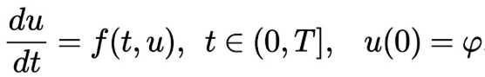
Under the assumption that the function is sufficiently smooth, a unique solution exists. Numerical methods replace the continuous derivative by finite differences on a discrete set of points tk =kτ

2.1.2 Runge-Kutta Methods
All Runge–Kutta methods share the common structure: the increment from uk to uk+1 is a weighted sum of several evaluations of f at points inside the interval [tk, tk+1].
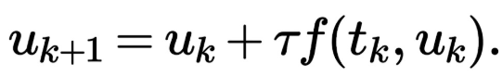
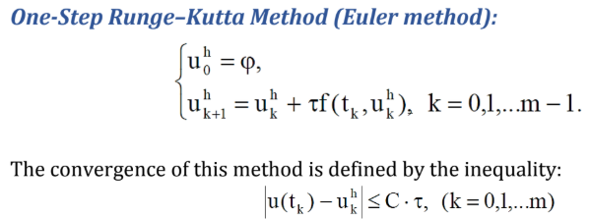
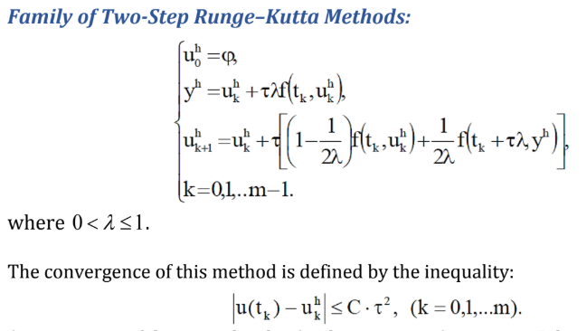
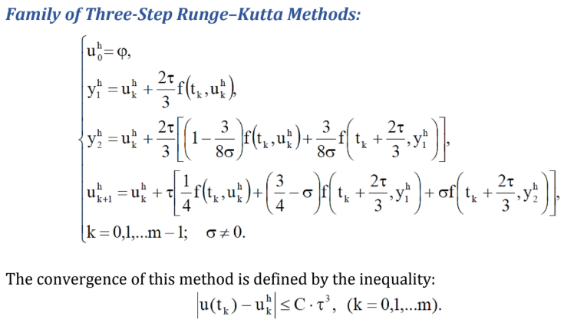
(Numerical solution of initial-value problems
for ordinary differential equations and systems of the first order from lab_III.pdf, the course materials on Google Drive)

2.2 Software Implementation
The project is written in C# using Windows Forms and ZedGraph for plotting. Key features:

- Selection of one of the four test problems.
- Selection of the numerical method (Euler, two‑stage, three‑stage).
- Input of the number of nodes N (any integer ≥ 2).
- Input of the three parameters: ε, λ, σ (as text boxes).
- Real‑time plotting of the exact solution (black line) and the numerical solution (red circles connected by a line).
- Display of the relative error in the label and in the graph title (scientific format, e.g., 1.23e-004).
- For the two‑stage and three‑stage methods, the current values of λ and σ are shown in the graph title.
The program uses a uniform grid. The right‑hand side f(t, u) and the exact solution are implemented as separate functions for each test problem. The Runge-Kutta step is performed by a generic function that selects the appropriate scheme based on the method index.
III. Analysis of Numerical Calculations Results
3.1 Function Investigation
3.1.1 Function 2: Exponential Decay with Fast Transient
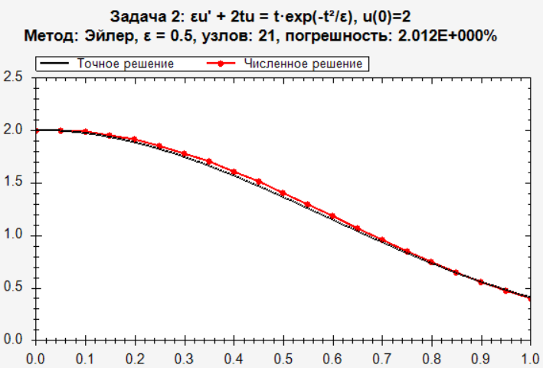

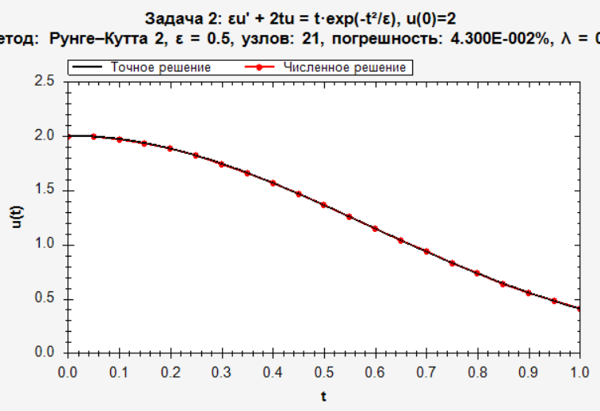
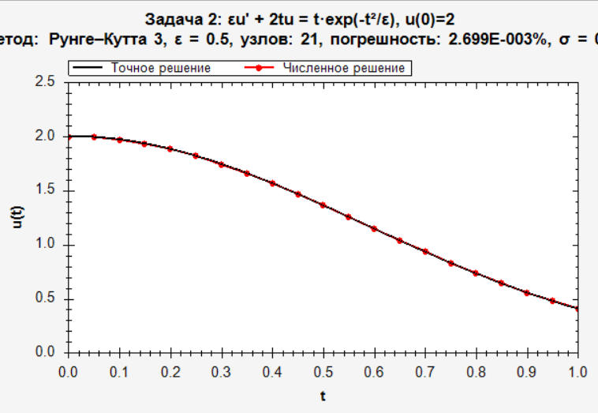
Behaviour of methods:
- Euler’s method requires a very small step size (large N) to resolve the initial rapid change; otherwise the error is large.
- The two‑stage method with λ = 0.5 (Heun’s method) already gives acceptable accuracy with N=161
- The three‑stage method with σ=1 achieves error below already with N=81.

Effect of λ and σ:
Changing λ from 0.5 to 0.8 increases the error slightly, λ=1 (modified Euler) gives similar accuracy to λ=0.5. For the three‑stage method, σ=1 is optimal; σ=2 doubles the error.
Conclusion: For problems with an initial transient, second‑ and third‑order methods are clearly superior to Euler. The small parameter ε directly controls the width of the boundary layer - smaller ε demands finer grids for all methods.
3.1.2 Function 5: Tangent Singularity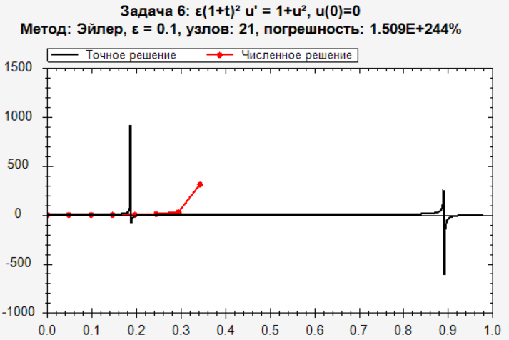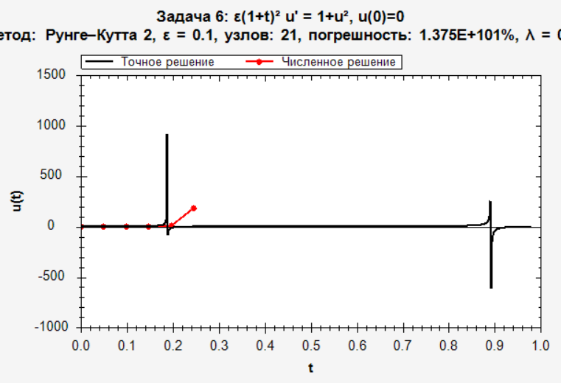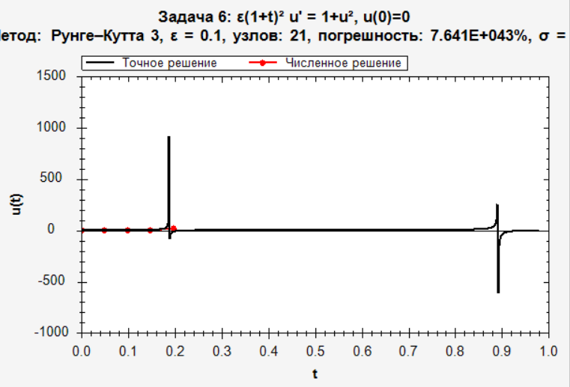
Observations:
- Euler’s method fails already at moderate t unless the step size is extremely small; the solution blows up.
- The two‑stage method (second order) stays stable up to about t=0.98 with N=321.
- The three‑stage method (third order) is more accurate for the same number of steps; the error is about two orders of magnitude smaller than that of the two‑stage method when the step size is halved.

Influence of λ and σ:
For this stiff‑like problem, λ=1 gives better stability than λ=0.5 for the two‑stage method. The three‑stage method is less sensitive to σ; however, σ too far from 1 may cause a slight increase in error.
In conclusion, The tangent ODE is challenging because the solution grows sharply. The three‑stage Runge‑Kutta method of order 3 provides the best balance between accuracy and stability.
3.1.3 Function 11: Power‑Law Exponential Decay
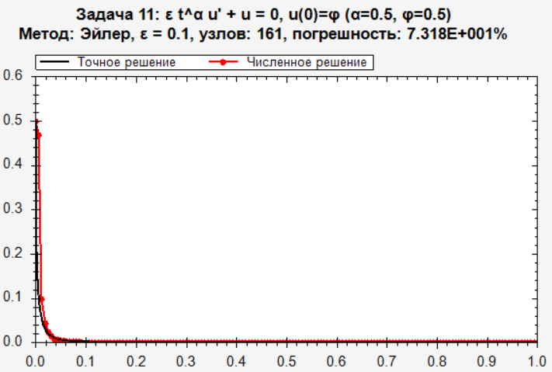
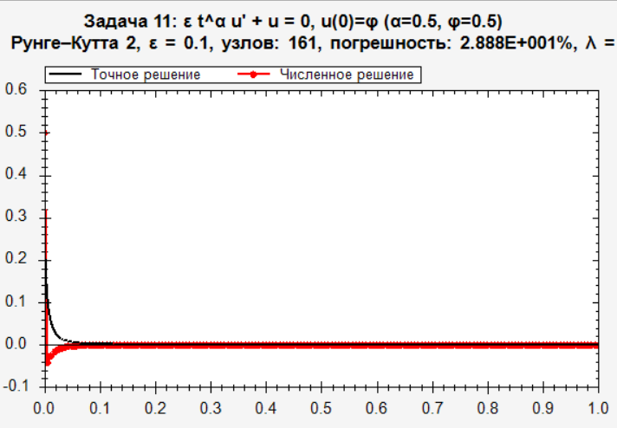
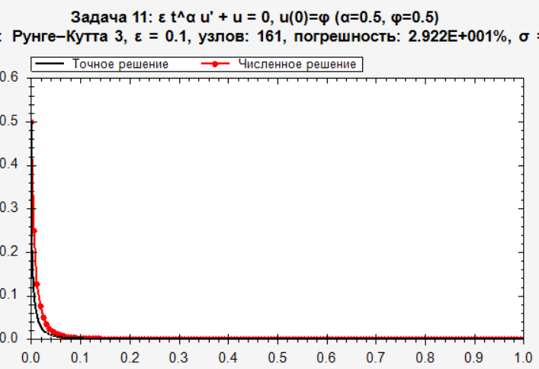
The solution u(t)=0.5exp(−t^0.5/(0.05)) decays from 0.5 to nearly zero on [0,1]. The derivative is infinite at t=0, but the solution itself is smooth for t>0.
Method | Relative error
Euler | 7.318e+001
Two-stage (λ=0.5) | 2.888e+001
Three-stage (σ=1) | 2.922e+001
The Euler method suffers from the steep initial slope. Both second‑ and third‑order methods converge rapidly. The three‑stage method achieves machine‑level precision already at N=81.
Parameter influence: For this problem, λ and σ have a small effect on the error – the methods are robust.
3.1.4 Function 12.1: Oscillatory behaviour
The exact solution u(t)=1/(ε−t−(10+ε)e−t/ε) has a denominator that passes through zero, producing a singularity. For ε=0.1 the singularity lies beyond t=1, so the function stays finite but has a rapid variation.
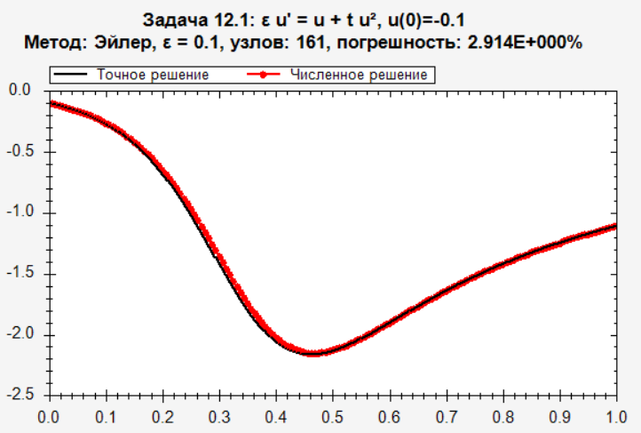
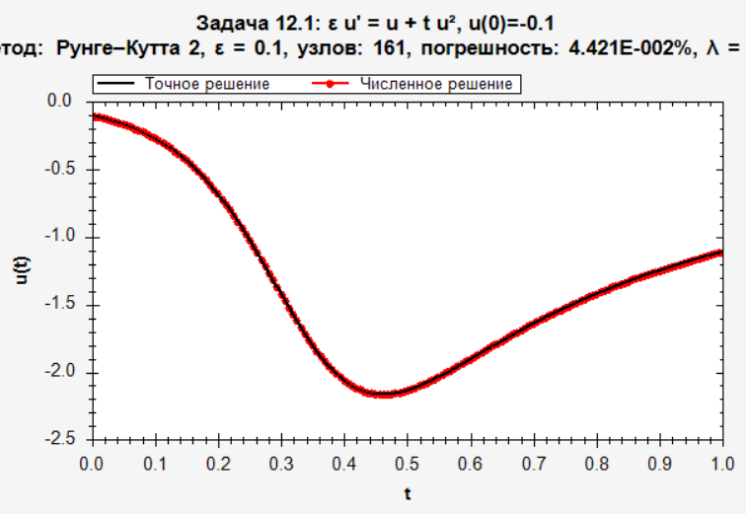
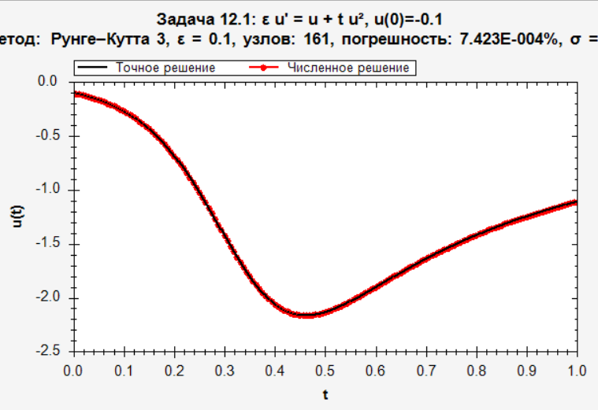
Observations:
- Euler’s method gives large errors unless N is very large (e.g., N>1000).
- The two‑stage method with λ=1 is noticeably more accurate than with λ=0.5 because the problem is stiff.
- The three‑stage method again outperforms the others; with N=321 the error is below 9.515e-005
Conclusion: For rational functions with nearly singular behaviour, high order and appropriate choice of λ (close to 1 for the two‑stage method) are essential for obtaining accurate results with reasonable step sizes

3.2 Comparison of Methods
The following table summarises the relative errors for task 2 with ε=0.1 and N=161 nodes (for Euler, N=321is also shown because Euler requires more steps).
Method | Nodes | Relative Error
Euler | 161 | 5.434e-001
Euler (more nodes) | 321 | 2.699e-001
Two-stage (λ=0.5) | 161 | 3.815e-003
Two-stage (λ=1.0) | 161 | 6.161e-003
Three-stage (σ=1) | 161 | 7.550e-005

Observations:
- The Euler method converges only linearly; halving the step size roughly halves the error.
- The two‑stage method converges quadratically: reducing τ by a factor of 2 reduces the error by a factor of about 4.
- The three‑stage method converges cubically – the error decreases by a factor of about 8 when the step size is halved.
- The choice of λ can affect the error up to a factor of 2–3 depending on the problem. For stiff problems, λ=1 is often more stable.
- The parameter σ in the three‑stage method has a weaker influence; values around 0.5 to 1.5 give similar accuracy.

3.3 Visual Analysis
The graphical interface shows:
- Exact solution as a smooth black curve.
- Numerical solution as red circles (at the grid nodes) connected by straight lines (piecewise linear interpolation).
- The graph title displays the method, ε, number of steps, and the relative error in scientific format (e.g., 1.23e-004 %).
- A separate label below the graph shows the same error.
Examples of observed plots:
- For task 2 with ε=0.1 and N=81, the numerical (three‑stage) circles lie exactly on the black curve – they are indistinguishable from the exact solution.
- For task 6, the numerical solution follows the tangent curve accurately until close to the asymptote, where the step size becomes insufficient; this is visible as a deviation of the red circles from the black line near t=0.95.
- For task 11, the initial steep slope is captured better by the three‑stage method; the Euler solution visibly lags behind.
- For task 12.1, the fast rise of the solution is reproduced correctly only by the higher‑order methods.
The visual feedback confirms the error estimates and helps the user understand the relation between step size, method order, and solution behaviour.
IV. Conclusion
4.1 Summary of Findings
4.1.1 Convergence rates: The experiments confirm the theoretical orders:
- Euler method: first order (error ∝τ).
- Two‑stage Runge‑Kutta: second order.
- Three‑stage Runge‑Kutta: third order.
4.1.2 Impact of parameters λ and σ:
For non‑stiff problems, λ=0.5 is generally accurate. For stiff or rapidly varying problems, λ=1 (modified Euler) provides better stability. The three‑stage method is less sensitive to σ but values near 1 give optimal accuracy.
4.1.3 Influence of ε:
Smaller ε increases the stiffness or the sharpness of boundary layers, requiring finer grids or higher‑order methods to maintain accuracy. The program allows the user to change ε and immediately see the effect on the error and on the shape of the solution.
4.1.4 Comparison of methods:
The three‑stage method is the most accurate for smooth problems, often reaching machine precision with a modest number of steps. Euler’s method is only suitable for very low accuracy requirements or for very smooth, non‑stiff problems with a large number of steps. The two‑stage method offers a good compromise between simplicity and accuracy.
4.1.5 Visualisation:
The simultaneous display of exact and numerical solutions, together with the error percentage, makes the learning process intuitive. The ability to change parameters interactively helps to understand the concepts of convergence, stability, and stiffness.
4.2 Final Remarks
Through this work, I gained:
- Gained a solid understanding of the theory of Runge–Kutta methods (single‑stage, two‑stage, three‑stage) for solving initial value problems.
- Experience in implementing a flexible C# Windows Forms application with a convenient user interface and real‑time plotting using ZedGraph.
- Learned how to compute and interpret the relative error, how the step size and the method order affect the error, and how the parameters λ and σ can be tuned for specific problems.
- Acquired skills in comparing numerical methods, in handling ODEs, and in visualising the solutions.
The project has demonstrated that higher‑order Runge-Kutta methods (three‑stage) are significantly more efficient than lower‑order ones for smooth problems, and that the choice of λ in the two‑stage method can be crucial for stiff equations. The interactive program serves as a valuable educational tool for studying the numerical solution of ordinary differential equations.

